

**Assignment Cover Sheet**

|  |  |  |  |
| --- | --- | --- | --- |
| **Qualification** | | **Module Number and Title** | |
| HND in Computing/HND in Software Engineering | | **Introduction to OOP- SEC4207** | |
| **Student Name & No.** | | **Assessor** | |
|  | |  | |
| **Hand out date** | | | **Submission Date** |
|  | | |  |
| **Assessment type**  WRIT1-Coursework | **Duration/Length of**  **Assessment Type**  3000 wordsequivalent | | **Weighting of Assessment**  100% |

|  |  |
| --- | --- |
| **Learner declaration** | |
| I certify that the work submitted for this assignment is my own and research sources are fully acknowledged. | |
|  | |  |  |  |  | | --- | --- | --- | --- | | **Marks Awarded** | | | | | First assessor | |  | | | IV marks | |  | | | Agreed grade | |  | | | Signature of the assessor |  | Date |  | |

**Feedback Form**

**International College of Business & Technology**

**Module:**

**Student:**

**Assessor:**

**Assignment:**

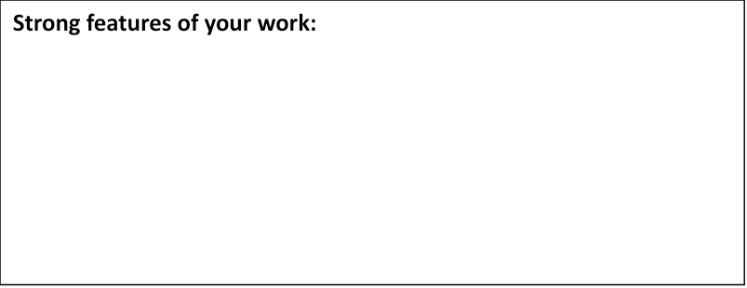

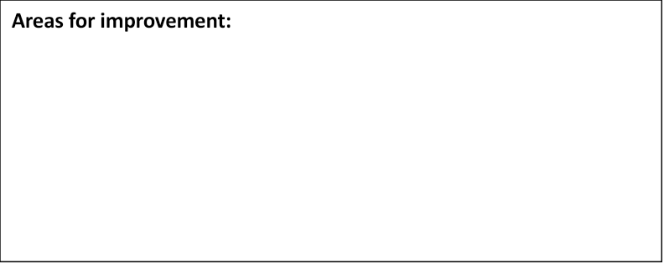



Coursework

**Learning outcomes covered**

LO1: Explain the fundamentals of Object-Oriented Programming concepts

LO2: Design Object-Oriented based applications

LO3: Develop Object-Oriented applications

**Scenario and the Task**

**“City Bank”** is one of the new bank located in the heart of the city. The company planned to implement an application in order to automate transaction process

**User levels and functionalities are follows**

**Cashier**

1. View all the account holders details
2. Manage transaction
   1. Withdraw money
   2. Deposit money
3. Check balance
4. Search details based on account number, name

**Manager**: (can perform all the functionality as cashier plus the following)

1. Create a new account (can have different account types)
2. Create new user account for cashier

***You are required to apply OOP concepts for the above scenario***

**Part A: Documentation**

**Task 1**.Provide design solution (UML diagrams) for the above mention Scenario. Provide clear explanation for all the diagrams mention below. (Provide assumption if necessary) **(30 marks) (LO2)**

1. Use case Diagram
2. Class Diagram
3. Sequence Diagram

**Task 2:** Develop suitable system for the above scenario based on the design. Required to use Object Oriented concepts (Object, Class, Abstraction, Inheritance, Encapsulation and Polymorphism) for the development. Document the main functionalities and Object Oriented concepts applied with proper explanation and source code.  **(Marks 20) (LO1, LO3)**

**Task 3:** Provide a user manual for the developed solution **(Marks 10) (LO3)**

**Task 4:** System demonstration. System should work according to the expected functionalities. Should be able to demonstrate Object Oriented concepts (Object, Class, Abstraction, Inheritance, Encapsulation, and Polymorphism) applied to the given scenario. **(Marks 40) (LO1, LO3)**

**Guidelines for the report format**

Paper A4

Margins 1.5” left, 1” right, top and bottom

Page numbers – bottom, right

Line spacing 1.5

Font

Headings 14pt, Bold

Normal 12pt

Font face- Times New Roman

**Assessment Criteria**

|  |  |  |
| --- | --- | --- |
| **This submission will be assessed as follows** | **Total marks Allocated** | **Marks obtained by the student for the answer provided** |
| **Part A: Task 1:** | Out of 30 |  |
| **POOR**  Poor use of Object Oriented Design Methodology  Use case Diagram   * Poor or no identification of use cases * Poor or no Identification of Actors and associations   Class Diagram   * Poor or no identification of associated methods, with correct signatures and attributes in each class * Poor or no identification of relationships   Sequence Diagram   * Poor or no identification of set of use cases as sequence diagrams. | 0-12 |  |
| **SATISFACTORY**  Proper use of Object Oriented Design Methodology  Use case Diagram   * Has identify few of correct use cases * Has identify few correct Actors and associations   Class Diagram   * Identification of associated methods, with correct signatures and attributes in each class * Correct identification of relationships   Sequence Diagram   * Has identified set of use cases (about 3) as sequence diagrams. | 13-18 |  |
| **GOOD**  Use case Diagram   * Accurate use of <<include> <<extend>> stereo types in use case diagram   Class Diagram   * Clear identification of private, public access modifiers & it is visible in the class diagram   Sequence Diagram   * Appropriate use of lifelines, messages and objects in proposed sequence diagrams   Correct use of UML notations with minor mistakes  Evaluation   * Student has given basic description about the design and given a reasonable justification * Effective judgements have been made about the content and levels of information to be included | 19-21 |  |
| **EXCELLENT**  Excellent Design   * Highly detailed diagram * Use of OO concepts clearly visible * Backed by relevant assumptions * Excellent use of UML notation   Evaluation   * Good justification of the design * Judge validity of results * Use critical reflection to evaluate the work and justify with valid explanations   Fluency (Of design)  Evidence of critical analysis on different perspectives covering how all UML diagrams support in designing | 22-30 |  |
| **Task 2:** | Out of 20 |  |
| **POOR**   * No proper standard coding * Insufficient code evidence with no or poor explanation * Poor use of Object oriented concepts no or poor explanation * Poor implementation of the design | **0-8** |  |
| **SATISFACTORY**   * Proper standard coding * Sufficient code evidence with proper explanation * Basic use of Object oriented concepts (at least 3 concepts) with basic explanation * Proper implementation of the design with minor mistakes | **9-12** |  |
| **GOOD**   * Proper use of Object oriented concepts (at least 4 concepts) with proper explanation * Proper implementation of the design with no mistakes | **13-15** |  |
| **EXCELLENT**  Excellent use of Object oriented concepts (all the concepts) with proper explanation | **16-20** |  |
| **Task 3:** | Out of 10 |  |
| **POOR**   * Poor structure no clear explanation and screenshots * Content is not specific and sufficient | 0-4 |  |
| **SATISFACTORY**   * Has provide basic explanation with screenshots * Content is specific and sufficient | **5-6** |  |
| **GOOD**   * Has provide average explanation with screenshots | **7-8** |  |
| **EXCELLENT**   * Excellent , clear and descriptive explanation with screenshots | **9-10** |  |
| **Part B: Task 4:** | Out of 40 |  |
| **POOR**   * System with syntax and logical errors * Poor or not able to explain and demonstrate implementation of the design Poor or not able to explain and demonstrate Object oriented concepts used in the system | 0-16 |  |
| **SATISFACTORY**   * Error free system * Partially able explain, demonstrate and justify the implementation of the design Partially able to explain and demonstrate Object oriented concepts used in the system | 17-24 |  |
| **GOOD**   * Able to explain, demonstrate and justify the implementation of the design * Able to explain and demonstrate Object oriented concepts used in the system | 25-30 |  |
| **EXCELLENT**  Has demonstrate excellent level of understanding of Object oriented concepts | 31-40 |  |
| **Total marks** | **100** |  |