WrisTrack

Prepared By: Dharshna Karthick

School : Hopkinton High School

Academic Year : 2027

Date : 10/16/2026

1. Project Summary

This project uses an IMU-based system for detecting wrist deviation during cricket bowling. Two BNO086 sensors are mounted on an athlete’s arm and wrist to measure their relative orientation and movement. Quaternion-based orientation data is processed by ESP-32 C6 microcontroller to determine the wrist’s deviation relative to the forearm. This system is intended to provide measurements to help bowlers minimize excessive wrist movement which can impact bowler’s consistent ball deliveries, speed of the ball and legal deliveries.

2. Problem Statement

2.1 Problem

During cricket bowling, it is difficult to identify movement of the wrist in the middle of a bowler’s action. A bowler’s wrist determines the direction of the ball and is one of the primary causes to wides. While technology to determine deviation exists, it is mainly used for international competitions and is not practical for an everyday player.

2.2 Proposed solution

Develop a wearable system using IMU sensors that can measure the wrist’s orientation relative to the forearm and identify lateral deviation.

3. Engineering Principles

3.1 What is an IMU?

IMU is an Inertial Measurement unit that can measure motion using sensors such as:

- Accelerometer
- Gyroscope
- Magnetometer

This project uses many different parts of the BNO086 such as:

3.2 Accelerometer

- Measures acceleration along X, Y and Z
- Units m/s^2 or g
- Useful for detecting movement and sudden changes in motion

3.3 Gyroscope

- Measures angular velocity
- Units: degrees/seconds or rad/s
- Useful for detecting rotational movement

3.4 Sensor Fusion

- Combines the measurements from the accelerometer and gyroscope
- Provides an orientation estimate that the microcontroller uses
- Helps overcome limitations that the sensors have individually

3.5 Quaternions

- Mathematical representation used to describe the orientation of an object in three dimensional space
- Orientations of the two sensors are easily compared
- q=(w,x,y,z)
- W = scalar component
- X,y, and z are vector components

- Used to avoid gimbal lock (the disadvantage to euler lock: losing a degree of freedom when two rotation axes align)

4. Architecture

BN0O86 IMU (Forearm)

BN0O86 IMU (Wrist)

ESP32-C6
I2C
I2C
Wi-Fi

Python program
ESP32-C6 processes

Calibration
Quaternion Data
Forearm Pitch Calculation
Relative Wrist Orientation
Bowling Phase Detection
Wrist Deviation Detection
UDP Data Transmission
Python Program

Receives Data via UDP
Stores data to CSV file
Plots wristdeviation vs number of balls

5. Hardware Components

Component | Purpose
ESP32-C6 | Microcontroller
*BNO086 #1 | Forearm Orientation
*BNO086 #2 | Wrist Orientation
Qwiic cables | I2C connections
Battery (3.7 V 850mAh) | System power

5.1 Parameters

Parameter | BNO086
Sensor type | 9-Axis IMU
Interface | I2C
Supply | 3.3 V
Output | Quaternion

6. Hardware Design

6.1 Sensor Placement

Two sensors, one on the forearm and one on wrist, were used to calculate deviation relative to one another because lateral wrist detection relies on how much the wrist deviates from the arm.

Sensor 1: Mounted on forearm
Sensor 2: Mounted on wrist

6.2 Connections/Wiring

The two BNO086 IMUs are connected to the ESP32-C6 through a shared I2C bus. When the microcontroller accesses information from the two sensors, the shared I2C bus makes it impossible to differentiate the data. To allow both sensors to operate on the same bus, their addresses are different - 0x4A for the wrist sensor and 0x4B for the forearm sensor - which allows the ESP32-C6 to read them as two different sensors.

BNO086 #2 → 0x4A

BNO086 #2 → 0x4A

3.3V
GND
GPIO 6
GPIO 7

VIN
GND
SDA
SCL

VIN
GND
SDA
SCL

BNO086 #1 → 0x4B

BNO086 #2 → 0x4A

7. Software Design

7.1 Tools/Languages Used

- Arduino IDE
- SparkFun BNO080 Libraries
- Python

7.2 Program Flow
7.3 Neutral Calibration

Start

Initialize IMU Sensors

Calibrate IMU Sensors

Connect to Wifi & Send UDP

Neutral Calibration

Calculate side value & pitch
Identify Top of Action

Calculate wrist angle

Yes
No
Python
Send Neutral
Above threshold
No
Send wrist deviation message
Yes
Send UDP

Each bowler’s neutral position differs, requiring a step to initialize the neutral position. When the IMUs have been stabilised, the program requires the bowler to keep their arm in starting position for 6 seconds. It captures the forearm and wrist quaternion and stores the neutral orientation. The deviation will be measured relative to this position.

7.4 Mathematical Model

How quaternion delta is calculated

Quaternion delta can’t be calculated by just subtracting. It has both scalar and vector components.

Formula for calculating quaternion delta - $q_{forearm}^{-1} * q_{wrist}$

$q_{forearm}^{-1}$ is calculated by negating the vector components and maintaining the scalar value.

Delta = multiply(inverse(forearmQuat), wristQuat)

By calculating inverse(forearmQuat), the program "undoes" whatever rotation the forearm is currently experiencing. Multiplying that inverse by the wristQuat cancels out the forearm's absolute global orientation, leaving only the raw, isolated difference between the two sensors.

Note : These forearm quaternions are calculated only once during the neutral calibration.

Also, each bowler has a different neutral position that must be taken into consideration. By multiplying the inverse of the neutral position, it establishes a 0 baseline that removes the slight tilt that each bowler may have.

7.5 Wrist Deviation Detection Algorithm

Side value of wrist movement is calculated by the relative orientation of the wrist based on the above quarterion formula. Wrist angle/Pitch is calculated using the identity$pitch=arcsin(2(w⋅y-z⋅x)$). A threshold of 0.20 degrees is set to disregard any natural side to side movement. If the wrist angle is deviated above the threshold, wrist deviation is detected.

A Bowler must reach release point before detecting wrist deviation. The program tracks the bowler’’s arm through three positions: front position, back position and top of position using the forearm pitch.

- If forearm pitch is between -10 and 30 degrees, front position is identified
- If forearm pitch goes past -30 degrees, back position is identified
- Once the pitch angle is greater than 3 degrees of previous pitch, the program detects arm’s upward movement
- When pitch angle is less than 3 degrees greater than previous pitch angle, the program captures previous pitch angle as peak angle

Wrist deviation detection begins after peak angle is detected.

8. Real time Testing

Setup

- Sensors mounted on arm and wrist
- Sensors are connected to ESP32 Microcontroller
- Battery is connected to the Micro controller

Test 1 - Stationary testing

Arm kept stationary

Output -

Expected - Verify whether angle/quaternion remains approximately constant
Actual - Angle remained approximately constant

Test 2 - Neutral Calibration

Arm kept in neutral position of bowler

Output -

Expected - Verify whether neutral calibration is calculated properly
Actual - Neutral calibration is calculated precisely and subsequent angle measurements accounted for this neutral calibration

Test 3 - Wrist deviation detection (above threshold)

Wrist moved more to the side

Output -

Expected - Verify whether wrist deviation is detected
Actual - Wrist deviation is detected and python program printed it as expected

Test 4 - Wrist deviation detection (below threshold)

Wrist moved slightly to the side

Output -

Expected - Verify whether wrist deviation is not detected
Actual - Wrist deviation is not detected for the slight movement of the wrist

Test 5 - No side movement, just up and down movement

Wrist moved just up and down during bowling
Output -

Expected - Verify whether wrist deviation is not detected for just up and down movement of wrist
Actual - Wrist deviation is not detected for up and down movement of wrist

Test 6 - Wrist deviation detection only after bowling action

Bowler starts the bowling action - rotating the arm all the way from front to back.

Pitch the ball to bowl with wrist slightly moved to side

Expected - Wrist deviation is detected only after the bowling action is completed
Actual - Wrist deviation is detected only after the bowling action is completed

Test 7 - Wrist deviation detection graph

Perform 10-20 trails

Expected - Verify is the results are captured and a graph is plotted
Actual - Results are captured and graph is plotted for angle in y, number of bowls in x axis

Results

Below is the picture showing a plot of wrist deviation detections per number of balls.

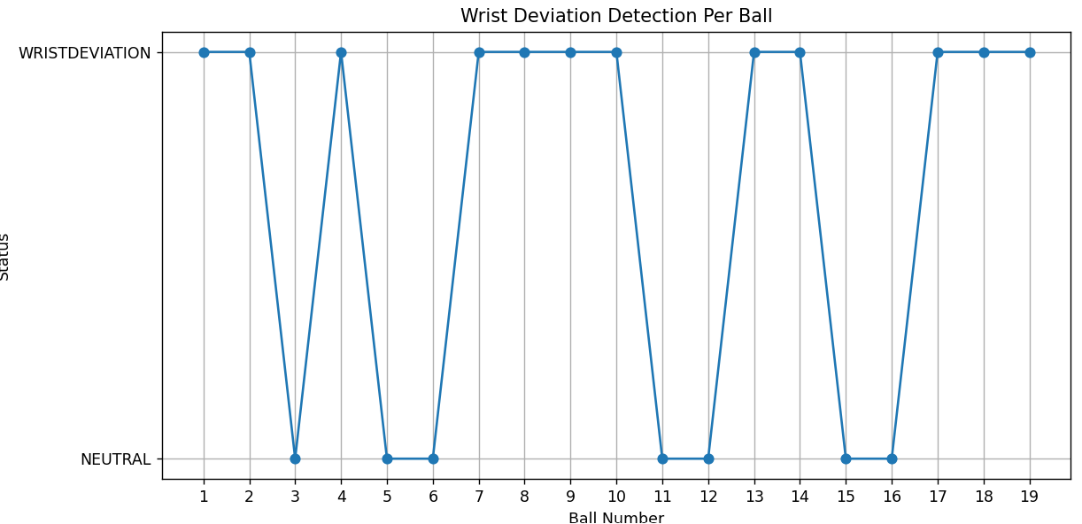

9. Challenges faced

Problem 1

Data from two IMU sensors are not captured after a few minutes of starting the system.

Investigation

Checked IMU sensors wiring
Checked whether IMU sensors are connected to right I2C address and whether its rightly defined in the code
Connected two sensors through multiplexer
Checked sparkfun Esp32/IMU forums for any known bugs

Solution

The issue was found neither in wiring or in the I2C address. There is a known bug mentioned in Sparkfun official forum that the BNO086 library/class won’t support more than one IMU sensor. So, older version of IMU which is BNO080 library was used, which resolved the issue

Problem 2

Initial calculation measures front/back or up and down movement instead of lateral deviation.

Solution

Changed the relative orientation calculation to isolate the desired wrist axis.

Problem 3

Initial bowling action was not detected properly when using acceleration and angle deviation of the forearm.

Solution

A sophisticated algorithm is used to detect the bowling action which involves detecting the arm moving downward, arm moving up and arm in the peak position using pitch angle variation.

Problem 4

Wrist deviation was not detected properly during the wrist flick.

Solution

A sampling algorithm was implemented which samples before and after the flick for a period of time and gets the maximum quaternions to detect the wrist deviation.

10. Limitations

- This system detects just lateral deviation in the wrist angle and it does not detect the impact of such deviation. It needs to be used in combination with other devices such as ball tracker, speed gun etc.

- Sensors has to be mounted properly and it must be consistent

- Each bowler requires individual calibration before they start to use the system

- Ball release detection may require additional sensors (eg) a sensor mounted to the shoulder and more sophisticated algorithm

- More testing is required to set the right threshold and it can vary due to the noise introduced by real world cricket environment

11. Future Improvements

Convert the whole hardware design into smaller wearable PCB

Mount one more sensor in shoulder and use that sensors data to detect ball release more accurately

