**Exercise 1: Control Structures**

**WEEK 2 – PL/SQL**

**HANDS-ON (ALL PROBLEMS COMPLETED)**

**9(**

**CREATE TABLE LOANS (**

**LoanID NUMBER PRIMARY KEY,**

**C_id NUMBER,**

**DueDate DATE,**

**FOREIGN KEY (C_id) REFERENCES Customers(C_id)**

**);**

**CREATE TABLE Customers (**

**c_id NUMBER PRIMARY KEY,**

**Name VARCHAR2(100),**

**Age NUMBER,**

**Balance NUMBER(10,2),**

**IsVIP CHAR(1) DEFAULT 'N',**

**LoanInterest NUMBER(5,2)**

**);**

**CUSTOMER**

INSERT INTO Customers VALUES (1, 'Alice', 65, 12000.00, 'N', 8.5);

INSERT INTO Customers VALUES (2, 'Bob', 45, 8000.00, 'N', 9.0);

INSERT INTO Customers VALUES (3, 'Charlie', 70, 5000.00, 'N', 7.5);

INSERT INTO Customers VALUES (4, 'Diana', 30, 15000.00, 'N', 8.0);

**LOAN**

INSERT INTO Loans VALUES (101, 1, SYSDATE + 10);

INSERT INTO Loans VALUES (102, 2, SYSDATE + 35);

INSERT INTO Loans VALUES (103, 3, SYSDATE + 20);

INSERT INTO Loans VALUES (104, 4, SYSDATE + 5);

**PL/SQL – SCENARIO 1**

BEGIN

    FOR cust IN (SELECT C_ID, LOANINTEREST FROM Customers WHERE Age>60) LOOP

        UPDATE Customers

        SET LOANINTEREST = LOANINTEREST- 1

        WHERE C_ID=cust.C_ID;

    END LOOP;

    COMMIT;

    DBMS_OUTPUT.PUT_LINE('1% discount applied to all customers above 60.');

END;

**OUTPUT:**

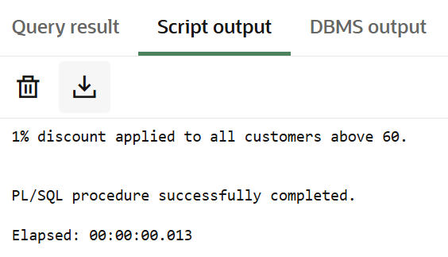

**PL/SQL – SCENARIO 2**

BEGIN

    FOR cust IN (SELECT C_ID FROM Customers WHERE Balance > 10000) LOOP

        UPDATE Customers

        SET IsVIP = 'Y'

        WHERE C_ID = cust.C_ID;

    END LOOP;

    COMMIT;

    DBMS_OUTPUT.PUT_LINE('VIP status updated for customers with balance WITH $10,000.');

END;

/

**OUTPUT**

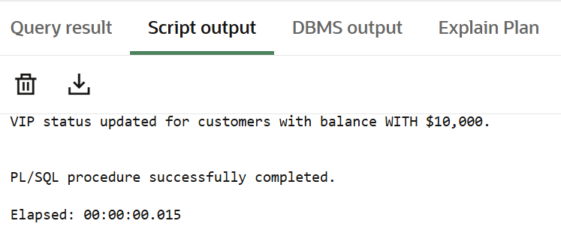

**PL/SQL – SCENARIO 3**

BEGIN

    FOR loan IN (

        SELECT L.LoanID, L.DueDate, C.Name, C.C_ID

        FROM Loans L

        JOIN Customers C ON L.C_ID = C.C_ID

        WHERE L.DueDate BETWEEN SYSDATE AND SYSDATE + 30

    ) LOOP

        DBMS_OUTPUT.PUT_LINE(

            'Reminder: Dear ' || loan.Name ||

            ', your loan (ID: ' || loan.LoanID ||

            ') is due on ' || TO_CHAR(loan.DueDate, 'DD-Mon-YYYY') || '.'

        );

    END LOOP;

END;

/

**OUTPUT**

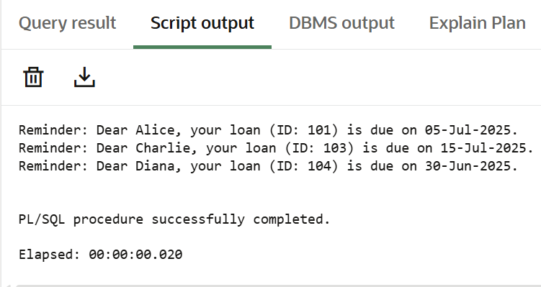

**--------------------------------------------------------------------------------------------------------------------------------------**

**Exercise 2: Error Handling**

**PL/SQL – SCENARIO 1**

CREATE OR REPLACE PROCEDURE SafeTransferFunds(

p_FromAcct IN NUMBER,

p_ToAcct IN NUMBER,

p_Amount IN NUMBER) IS

BEGIN

DECLARE

v_Balance NUMBER;

BEGIN

SELECT Balance INTO v_Balance FROM Accounts WHERE AccountID = p_FromAcct;

IF v_Balance < p_Amount THEN

RAISE_APPLICATION_ERROR(-20001, 'Insufficient funds in source account.');

END IF;

UPDATE Accounts SET Balance = Balance - p_Amount WHERE AccountID = p_FromAcct;

UPDATE Accounts SET Balance = Balance + p_Amount WHERE AccountID = p_ToAcct;

COMMIT;

DBMS_OUTPUT.PUT_LINE('Transfer completed successfully.');

EXCEPTION

WHEN OTHERS THEN

ROLLBACK;

DBMS_OUTPUT.PUT_LINE('Error during fund transfer: ' || SQLERRM);

END;

END;

/

**OUTPUT**

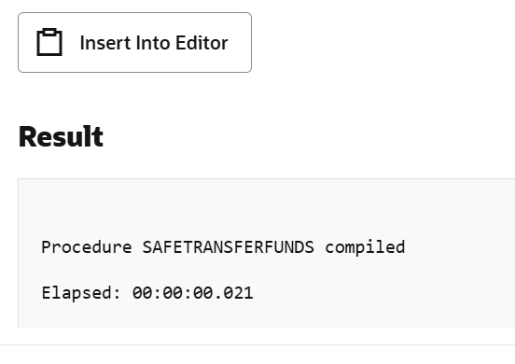

**PL/SQL SCENARIO 2**

CREATE OR REPLACE PROCEDURE UpdateSalary(

    p_EmpID IN NUMBER,

    p_Percent IN NUMBER) IS

BEGIN

    UPDATE Employees

    SET Salary = Salary + (Salary *p_Percent/100)

    WHERE EmpID = p_EmpID;

    IF SQL%ROWCOUNT = 0 THEN

        RAISE_APPLICATION_ERROR(-20002,'Employee ID not found.');

    END IF;

    COMMIT;

    DBMS_OUTPUT.PUT_LINE('Salary updated successfully.');

EXCEPTION

    WHEN OTHERS THEN

        ROLLBACK;

        DBMS_OUTPUT.PUT_LINE('Error updating salary: '||SQLERRM);

END;

/

**OUTPUT**

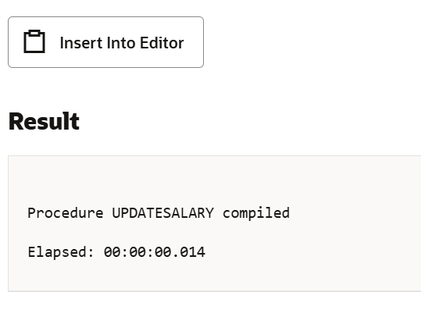

**PL/SQL SCENARIO 3**

CREATE OR REPLACE PROCEDURE AddNewCustomer(

p_C_ID IN NUMBER,

p_Name IN VARCHAR2,

p_Age IN NUMBER,

p_Balance IN NUMBER,

p_InterestRate IN NUMBER

)

IS

BEGIN

INSERT INTO Customers (C_ID, Name, Age, Balance, IsVIP, LOANINTEREST)

VALUES (p_C_ID, p_Name, p_Age, p_Balance, 'N', p_InterestRate);

COMMIT;

DBMS_OUTPUT.PUT_LINE('Customer added successfully.');

EXCEPTION

WHEN DUP_VAL_ON_INDEX THEN

DBMS_OUTPUT.PUT_LINE('Customer ID already exists. Cannot insert duplicate.');

WHEN OTHERS THEN

DBMS_OUTPUT.PUT_LINE('Error inserting customer: ' || SQLERRM);

END;

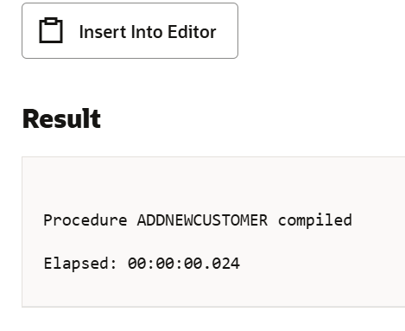

**--------------------------------------------------------------------------------------------------------------------------------------**

**Exercise 3: Stored Procedures**

**PL/SQL SCENARIO 1**

CREATE OR REPLACE PROCEDURE ProcessMonthlyInterest is

BEGIN

UPDATE Accounts

SET Balance = Balance + (Balance * 0.01)

WHERE AccountType = 'Savings';

COMMIT;

DBMS_OUTPUT.PUT_LINE('✅ Monthly interest applied to all Savings accounts.');

END;

/

**OUTPUT**

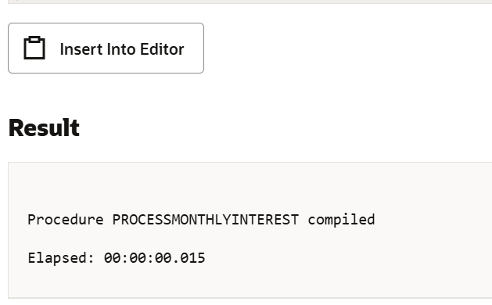

**PL/SQL SCENARIO 2**

CREATE OR REPLACE PROCEDURE UpdateEmployeeBonusByID(

    p_EmpID IN NUMBER,

    p_BonusPercent IN NUMBER

)

IS

BEGIN

    UPDATE Employees

    SET Salary = Salary + (Salary * p_BonusPercent / 100)

    WHERE EmpID = p_EmpID;

    IF SQL%ROWCOUNT > 0 THEN

        COMMIT;

        DBMS_OUTPUT.PUT_LINE('Bonus applied to employee ID: ' || p_EmpID);

    ELSE

        DBMS_OUTPUT.PUT_LINE('No employee found with ID: ' || p_EmpID);

    END IF;

EXCEPTION

    WHEN OTHERS THEN

        ROLLBACK;

        DBMS_OUTPUT.PUT_LINE('Error applying bonus: ' || SQLERRM);

END;

/

**OUTPUT**

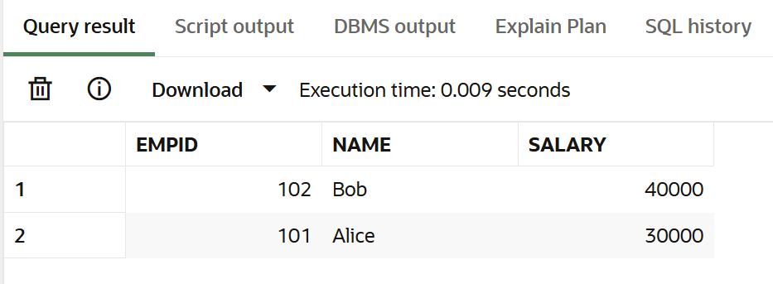

**PL/SQL SCENARIO 3**

CREATE OR REPLACE PROCEDURE TransferFunds(

p_FromAcct IN NUMBER,

p_ToAcct IN NUMBER,

p_Amount IN NUMBER

v_Balance NUMBER)IS

BEGIN

SELECT Balance INTO v_Balance FROM Accounts2 WHERE AccountID = p_FromAcct;

IF v_Balance < p_Amount THEN

RAISE_APPLICATION_ERROR(-20001, 'Insufficient funds in source account.');

END IF;

UPDATE Accounts2

SET Balance = Balance - p_Amount

WHERE AccountID = p_FromAcct;

UPDATE Accounts2

SET Balance = Balance + p_Amount

WHERE AccountID = p_ToAcct;

COMMIT;

DBMS_OUTPUT.PUT_LINE('Transfer successful from account ' || p_FromAcct || ' to account ' || p_ToAcct);

EXCEPTION

WHEN OTHERS THEN

ROLLBACK;

DBMS_OUTPUT.PUT_LINE('Error during fund transfer: ' || SQLERRM);

END;

/

**OUTPUT**

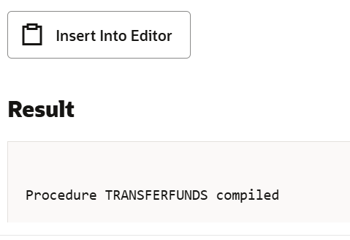

**--------------------------------------------------------------------------------------------------------------------------------------**

**Exercise 4: Functions**

**PL/SQL SCENARIO 1**

CREATE OR REPLACE FUNCTION CalculateAge(p_DOB DATE) RETURN NUMBER IS

v_Age NUMBER;

BEGIN

v_Age := TRUNC(MONTHS_BETWEEN(SYSDATE, p_DOB) / 12);

RETURN v_Age;

END;

/

**OUTPUT**

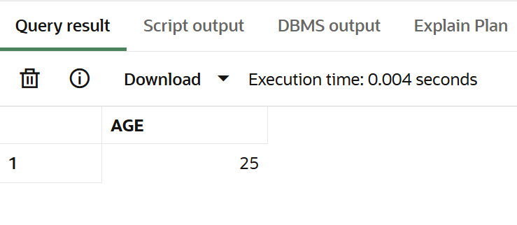

**PL/SQL SCENARIO 2**

CREATE OR REPLACE FUNCTION CalculateMonthlyInstallment(

    p_LoanAmount NUMBER,

    p_AnnualRate NUMBER,

    p_DurationYears NUMBER

) RETURN NUMBER

IS

    v_MonthlyRate NUMBER := p_AnnualRate / 12 / 100;

    v_TotalMonths NUMBER := p_DurationYears * 12;

    v_EMI NUMBER;

BEGIN

    IF v_MonthlyRate = 0 THEN

        v_EMI := p_LoanAmount / v_TotalMonths;

    ELSE

        v_EMI := p_LoanAmount * v_MonthlyRate * POWER(1 + v_MonthlyRate, v_TotalMonths) /

                 (POWER(1 + v_MonthlyRate, v_TotalMonths) - 1);

    END IF;

    RETURN ROUND(v_EMI, 2);

END;

/

**OUTPUT**

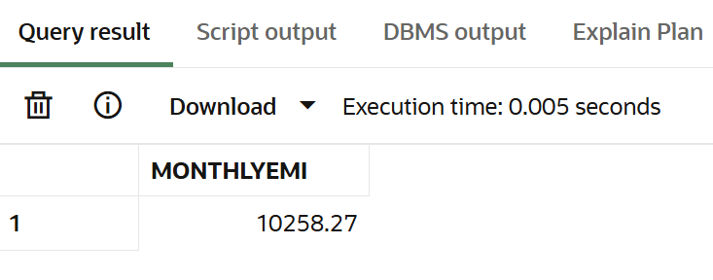

**PL/SQL SCENARIO 3**

CREATE OR REPLACE FUNCTION HasSufficientBalance( p_AccountID NUMBER, p_Amount NUMBER

) RETURN BOOLEAN IS

    v_Balance NUMBER;

BEGIN

    SELECT Balance INTO v_Balance FROM Accounts2 WHERE AccountID = p_AccountID;

    RETURN v_Balance >= p_Amount;

EXCEPTION

    WHEN NO_DATA_FOUND THEN

        RETURN FALSE;

    WHEN OTHERS THEN

        RETURN FALSE;

END;

/

**OUTPUT**

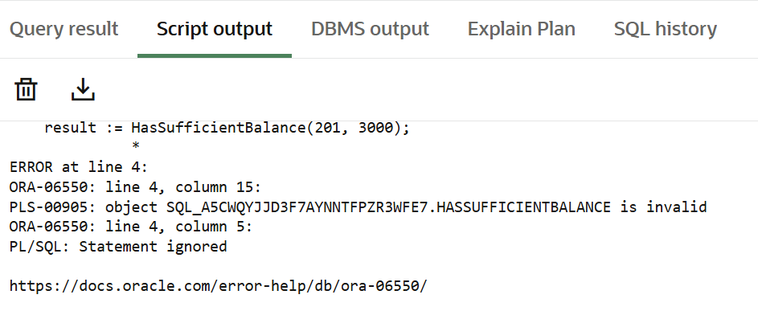

**--------------------------------------------------------------------------------------------------------------------------------------**

**Exercise 5: Triggers**

**PL/SQL SCENARIO 1**

CREATE OR REPLACE TRIGGER UpdateCustomerLastModified

BEFORE UPDATE ON Customers

FOR EACH ROW

BEGIN

    :NEW.LastModified := SYSDATE;

END;

/

**OUTPUT**

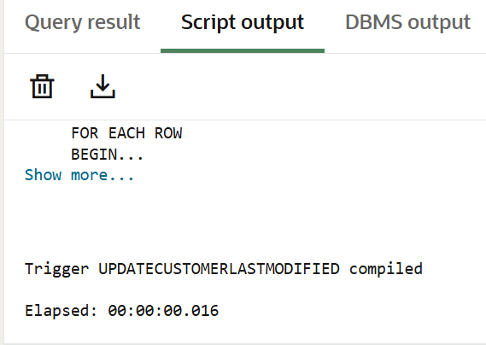

**PL/SQL SCENARIO 2**

INSERT INTO Transactions2 (TransactionID, AccountID, Type, Amount, TransactionDate)

VALUES (1001, 201, 'Deposit', 5000, SYSDATE);

SELECT * FROM AuditLog;

**OUTPUT**

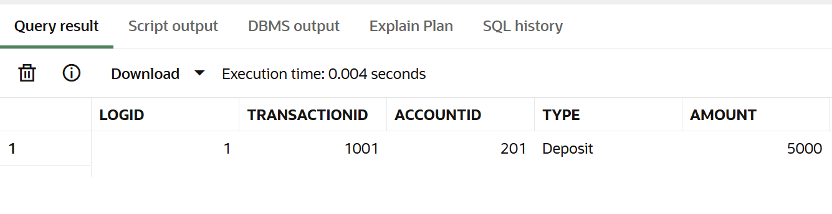

**PL/SQL SCENARIO 3**

CREATE OR REPLACE TRIGGER CheckTransactionRules2

BEFORE INSERT ON Transactions2

FOR EACH ROW

DECLARE

v_Balance NUMBER;

BEGIN

SELECT Balance INTO v_Balance FROM Accounts2 WHERE AccountID = :NEW.AccountID;

IF :NEW.Type = 'Withdrawal' THEN

IF :NEW.Amount > v_Balance THEN

RAISE_APPLICATION_ERROR(-20001, 'Withdrawal amount exceeds current account balance.');

ELSIF :NEW.Amount <= 0 THEN

RAISE_APPLICATION_ERROR(-20002, 'Withdrawal amount must be greater than 0.');

END IF;

ELSIF :NEW.Type = 'Deposit' THEN

IF :NEW.Amount <= 0 THEN

RAISE_APPLICATION_ERROR(-20003, 'Deposit amount must be greater than 0.');

END IF;

ELSE

RAISE_APPLICATION_ERROR(-20004, 'Invalid transaction type.');

END IF;

END;

/

**OUTPUT**

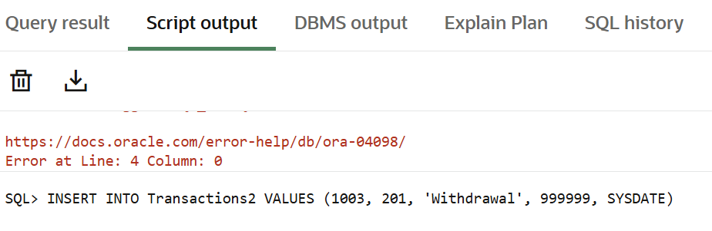

**--------------------------------------------------------------------------------------------------------------------------------------**

**Exercise 6: Cursors**

**PL/SQL SCENARIO 1**

DECLARE

    CURSOR txn_cur IS

        SELECT AccountID, Type, Amount, TransactionDate

        FROM Transactions2

        WHERE TO_CHAR(TransactionDate, 'MMYYYY') = TO_CHAR(SYSDATE, 'MMYYYY');

    v_acctID Transactions2.AccountID%TYPE;

    v_type   Transactions2.Type%TYPE;

    v_amt    Transactions2.Amount%TYPE;

    v_date   Transactions2.TransactionDate%TYPE;

BEGIN

    DBMS_OUTPUT.PUT_LINE('--- Monthly Statement ---');

    OPEN txn_cur;

    LOOP

        FETCH txn_cur INTO v_acctID, v_type, v_amt, v_date;

        EXIT WHEN txn_cur%NOTFOUND;

        DBMS_OUTPUT.PUT_LINE('Account: ' || v_acctID ||   ' | ' || v_type ||  ' | Amount: ' ' | Date: ' || TO_CHAR(v_date, 'DD-Mon-YYYY'));

    END LOOP;

    CLOSE txn_cur;

END;

/

**OUTPUT**

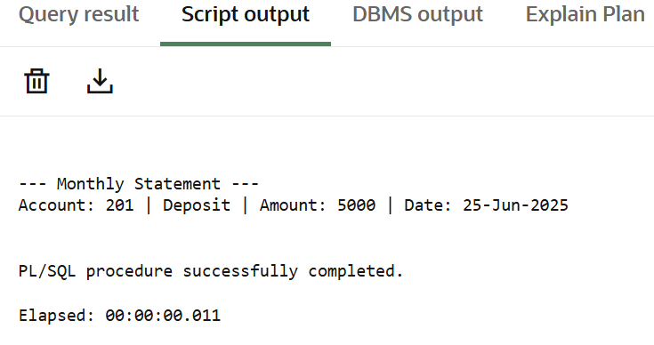

**PL/SQL SCENARIO 2**

DECLARE

CURSOR txn_cur IS

SELECT AccountID, Type, Amount, TransactionDate

FROM Transactions2

WHERE TO_CHAR(TransactionDate, 'MMYYYY') = TO_CHAR(SYSDATE, 'MMYYYY');

v_acctID Transactions2.AccountID%TYPE;

v_type Transactions2.Type%TYPE;

v_amt Transactions2.Amount%TYPE;

v_date Transactions2.TransactionDate%TYPE;

BEGIN

DBMS_OUTPUT.PUT_LINE('--- Monthly Statement ---');

OPEN txn_cur;

LOOP

FETCH txn_cur INTO v_acctID, v_type, v_amt, v_date;

EXIT WHEN txn_cur%NOTFOUND;

DBMS_OUTPUT.PUT_LINE('Account: ' || v_acctID || ' | ' || v_type || ' | Amount: ' || v_amt ||

' | Date: ' || TO_CHAR(v_date, 'DD-Mon-YYYY'));

END LOOP;

CLOSE txn_cur;

END; /

**OUTPUT**

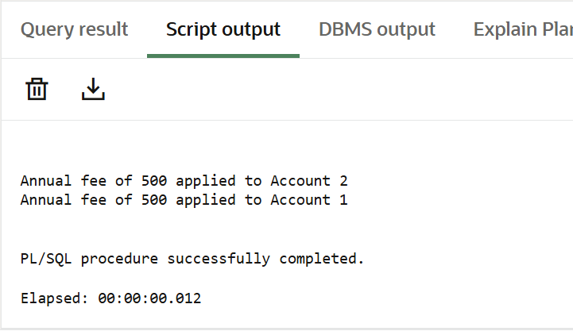

**PL/SQL SCENARIO 3**

DECLARE

CURSOR loan_cur IS

SELECT LoanID, LoanInterestRate FROM Loans;

v_LoanID Loans.LoanID%TYPE;

v_Rate Loans.LoanInterestRate%TYPE;

BEGIN

OPEN loan_cur;

LOOP

FETCH loan_cur INTO v_LoanID, v_Rate;

EXIT WHEN loan_cur%NOTFOUND;

IF v_Rate > 10 THEN

UPDATE Loans

SET LoanInterestRate = v_Rate - 1

WHERE LoanID = v_LoanID;

DBMS_OUTPUT.PUT_LINE('Loan ' || v_LoanID || ': Interest reduced to ' || (v_Rate - 1));

ELSE

UPDATE Loans

SET LoanInterestRate = v_Rate + 0.5

WHERE LoanID = v_LoanID;

DBMS_OUTPUT.PUT_LINE('Loan ' || v_LoanID || ': Interest increased to ' || (v_Rate + 0.5));

END IF;

END LOOP;

CLOSE loan_cur;

COMMIT;

END;

/

**OUTPUT**

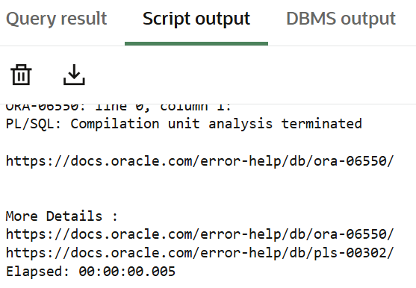

**------------------------------------------------------------------------------------------------------------------------------------**

**Exercise 7: Packages**

**PL/SQL SCENARIO 1**

CREATE OR REPLACE PACKAGE BODY CustomerManagement AS

PROCEDURE AddCustomer(p_ID NUMBER, p_Name VARCHAR2, p_Balance NUMBER) IS

BEGIN

INSERT INTO Customers (CustomerID, Name, Balance)

VALUES (p_ID, p_Name, p_Balance);

END;

PROCEDURE UpdateCustomer(p_ID NUMBER, p_Name VARCHAR2) IS

BEGIN

UPDATE Customers

SET Name = p_Name

WHERE CustomerID = p_ID;

END;

FUNCTION GetCustomerBalance(p_ID NUMBER) RETURN NUMBER IS

v_Balance NUMBER;

BEGIN

SELECT Balance INTO v_Balance

FROM Customers

WHERE CustomerID = p_ID;

RETURN v_Balance;

END;

END CustomerManagement;

/

**OUTPUT**

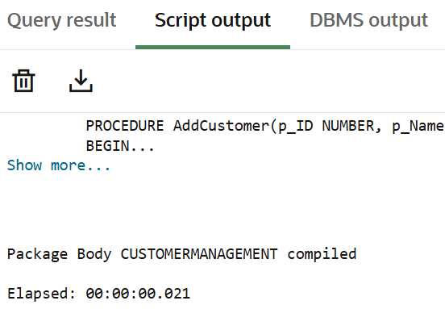

**PL/SQL SCENARIO 2**

CREATE OR REPLACE PACKAGE BODY EmployeeManagement AS

PROCEDURE HireEmployee(p_ID NUMBER, p_Name VARCHAR2, p_Salary NUMBER) IS

BEGIN

INSERT INTO Employees (EmpID, EmpName, Salary)

VALUES (p_ID, p_Name, p_Salary);

END;

PROCEDURE UpdateEmployee(p_ID NUMBER, p_Name VARCHAR2) IS

BEGIN

UPDATE Employees

SET EmpName = p_Name

WHERE EmpID = p_ID;

END;

FUNCTION CalculateAnnualSalary(p_ID NUMBER) RETURN NUMBER IS

v_Salary NUMBER;

BEGIN

SELECT Salary INTO v_Salary

FROM Employees

WHERE EmpID = p_ID;

RETURN v_Salary * 12;

END;

END EmployeeManagement;

/

**OUTPUT**

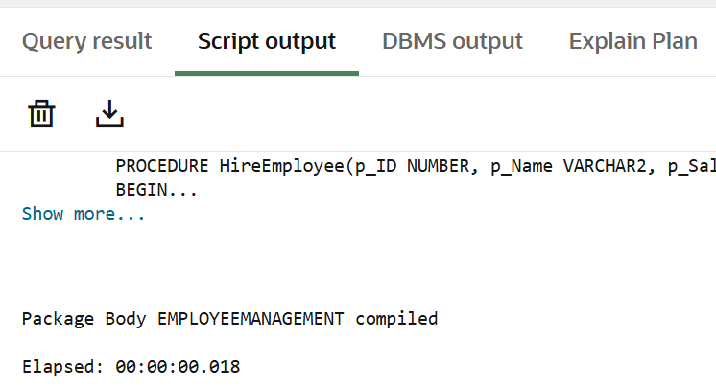

**PL/SQL SCENARIO 3**

CREATE OR REPLACE PACKAGE BODY AccountOperations AS

    PROCEDURE OpenAccount(

        p_AccID NUMBER,

        p_CustID NUMBER,

        p_Type VARCHAR2,

        p_Balance NUMBER) IS

    BEGIN

        INSERT INTO Accounts (AccountID, CustomerID, AccountType, Balance)

        VALUES (p_AccID, p_CustID, p_Type, p_Balance);

    END;

    PROCEDURE CloseAccount(p_AccID NUMBER) IS

    BEGIN

        DELETE FROM Accounts

  WHERE AccountID = p_AccID;

    END;

    FUNCTION GetTotalBalance(p_CustID NUMBER) RETURN NUMBER IS

        v_Total NUMBER;

    BEGIN

        SELECT NVL(SUM(Balance), 0)

        INTO v_Total

        FROM Accounts

        WHERE CustomerID = p_CustID;

        RETURN v_Total;

    END;

END AccountOperations;

/

**OUTPUT**

