**CREATING DATABASE & TABLES:**

CREATE DATABASE ecommerce_db;

USE ecommerce_db;

1) Orders Table

CREATE TABLE Orders (OrderID VARCHAR(20) PRIMARY KEY, OrderDate DATE, CustomerName VARCHAR(100), State VARCHAR(50), City VARCHAR(50));

2) OrderDetails Table

CREATE TABLE OrderDetails (DetailID INT AUTO_INCREMENT PRIMARY KEY, OrderID VARCHAR(20), Amount DECIMAL(10,2), Profit DECIMAL(10,2), Quantity INT, Category VARCHAR(50), SubCategory VARCHAR(50), FOREIGN KEY (OrderID) REFERENCES Orders(OrderID));

3) SalesTarget Table

CREATE TABLE SalesTarget (TargetID INT AUTO_INCREMENT PRIMARY KEY,MonthOfOrderDate VARCHAR(20),Category VARCHAR(50),Target DECIMAL(10,2));

**IMPORTING OR LOADING CSV Files:**

1. LOAD DATA LOCAL INFILE 'C:/Program Files/MySQL/MySQL Server 8.0/Uploads/orders.csv'

INTO TABLE OrdersFIELDS TERMINATED BY ','ENCLOSED BY '"'LINES TERMINATED BY '\r\n'IGNORE 1 ROWS

(@OrderID, @OrderDate, CustomerName, State, City)

SET

OrderID = @OrderID,

OrderDate = STR_TO_DATE(@OrderDate, '%d-%m-%Y'),

CustomerName = CustomerName,

State = State,

City = City;

2. LOAD DATA LOCAL INFILE 'C:/Program Files/MySQL/MySQL Server 8.0/Uploads/order_details.csv'

INTO TABLE orderdetailsFIELDS TERMINATED BY ','ENCLOSED BY '"'LINES TERMINATED BY '\r\n'IGNORE 1 ROWS

(@OrderID, @OrderDate, @Amount, @Profit, @Quantity, @Category, @SubCategory)

SET

OrderID = @OrderID,

OrderDate = STR_TO_DATE(@OrderDate, '%d-%m-%Y'), -- adjust format to match CSV

Amount = @Amount,

Profit = @Profit,

Quantity = @Quantity,

Category = @Category,

SubCategory = @SubCategory;

3. LOAD DATA LOCAL INFILE 'C:/Program Files/MySQL/MySQL Server 8.0/Uploads/Sales_target.csv'

INTO TABLE salestarget

FIELDS TERMINATED BY ','

ENCLOSED BY '"'

LINES TERMINATED BY '\r\n'

IGNORE 1 ROWS;

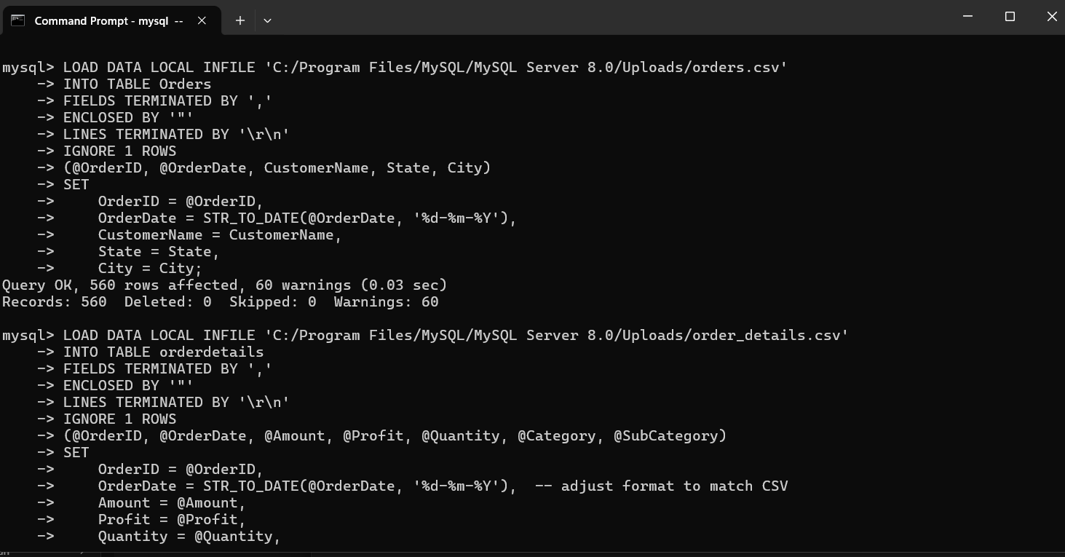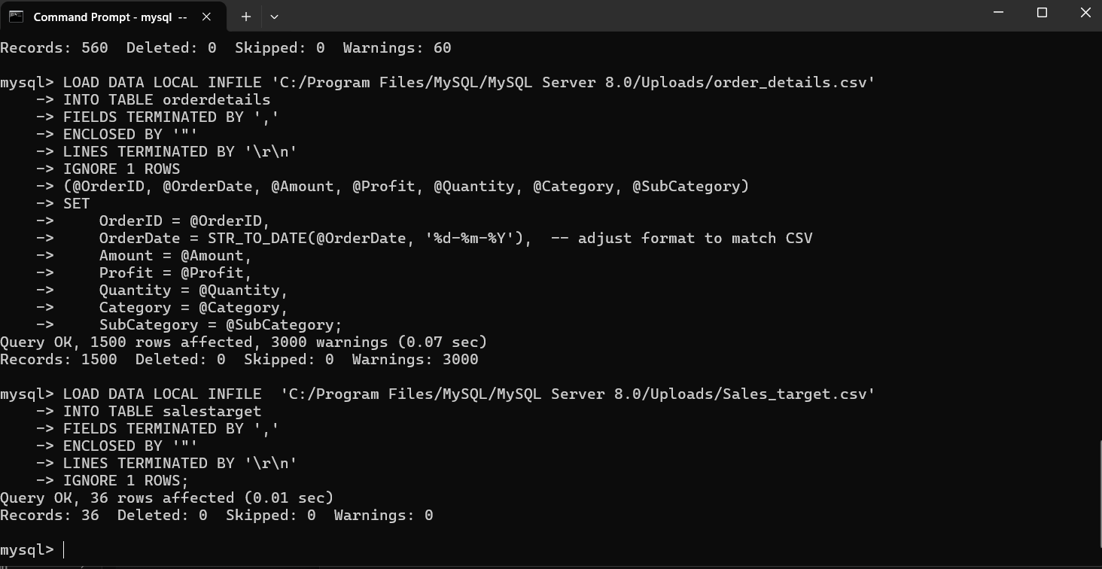

**SELECT queries**

1.SELECT * FROM orders LIMIT 5;

2. SELECT * FROM SalesTarget LIMIT 5;

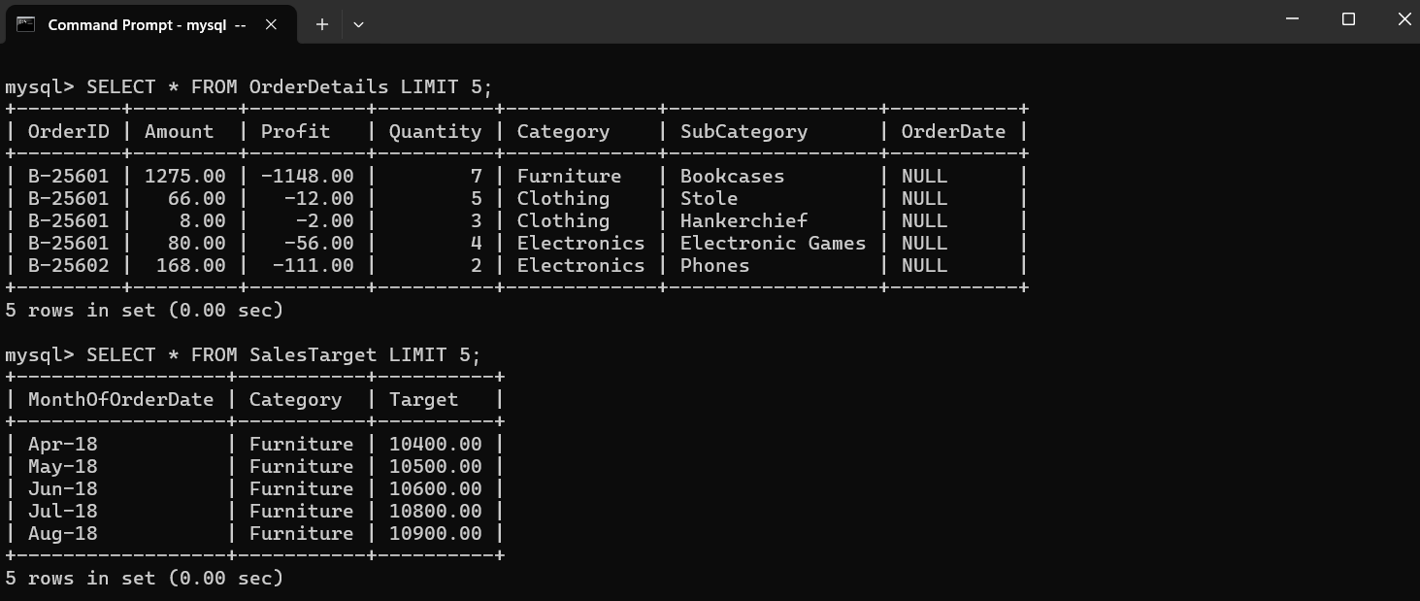

**WHERE & ORDERBY & GROUPBY queries**

1.SELECT OrderID, CustomerName, City, OrderDate

-> FROM Orders

-> WHERE City = 'Mumbai'

-> ORDER BY OrderDate DESC;

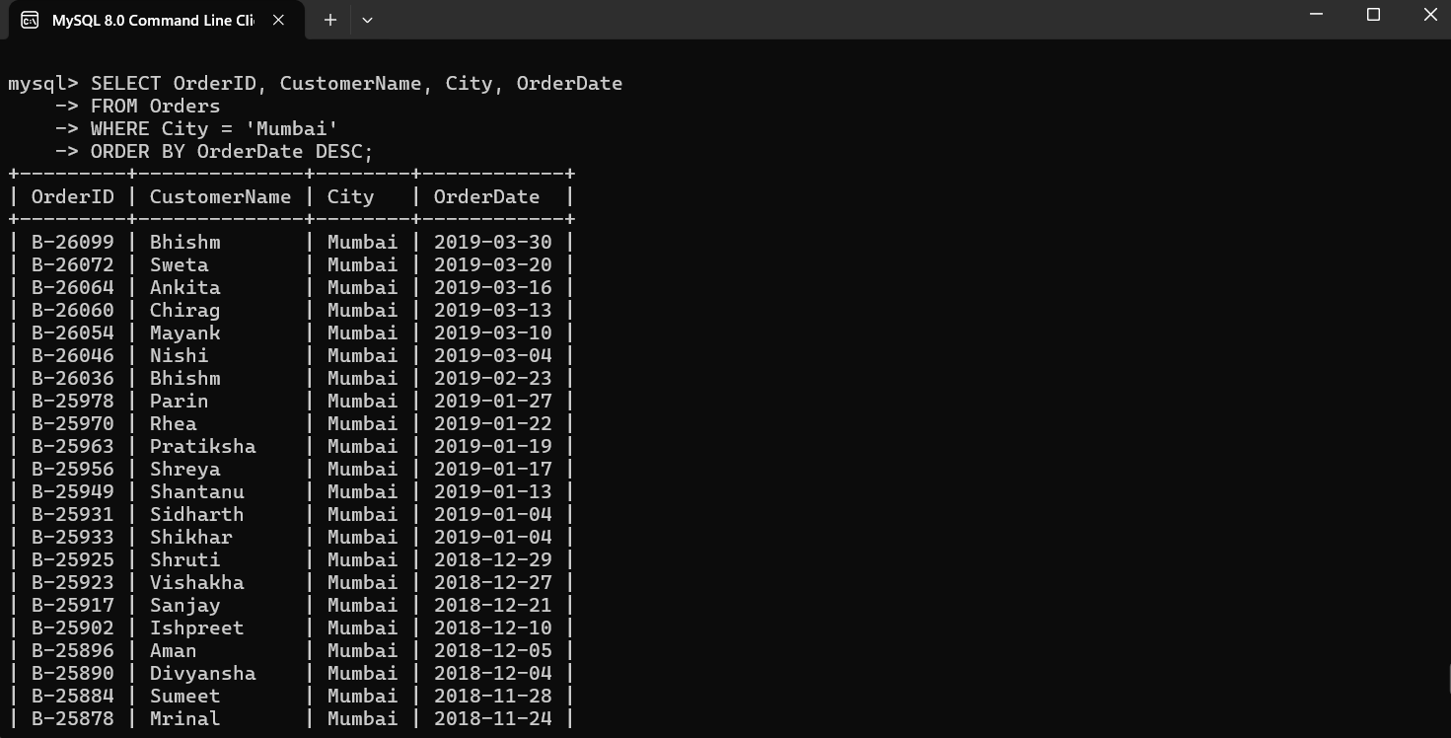

2. SELECT State, COUNT(*) AS TotalOrders

-> FROM Orders

-> GROUP BY State;

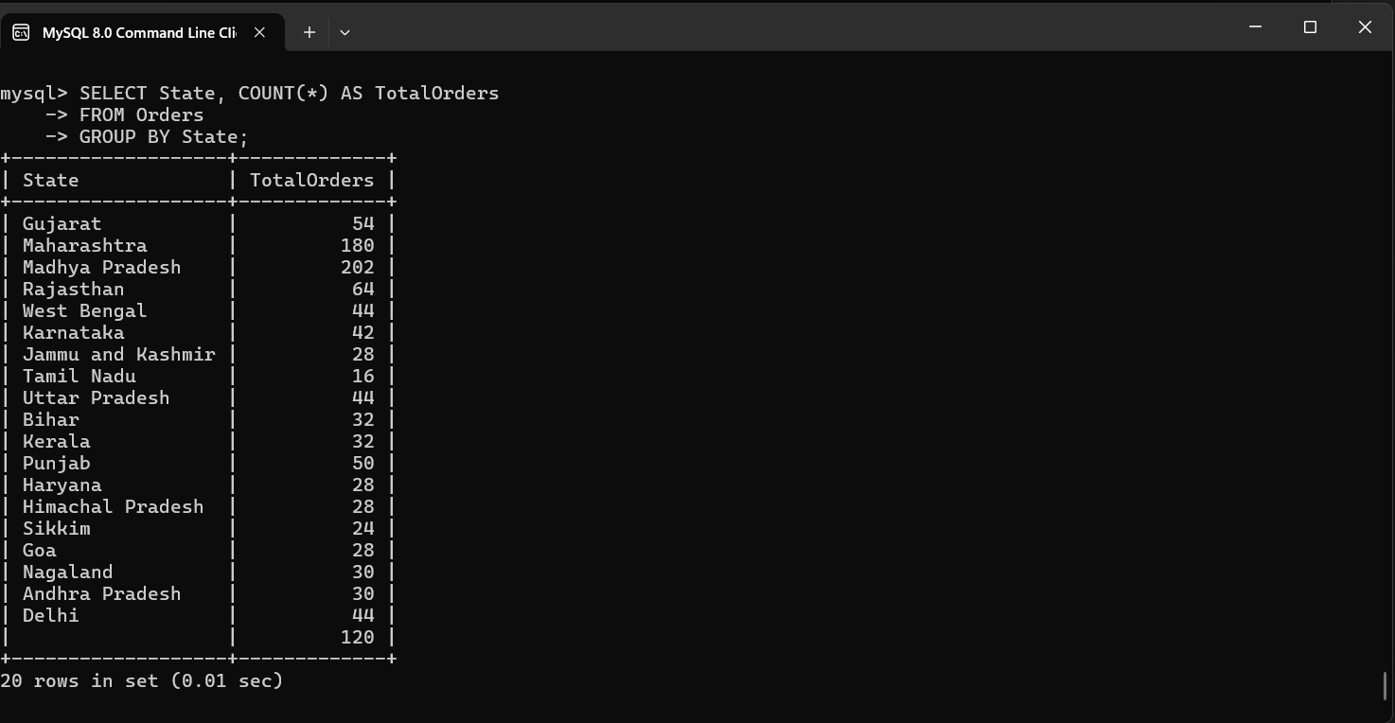

**JOINS QUERIES (INNER, LEFT, RIGHT)**

**1️⃣ INNER JOIN – Total sales per category vs target**

SELETCT

-> od.Category,

-> SUM(od.Amount) AS TotalSales,

-> st.Target AS SalesTarget

-> FROM OrderDetails od

-> INNER JOIN Orders o ON od.OrderID = o.OrderID

-> INNER JOIN SalesTarget st ON od.Category = st.Category

-> GROUP BY od.Category, st.Target

-> ORDER BY TotalSales DESC;

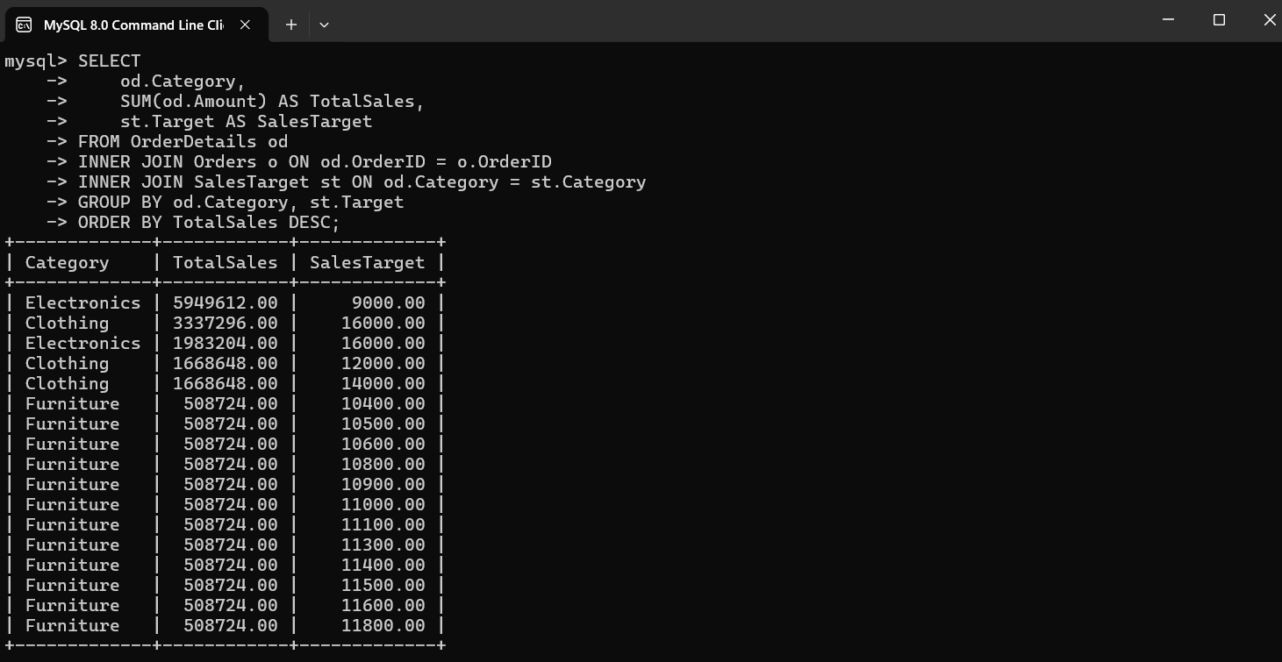

2️⃣ **LEFT JOIN** – Orders and their details (including orders without details)

SELECT

-> o.OrderID,

-> o.CustomerName,

-> o.City,

-> od.Amount,

-> od.Profit

-> FROM Orders o

-> LEFT JOIN OrderDetails od ON o.OrderID = od.OrderID

-> ORDER BY o.OrderDate DESC

-> LIMIT 10;

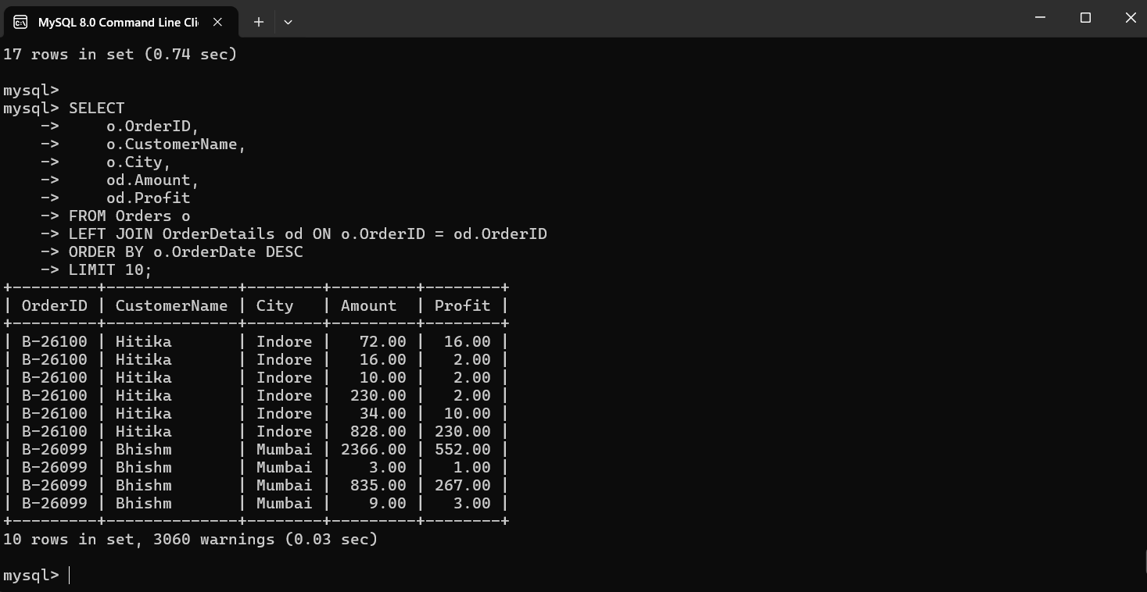

3️⃣ **RIGHT JOIN** – Sales targets and actual sales (including targets without sales)

SELECT

-> st.Category,

-> st.MonthOfOrderDate,

-> st.Target,

-> SUM(od.Amount) AS ActualSales

-> FROM SalesTarget st

-> RIGHT JOIN OrderDetails od ON st.Category = od.Category

-> GROUP BY st.Category, st.MonthOfOrderDate, st.Target

-> ORDER BY ActualSales DESC;

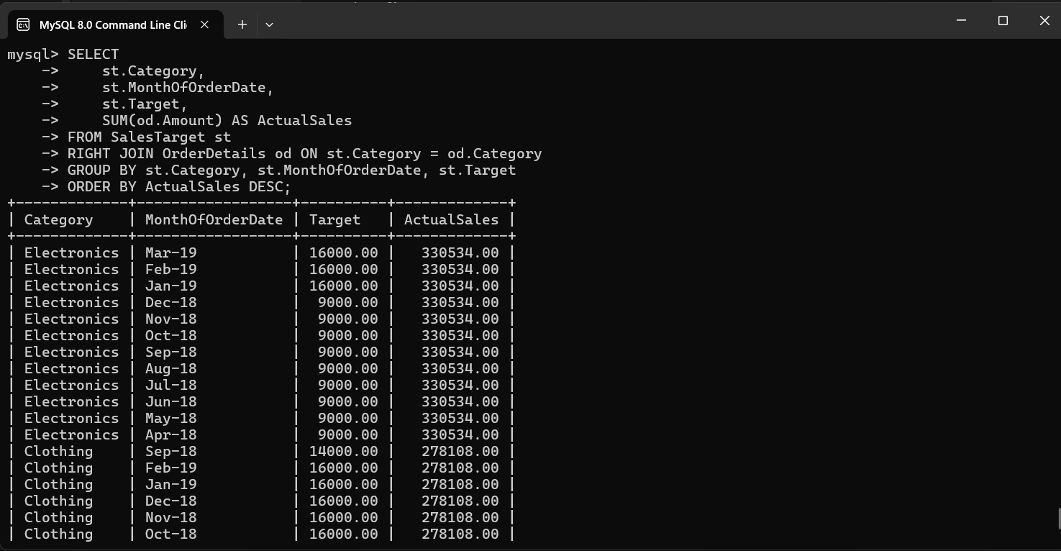

**SUBQUERIES**

1️⃣ Subquery in WHERE – Orders with amount greater than the average amount

SELECT OrderID, CustomerName, City

-> FROM Orders

-> WHERE OrderID IN (

-> SELECT OrderID

-> FROM OrderDetails

-> WHERE Amount > (SELECT AVG(Amount) FROM OrderDetails)

-> );

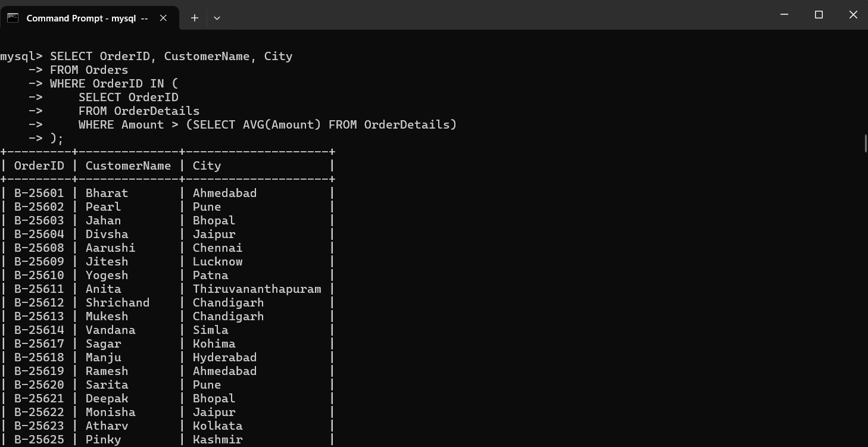

2️⃣ **Subquery in SELECT** – Show each order with its total profit

SELECT

o.OrderID,

o.CustomerName,

(SELECT SUM(Profit)

FROM OrderDetails od

WHERE od.OrderID = o.OrderID) AS TotalProfit

FROM Orders o

ORDER BY TotalProfit DESC;

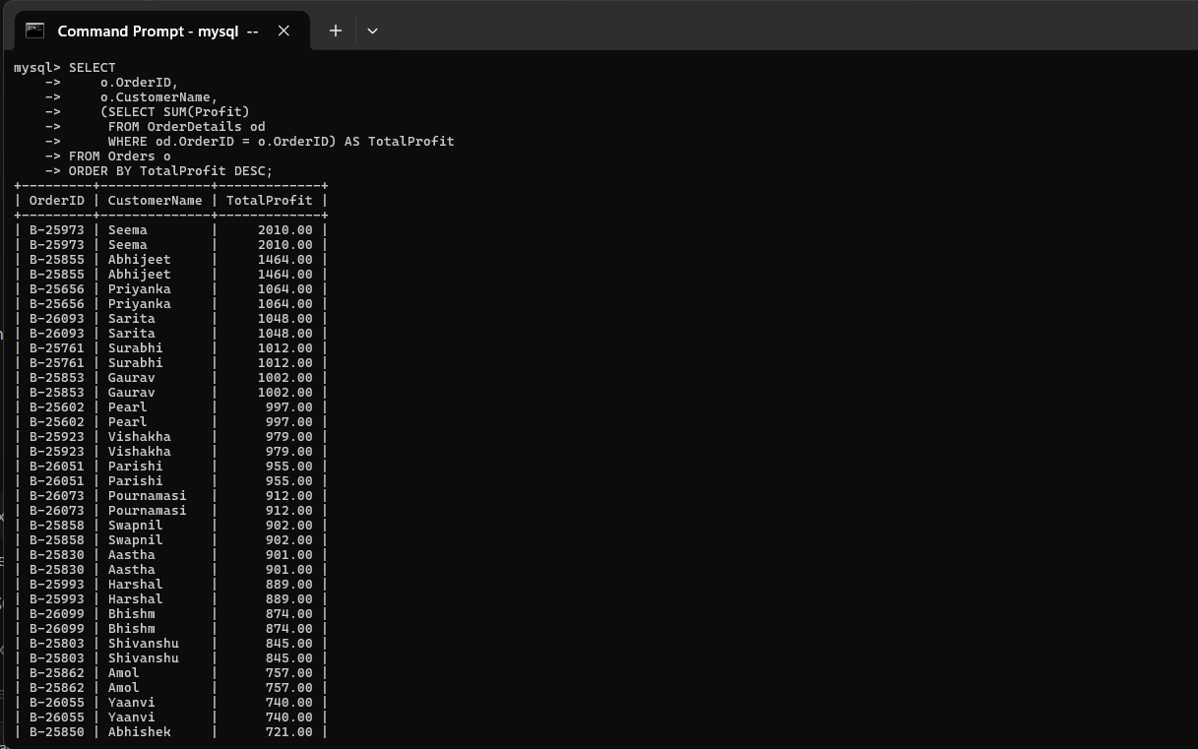

**3️⃣Subquery in FROM (Derived Table)** – Monthly sales per category

SELECT Category, MonthOfOrderDate, TotalSales

-> FROM (

-> SELECT

-> od.Category,

-> MONTH(o.OrderDate) AS MonthOfOrderDate,

-> SUM(od.Amount) AS TotalSales

-> FROM OrderDetails od

-> INNER JOIN Orders o ON od.OrderID = o.OrderID

-> GROUP BY od.Category, MONTH(o.OrderDate)

-> ) AS MonthlySales

-> WHERE TotalSales > 5000

-> ORDER BY TotalSales DESC;

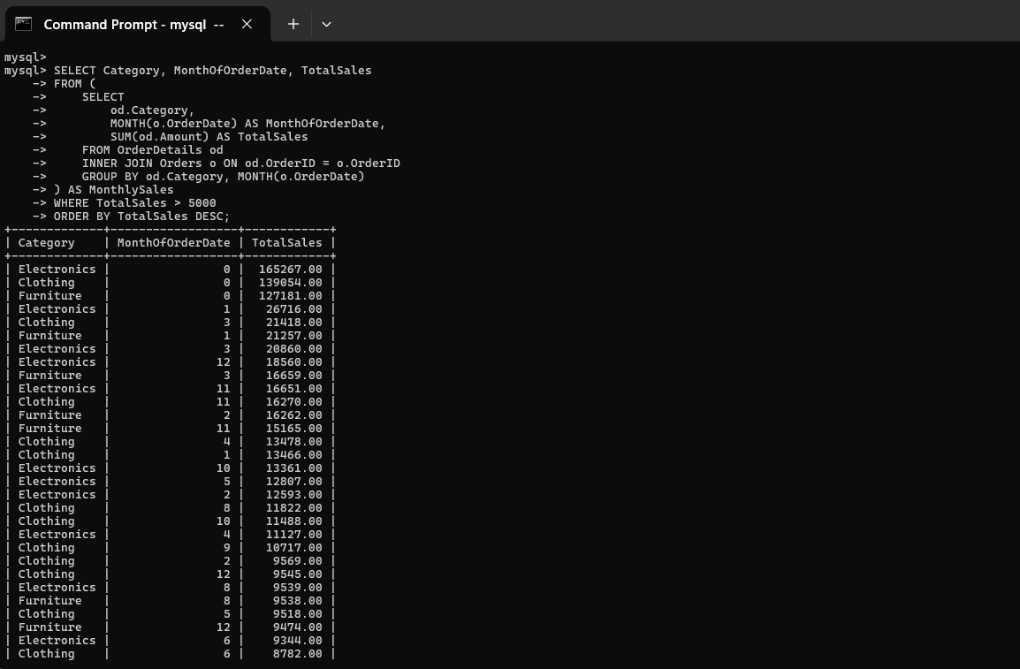

**AGGEREGATE FUNCTIONS**

1.SELECT SUM(Amount) AS TotalSales

-> FROM OrderDetails;

2. SELECT Category, AVG(Amount) AS AvgAmount

-> FROM OrderDetails

-> GROUP BY Category;

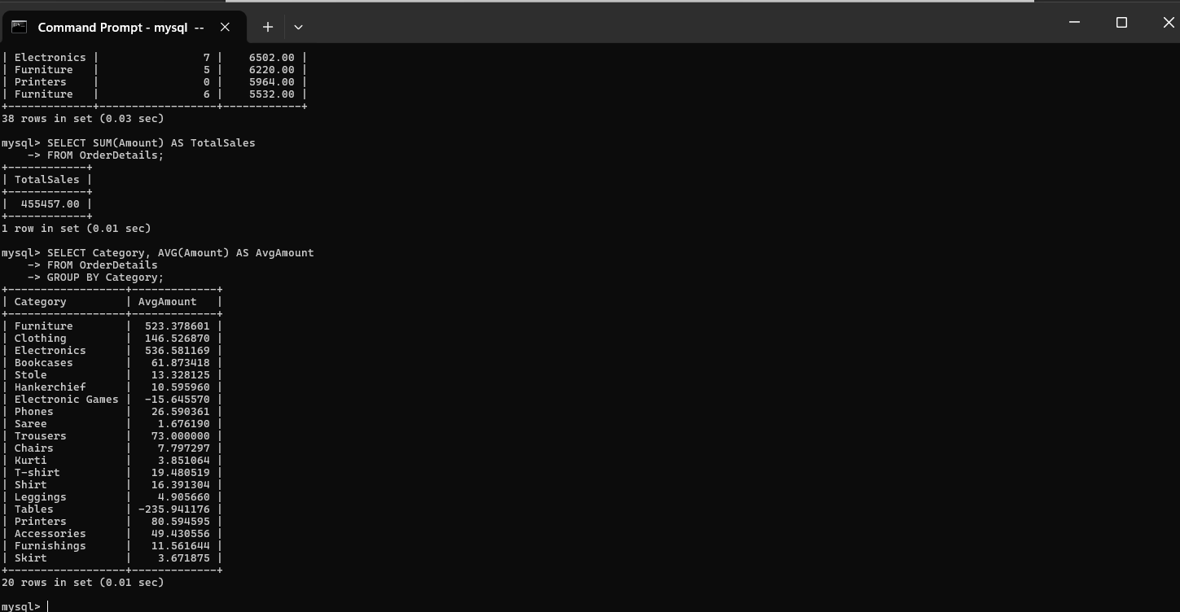

3. SELECT Category, COUNT(*) AS DetailsCount

-> FROM OrderDetails

-> GROUP BY Category;

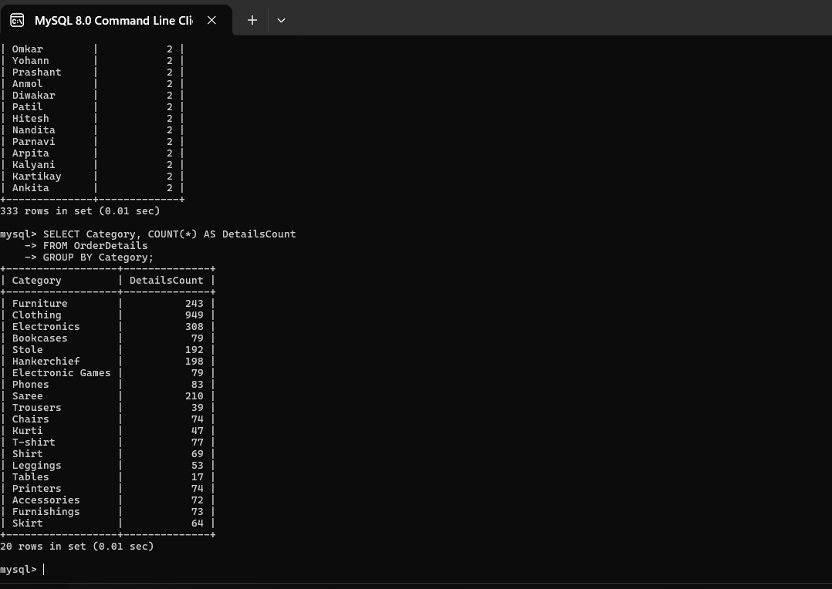

**VIEWS**

1️⃣ Create a View for Total Sales per Category

CREATE VIEW TotalSalesPerCategory AS

-> SELECT

-> od.Category,

-> SUM(od.Amount) AS TotalSales,

-> SUM(od.Profit) AS TotalProfit

-> FROM OrderDetails od

-> GROUP BY od.Category;

SELECT * FROM TotalSalesPerCategory;

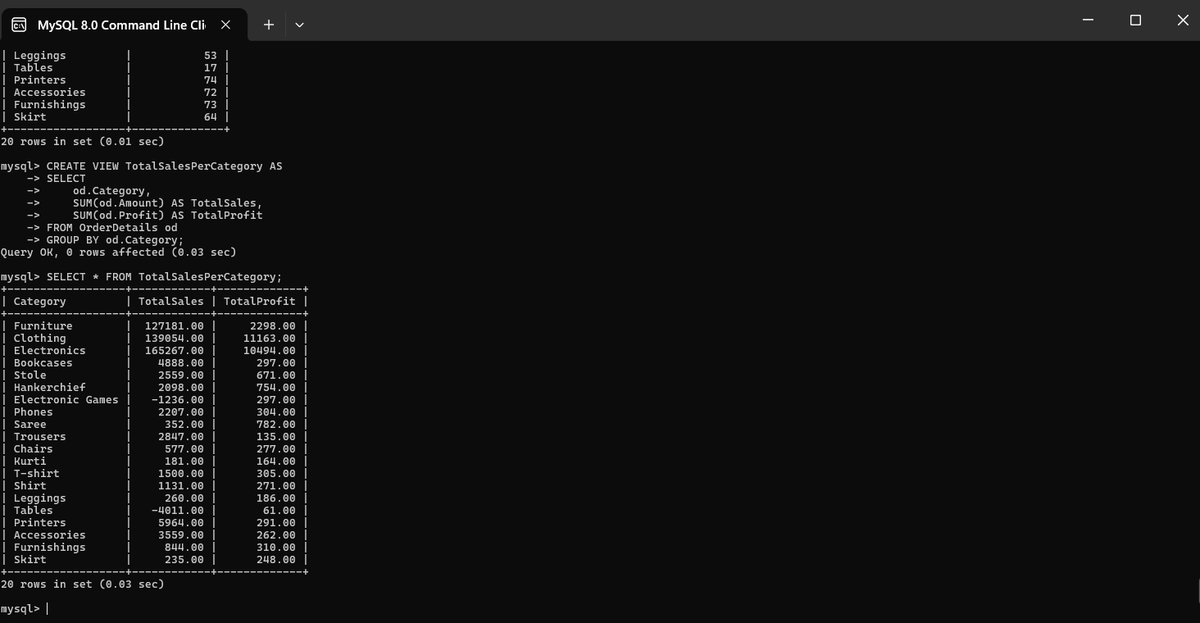

2️⃣ Create a View for Monthly Sales per State

mysql> CREATE VIEW MonthlySalesPerState AS

-> SELECT

-> o.State,

-> MONTH(o.OrderDate) AS MonthOfOrder,

-> SUM(od.Amount) AS TotalSales,

-> SUM(od.Profit) AS TotalProfit

-> FROM Orders o

-> INNER JOIN OrderDetails od ON o.OrderID = od.OrderID

-> GROUP BY o.State, MONTH(o.OrderDate);

SELECT * FROM MonthlySalesPerState WHERE State = 'Gujarat';

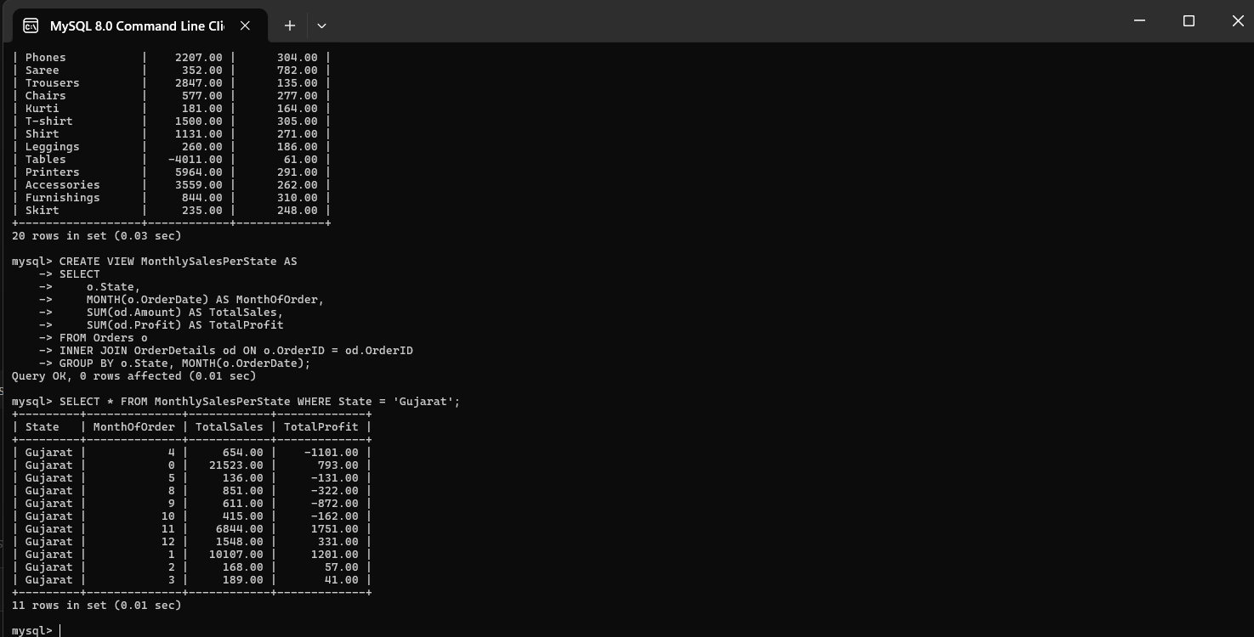

3️⃣ Create a View Comparing Sales vs Target

CREATE VIEW SalesVsTarget AS

-> SELECT

-> st.MonthOfOrderDate,

-> st.Category,

-> st.Target AS TargetAmount,

-> IFNULL(SUM(od.Amount), 0) AS TotalSales,

-> IFNULL(SUM(od.Amount), 0) - st.Target AS Difference

-> FROM SalesTarget st

-> LEFT JOIN OrderDetails od ON st.Category = od.Category

-> LEFT JOIN Orders o ON od.OrderID = o.OrderID AND MONTH(o.OrderDate) = MONTH(STR_TO_DATE(st.MonthOfOrderDate, '%M'))

-> GROUP BY st.MonthOfOrderDate, st.Category, st.Target;

SELECT * FROM SalesVsTarget ORDER BY Difference DESC;

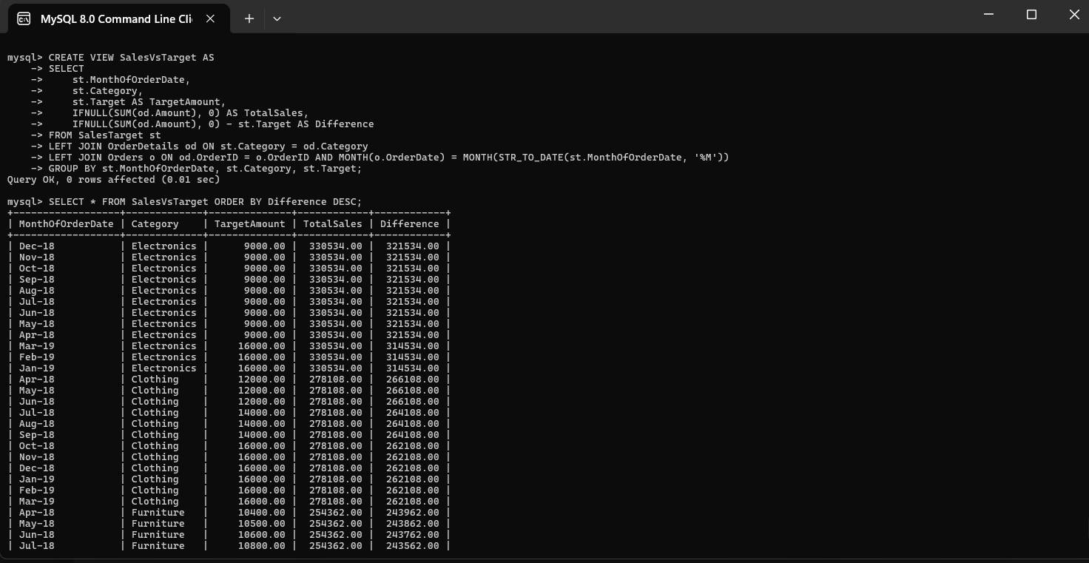

**Queries with indexes**

**a) Index on foreign key for faster joins**

CREATE INDEX idx_orderdetails_orderid ON OrderDetails(OrderID);

**b)Index on frequently filtered columns**

CREATE INDEX idx_orders_state ON Orders(State);

CREATE INDEX idx_orderdetails_category ON OrderDetails(Category);

CREATE INDEX idx_salestarget_month_category ON SalesTarget(MonthOfOrderDate, Category);

**c) Index on columns used in ORDER BY**

CREATE INDEX idx_orders_orderdate ON Orders(OrderDate);

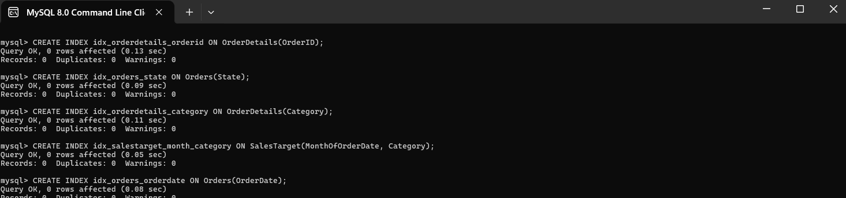

**i) Total profit per state (optimized join on indexed columns)**

SELECT o.State, SUM(od.Profit) AS TotalProfit

-> FROM Orders o

-> INNER JOIN OrderDetails od ON o.OrderID = od.OrderID

-> WHERE o.State = 'Gujarat'

-> GROUP BY o.State;

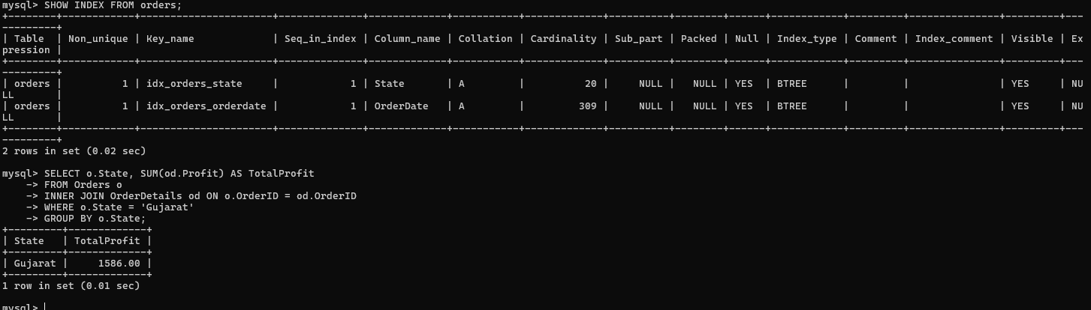

**ii) High-value orders per category**

SELECT od.Category, COUNT(*) AS OrdersCount, SUM(od.Amount) AS TotalSales

-> FROM OrderDetails od

-> WHERE od.Amount > 1000

-> GROUP BY od.Category

-> ORDER BY TotalSales DESC;  
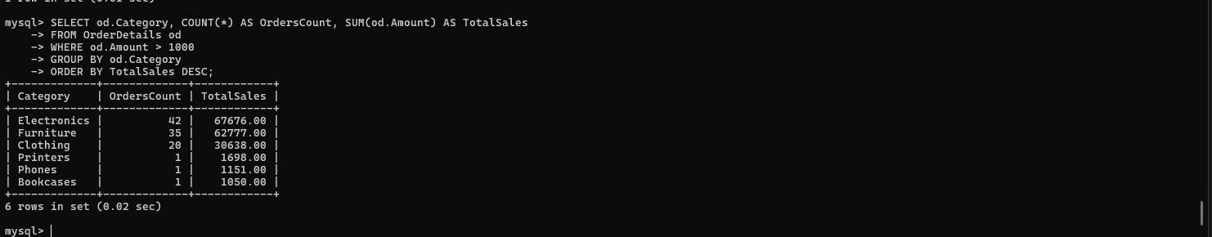

**iii) Monthly sales vs target (optimized with composite index)**

SELECT st.MonthOfOrderDate, st.Category, st.Target AS TargetAmount, SUM(od.Amount) AS TotalSales

-> FROM SalesTarget st

-> LEFT JOIN OrderDetails od ON st.Category = od.Category

-> LEFT JOIN Orders o ON od.OrderID = o.OrderID AND MONTH(o.OrderDate) = MONTH(STR_TO_DATE(st.MonthOfOrderDate, '%M'))

-> GROUP BY st.MonthOfOrderDate, st.Category, st.Target

-> ORDER BY TotalSales DESC;

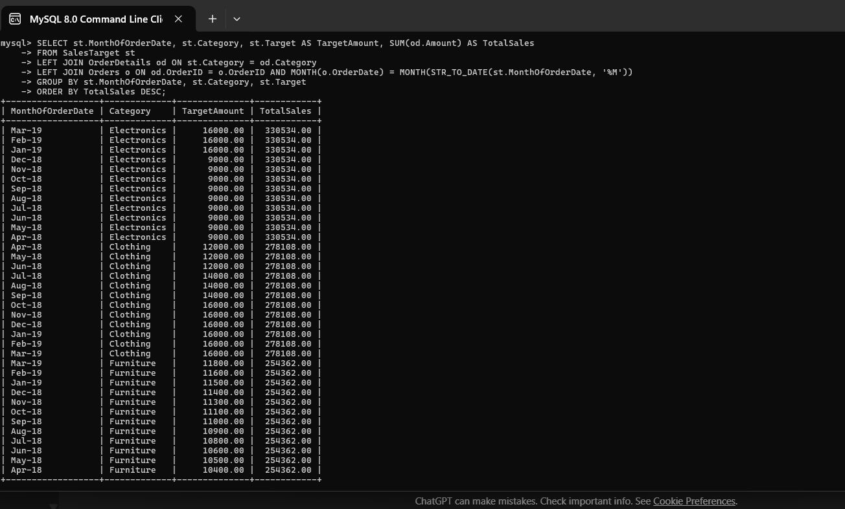

mysql> show databases;

+--------------------+

| Database |

+--------------------+

| db |

| ecommerce |

| ecommerce_db |

| information_schema |

| login |

| mysql |

| performance_schema |

| sd |

| sys |

+--------------------+

9 rows in set (0.00 sec)

mysql> use ecommerce_db

Database changed

mysql> LOAD DATA LOCAL INFILE 'C:/Program Files/MySQL/MySQL Server 8.0/Uploads/Orders.csv'

-> INTO TABLE orders

-> FIELDS TERMINATED BY ','

-> ENCLOSED BY '"'

-> LINES TERMINATED BY '\r\n'

-> IGNORE 1 ROWS;

Query OK, 560 rows affected, 560 warnings (0.06 sec)

Records: 560 Deleted: 0 Skipped: 0 Warnings: 560

mysql> LOAD DATA LOCAL INFILE 'C:/Program Files/MySQL/MySQL Server 8.0/Uploads/order_details.csv'

-> INTO TABLE orderdetails

-> FIELDS TERMINATED BY ','

-> ENCLOSED BY '"'

-> LINES TERMINATED BY '\r\n'

-> IGNORE 1 ROWS;

Query OK, 1500 rows affected (0.09 sec)

Records: 1500 Deleted: 0 Skipped: 0 Warnings: 0

mysql> LOAD DATA LOCAL INFILE 'C:/Program Files/MySQL/MySQL Server 8.0/Uploads/Sales_target.csv'

-> INTO TABLE salestarget

-> FIELDS TERMINATED BY ','

-> ENCLOSED BY '"'

-> LINES TERMINATED BY '\r\n'

-> IGNORE 1 ROWS;

Query OK, 36 rows affected (0.01 sec)

Records: 36 Deleted: 0 Skipped: 0 Warnings: 0

mysql> SELECT * FROM orders LIMIT 5;

+---------+------------+--------------+----------------+-----------+

| OrderID | OrderDate | CustomerName | State | City |

+---------+------------+--------------+----------------+-----------+

| B-25601 | 0000-00-00 | Bharat | Gujarat | Ahmedabad |

| B-25602 | 0000-00-00 | Pearl | Maharashtra | Pune |

| B-25603 | 0000-00-00 | Jahan | Madhya Pradesh | Bhopal |

| B-25604 | 0000-00-00 | Divsha | Rajasthan | Jaipur |

| B-25605 | 0000-00-00 | Kasheen | West Bengal | Kolkata |

+---------+------------+--------------+----------------+-----------+

5 rows in set (0.00 sec)

**SELECT**

mysql> SELECT * FROM OrderDetails LIMIT 5;

+---------+---------+----------+----------+-------------+------------------+-----------+

| OrderID | Amount | Profit | Quantity | Category | SubCategory | OrderDate |

+---------+---------+----------+----------+-------------+------------------+-----------+

| B-25601 | 1275.00 | -1148.00 | 7 | Furniture | Bookcases | NULL |

| B-25601 | 66.00 | -12.00 | 5 | Clothing | Stole | NULL |

| B-25601 | 8.00 | -2.00 | 3 | Clothing | Hankerchief | NULL |

| B-25601 | 80.00 | -56.00 | 4 | Electronics | Electronic Games | NULL |

| B-25602 | 168.00 | -111.00 | 2 | Electronics | Phones | NULL |

+---------+---------+----------+----------+-------------+------------------+-----------+

5 rows in set (0.00 sec)

mysql> SELECT * FROM SalesTarget LIMIT 5;

+------------------+-----------+----------+

| MonthOfOrderDate | Category | Target |

+------------------+-----------+----------+

| Apr-18 | Furniture | 10400.00 |

| May-18 | Furniture | 10500.00 |

| Jun-18 | Furniture | 10600.00 |

| Jul-18 | Furniture | 10800.00 |

| Aug-18 | Furniture | 10900.00 |

+------------------+-----------+----------+

5 rows in set (0.00 sec)

mysql> SELECT OrderID, CustomerName, City FROM Orders LIMIT 5;

+---------+--------------+-----------+

| OrderID | CustomerName | City |

+---------+--------------+-----------+

| B-25601 | Bharat | Ahmedabad |

| B-25602 | Pearl | Pune |

| B-25603 | Jahan | Bhopal |

| B-25604 | Divsha | Jaipur |

| B-25605 | Kasheen | Kolkata |

+---------+--------------+-----------+

5 rows in set (0.00 sec)

**WHERE and ORDER BY**

mysql> SELECT OrderID, CustomerName, City, OrderDate

-> FROM Orders

-> WHERE City = 'Mumbai'

-> ORDER BY OrderDate DESC;

+---------+--------------+--------+------------+

| OrderID | CustomerName | City | OrderDate |

+---------+--------------+--------+------------+

| B-26099 | Bhishm | Mumbai | 2019-03-30 |

| B-26072 | Sweta | Mumbai | 2019-03-20 |

| B-26064 | Ankita | Mumbai | 2019-03-16 |

| B-26060 | Chirag | Mumbai | 2019-03-13 |

| B-26054 | Mayank | Mumbai | 2019-03-10 |

| B-26046 | Nishi | Mumbai | 2019-03-04 |

| B-26036 | Bhishm | Mumbai | 2019-02-23 |

| B-25978 | Parin | Mumbai | 2019-01-27 |

| B-25970 | Rhea | Mumbai | 2019-01-22 |

| B-25963 | Pratiksha | Mumbai | 2019-01-19 |

| B-25956 | Shreya | Mumbai | 2019-01-17 |

| B-25949 | Shantanu | Mumbai | 2019-01-13 |

| B-25931 | Sidharth | Mumbai | 2019-01-04 |

| B-25933 | Shikhar | Mumbai | 2019-01-04 |

| B-25925 | Shruti | Mumbai | 2018-12-29 |

| B-25923 | Vishakha | Mumbai | 2018-12-27 |

| B-25917 | Sanjay | Mumbai | 2018-12-21 |

| B-25902 | Ishpreet | Mumbai | 2018-12-10 |

| B-25896 | Aman | Mumbai | 2018-12-05 |

| B-25890 | Divyansha | Mumbai | 2018-12-04 |

| B-25884 | Sumeet | Mumbai | 2018-11-28 |

| B-25878 | Mrinal | Mumbai | 2018-11-24 |

| B-25872 | Saurabh | Mumbai | 2018-11-22 |

| B-25864 | Aromal | Mumbai | 2018-11-15 |

| B-25858 | Swapnil | Mumbai | 2018-11-13 |

| B-25856 | Abhijeet | Mumbai | 2018-11-10 |

| B-25843 | Mrunal | Mumbai | 2018-11-03 |

| B-25841 | Ashvini | Mumbai | 2018-11-01 |

| B-25837 | Palak | Mumbai | 2018-10-29 |

| B-25832 | Harshita | Mumbai | 2018-10-28 |

| B-25826 | Tanushree | Mumbai | 2018-10-22 |

| B-25823 | Rohan | Mumbai | 2018-10-18 |

| B-25817 | Praneet | Mumbai | 2018-10-13 |

| B-25811 | Utsav | Mumbai | 2018-10-10 |

| B-25813 | Hrisheekesh | Mumbai | 2018-10-10 |

| B-25802 | Yash | Mumbai | 2018-10-05 |

| B-25805 | Ankit | Mumbai | 2018-10-05 |

| B-25792 | Abhishek | Mumbai | 2018-09-24 |

| B-25796 | Sukrith | Mumbai | 2018-09-24 |

| B-25782 | Aayushi | Mumbai | 2018-09-15 |

| B-25778 | Surabhi | Mumbai | 2018-09-11 |

| B-25776 | Mousam | Mumbai | 2018-09-09 |

| B-25769 | Surbhi | Mumbai | 2018-09-02 |

| B-25761 | Surabhi | Mumbai | 2018-08-25 |

| B-25756 | Mohan | Mumbai | 2018-08-20 |

| B-25751 | Nishant | Mumbai | 2018-08-14 |

| B-25749 | Ayush | Mumbai | 2018-08-13 |

| B-25740 | Rane | Mumbai | 2018-08-03 |

| B-25736 | Akshat | Mumbai | 2018-07-31 |

| B-25733 | Dhirajendu | Mumbai | 2018-07-28 |

| B-25726 | Kiran | Mumbai | 2018-07-21 |

| B-25723 | Wale | Mumbai | 2018-07-18 |

| B-25718 | Anjali | Mumbai | 2018-07-12 |

| B-25707 | Shivani | Mumbai | 2018-07-01 |

| B-25704 | Riya | Mumbai | 2018-06-29 |

| B-25702 | Shaily | Mumbai | 2018-06-27 |

| B-25700 | Shubhi | Mumbai | 2018-06-25 |

| B-25691 | Akancha | Mumbai | 2018-06-16 |

| B-25689 | Bhaggyasree | Mumbai | 2018-06-14 |

| B-25687 | Sanjna | Mumbai | 2018-06-11 |

| B-25684 | Samiksha | Mumbai | 2018-06-09 |

| B-25679 | Avni | Mumbai | 2018-06-04 |

| B-25662 | Sweta | Mumbai | 2018-05-17 |

| B-25654 | Sabah | Mumbai | 2018-05-10 |

| B-25650 | Chirag | Mumbai | 2018-05-06 |

| B-25644 | Mayank | Mumbai | 2018-04-30 |

| B-25636 | Nishi | Mumbai | 2018-04-26 |

| B-25626 | Bhishm | Mumbai | 2018-04-23 |

**GROUP BY**

mysql> SELECT State, COUNT(*) AS TotalOrders

-> FROM Orders

-> GROUP BY State;

+-------------------+-------------+

| State | TotalOrders |

+-------------------+-------------+

| Gujarat | 54 |

| Maharashtra | 180 |

| Madhya Pradesh | 202 |

| Rajasthan | 64 |

| West Bengal | 44 |

| Karnataka | 42 |

| Jammu and Kashmir | 28 |

| Tamil Nadu | 16 |

| Uttar Pradesh | 44 |

| Bihar | 32 |

| Kerala | 32 |

| Punjab | 50 |

| Haryana | 28 |

| Himachal Pradesh | 28 |

| Sikkim | 24 |

| Goa | 28 |

| Nagaland | 30 |

| Andhra Pradesh | 30 |

| Delhi | 44 |

| | 120 |

+-------------------+-------------+

20 rows in set (0.01 sec)

**JOINS**  
mysql> SELECT

-> od.Category,

-> SUM(od.Amount) AS TotalSales,

-> st.Target AS SalesTarget

-> FROM OrderDetails od

-> INNER JOIN Orders o ON od.OrderID = o.OrderID

-> INNER JOIN SalesTarget st ON od.Category = st.Category

-> GROUP BY od.Category, st.Target

-> ORDER BY TotalSales DESC;

+-------------+------------+-------------+

| Category | TotalSales | SalesTarget |

+-------------+------------+-------------+

| Electronics | 5949612.00 | 9000.00 |

| Clothing | 3337296.00 | 16000.00 |

| Electronics | 1983204.00 | 16000.00 |

| Clothing | 1668648.00 | 12000.00 |

| Clothing | 1668648.00 | 14000.00 |

| Furniture | 508724.00 | 10400.00 |

| Furniture | 508724.00 | 10500.00 |

| Furniture | 508724.00 | 10600.00 |

| Furniture | 508724.00 | 10800.00 |

| Furniture | 508724.00 | 10900.00 |

| Furniture | 508724.00 | 11000.00 |

| Furniture | 508724.00 | 11100.00 |

| Furniture | 508724.00 | 11300.00 |

| Furniture | 508724.00 | 11400.00 |

| Furniture | 508724.00 | 11500.00 |

| Furniture | 508724.00 | 11600.00 |

| Furniture | 508724.00 | 11800.00 |

+-------------+------------+-------------+

17 rows in set (0.74 sec)

mysql> SELECT

-> o.OrderID,

-> o.CustomerName,

-> o.City,

-> od.Amount,

-> od.Profit

-> FROM Orders o

-> LEFT JOIN OrderDetails od ON o.OrderID = od.OrderID

-> ORDER BY o.OrderDate DESC

-> LIMIT 10;

+---------+--------------+--------+---------+--------+

| OrderID | CustomerName | City | Amount | Profit |

+---------+--------------+--------+---------+--------+

| B-26100 | Hitika | Indore | 72.00 | 16.00 |

| B-26100 | Hitika | Indore | 16.00 | 2.00 |

| B-26100 | Hitika | Indore | 10.00 | 2.00 |

| B-26100 | Hitika | Indore | 230.00 | 2.00 |

| B-26100 | Hitika | Indore | 34.00 | 10.00 |

| B-26100 | Hitika | Indore | 828.00 | 230.00 |

| B-26099 | Bhishm | Mumbai | 2366.00 | 552.00 |

| B-26099 | Bhishm | Mumbai | 3.00 | 1.00 |

| B-26099 | Bhishm | Mumbai | 835.00 | 267.00 |

| B-26099 | Bhishm | Mumbai | 9.00 | 3.00 |

+---------+--------------+--------+---------+--------+

10 rows in set, 3060 warnings (0.03 sec)

mysql> SELECT

-> st.Category,

-> st.MonthOfOrderDate,

-> st.Target,

-> SUM(od.Amount) AS ActualSales

-> FROM SalesTarget st

-> RIGHT JOIN OrderDetails od ON st.Category = od.Category

-> GROUP BY st.Category, st.MonthOfOrderDate, st.Target

-> ORDER BY ActualSales DESC;

+-------------+------------------+----------+-------------+

| Category | MonthOfOrderDate | Target | ActualSales |

+-------------+------------------+----------+-------------+

| Electronics | Mar-19 | 16000.00 | 330534.00 |

| Electronics | Feb-19 | 16000.00 | 330534.00 |

| Electronics | Jan-19 | 16000.00 | 330534.00 |

| Electronics | Dec-18 | 9000.00 | 330534.00 |

| Electronics | Nov-18 | 9000.00 | 330534.00 |

| Electronics | Oct-18 | 9000.00 | 330534.00 |

| Electronics | Sep-18 | 9000.00 | 330534.00 |

| Electronics | Aug-18 | 9000.00 | 330534.00 |

| Electronics | Jul-18 | 9000.00 | 330534.00 |

| Electronics | Jun-18 | 9000.00 | 330534.00 |

| Electronics | May-18 | 9000.00 | 330534.00 |

| Electronics | Apr-18 | 9000.00 | 330534.00 |

| Clothing | Sep-18 | 14000.00 | 278108.00 |

| Clothing | Feb-19 | 16000.00 | 278108.00 |

| Clothing | Jan-19 | 16000.00 | 278108.00 |

| Clothing | Dec-18 | 16000.00 | 278108.00 |

| Clothing | Nov-18 | 16000.00 | 278108.00 |

| Clothing | Oct-18 | 16000.00 | 278108.00 |

| Clothing | Mar-19 | 16000.00 | 278108.00 |

| Clothing | Aug-18 | 14000.00 | 278108.00 |

| Clothing | Jul-18 | 14000.00 | 278108.00 |

| Clothing | Jun-18 | 12000.00 | 278108.00 |

| Clothing | May-18 | 12000.00 | 278108.00 |

| Clothing | Apr-18 | 12000.00 | 278108.00 |

| Furniture | Sep-18 | 11000.00 | 254362.00 |

| Furniture | Aug-18 | 10900.00 | 254362.00 |

| Furniture | Jul-18 | 10800.00 | 254362.00 |

| Furniture | Jun-18 | 10600.00 | 254362.00 |

| Furniture | May-18 | 10500.00 | 254362.00 |

| Furniture | Apr-18 | 10400.00 | 254362.00 |

| Furniture | Mar-19 | 11800.00 | 254362.00 |

| Furniture | Feb-19 | 11600.00 | 254362.00 |

| Furniture | Jan-19 | 11500.00 | 254362.00 |

| Furniture | Dec-18 | 11400.00 | 254362.00 |

| Furniture | Nov-18 | 11300.00 | 254362.00 |

| Furniture | Oct-18 | 11100.00 | 254362.00 |

| NULL | NULL | NULL | 23955.00 |

+-------------+------------------+----------+-------------+

37 rows in set (0.12 sec)

**SUBQURIES**

mysql> SELECT OrderID, CustomerName, City

-> FROM Orders

-> WHERE OrderID IN (

-> SELECT OrderID

-> FROM OrderDetails

-> WHERE Amount > (SELECT AVG(Amount) FROM OrderDetails)

-> );

+---------+--------------+--------------------+

| OrderID | CustomerName | City |

+---------+--------------+--------------------+

| B-25601 | Bharat | Ahmedabad |

| B-25602 | Pearl | Pune |

| B-25603 | Jahan | Bhopal |

| B-25604 | Divsha | Jaipur |

| B-25608 | Aarushi | Chennai |

| B-25609 | Jitesh | Lucknow |

| B-25610 | Yogesh | Patna |

| B-25611 | Anita | Thiruvananthapuram |

| B-25612 | Shrichand | Chandigarh |

| B-25613 | Mukesh | Chandigarh |

| B-25614 | Vandana | Simla |

| B-25617 | Sagar | Kohima |

| B-25618 | Manju | Hyderabad |

| B-25619 | Ramesh | Ahmedabad |

| B-25620 | Sarita | Pune |

| B-25621 | Deepak | Bhopal |

| B-25622 | Monisha | Jaipur |

mysql> SELECT Category, MonthOfOrderDate, TotalSales

-> FROM (

-> SELECT

-> od.Category,

-> MONTH(o.OrderDate) AS MonthOfOrderDate,

-> SUM(od.Amount) AS TotalSales

-> FROM OrderDetails od

-> INNER JOIN Orders o ON od.OrderID = o.OrderID

-> GROUP BY od.Category, MONTH(o.OrderDate)

-> ) AS MonthlySales

-> WHERE TotalSales > 5000

-> ORDER BY TotalSales DESC;

+-------------+------------------+------------+

| Category | MonthOfOrderDate | TotalSales |

+-------------+------------------+------------+

| Electronics | 0 | 165267.00 |

| Clothing | 0 | 139054.00 |

| Furniture | 0 | 127181.00 |

| Electronics | 1 | 26716.00 |

| Clothing | 3 | 21418.00 |

| Furniture | 1 | 21257.00 |

| Electronics | 3 | 20860.00 |

| Electronics | 12 | 18560.00 |

| Furniture | 3 | 16659.00 |

| Electronics | 11 | 16651.00 |

| Clothing | 11 | 16270.00 |

| Furniture | 2 | 16262.00 |

| Furniture | 11 | 15165.00 |

| Clothing | 4 | 13478.00 |

| Clothing | 1 | 13466.00 |

| Electronics | 10 | 13361.00 |

| Electronics | 5 | 12807.00 |

| Electronics | 2 | 12593.00 |

| Clothing | 8 | 11822.00 |

| Clothing | 10 | 11488.00 |

| Electronics | 4 | 11127.00 |

| Clothing | 9 | 10717.00 |

| Clothing | 2 | 9569.00 |

| Clothing | 12 | 9545.00 |

| Electronics | 8 | 9539.00 |

| Furniture | 8 | 9538.00 |

| Clothing | 5 | 9518.00 |

| Furniture | 12 | 9474.00 |

| Electronics | 6 | 9344.00 |

| Clothing | 6 | 8782.00 |

| Furniture | 9 | 8704.00 |

| Furniture | 4 | 8121.00 |

| Electronics | 9 | 7207.00 |

| Furniture | 10 | 6766.00 |

| Electronics | 7 | 6502.00 |

| Furniture | 5 | 6220.00 |

| Printers | 0 | 5964.00 |

| Furniture | 6 | 5532.00 |

+-------------+------------------+------------+

38 rows in set (0.03 sec)

**Aggregate functions**

mysql> SELECT Category, COUNT(*) AS DetailsCount

-> FROM OrderDetails

-> GROUP BY Category;

+------------------+--------------+

| Category | DetailsCount |

+------------------+--------------+

| Furniture | 243 |

| Clothing | 949 |

| Electronics | 308 |

| Bookcases | 79 |

| Stole | 192 |

| Hankerchief | 198 |

| Electronic Games | 79 |

| Phones | 83 |

| Saree | 210 |

| Trousers | 39 |

| Chairs | 74 |

| Kurti | 47 |

| T-shirt | 77 |

| Shirt | 69 |

| Leggings | 53 |

| Tables | 17 |

| Printers | 74 |

| Accessories | 72 |

| Furnishings | 73 |

| Skirt | 64 |

+------------------+--------------+

20 rows in set (0.01 sec)

mysql> SELECT SUM(Amount) AS TotalSales

-> FROM OrderDetails;

+------------+

| TotalSales |

+------------+

| 455457.00 |

+------------+

1 row in set (0.01 sec)

mysql> SELECT Category, AVG(Amount) AS AvgAmount

-> FROM OrderDetails

-> GROUP BY Category;

+------------------+-------------+

| Category | AvgAmount |

+------------------+-------------+

| Furniture | 523.378601 |

| Clothing | 146.526870 |

| Electronics | 536.581169 |

| Bookcases | 61.873418 |

| Stole | 13.328125 |

| Hankerchief | 10.595960 |

| Electronic Games | -15.645570 |

| Phones | 26.590361 |

| Saree | 1.676190 |

| Trousers | 73.000000 |

| Chairs | 7.797297 |

| Kurti | 3.851064 |

| T-shirt | 19.480519 |

| Shirt | 16.391304 |

| Leggings | 4.905660 |

| Tables | -235.941176 |

| Printers | 80.594595 |

| Accessories | 49.430556 |

| Furnishings | 11.561644 |

| Skirt | 3.671875 |

+------------------+-------------+

20 rows in set (0.01 sec)

**VIEWS**

mysql> CREATE VIEW TotalSalesPerCategory AS

-> SELECT

-> od.Category,

-> SUM(od.Amount) AS TotalSales,

-> SUM(od.Profit) AS TotalProfit

-> FROM OrderDetails od

-> GROUP BY od.Category;

Query OK, 0 rows affected (0.03 sec)

mysql> SELECT * FROM TotalSalesPerCategory;

+------------------+------------+-------------+

| Category | TotalSales | TotalProfit |

+------------------+------------+-------------+

| Furniture | 127181.00 | 2298.00 |

| Clothing | 139054.00 | 11163.00 |

| Electronics | 165267.00 | 10494.00 |

| Bookcases | 4888.00 | 297.00 |

| Stole | 2559.00 | 671.00 |

| Hankerchief | 2098.00 | 754.00 |

| Electronic Games | -1236.00 | 297.00 |

| Phones | 2207.00 | 304.00 |

| Saree | 352.00 | 782.00 |

| Trousers | 2847.00 | 135.00 |

| Chairs | 577.00 | 277.00 |

| Kurti | 181.00 | 164.00 |

| T-shirt | 1500.00 | 305.00 |

| Shirt | 1131.00 | 271.00 |

| Leggings | 260.00 | 186.00 |

| Tables | -4011.00 | 61.00 |

| Printers | 5964.00 | 291.00 |

| Accessories | 3559.00 | 262.00 |

| Furnishings | 844.00 | 310.00 |

| Skirt | 235.00 | 248.00 |

+------------------+------------+-------------+

20 rows in set (0.03 sec)

SELECT * FROM TotalSalesPerCategory;

mysql> CREATE VIEW MonthlySalesPerState AS

-> SELECT

-> o.State,

-> MONTH(o.OrderDate) AS MonthOfOrder,

-> SUM(od.Amount) AS TotalSales,

-> SUM(od.Profit) AS TotalProfit

-> FROM Orders o

-> INNER JOIN OrderDetails od ON o.OrderID = od.OrderID

-> GROUP BY o.State, MONTH(o.OrderDate);

Query OK, 0 rows affected (0.01 sec)

mysql> SELECT * FROM MonthlySalesPerState WHERE State = 'Gujarat';

+---------+--------------+------------+-------------+

| State | MonthOfOrder | TotalSales | TotalProfit |

+---------+--------------+------------+-------------+

| Gujarat | 4 | 654.00 | -1101.00 |

| Gujarat | 0 | 21523.00 | 793.00 |

| Gujarat | 5 | 136.00 | -131.00 |

| Gujarat | 8 | 851.00 | -322.00 |

| Gujarat | 9 | 611.00 | -872.00 |

| Gujarat | 10 | 415.00 | -162.00 |

| Gujarat | 11 | 6844.00 | 1751.00 |

| Gujarat | 12 | 1548.00 | 331.00 |

| Gujarat | 1 | 10107.00 | 1201.00 |

| Gujarat | 2 | 168.00 | 57.00 |

| Gujarat | 3 | 189.00 | 41.00 |

+---------+--------------+------------+-------------+

11 rows in set (0.01 sec)

mysql> CREATE VIEW SalesVsTarget AS

-> SELECT

-> st.MonthOfOrderDate,

-> st.Category,

-> st.Target AS TargetAmount,

-> IFNULL(SUM(od.Amount), 0) AS TotalSales,

-> IFNULL(SUM(od.Amount), 0) - st.Target AS Difference

-> FROM SalesTarget st

-> LEFT JOIN OrderDetails od ON st.Category = od.Category

-> LEFT JOIN Orders o ON od.OrderID = o.OrderID AND MONTH(o.OrderDate) = MONTH(STR_TO_DATE(st.MonthOfOrderDate, '%M'))

-> GROUP BY st.MonthOfOrderDate, st.Category, st.Target;

Query OK, 0 rows affected (0.01 sec)

mysql> SELECT * FROM SalesVsTarget ORDER BY Difference DESC;

+------------------+-------------+--------------+------------+------------+

| MonthOfOrderDate | Category | TargetAmount | TotalSales | Difference |

+------------------+-------------+--------------+------------+------------+

| Dec-18 | Electronics | 9000.00 | 330534.00 | 321534.00 |

| Nov-18 | Electronics | 9000.00 | 330534.00 | 321534.00 |

| Oct-18 | Electronics | 9000.00 | 330534.00 | 321534.00 |

| Sep-18 | Electronics | 9000.00 | 330534.00 | 321534.00 |

| Aug-18 | Electronics | 9000.00 | 330534.00 | 321534.00 |

| Jul-18 | Electronics | 9000.00 | 330534.00 | 321534.00 |

| Jun-18 | Electronics | 9000.00 | 330534.00 | 321534.00 |

| May-18 | Electronics | 9000.00 | 330534.00 | 321534.00 |

| Apr-18 | Electronics | 9000.00 | 330534.00 | 321534.00 |

| Mar-19 | Electronics | 16000.00 | 330534.00 | 314534.00 |

| Feb-19 | Electronics | 16000.00 | 330534.00 | 314534.00 |

| Jan-19 | Electronics | 16000.00 | 330534.00 | 314534.00 |

| Apr-18 | Clothing | 12000.00 | 278108.00 | 266108.00 |

| May-18 | Clothing | 12000.00 | 278108.00 | 266108.00 |

| Jun-18 | Clothing | 12000.00 | 278108.00 | 266108.00 |

| Jul-18 | Clothing | 14000.00 | 278108.00 | 264108.00 |

| Aug-18 | Clothing | 14000.00 | 278108.00 | 264108.00 |

| Sep-18 | Clothing | 14000.00 | 278108.00 | 264108.00 |

| Oct-18 | Clothing | 16000.00 | 278108.00 | 262108.00 |

| Nov-18 | Clothing | 16000.00 | 278108.00 | 262108.00 |

| Dec-18 | Clothing | 16000.00 | 278108.00 | 262108.00 |

| Jan-19 | Clothing | 16000.00 | 278108.00 | 262108.00 |

| Feb-19 | Clothing | 16000.00 | 278108.00 | 262108.00 |

| Mar-19 | Clothing | 16000.00 | 278108.00 | 262108.00 |

| Apr-18 | Furniture | 10400.00 | 254362.00 | 243962.00 |

| May-18 | Furniture | 10500.00 | 254362.00 | 243862.00 |

| Jun-18 | Furniture | 10600.00 | 254362.00 | 243762.00 |

| Jul-18 | Furniture | 10800.00 | 254362.00 | 243562.00 |

| Aug-18 | Furniture | 10900.00 | 254362.00 | 243462.00 |

| Sep-18 | Furniture | 11000.00 | 254362.00 | 243362.00 |

| Oct-18 | Furniture | 11100.00 | 254362.00 | 243262.00 |

| Nov-18 | Furniture | 11300.00 | 254362.00 | 243062.00 |

| Dec-18 | Furniture | 11400.00 | 254362.00 | 242962.00 |

| Jan-19 | Furniture | 11500.00 | 254362.00 | 242862.00 |

| Feb-19 | Furniture | 11600.00 | 254362.00 | 242762.00 |

| Mar-19 | Furniture | 11800.00 | 254362.00 | 242562.00 |

+------------------+-------------+--------------+------------+------------+

36 rows in set, 36000 warnings (0.26 sec)