**1.Git-HOL**

**Step 1: Setup your machine with Git Configuration**

**Step 2: Integrate notepad++.exe to Git and make it a default editor**

**Step 3: Add a file to source code repository  
  
  
  
 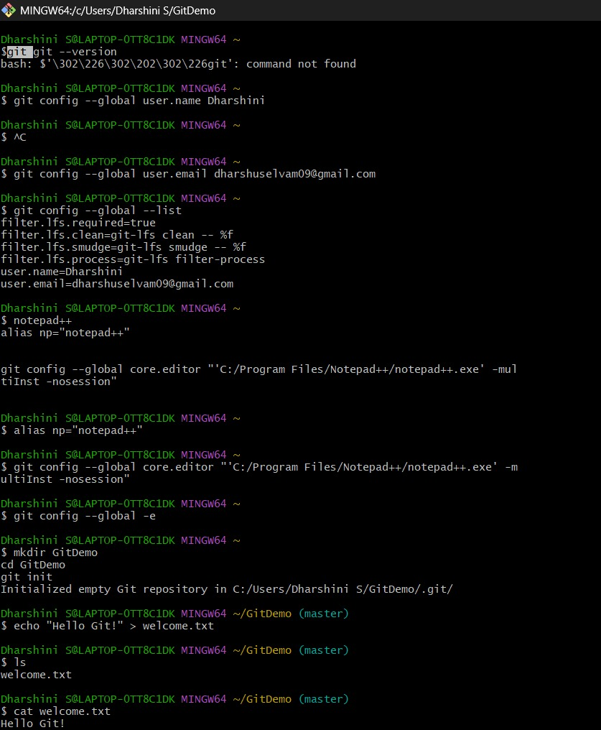**

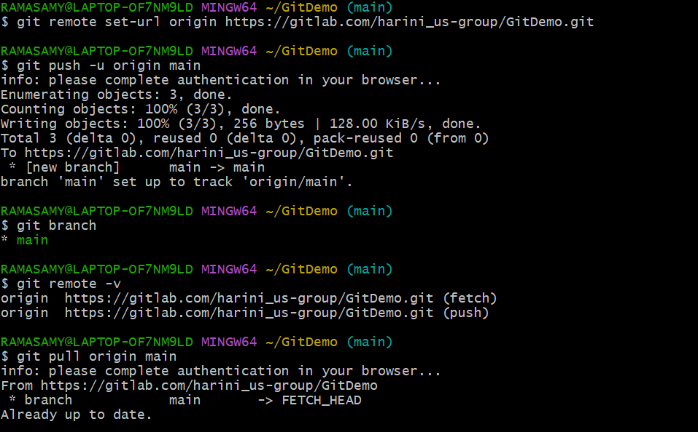

**Output:**

