**ASSIGNMENT 8.6**

**1.Find the top five kinds of GoogleKnowlege_Occupation people who were guests in the show, in a particular time period i.e., between '1/11/99' and 6/11/99. You need to write an UDF to compare the dates.**

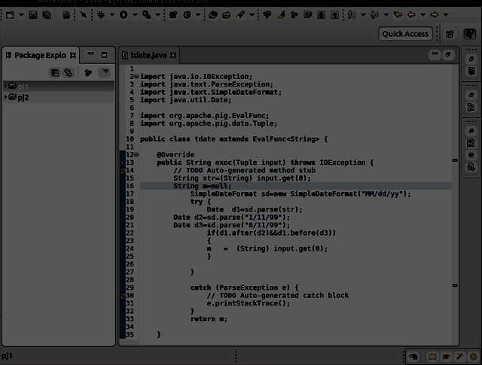

**Pig Steps:**

**Step 1:REGISTERING UDF**

**Step2:Generating google knowledge column and used tdate(date column);**

**Step3:filter it for not null condition**

**Step4:made group by google knowledge occupation**

**Step5:made count**

**Step6:order by count desc**

**Step7:made limit of 5**

**OUTPUT:**

