MINI PROJECT REPORT

ON

Study Notes Organizer

Submitted by

**DHARUN KAARTHICK . S**

**NC.SC.U4CSE24012**

For

23CSE113-User Interface Design

II Semester

B.Tech. CSE

School of Computing

Amrita Vishwa Vidyapeetham, Nagercoil

Index

|  |  |
| --- | --- |
|  |  |

|  |  |  |
| --- | --- | --- |
| **Sl. No.** | **Chapter Name** | **Page No.** |
| 1. | Introduction | 3 |
| 2. | Problem Statement | 3 |
| 3. | Objectives | 3 |
| 4. | System Design | 3 |
| 5. | Modules of project | 4 |
| 6. | Code | 5 |
| 7. | Output Screenshots | 12 |
| 8. | Application of the project | 14 |
| 9. | Limitations of the project | 15 |
| 10. | Bibliography(5 lines) | 15 |
| 11. | GitHub link of the project | 15 |

**1. Introduction**

This Study Notes Organizer is a web-based platform designed to assist students in managing and organizing their study notes efficiently. The website provides a user-friendly interface to create, store, and access notes across various subjects, enhancing the learning experience through structured organization and accessibility. Key features include a responsive design, subject-based note categorization, user authentication, and note search functionality using regular expressions. The platform aims to empower learners by offering a centralized, digital solution for note management, as highlighted by its mission: "Empowering learners through structured knowledge and organized study materials."

**2. Problem Statement**

Many students often struggle to keep their study notes organized, leading to difficulties in accessing relevant materials when needed. Traditional note-taking methods, such as physical notebooks or scattered digital files, are prone to disorganization, loss, or inefficiency. Additionally, students lack a centralized platform that allows them to manage notes across multiple subjects, access them on various devices, and search for specific content quickly. The absence of a user-friendly, accessible, and structured digital solution hinders effective study habits and knowledge retention.

**3. Objectives**

The primary objectives of the Study Notes Organizer project are:

* To provide a centralized platform for students to create, store, and manage study notes across different subjects.
* To ensure accessibility by designing a mobile-responsive interface that works seamlessly on various devices.
* To enhance user experience with a clean, intuitive, and aesthetically pleasing design.
* To implement user authentication to secure personal notes and enable personalized access.
* To offer advanced search functionality, such as regular expression-based searches, to quickly locate specific notes.
* To promote effective study habits by providing features like organized note structures and learning tips

**4. System Design**

The Study Notes Organizer is built using a client-side web architecture with HTML, CSS, and JavaScript. The system design includes the following components:

* **Frontend**:
  + **HTML**: Provides the structure for various pages used in this platform
  + **CSS**: A shared style.css file ensures a consistent, responsive, and visually appealing design across all pages. Features include fade-in animations, card-based layouts, and a mobile-friendly navigation menu.
  + **JavaScript**:
    - script.js handles general interactivity, such as menu toggling and animations.
    - login.js manages user authentication logic for login and registration forms.
    - Custom scripts in my-notes.html handle note creation, storage, and regex-based search functionality.

**5. Project Modules**

The project is divided into the following modules, each corresponding to specific functionality:

1. **Home Module (**index.html**)**
   * Displays a welcoming hero section with a call-to-action to explore subjects.
   * Highlights key features (Digital Notes, Organized Structure, Study Smarter) using animated feature cards.
   * Provides navigation to other sections of the website.
2. **About Module (**about.html**)**
   * Describes the platform’s mission, benefits, and team values.
   * Lists benefits like simple layout, quick navigation, beautiful interface, and mobile responsiveness.
   * Offers study tips to enhance learning efficiency.
3. **Authentication Module (**login.html**)**
   * Handles user login and registration through interactive forms.
   * Includes client-side validation for username, password, email, and password confirmation.
   * Toggles between login and registration forms dynamically.
4. **Notes Management Module (**my-notes.html**)**
   * Allows logged-in users to create notes with a title, subject, and content.
   * Supports subject categorization (Mathematics, Science, English, History, Geography, Other).
   * Provides a regex-based search feature to locate notes efficiently.
   * Displays saved notes in a dedicated section.
5. **Navigation (Shared Across Pages)**
   * Implements a responsive navigation bar with a toggle menu for mobile devices.
   * Ensures consistent styling via style.css and interactivity via script.js.
   * Includes a footer with copyright information and social media links.
6. **Minor Modules**

* **Subjects Module (**subjects.html**)**: Likely provides a listing or categorization of subjects for note organization, though not provided in the submitted files.
* **Contact Module (**contact.html**)**: Facilitates user communication with the platform team, possibly through a contact form or contact details, though not provided in the submitted files.

**6.Code**

**Index.html**

<!DOCTYPE html>

<html lang="en">

<head>

    <meta charset="UTF-8">

    <meta name="viewport" content="width=device-width, initial-scale=1.0">

    <title>Study Notes Organizer</title>

    <link rel="stylesheet" href="style.css">

</head>

<body>

    <div class="page-wrapper">

        <header>

            <div class="logo-container">

                <img src="2tuju-19.jpg" alt="Study Notes Logo" class="logo">

                <h1 class="title-text">Study Notes Organizer</h1>

            </div>

            <nav>

                <ul>

                    <li><a href="index.html" class="active">Home</a></li>

                    <li><a href="subjects.html">Subjects</a></li>

                    <li><a href="about.html">About</a></li>

                    <li><a href="my-notes.html">My Notes</a></li>

                    <li><a href="contact.html">Contact</a></li>

                </ul>

            </nav>

            <div class="menu-toggle">Menu</div>

        </header>

        <section class="hero">

            <div class="hero-content">

                <h2 class="fade-in">Organize Your Study Notes Easily</h2>

                <p class="subtitle fade-in">Effortlessly access and manage your subject notes in one place.</p>

                <a href="subjects.html" class="action-button pulse">Get Started</a>

            </div>

        </section>

        <section class="features stagger-animation">

            <div class="feature-card fade-in">

                <h3>Digital Notes</h3>

                <p>Access your notes anytime, anywhere on any device.</p>

            </div>

            <div class="feature-card fade-in">

                <h3>Organized Structure</h3>

                <p>Keep all your subjects organized in one place.</p>

            </div>

            <div class="feature-card fade-in">

                <h3>Study Smarter</h3>

                <p>Improve retention with structured study materials.</p>

            </div>

        </section>

        <footer>

            <div class="footer-content">

                <p>&copy; 2025 Study Notes Organizer | Designed for learners</p>

                <div class="social-icons">

                    <a href="#">Facebook</a>

                    <a href="#">Twitter</a>

                    <a href="#">Instagram</a>

                </div>

            </div>

        </footer>

    </div>

    <script src="script.js"></script>

</body>

</html>

***STYLES.CSS***

* {

    margin: 0;

    padding: 0;

    box-sizing: border-box;

}

:root {

    --primary-gradient: linear-gradient(135deg, #6a11cb, #2575fc);

    --secondary-gradient: linear-gradient(135deg, #f83600, #fe8c00);

    --text-gradient: linear-gradient(45deg, #FF3366, #FF9933);

    --card-bg: rgba(255, 255, 255, 0.95);

    --dark-bg: #151823;

    --text-light: #f8f9fa;

    --text-dark: #333;

    --shadow: 0 10px 30px rgba(0, 0, 0, 0.15);

    --border-radius: 15px;

}

body {

    font-family: 'Poppins', sans-serif;

    background: var(--primary-gradient);

    color: var(--text-dark);

    overflow-x: hidden;

}

.page-wrapper {

    min-height: 100vh;

    display: flex;

    flex-direction: column;

}

header {

    position: fixed;

    top: 0;

    width: 100%;

    background: rgba(21, 24, 35, 0.9);

    backdrop-filter: blur(10px);

    padding: 15px 40px;

    display: flex;

    justify-content: space-between;

    align-items: center;

    z-index: 1000;

    box-shadow: 0 2px 20px rgba(0, 0, 0, 0.2);

    transition: all 0.3s ease;

}

header.scrolled {

    padding: 10px 40px;

    background: rgba(21, 24, 35, 0.95);

}

.logo-container {

    display: flex;

    align-items: center;

    gap: 12px;

}

.logo {

    width: 50px;

    height: 50px;

    border-radius: 50%;

    box-shadow: 0 0 15px rgba(255, 255, 255, 0.2);

    transition: transform 0.5s, box-shadow 0.5s;

}

.logo:hover {

    transform: rotate(360deg);

    box-shadow: 0 0 20px rgba(255, 255, 255, 0.4);

}

.title-text {

    color: var(--text-light);

    font-size: 24px;

    font-weight: 700;

    letter-spacing: 0.5px;

    text-shadow: 0 2px 10px rgba(0, 0, 0, 0.3);

}

nav ul {

    display: flex;

    gap: 30px;

    list-style: none;

}

nav ul li a {

    color: rgba(255, 255, 255, 0.7);

    text-decoration: none;

    font-size: 16px;

    font-weight: 500;

    padding: 8px 15px;

    border-radius: 30px;

    transition: all 0.3s;

    position: relative;

    display: flex;

    align-items: center;

    gap: 6px;

}

nav ul li a::after {

    content: '';

    position: absolute;

    bottom: 0;

    left: 50%;

    width: 0;

    height: 2px;

    background: linear-gradient(to right, #f83600, #fe8c00);

    transition: width 0.3s, left 0.3s;

}

nav ul li a:hover {

    color: white;

}

nav ul li a:hover::after {

    width: 80%;

    left: 10%;

}

nav ul li a.active {

    color: white;

    background: rgba(255, 255, 255, 0.1);

}

nav ul li a.active::after {

    width: 80%;

    left: 10%;

}

.menu-toggle {

    display: none;

    color: white;

    font-size: 24px;

    cursor: pointer;

}

.hero {

    min-height: 100vh;

    display: flex;

    align-items: center;

    justify-content: center;

    text-align: center;

    padding: 100px 20px;

    position: relative;

    overflow: hidden;

}

.hero::before {

    content: '';

    position: absolute;

    top: 0;

    left: 0;

    width: 100%;

    height: 100%;

    opacity: 0.05;

    z-index: -1;

}

.hero-content {

    max-width: 800px;

    z-index: 1;

}

.hero h2 {

    font-size: 48px;

    font-weight: 700;

    margin-bottom: 20px;

    background: var(--text-gradient);

    text-shadow: 0 5px 15px rgba(0, 0, 0, 0.2);

}

.subtitle {

    font-size: 22px;

    color: var(--text-light);

    margin-bottom: 40px;

    opacity: 0.9;

}

.action-button {

    background: var(--secondary-gradient);

    padding: 16px 32px;

    font-size: 18px;

    font-weight: 600;

    color: white;

    border-radius: 50px;

    text-decoration: none;

    transition: all 0.3s;

    display: inline-flex;

    align-items: center;

    gap: 10px;

    box-shadow: 0 10px 20px rgba(0, 0, 0, 0.2);

    position: relative;

    overflow: hidden;

    z-index: 1;

}

.action-button::before {

    content: '';

    position: absolute;

    top: 0;

    left: 0;

    width: 100%;

    height: 100%;

    background: linear-gradient(45deg, #ff3366, #ff9933);

    z-index: -1;

    opacity: 0;

    transition: opacity 0.3s;

}

.action-button:hover {

    transform: translateY(-5px);

    box-shadow: 0 15px 25px rgba(0, 0, 0, 0.3);

}

.action-button:hover::before {

    opacity: 1;

}

.features {

    display: flex;

    flex-wrap: wrap;

    justify-content: center;

    gap: 30px;

    padding: 80px 20px;

    background: linear-gradient(180deg, rgba(21, 24, 35, 0.9), rgba(21, 24, 35, 0.7));

}

.feature-card {

    flex: 1;

    min-width: 280px;

    max-width: 350px;

    background: var(--card-bg);

    padding: 30px;

    border-radius: var(--border-radius);

    box-shadow: var(--shadow);

    text-align: center;

    transition: transform 0.3s, box-shadow 0.3s;

    position: relative;

    overflow: hidden;

    z-index: 1;

}

.feature-card::before {

    content: '';

    position: absolute;

    top: 0;

    left: 0;

    width: 100%;

    height: 5px;

    background: var(--secondary-gradient);

}

.feature-card:hover {

    transform: translateY(-10px);

    box-shadow: 0 15px 30px rgba(0, 0, 0, 0.2);

}

.feature-card h3 {

    font-size: 22px;

    margin-bottom: 15px;

    color: var(--text-dark);

}

.feature-card p {

    color: #666;

    line-height: 1.6;

}

footer {

    background: var(--dark-bg);

    color: var(--text-light);

    padding: 20px;

    text-align: center;

    margin-top: auto;

}

.footer-content {

    display: flex;

    justify-content: space-between;

    align-items: center;

    max-width: 1200px;

    margin: 0 auto;

}

.social-icons {

    display: flex;

    gap: 15px;

}

.social-icons a {

    color: rgba(255, 255, 255, 0.7);

    font-size: 18px;

    transition: all 0.3s;

}

.social-icons a:hover {

    color: white;

    transform: translateY(-3px);

}

@keyframes fadeIn {

    from {opacity: 0;transform: translateY(30px);}

    to {opacity: 1;transform: translateY(0);}

}

@keyframes pulse {

    0% {transform: scale(1);}

    50% {transform: scale(1.05);}

    100% {transform: scale(1);}

}

.fade-in {

    opacity: 0;

    animation: fadeIn 1s ease-out forwards;

}

.pulse {

    animation: pulse 2s infinite;

}

**OUTPUT:**

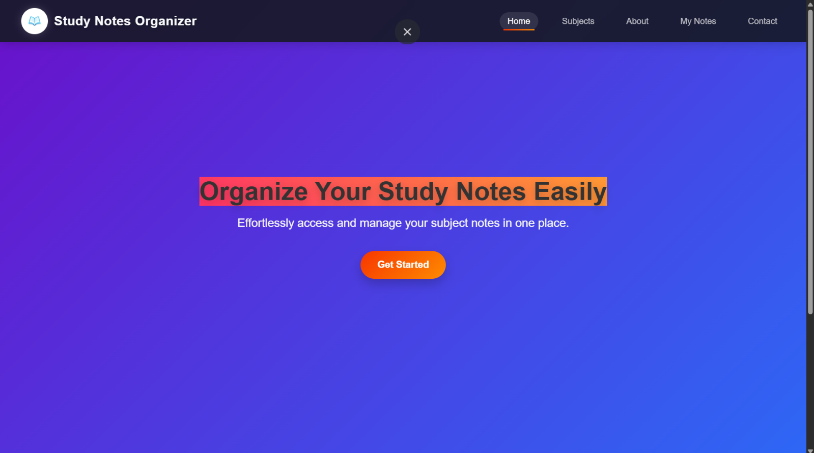

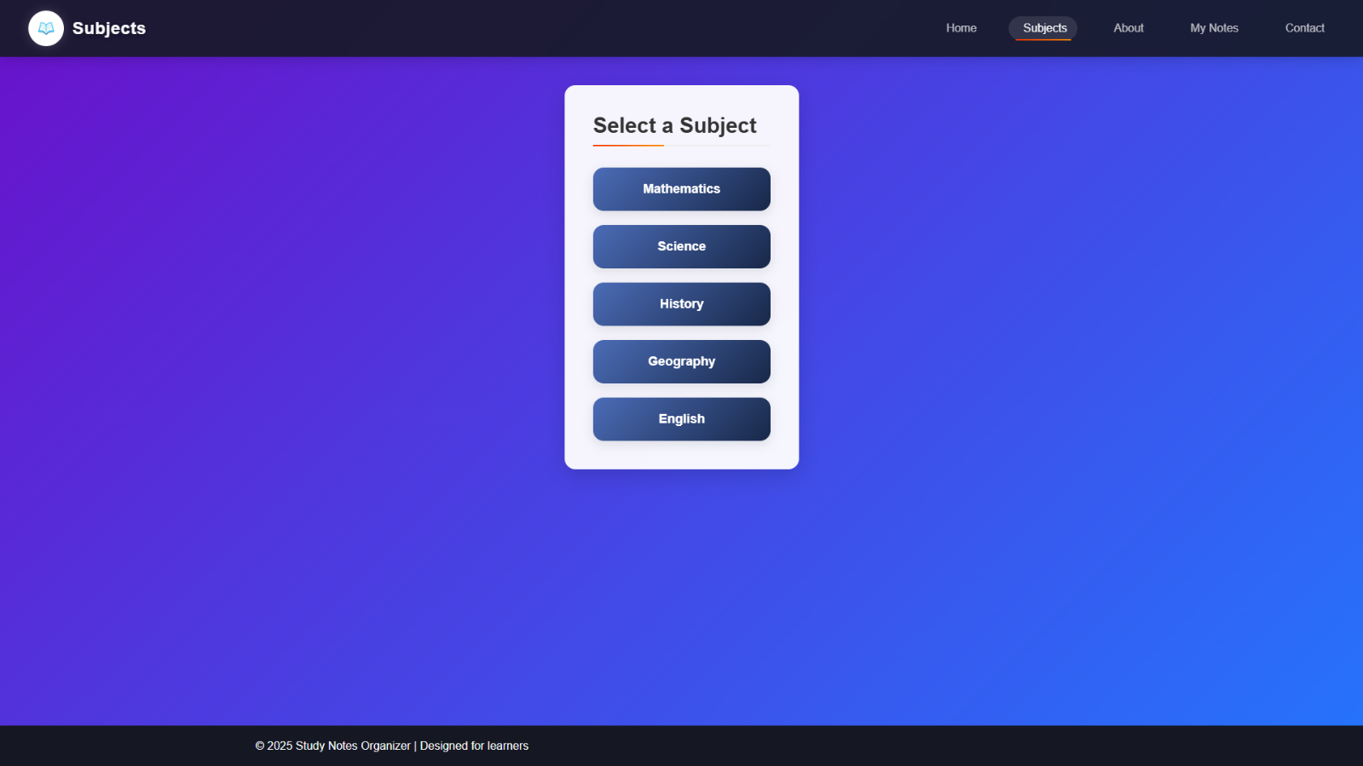

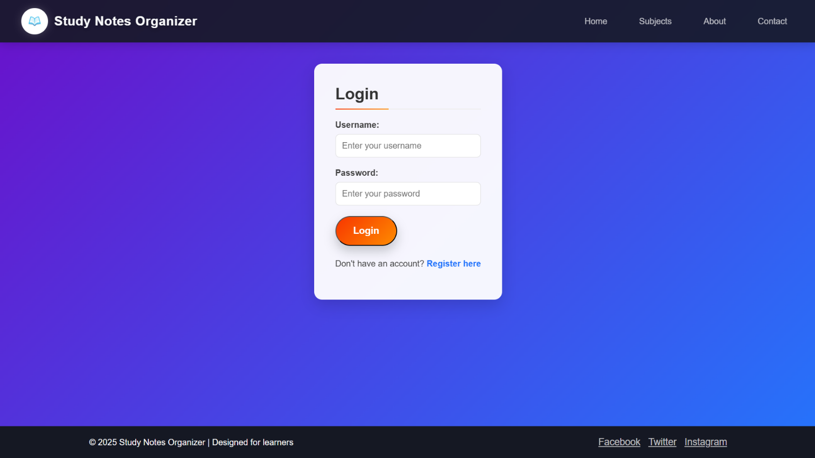

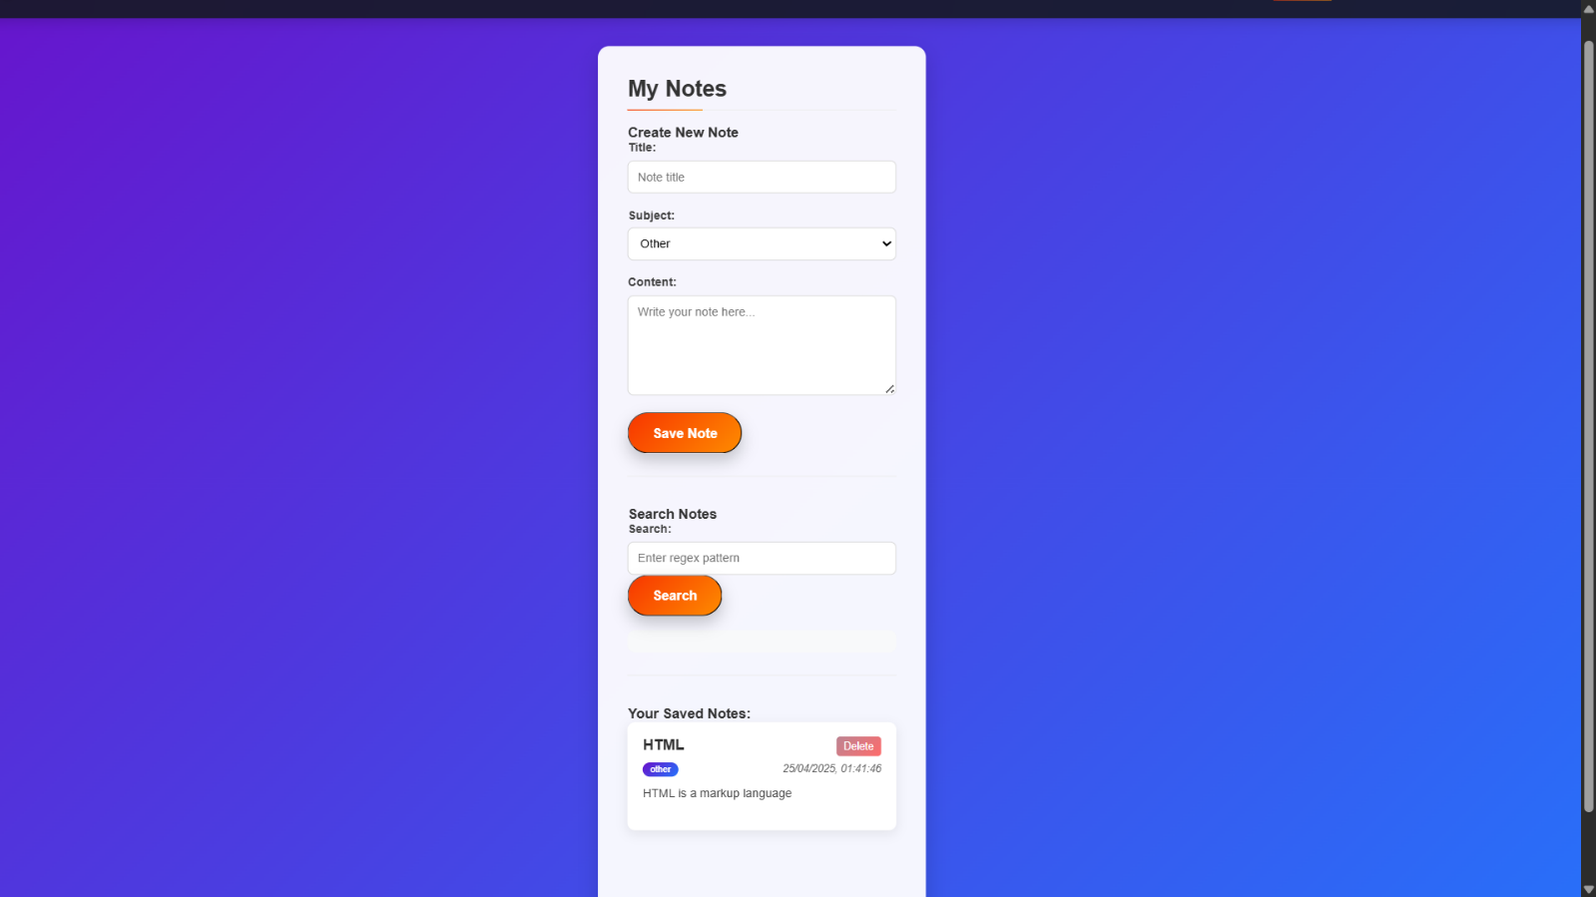

**8. Applications**

The Study Notes Organizer has several practical applications for its target audience, primarily students and learners:

* **Academic Support**: Students can organize notes by subject, making it easier to prepare for exams or review concepts.
* **Accessibility**: The mobile-responsive design allows access to notes on smartphones, tablets, or desktops, supporting on-the-go learning.
* **Efficient Search**: The regex search feature allows advanced users to quickly find specific notes, improving study efficiency.
* **Study Habit Improvement**: Features like structured note organization and learning tips encourage better study practices, such as regular review and focused study sessions.

The project is particularly valuable for high school and college students who need a digital solution to manage coursework across multiple subjects.

**9. Limitations**

Despite its strengths, the Study Notes Organizer has some limitations:

* **Client-Side Storage**: Notes and user data are likely stored in the browser (e.g., localStorage), which limits storage capacity and risks data loss if the browser cache is cleared.
* **No Backend Integration**: The absence of a server-side backend means no persistent storage, user data synchronization across devices, or robust security for user credentials.
* **Basic Authentication**: Client-side validation for login and registration is vulnerable to manipulation and lacks encryption or secure storage.
* **Limited Scalability**: The client-side architecture may struggle to handle large volumes of notes or complex features like real-time collaboration.

**10. Bibliography**

1. MDN Web Docs – HTML , CSS , JAVASCRIPT

<https://developer.mozilla.org/en-US/docs/Web/JavaScript/Guide/Regular_expressions>

<https://developer.mozilla.org/en-US/docs/Web/CSS/:root>

1. The Odin Project - CSS ANIMATIONS AND TRANSITIONS

<https://www.theodinproject.com/lessons/node-path-advanced-html-and-css-transitions>

<https://www.theodinproject.com/lessons/node-path-advanced-html-and-css-introduction-to-responsive-design>

**11) GitHub Repository Link:**

<https://github.com/Dharun-2k7/Study-Notes-Organizer>