23CSE202 DATABASE MANAGEMENT SYSTEMS
S3 B.Tech CSE
Department of Computer Science and Engineering
Amrita School of Computing, Amritapuri Campus
3. Database Design
Group No: C5
Project Title: Smart Campus Resource Booking System
Team Members:
Roll No | Student Name
AM.SC.U4CSE25201 | AKSHANYA S
AM.SC.U4CSE25229 | KRISHNA JAYAKUMAR
AM.SC.U4CSE25215 | DHARUN A

3.1 Detailed Description of the Project
Campus resources like classrooms, labs, study rooms, sports venues, equipment and parking are currently tracked through manual registers, causing double bookings and no real-time visibility. The Smart Campus Resource Booking System replaces this with a single database-backed platform used by two kinds of people: Students/Faculty, who search for and reserve resources, and Admin/Maintenance Staff, who approve requests, schedule maintenance and view utilisation reports. Every person is stored as a User (Name, Email, Phone, Password) and linked to exactly one Role, which decides what they can do.
Resources (Name, Location, Capacity, Status) are grouped under Resource Categories, and each Reservation links a User to a Resource for a given BookingDate/StartTime/EndTime with a Status (Pending /Approved /Rejected /Cancelled /Completed).
Business rules: the system never allows two reservations on the same resource to overlap while both are pending or approved. Shared resources go through an Approval step recorded against the reservation and the approver — since a rejected reservation can be resubmitted, one reservation can end up with more than one approval record. If a slot is already taken, a user can join a Waitlist and is notified automatically when it frees up, and a resource under an active Maintenance Record cannot be booked for that period. Notifications keep everyone informed of confirmations, rejections, approvals and waitlist updates.

3.2 ER Diagram
PK is underlined, FK is italicised. The pair next to each entity gives cardinality and participation — (1,1) = total, (0,N)/(0,1) = partial.
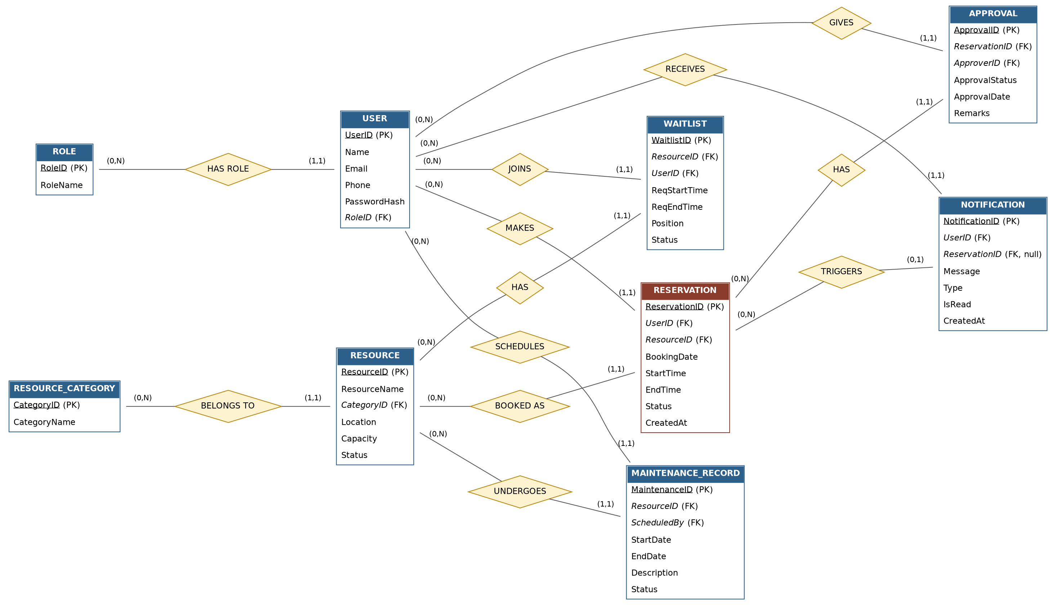

3.3 Relational Schema

ROLE (RoleID, RoleName)
USER (UserID, Name, Email, Phone, Password, RoleID*)
RESOURCE_CATEGORY (CategoryID, CategoryName)
RESOURCE (ResourceID, ResourceName, CategoryID*, Location, Capacity, Status)
RESERVATION (ReservationID, UserID*, ResourceID*, BookingDate, StartTime, EndTime, Status, CreatedAt)
APPROVAL (ApprovalID, ReservationID*, ApproverID*, ApprovalStatus, ApprovalDate, Remarks)
WAITLIST (WaitlistID, ResourceID*, UserID*, ReqStartTime, ReqEndTime, Position, Status)
MAINTENANCE_RECORD (MaintenanceID, ResourceID*, ScheduledBy*, StartDate, EndDate, Description, Status)
NOTIFICATION (NotificationID, UserID*, ReservationID*, Message, Type, IsRead, CreatedAt)
(* = foreign key; primary key of each relation is underlined below.)
Column | Data Type | Constraint
ROLE
RoleID | SERIAL | PRIMARY KEY
RoleName | VARCHAR(50) | NOT NULL, UNIQUE
USER
UserID | SERIAL | PRIMARY KEY
Name | VARCHAR(100) | NOT NULL
Email | VARCHAR(100) | NOT NULL, UNIQUE
Phone | VARCHAR(15) | —
Password | VARCHAR(255) | NOT NULL
RoleID | INT | NOT NULL, FK → ROLE(RoleID)
RESOURCE_CATEGORY
CategoryID | SERIAL | PRIMARY KEY
CategoryName | VARCHAR(50) | NOT NULL, UNIQUE
RESOURCE
ResourceID | SERIAL | PRIMARY KEY
ResourceName | VARCHAR(100) | NOT NULL
CategoryID | INT | NOT NULL, FK → RESOURCE_CATEGORY
Location | VARCHAR(100) | —
Capacity | INT | CHECK (Capacity > 0)
Status | VARCHAR(20) | CHECK IN ('Available','Under Maintenance','Inactive'), DEFAULT 'Available'
RESERVATION
ReservationID | SERIAL | PRIMARY KEY
UserID | INT | NOT NULL, FK → USER
ResourceID | INT | NOT NULL, FK → RESOURCE
BookingDate | DATE | NOT NULL
StartTime | TIMESTAMP | NOT NULL
EndTime | TIMESTAMP | NOT NULL, CHECK (EndTime > StartTime)
Status | VARCHAR(20) | CHECK IN ('Pending','Approved','Rejected','Cancelled','Completed')
CreatedAt | TIMESTAMP | DEFAULT CURRENT_TIMESTAMP
APPROVAL
ApprovalID | SERIAL | PRIMARY KEY
ReservationID | INT | NOT NULL, FK → RESERVATION
ApproverID | INT | NOT NULL, FK → USER
ApprovalStatus | VARCHAR(20) | CHECK IN ('Approved','Rejected','Pending')
ApprovalDate | TIMESTAMP | —
Remarks | VARCHAR(255) | —
WAITLIST
WaitlistID | SERIAL | PRIMARY KEY
ResourceID | INT | NOT NULL, FK → RESOURCE
UserID | INT | NOT NULL, FK → USER
ReqStartTime | TIMESTAMP | NOT NULL
ReqEndTime | TIMESTAMP | NOT NULL, CHECK (> ReqStartTime)
Position | INT | NOT NULL
Status | VARCHAR(20) | CHECK IN ('Waiting','Notified','Expired','Converted')
MAINTENANCE_RECORD
MaintenanceID | SERIAL | PRIMARY KEY
ResourceID | INT | NOT NULL, FK → RESOURCE
ScheduledBy | INT | NOT NULL, FK → USER
StartDate | DATE | NOT NULL
EndDate | DATE | NOT NULL, CHECK (>= StartDate)
Description | VARCHAR(255) | —
Status | VARCHAR(20) | CHECK IN ('Scheduled','In Progress','Completed','Cancelled')
NOTIFICATION
NotificationID | SERIAL | PRIMARY KEY
UserID | INT | NOT NULL, FK → USER
ReservationID | INT | NULL, FK → RESERVATION
Message | VARCHAR(255) | NOT NULL
Type | VARCHAR(30) | —
IsRead | BOOLEAN | DEFAULT FALSE
CreatedAt | TIMESTAMP | DEFAULT CURRENT_TIMESTAMP

- No two rows in RESERVATION for the same ResourceID may have overlapping time ranges while both are Pending/Approved (no double booking).
- UNIQUE (ReservationID, ApproverID) in APPROVAL — the same approver reviews a given reservation only once.

3.4 Normalization and Functional Dependency Analysis

Since one reservation can be reviewed by more than one approver over time, this register has a repeating group of approval details per reservation.

UNF
BOOKING_REGISTER (ReservationID, UserID, UserName, UserEmail, RoleID, RoleName, ResourceID,
ResourceName, CategoryID, CategoryName, Location, Capacity, BookingDate, StartTime, EndTime,
Status, { ApproverID, ApproverName, ApprovalStatus, ApprovalDate } )

1NF
Removing the repeating approval group (one row per ReservationID-ApproverID pair) gives an all-atomic relation:
BOOKING_REGISTER_1NF (ReservationID, ApproverID, UserID, UserName, UserEmail, RoleID, RoleName,
ResourceID, ResourceName, CategoryID, CategoryName, Location, Capacity, BookingDate, StartTime, EndTime, Status, ApproverName, ApprovalStatus, ApprovalDate)
Functional dependencies:
- F1: ReservationID → UserID, ResourceID, BookingDate, StartTime, EndTime, Status
- F2: UserID → UserName, UserEmail, RoleID
- F3: RoleID → RoleName
- F4: ResourceID → ResourceName, CategoryID, Location, Capacity
- F5: CategoryID → CategoryName
- F6: ApproverID → ApproverName
- F7: ReservationID, ApproverID → ApprovalStatus, ApprovalDate
ReservationID alone can't be the key: it never determines ApprovalStatus/ApprovalDate, since one reservation can have several approvers. Taking the closure of {ReservationID, ApproverID} through F1–F7 covers every attribute, and no smaller set does, so the primary key is {ReservationID, ApproverID}.

2NF
UserID, ResourceID, BookingDate, StartTime, EndTime, Status (and everything reachable from them) depend on ReservationID alone; ApproverName depends on ApproverID alone. Both are partial dependencies on the composite key, so this violates 2NF. Splitting on the true determinant:
RESERVATION_2NF (ReservationID, UserID, ResourceID, BookingDate, StartTime, EndTime, Status, ...UserName, ResourceName, etc.)
APPROVER_2NF (ApproverID, ApproverName)
APPROVAL_2NF (ReservationID, ApproverID, ApprovalStatus, ApprovalDate)

3NF
RESERVATION_2NF still has transitive dependencies: ReservationID → UserID → {UserName, UserEmail, RoleID} → RoleName, and ReservationID → ResourceID → {ResourceName, CategoryID, Location, Capacity} → CategoryName. Removing these — and dropping APPROVER_2NF, since an approver is just a User already in the USER table — gives the final relations, matching Section 3.3:
RESERVATION, USER, ROLE, RESOURCE, RESOURCE_CATEGORY, APPROVAL

BCNF
Checking that every determinant is a candidate key:
Relation | Determinant | Key? → BCNF?
RESERVATION | ReservationID → all other columns | ReservationID is the only key → BCNF ✓
USER | UserID → all; Email → all (Email is unique) | Both are candidate keys → BCNF ✓
ROLE | RoleID → RoleName | Only key → BCNF ✓
RESOURCE | ResourceID → all other columns | Only key → BCNF ✓
RESOURCE_CATEGORY | CategoryID → CategoryName | Only key → BCNF ✓
APPROVAL | (ReservationID, ApproverID) → rest | Whole key is the only determinant → BCNF ✓
All relations satisfy BCNF, so the final design in Section 3.3 is free of redundancy from non-key dependencies.

