SYMBIOLINK AI · PROJECT OVERVIEW
SymbioLink AI
Abstract & System Architecture
Team CircuLink · Sustainability Hackathon 2026 · Theme: Circular Economy

Abstract
SymbioLink AI is a working prototype for a digital industrial-symbiosis platform that connects small and medium manufacturing units (MSMEs) within a shared industrial cluster, turning one factory's waste into another factory's cheap raw material. Rather than a simple one-to-one classifieds board, the system models the cluster as a graph and searches for both direct matches and 2–3 hop exchange chains — Unit A's waste feeding Unit B, whose own byproduct feeds Unit C — ranking each by estimated cost savings, transport distance, and a trust score built from past completed exchanges.
A predictive layer forecasts a unit's next likely waste listing from its posting history, so a buyer can be lined up before the waste is even generated, and a logistics-pooling layer groups nearby low-volume matches into shared transport runs that would otherwise be too small to justify a solo pickup. Listings can be created through a lightweight web form or, in a simulated preview of the intended production path, through a WhatsApp or voice-note message parsed into a structured listing — removing the literacy and app-adoption barriers that keep many MSME owners out of digital marketplaces today.
A full order lifecycle — placed, confirmed, picked up, delivered, completed — closes the loop: every completed exchange feeds a two-way rating back into the trust ledger, which in turn raises or lowers that unit's confidence score in future match rankings, creating a self-reinforcing feedback cycle between transactions and trust.
Built with Flask on a synthetic dataset modeled on documented Indian industrial cluster patterns (e.g. Muzaffarnagar's paper/sugar-mill belt, Mysore's mixed manufacturing cluster), the prototype is intentionally rules-based and transparent rather than a black-box model, with reference prices and transport rates flagged honestly as illustrative estimates pending real-world tuning ahead of a pilot deployment.

System Architecture
The six layers below mirror the project's concept note: listings enter through either a lightweight web form or a simulated WhatsApp/voice-note intake, land in a shared in-memory data model, and flow through the predictive, matching, pooling, and trust layers before every result is rendered live on one dashboard. A feedback loop closes the system: completed orders generate two-way ratings that update the trust ledger, which in turn feeds an “average trust” confidence score back into the matching engine's own ranking.
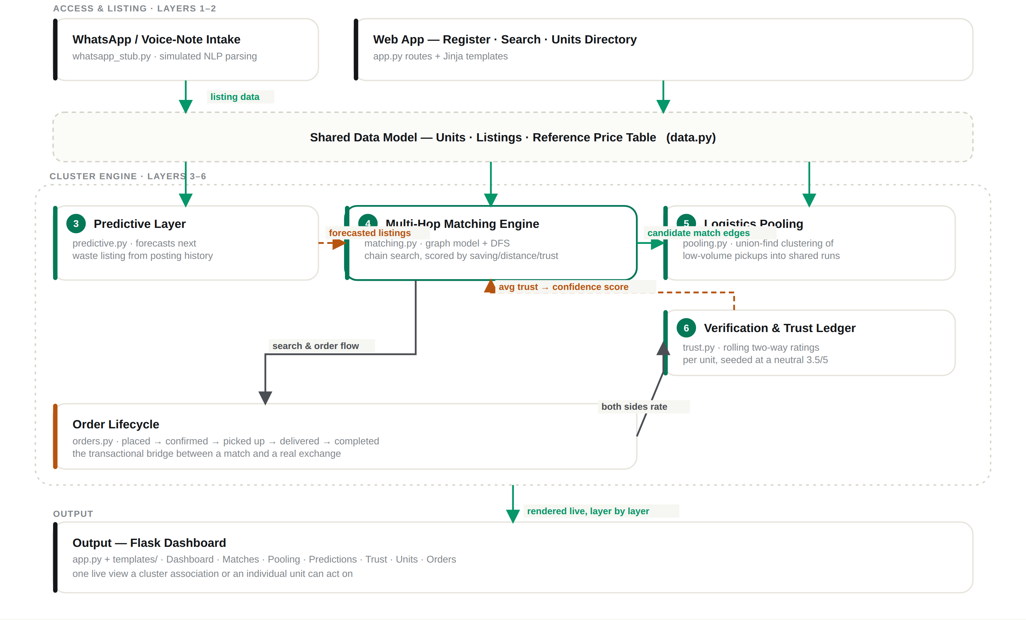
Figure 1. SymbioLink AI system architecture — solid green arrows are the primary data flow; dashed amber arrows are the predictive signal and trust feedback loop; the dashed grey boundary marks the shared data substrate and the cluster-engine grouping.
Honest scope note: today, Search and Order creation read listings directly rather than being gated by the Matching Engine's ranked chains — those chains are surfaced as suggestions on the dashboard, on register confirmation, and on unit profiles. Tightening that pipeline is a natural next step, alongside the other items in the project's “Next steps toward a pilot.”

Software Modules
The prototype is organized as a small set of single-responsibility Python modules sitting behind the Flask app, so each layer in the architecture diagram maps to one readable file rather than a sprawling monolith.
Module | Responsibility
app.py | Flask application — routes, request handling, and page rendering for all six layers.
data.py | Core data model: Units, Listings, categories, and the reference price table.
matching.py | Multi-Hop Matching Engine — graph model + DFS chain search, scored by saving, distance, and trust.
predictive.py | Predictive Layer — forecasts a unit's next likely waste listing from its posting history.
pooling.py | Logistics Pooling — union-find clustering of nearby low-volume pickups into shared transport runs.
trust.py | Verification & Trust Ledger — rolling two-way ratings per unit, seeded at a neutral 3.5 / 5.
orders.py | Order Lifecycle — placed → confirmed → picked up → delivered → completed; the transactional bridge between a match and a real exchange.
whatsapp_stub.py | Simulated WhatsApp / voice-note intake — lightweight parser that turns a free-text message into a structured listing.
templates/ | Jinja2 templates for every page — dashboard, listings, units, matches, pooling, and orders.
static/style.css | The dark, glass-morphism design system — tokens, layout, and components shared across all pages.

Tech Stack
- Python 3 + Flask — application server and routing
- Jinja2 templates — server-rendered pages
- In-memory data model — Units, Listings, Orders, Trust ledger (data.py / orders.py / trust.py)
- Chart.js — the dashboard's savings chart
- vis-network — the cluster network graph
- Twilio WhatsApp (planned) — real inbound message intake
- Whisper / speech-to-text (planned) — voice-note transcription
- SQLite (planned) — persistence beyond the current in-memory demo state
SymbioLink AI · Team CircuLink · Sustainability Hackathon 2026

