**EX – 1 :**

**Home.html**

<!DOCTYPE html>

<html lang="en">

<head>

<meta charset="UTF-8">

<meta name="viewport" content="width=device-width, initial-scale=1.0">

<title>EX - 1</title>

</head>

<body>

<nav>

<div>

<h1>Ticket</h1>

</div>

<div>

<ul>

<li><a href="#">Home</a></li>

<li><a href="#">Book</a></li>

<li><a href="#">Contact</a></li>

<li><a href="#">SignIn/SignUp</a></li>

</ul>

</div>

</nav>

<header>

<div>

<center>

<img src="./images/img.jpg" alt="">

</center>

</div>

<div>

<h1>Welcome to Ticket Booking</h1>

<p>Book your tickets easily and quickly.</p>

<a href="#">Get Started</a>

</div>

</header>

<section>

<div>

<h2>Featured Events</h2>

<table>

<tr>

<td>

<div>

<img src="./images/e1.jpg" width="500" alt="Event 1">

<h3>Concert</h3>

<p>Date: 2025-01-01</p>

<p>Location: City Hall</p>

<a href="#">Book Now</a>

</div>

</td>

<td>

<div>

<img src="./images/e2.jpg" width="500" alt="Event 2">

<h3>Theater Play</h3>

<p>Date: 2025-02-15</p>

<p>Location: Grand Theater</p>

<a href="#">Book Now</a>

</div>

</td>

<td>

<div>

<img src="./images/e3.jpg" width="500" alt="Event 3">

<h3>Art Exhibition</h3>

<p>Date: 2025-03-10</p>

<p>Location: Art Gallery</p>

<a href="#">Book Now</a>

</div>

</td>

</tr>

</table>

</div>

</section>

<footer>

<div>

<p>&copy; 2025 Ticket Booking. All rights reserved.</p>

</div>

<div>

<h5>Quick Links</h5>

<ul>

<li><a href="#">Privacy Policy</a></li>

<li><a href="#">Terms of Service</a></li>

<li><a href="#">Help</a></li>

</ul>

</div>

<div>

<h5>social Links</h5>

<ul>

<li><a href="#">Facebook</a></li>

<li><a href="#">Twitter</a></li>

<li><a href="#">Instagram</a></li>

</ul>

</div>

</footer>

</body>

</html>

**ScreenShots :**

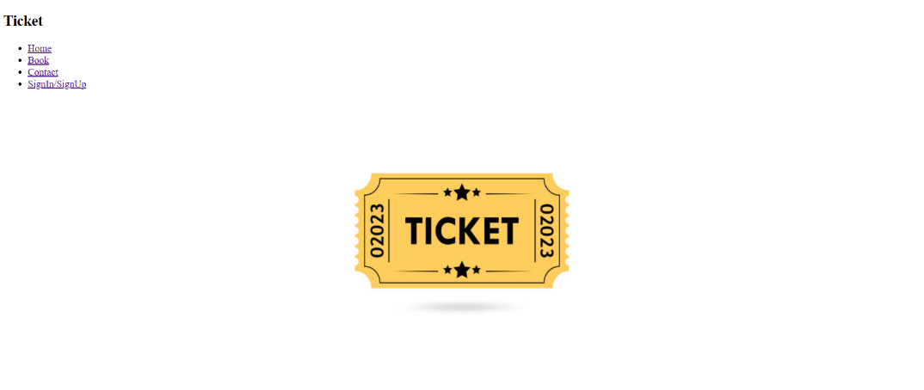

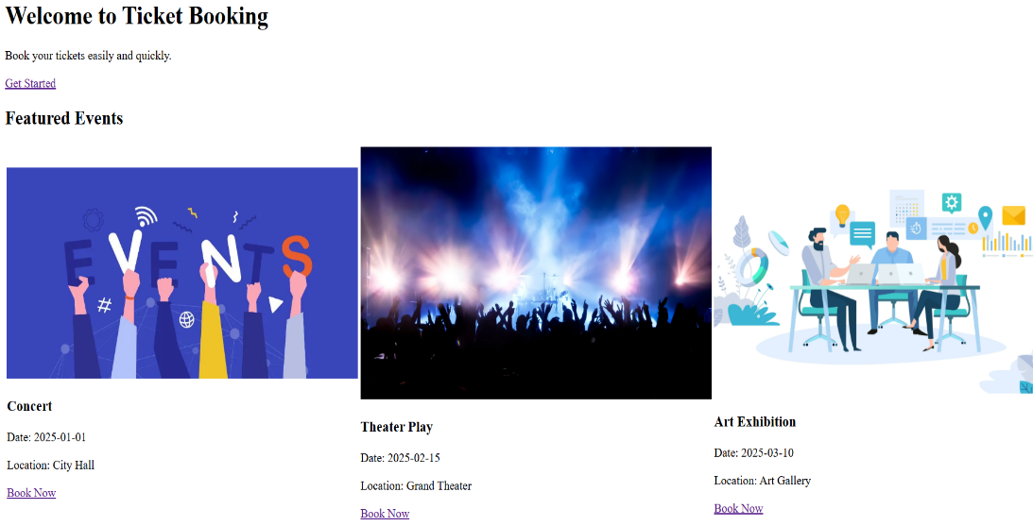 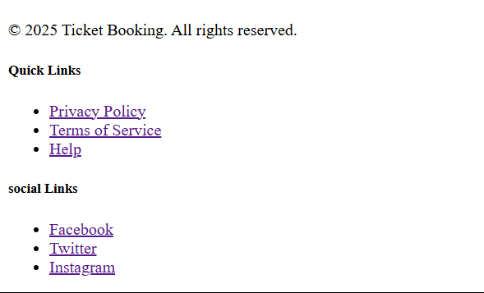

**GitHub :**

