Home Page :

<!DOCTYPE html>

<html lang="en">

<head>

<meta charset="UTF-8">

<meta name="viewport" content="width=device-width, initial-scale=1.0">

<title>Ex-2</title>

</head>

<body>

<nav>

<div>

<center>

<h1>DN Style Online Shopping</h1>

</center>

</div>

<div>

<a href="home.html">Home</a>

<a href="shop.html">Shop</a>

<a href="cart.html">Cart</a>

<a href="signin.html">SignIn</a>

</div>

</nav>

<center>

<header>

<div>

<h1>DN Style an Online Shopping</h1>

</div>

<div>

<h4>An Online platform were you can purchase things</h4>

</div>

<video src="./images and videos/file_example_MP4_1920_18MG.mp4" autoplay muted loop width="1000px"></video>

<audio src="./images and videos/file_example_MP3_5MG.mp3" autoplay></audio><br><br>

<button><a href="shop.html">Explore Now</a></button><br><br>

<h2>Location</h2>

<iframe src="https://www.google.com/maps/embed?pb=!1m18!1m12!1m3!1d3974.0660504825364!2d77.9632272750738!3d9.672812990416544!2m3!1f0!2f0!3f0!3m2!1i1024!2i768!4f13.1!3m3!1m2!1s0x3b012a8e3d378b53%3A0x15d8265b00bea0df!2sKamaraj%20College%20of%20Engineering%20%26%20Technology%20(Autonomous)!5e1!3m2!1sen!2sin!4v1753779625122!5m2!1sen!2sin" width="600" height="450" style="border:0;" allowfullscreen="" loading="lazy" referrerpolicy="no-referrer-when-downgrade"></iframe>

</header>

</center>

<footer>

<div>

<h5>copyright</h5>

</div>

<div>

<h2>Quick Links</h2>

<h6><a href="home.html">Home</a></h6>

<h6><a href="shop.html">Shop</a></h6>

<h6><a href="cart.html">cart</a></h6>

<h6><a href="signin.html">SignIn</a></h6>

</div>

<div>

<h2>Social Links</h2>

<h4><a href="">Facebook</a></h4>

<h4><a href="">Linkedin</a></h4>

<h4><a href="">Whatsapp</a></h4>

</div>

</footer>

</body>

</html>

**Shop page :**

<!DOCTYPE html>

<html lang="en">

<head>

<meta charset="UTF-8">

<meta name="viewport" content="width=device-width, initial-scale=1.0">

<title>Ex-2</title>

</head>

<body>

<nav>

<div>

<h1>DN Style Online Shopping</h1>

</div>

<div>

<a href="home.html">Home</a>

<a href="shop.html">Shop</a>

<a href="cart.html">Cart</a>

<a href="signin.html">SignIn</a>

</div>

</nav>

<section>

<table>

<tr>

<td>

<div>

<img src="./images and videos/shoe.jpg" width="500px" alt="">

</div>

<div>

<h1>Shoes</h1>

<button><a href="cart.html">Order</a></button>

</div>

</td>

<td>

<div>

<img src="./images and videos/socks.jpg" height="500px" width="500px" alt="">

</div>

<div>

<h1>Socks</h1>

<button><a href="cart.html">Order</a></button>

</div>

</td>

<td>

<div>

<img src="./images and videos/shorts.jpg" width="500px" alt="">

</div>

<div>

<h1>Shoes</h1>

<button><a href="cart.html">Order</a></button>

</div>

</td>

</tr>

<tr>

<td>

<div>

<img src="./images and videos/shirt.jpg" width="500px" alt="">

</div>

<div>

<h1>Shirt</h1>

<button><a href="cart.html">Order</a></button>

</div>

</td>

<td>

<div>

<img src="./images and videos/tshirt.jpg" width="500px" alt="">

</div>

<div>

<h1>T-Shirt</h1>

<button><a href="cart.html">Order</a></button>

</div>

</td>

<td>

<div>

<img src="./images and videos/hoddy.jpg" width="500px" alt="">

</div>

<div>

<h1>Hoddy</h1>

<button><a href="cart.html">Order</a></button>

</div>

</td>

</tr>

<tr>

<td>

<div>

<img src="./images and videos/pants.png" width="500px" alt="">

</div>

<div>

<h1>Pants</h1>

<button><a href="cart.html">Order</a></button>

</div>

</td>

<td>

<div>

<img src="./images and videos/mask.jpg" width="500px" alt="">

</div>

<div>

<h1>Mask</h1>

<button><a href="cart.html">Order</a></button>

</div>

</td>

<td>

<div>

<img src="./images and videos/coat.jpg" width="500px" alt="">

</div>

<div>

<h1>Coat</h1>

<button><a href="cart.html">Order</a></button>

</div>

</td>

</tr>

</table>

</section>

<footer>

<div>

<h5>copyright</h5>

</div>

<div>

<h2>Quick Links</h2>

<h6><a href="home.html">Home</a></h6>

<h6><a href="shop.html">Shop</a></h6>

<h6><a href="cart.html">cart</a></h6>

<h6><a href="signin.html">SignIn</a></h6>

</div>

<div>

<h2>Social Links</h2>

<h4><a href="">Facebook</a></h4>

<h4><a href="">Linkedin</a></h4>

<h4><a href="">Whatsapp</a></h4>

</div>

</footer></body>

</html>

Cart Page :

<!DOCTYPE html>

<html lang="en">

<head>

<meta charset="UTF-8">

<meta name="viewport" content="width=device-width, initial-scale=1.0">

<title>Document</title>

</head>

<body>

<nav>

<div>

<h1>DN Style Online Shopping</h1>

</div>

<div>

<a href="home.html">Home</a>

<a href="shop.html">Shop</a>

<a href="cart.html">Cart</a>

<a href="signin.html">SignIn</a>

</div>

</nav>

<center>

<section>

<form action="">

<p>Name</p>

<input type="text" placeholder="Enter the Name">

<p>Quantity</p>

<select>

<option value="">Select</option>

<option value="">1</option>

<option value="">2</option>

<option value="">3</option>

</select>

<p>Address</p>

<textarea placeholder="Address"></textarea><br><br>

<button>Order</button>

</form>

</section>

</center>

<footer>

<div>

<h5>copyright</h5>

</div>

<div>

<h2>Quick Links</h2>

<h6><a href="home.html">Home</a></h6>

<h6><a href="shop.html">Shop</a></h6>

<h6><a href="cart.html">cart</a></h6>

<h6><a href="signin.html">SignIn</a></h6>

</div>

<div>

<h2>Social Links</h2>

<h4><a href="">Facebook</a></h4>

<h4><a href="">Linkedin</a></h4>

<h4><a href="">Whatsapp</a></h4>

</div>

</footer>

</body>

</html>

SignIn Page:

<!DOCTYPE html>

<html lang="en">

<head>

<meta charset="UTF-8">

<meta name="viewport" content="width=device-width, initial-scale=1.0">

<title>Document</title>

</head>

<body>

<nav>

<div>

<h1>DN Style Online Shopping</h1>

</div>

<div>

<a href="home.html">Home</a>

<a href="shop.html">Shop</a>

<a href="cart.html">Cart</a>

<a href="signin.html">SignIn</a>

</div>

</nav>

<section>

<center>

<form action="">

<p>Email</p>

<input type="text" placeholder="Enter the mail">

<p>Password</p>

<input type="password" placeholder="Enter the password"><br><br>

<button>Submit</button>

<p>Do not have an account? <a href="signup.html">SignUp</a> </p>

</form>

</center>

</section>

<footer>

<div>

<h5>copyright</h5>

</div>

<div>

<h2>Quick Links</h2>

<h6><a href="home.html">Home</a></h6>

<h6><a href="shop.html">Shop</a></h6>

<h6><a href="cart.html">cart</a></h6>

<h6><a href="signin.html">SignIn</a></h6>

</div>

<div>

<h2>Social Links</h2>

<h4><a href="">Facebook</a></h4>

<h4><a href="">Linkedin</a></h4>

<h4><a href="">Whatsapp</a></h4>

</div>

</footer>

</body>

</html>

SignUp Page :

<!DOCTYPE html>

<html lang="en">

<head>

<meta charset="UTF-8">

<meta name="viewport" content="width=device-width, initial-scale=1.0">

<title>Document</title>

</head>

<body>

<nav>

<div>

<h1>DN Style Online Shopping</h1>

</div>

<div>

<a href="home.html">Home</a>

<a href="shop.html">Shop</a>

<a href="cart.html">Cart</a>

<a href="signin.html">SignIn</a>

</div>

</nav>

<section>

<center>

<form action="">

<p>Name</p>

<input type="text" placeholder="Enter the Name">

<p>Email</p>

<input type="text" placeholder="Enter the mail">

<p>Password</p>

<input type="password" placeholder="Enter the password"><br><br>

<button>Submit</button>

<p>Already have an account? <a href="signin.html">SignIn</a> </p>

</form>

</center>

</section>

<footer>

<div>

<h5>copyright</h5>

</div>

<div>

<h2>Quick Links</h2>

<h6><a href="home.html">Home</a></h6>

<h6><a href="shop.html">Shop</a></h6>

<h6><a href="cart.html">cart</a></h6>

<h6><a href="signin.html">SignIn</a></h6>

</div>

<div>

<h2>Social Links</h2>

<h4><a href="">Facebook</a></h4>

<h4><a href="">Linkedin</a></h4>

<h4><a href="">Whatsapp</a></h4>

</div>

</footer>

</body>

</html>

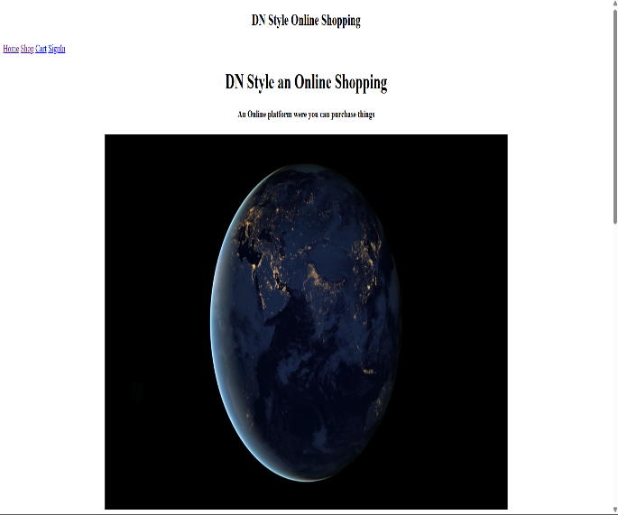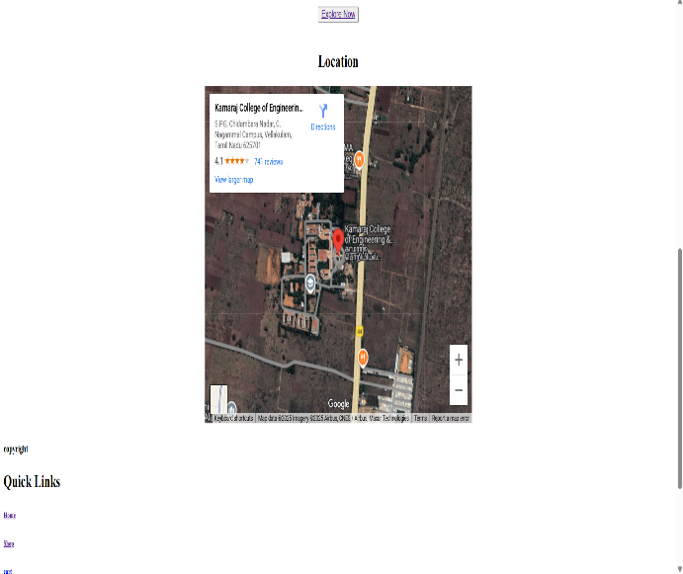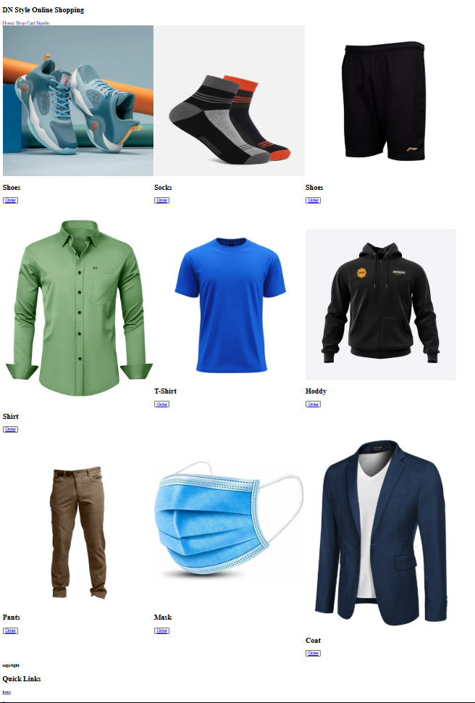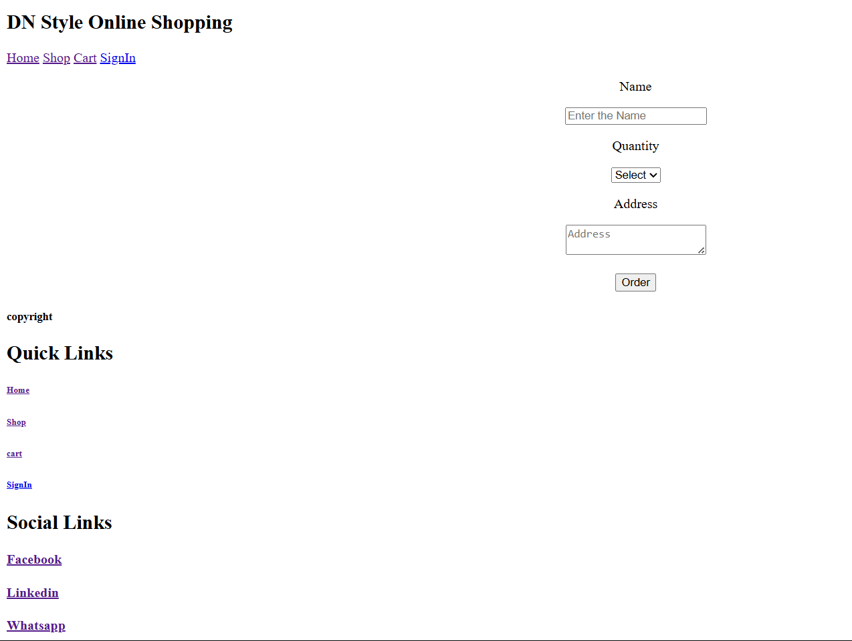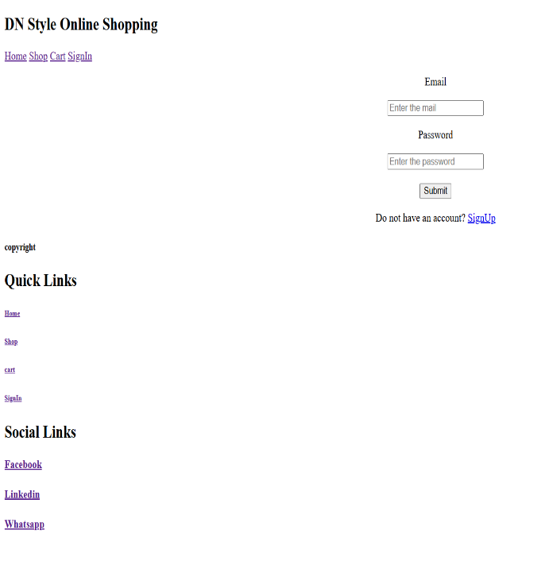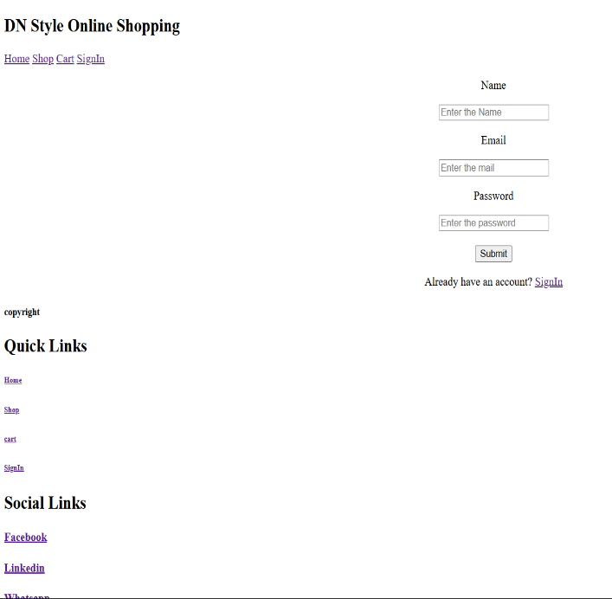

GitHub Link :

https://github.com/DharunNagavel/ip-lab/tree/main/EX-2