**CREDIT CARD FRAUD**

**DETECTION**

**INTRODUCTION:**

Credit card fraud detection is a crucial financial security task that leverages data science and machine learning in Python. Supervised machine learning models can distinguish between legitimate and fraudulent credit card transactions by analyzing historical transaction data. Key steps include data preprocessing, model selection, and training. The trained models are deployed in real time environments, like web applications, to detect fraud promptly. Python's flexibility and extensive libraries make it a popular choice for developing and maintaining these systems, enabling businesses to protect their customers from unauthorized transactions and substantial financial losses.

**Key Concepts:**

**Feature Engineering:**

Feature engineering is the process of selecting, transforming, or creating relevant features from the dataset to improve the performance of the fraud detection model.

**Model Training:**

Model training involves building and training a machine learning or deep learning model using the preprocessed and engineered features.

**Evaluation:**

Model evaluation is crucial to assess how well your credit card fraud detection model is performing.

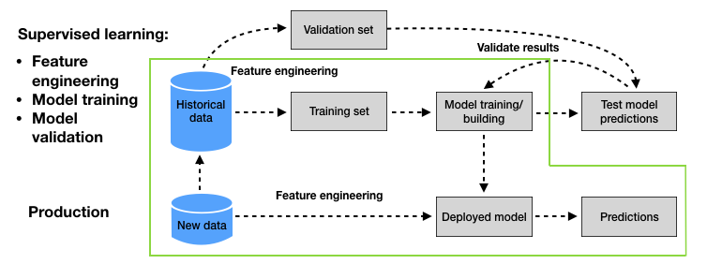

**Feature Engineering:**

Feature engineering is the process of selecting, transforming, or creating relevant features from the dataset to improve the performance of the fraud detection model. In the case of credit card fraud detection, some common feature engineering steps include:

**a. Data Preprocessing:**

Data Cleaning: Handle missing values, duplicates, and outliers in the dataset.Data Scaling: Normalize or standardize numerical features to have a similar scale.

One-Hot Encoding: Convert categorical variables into numerical format using one-hot encoding.

**b. Feature Selection:**

Identify important features using techniques like feature importance analysis, correlation analysis, or domain knowledge.

Remove irrelevant or redundant features to reduce model complexity.

**c. Feature Creation:**

Generate new features that might be informative, such as transaction amount relative to the cardholder's historical spending patterns.

**Model Training:**

Model training involves building and training a machine learning or deep learning model using the preprocessed and engineered features. For credit card fraud detection, you can use various algorithms, including:

a. Logistic Regression

b. Random Forest

c. Gradient Boosting (e.g., XGBoost, LightGBM)

d. Neural Networks (Deep Learning)

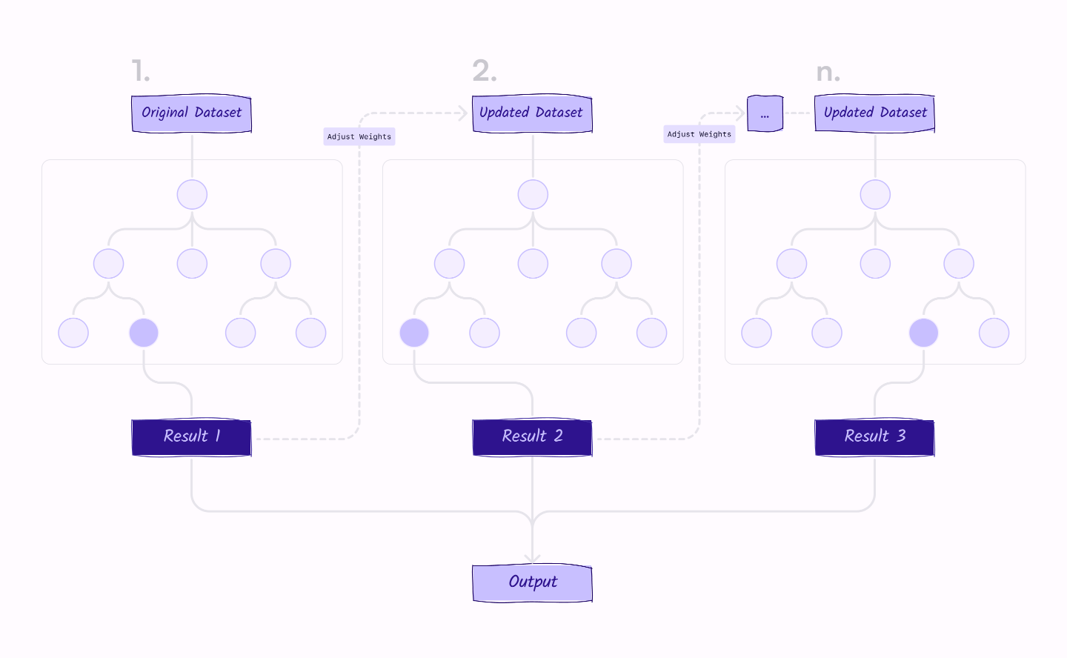

**Steps for model training:**

* Split the data into training and testing sets to evaluate model performance.
* Choose an appropriate algorithm and train the model on the training data.
* Tune hyperparameters using techniques like cross-validation and grid search.
* Evaluate the model's performance on the testing data using metrics like accuracy, precision, recall, F1-score, and the ROC curve.

**Evaluation:**

Model evaluation is crucial to assess how well your credit card fraud detection model is performing. Here are some key evaluation steps:

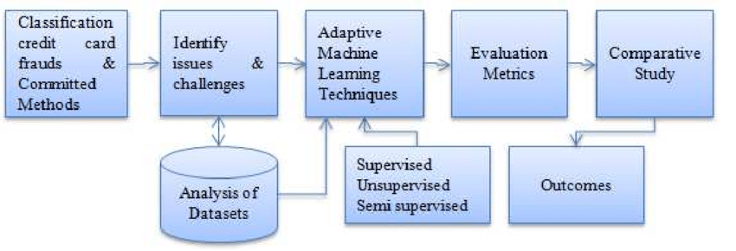

**a. Performance Matrices:**

Calculate various performance metrics such as accuracy, precision, recall, F1-score, and the area under the ROC curve (AUC-ROC).

Pay special attention to recall (true positive rate) since it is essential to identify fraudulent transactions.

**b. Confusion Matrix:**

Analyze the confusion matrix to understand how the model is making correct and incorrect predictions.

**c. Threshold Selection:** Depending on your model's goals, you may need to adjust the classification threshold to balance false positives and false negatives.

**d. Cross-Validation:**

Perform k-fold cross-validation to ensure the model's performance is robust and not overfitting the training data.

**e. Monitoring and Updating:**

Credit card fraud patterns may change over time, so regularly monitor the model's performance and update it as needed.