**DATA ANALYTICS ASSIGNMENT**

**by:- C.Dharun and Sricharan**

**Statistics** is a discipline that concerns the collection, organization, analysis, interpretation and presentation of data. It can help generate inferences from existing data.

**A statistical hypothesis test** is a method of statistical inference used to decide whether the data at the hand sufficiently supports a hypothesis. Hypothesis testing allows the researcher to determine whether the data from the sample is statistically significant. Hypothesis testing is one of the most important processes for measuring the validity and reliability of outcomes in any systematic investigation.

**The null hypothesis** is a typical statistical theory which suggests that no statistical relationship and significance exists in a set of given single observed variable, between two sets of observed data and measured phenomena.

In statistical hypothesis testing, **the alternative hypothesis** is one of the proposed proposition in the hypothesis test.

**A t-test** is a type of inferential [statistic](https://www.investopedia.com/terms/s/statistics.asp) used to determine if there is a significant difference between the means of two groups, which may be related in certain features. It is mostly used when the data sets, like the data set recorded as the outcome from flipping a coin 100 times, would follow a normal distribution and may have unknown variances. A t-test is used as a hypothesis testing tool, which allows testing of an [assumption](https://www.investopedia.com/ask/answers/073115/what-assumptions-are-made-when-conducting-ttest.asp) applicable to a population..

We have a **dataset that** about AVAX cryptocurrency Historical Data

This dataset comprises of Avalanche, whicg is a decentralized, open-source proof of stake blockchain with smart contract functionality. AVAX is the native cryptocurrency of the platform.

There are twelve column in it :

1. Open Time
2. Open
3. High
4. Low
5. Close
6. Volume
7. Close Time
8. Quote assest volume
9. Number of trades
10. TB Base Volume
11. TB Quote Volume
12. Ignore

**Now we have to check for inconsistency in the csv if so we have to preprocess the data .**

A csv file is imported and preprocessed in using the pandas.dropna() function of Python’s pandas module and then use the data frame for our analysis.

**Source Code:**

https://github.com/Dharundds/t_test

**Output:**

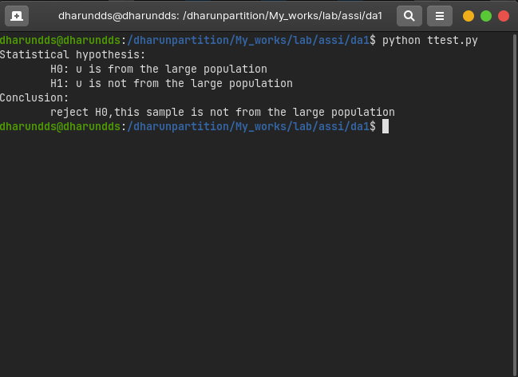

**References:**

Kaggle.com