Project Report: Tomato Plant Disease Prediction

Project Description:

The Tomato Plant Disease Prediction System is a user-friendly application designed to assist farmers and gardeners in identifying diseases affecting tomato plants. By analyzing images of tomato leaves using advanced technology, the system predicts diseases and recommends appropriate treatments.

Introduction

In this section, provide an overview of the project and its objectives. Explain the importance of developing a Tomato Plant Disease Prediction App and its potential benefits for agriculture and plant health management.

Goals:
1. Develop an easy-to-use application for predicting tomato plant diseases.
2. Provide accurate disease predictions and treatment recommendations.
3. Enable early intervention to minimize crop loss and increase yield.

Outcomes:
1. Creation of an accurate and efficient disease prediction application.
2. Improved crop management strategies among farmers.
3. Reduced crop loss, leading to enhanced agricultural productivity.
4. Increased adoption of technology in agriculture.

Components Needed

List the hardware and software components required to run the application:

Hardware Components:
- Raspberry Pi
- Camera module (for real-time option)
- Heatsink
- PowerSupply Adapter
- HDMI Cable

Software Components:
- Python
- Streamlit
- OpenCV
- Ultralytics YOLO (You Only Look Once) model
- PIL (Python Imaging Library)

Workflow

Step-by-step workflow of the Tomato Plant Disease Predictor

3.1. Powering Up the Raspberry Pi
- Describe the process of connecting the Raspberry Pi to a power source and waiting for the services to start.

3.2. Opening the Application
- Explain how the user should locate and double-tap the "Tomato" shortcut on the desktop to open the application.

3.3. Executing the Application
- Describe the pop-up window with the "Execute" button and how the user should tap it to start the application.

3.4. Choosing an Option
- Explain the two main options: "Upload Image" and "Real Time".
- Describe how the user can choose between uploading an image or using real-time camera input.

3.5. For "Upload Image" Option
- Provide detailed steps for the user to upload an image and click the "Predict" button.
- Explain how the app uses the YOLO model to predict the disease based on the uploaded image.

3.6. For "Real Time" Option
- Describe the real-time camera feed and how the user can capture images using the "Take Photo" button.
- Explain the prediction process using the YOLO model for real-time input.

3.7. Viewing Predicted Disease and Treatments
- Explain how the app displays the predicted disease image along with treatment recommendations.
- Describe the link between the predicted disease and the displayed treatments.

Use Cases:
1. Farmers can swiftly identify diseases and take action.
2. Gardeners can proactively manage their tomato plants.
3. Agricultural workers can provide targeted support to local farmers.

Social Impact:
1. Empowers farmers with technology for better crop management.
2. Promotes sustainable agricultural practices.
3. Enhances livelihoods by reducing crop loss.

Benefits and Advantages:
1. Quick disease detection and timely action.
2. Reduced crop loss and improved agricultural yield.
3. Simple interface for users without technical expertise.
4.Tailored treatment recommendations guide effective responses.

Sample Images:
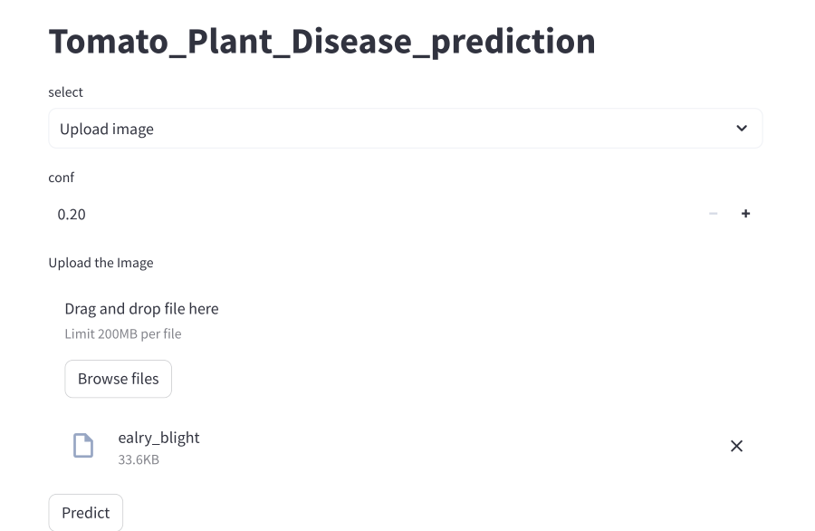
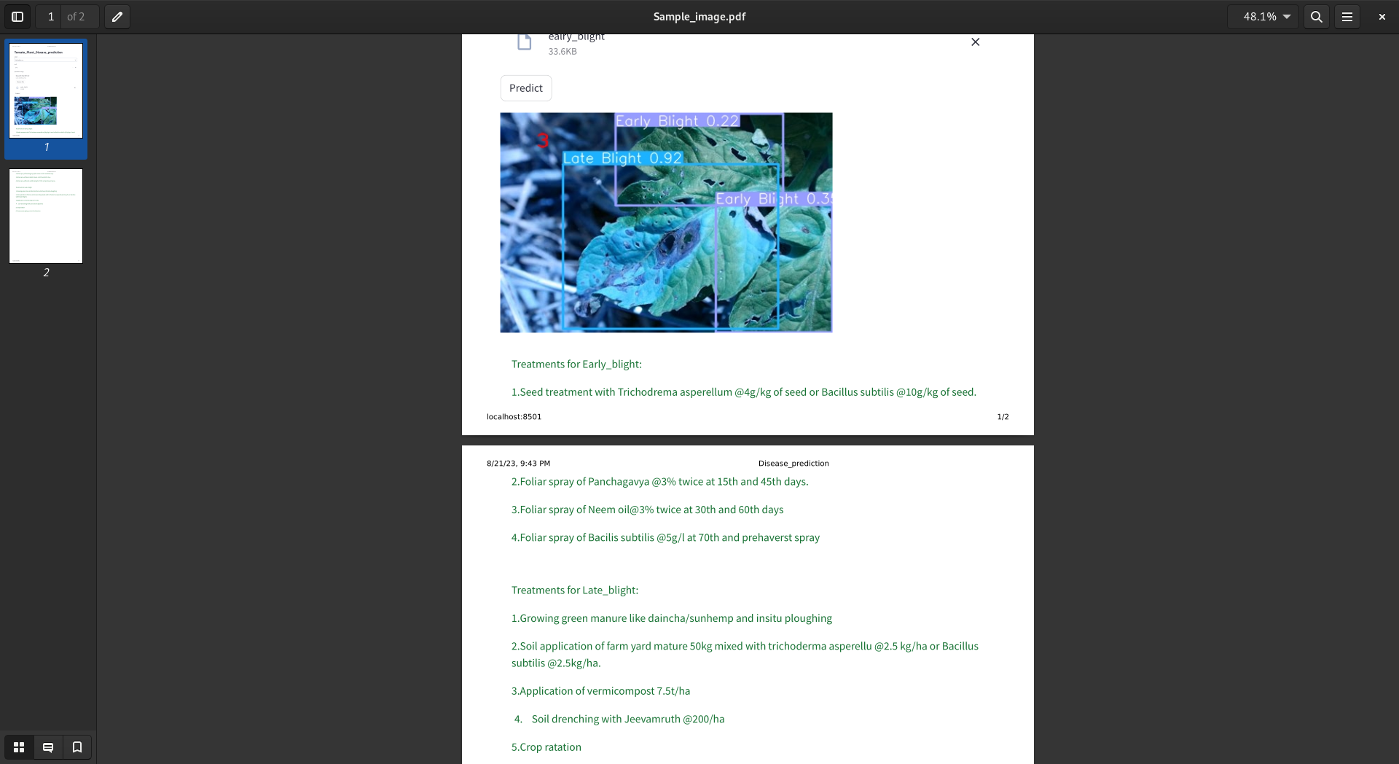

Conclusion
The Tomato Plant Disease Prediction System merges technology and agriculture to benefit farmers and improve crop health. By offering timely disease predictions and treatment guidance, the application contributes to minimizing crop loss and enhancing overall agricultural efficiency. The user-friendly design ensures that the benefits of technology are accessible to all, regardless of technical expertise, ultimately strengthening the farming community.

