1. **What is DAM and Why Do We Use It?**

Digital Asset Management (DAM) in AEM is used to store, manage, and deliver digital assets like images, videos, and documents.

* + It provides centralized storage for assets.
  + Helps in version control and metadata management.
  + Allows easy search and retrieval of assets.
  + Enables renditions (automatic resizing and format conversion).

1. **Create one folder inside our project folder and follow the path:**

**“/content/dam/myTraining/us/en-us” and upload 2 images and author those images on page**

**using image component as we see today.**

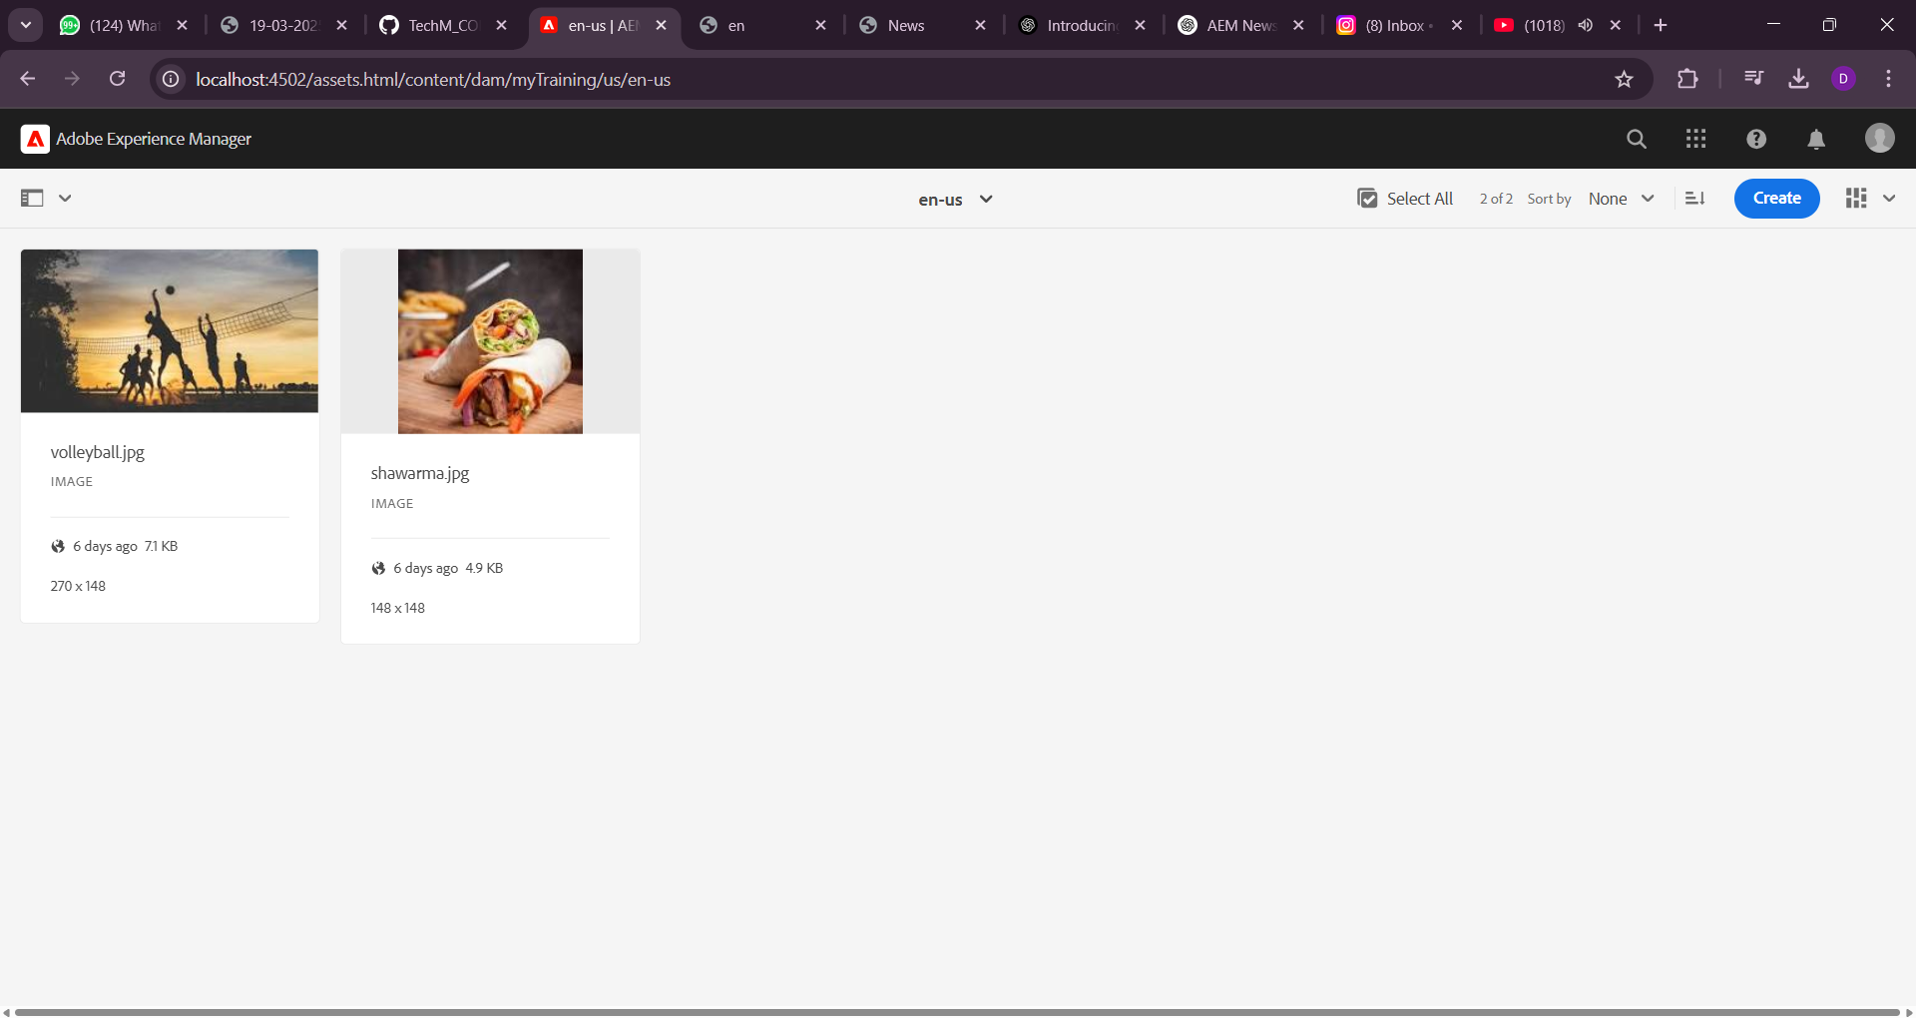

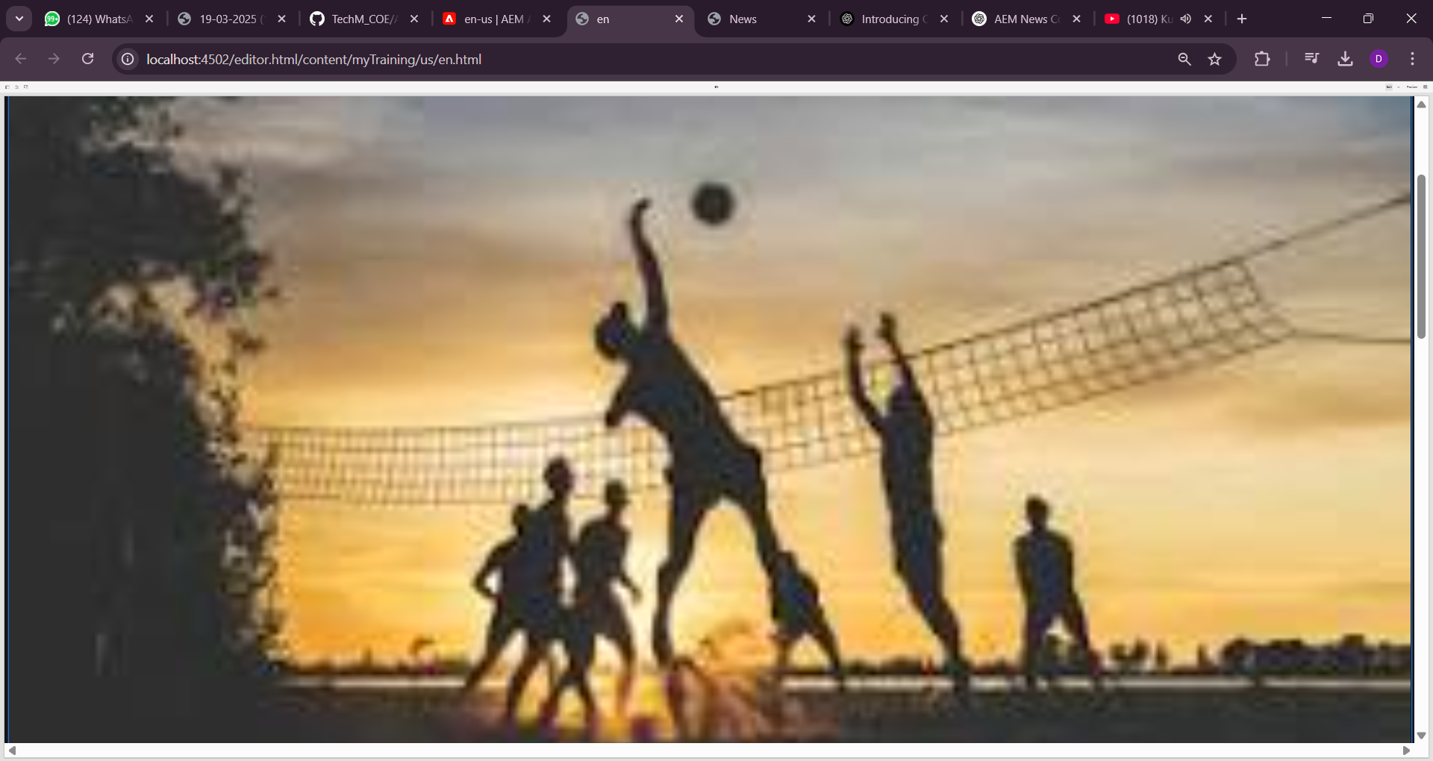

**3 What is renditions? Check the renditions for 2 images which we had uploaded**

Renditions are automatically generated versions of an image with different sizes and formats

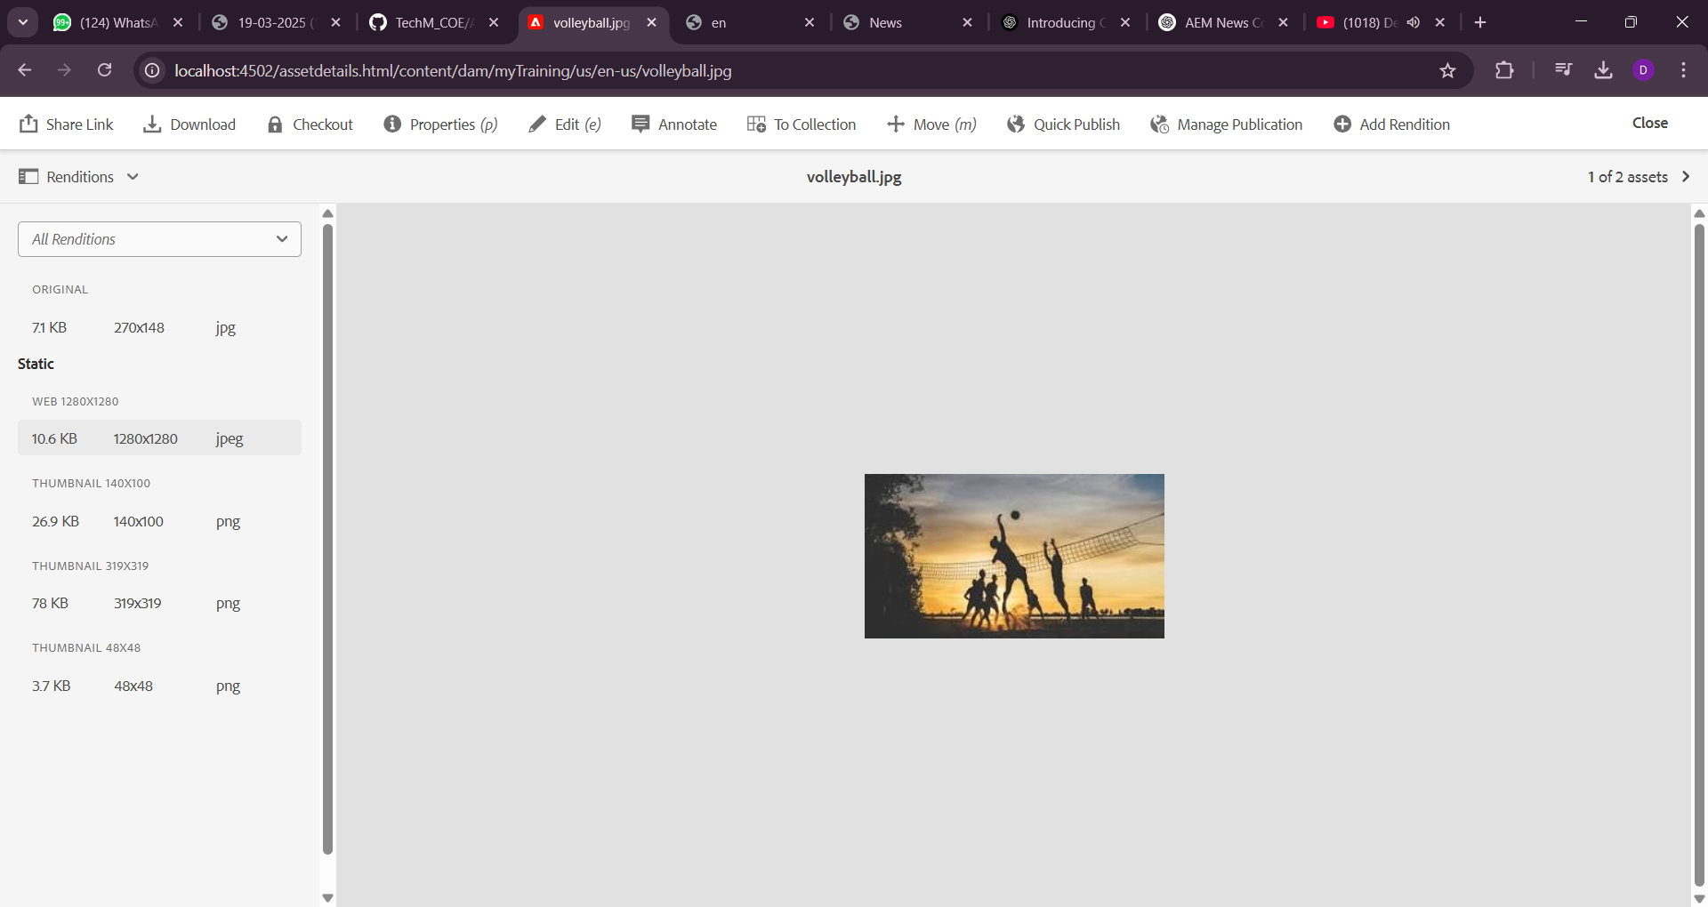

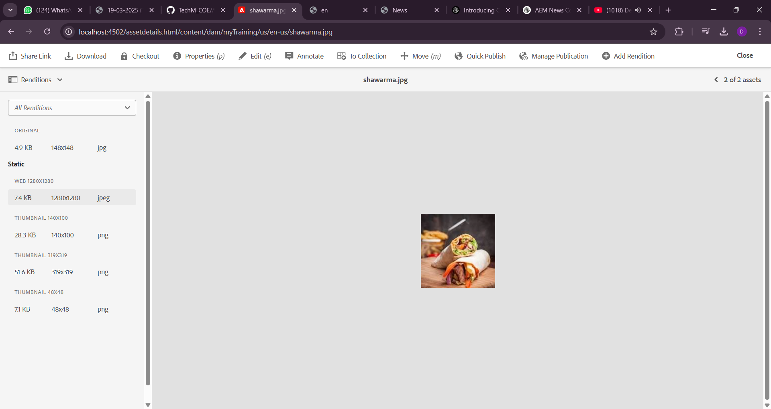

1. **Add two fields in hello world component with name FirstName and Last Name and print the values on hello world.html component using properties**

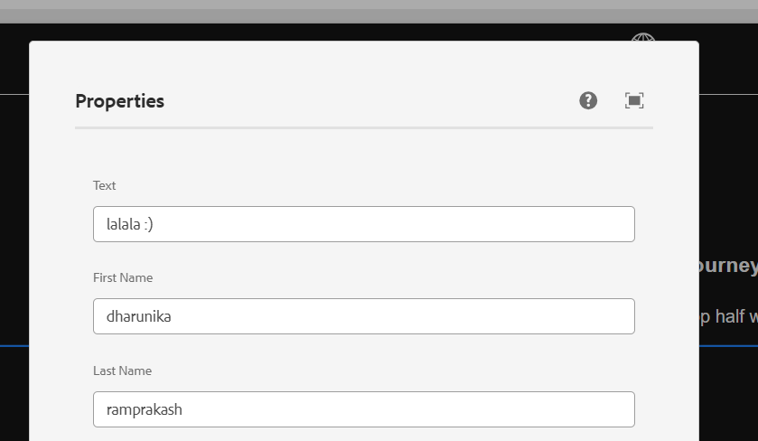

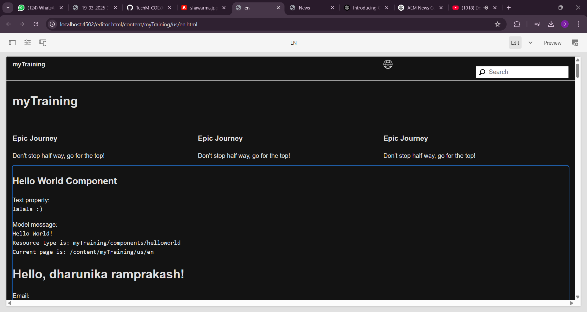

1. **Give try using @ValueMapValue annotation on HelloWorldModel sling java model**

**“com.myTraining.core.models.HelloWorldModel”**

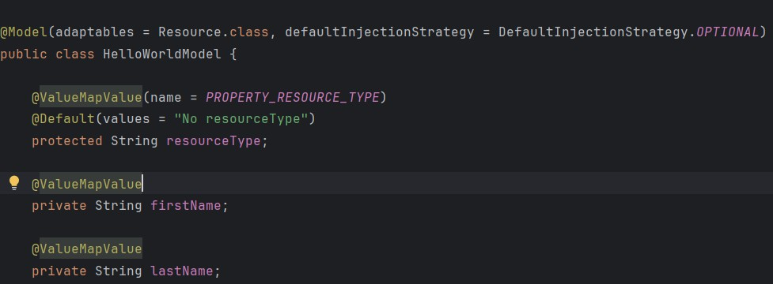

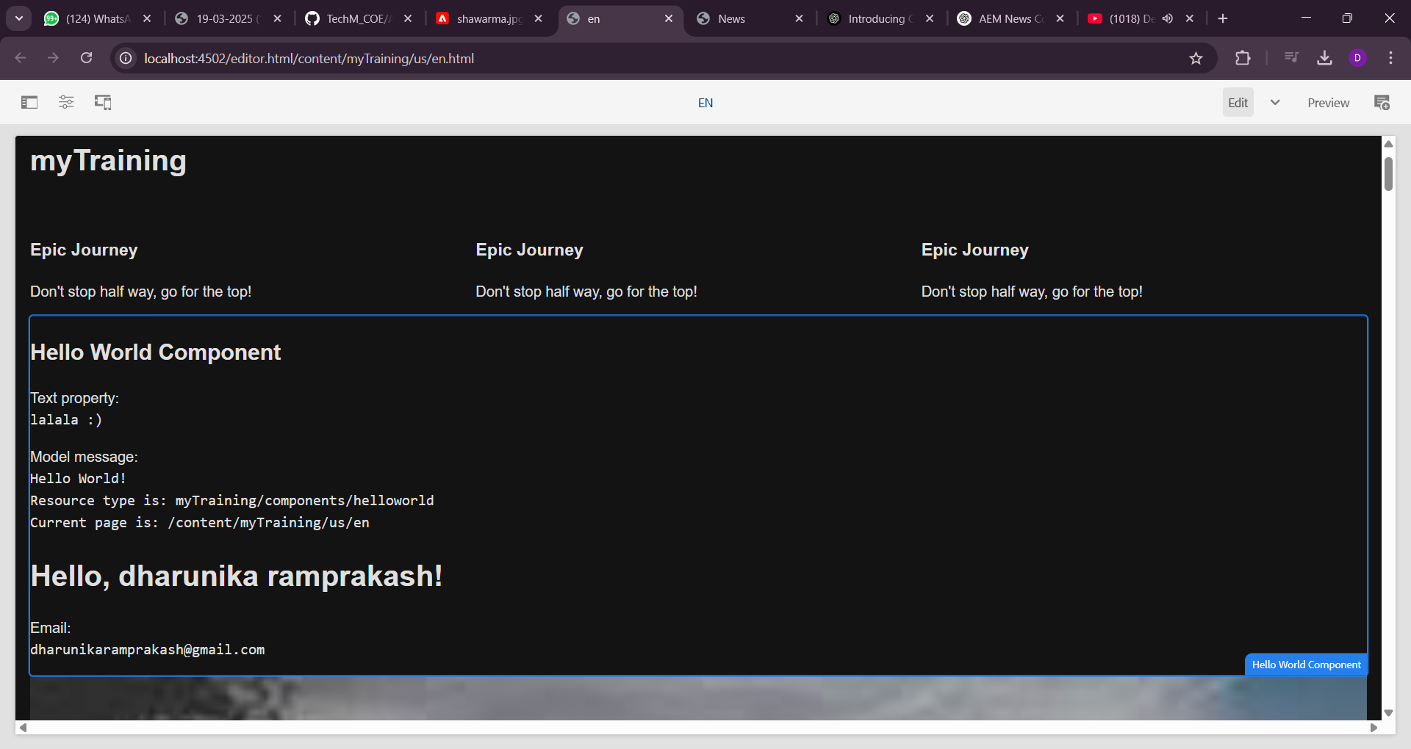

1. **Why we are using package manager and jar create package for the hello world component and 2 images what we have uploaded, There should be 2 packages 1 for dam which is images and 2 one is for helloworld component.**

AEM’s Package Manager helps in exporting, transferring, and deploying content and code between AEM instances.

1. Content Migration → Move assets, components, or configurations from one AEM instance to

another.

1. Backup & Restore → Store a package as a backup and reinstall if needed.
2. Deployment & Versioning → Packages help in structured and controlled deployment of code and

assets.

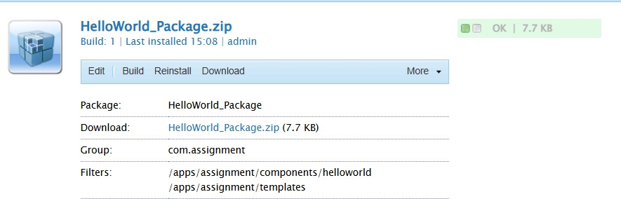

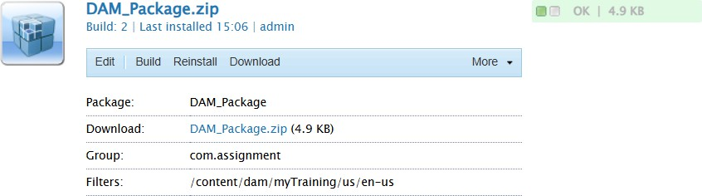

**7. Configure Replication Agent and Publish Page Steps to Configure Replication Agent:**

1. Open <http://localhost:4502/etc/replication/agents.author.html>.

2. Click Default Agent (Publish).

3. Under Settings:

o Enable it by checking the Enabled option.

o Set Transport URI to <http://localhost:4503/bin/receive>.

o Click Test Connection and ensure it is successful.

Steps to Publish Page from Author to Publish:

1. Open <http://localhost:4502/sites.html>.

2. Navigate to the page where you added the image component.

3. Click Publish → Publish Page.

4. Open http://localhost:4503/sites.html (AEM Publish instance).

5. Verify that the page is available in the Publish environment.

