**1. Create Custom Workflow (my custom workflow).**

Go to Tools > Workflow > Models.  
Click on "Create".  
Enter the title: my custom workflow.  
Click on "Create & Open".  
Add a Process Step to the workflow model.  
Configure the Process Step:

* Title: Custom Process Step
* Process: CustomWorkflowProcess   
  Save the workflow.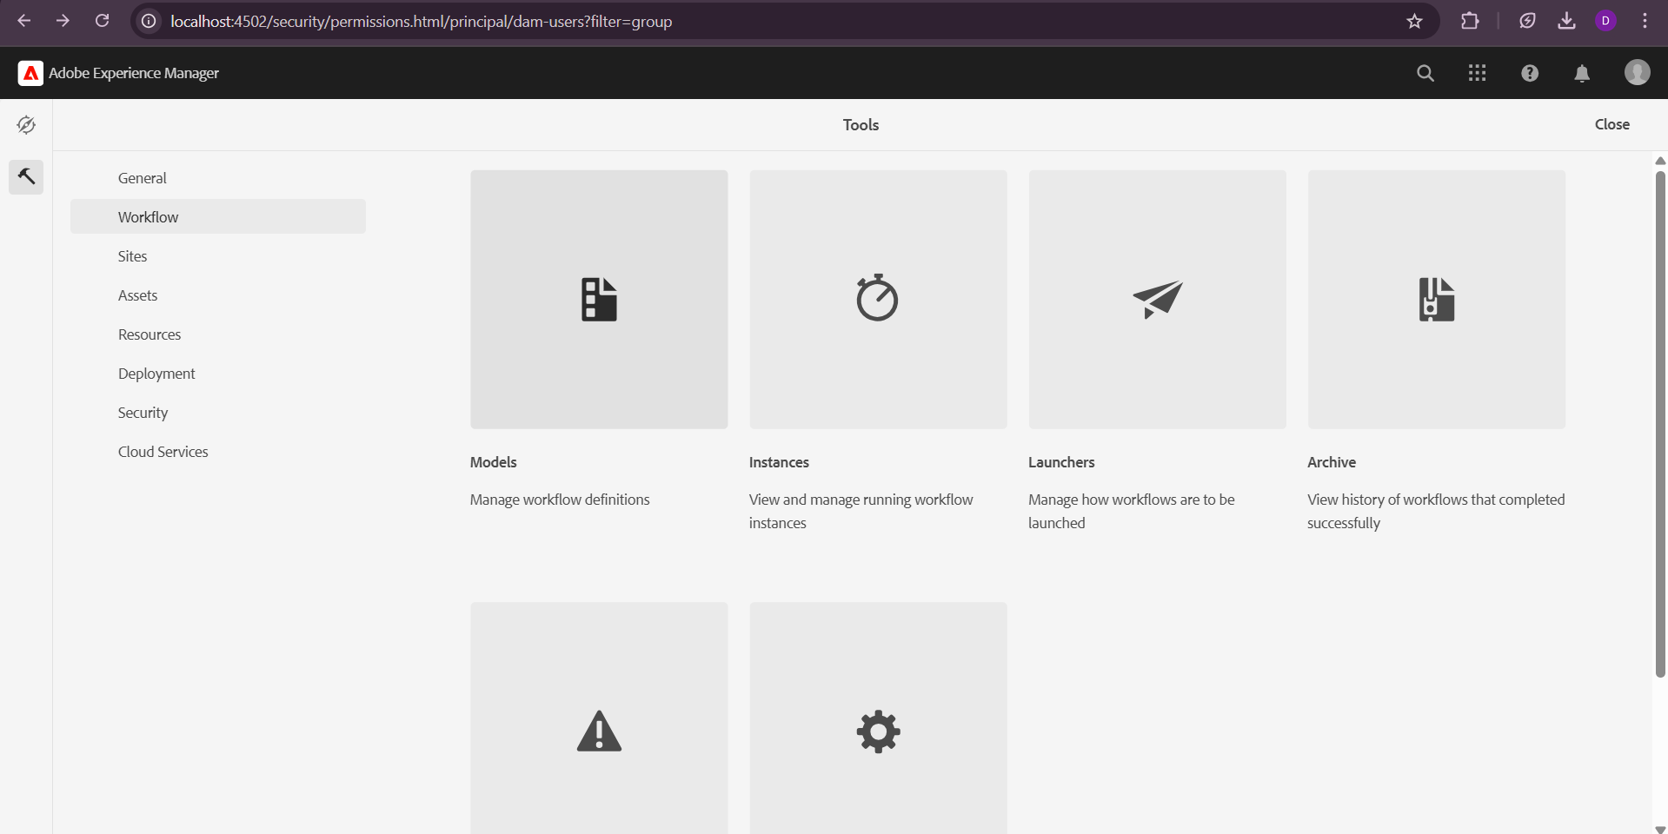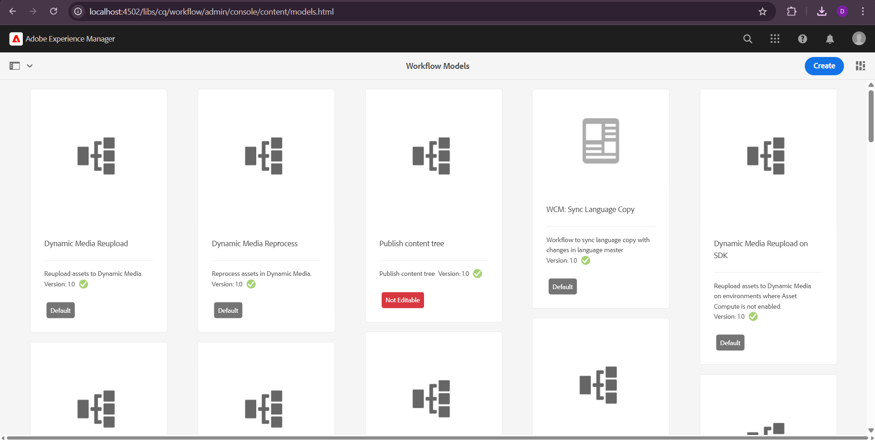 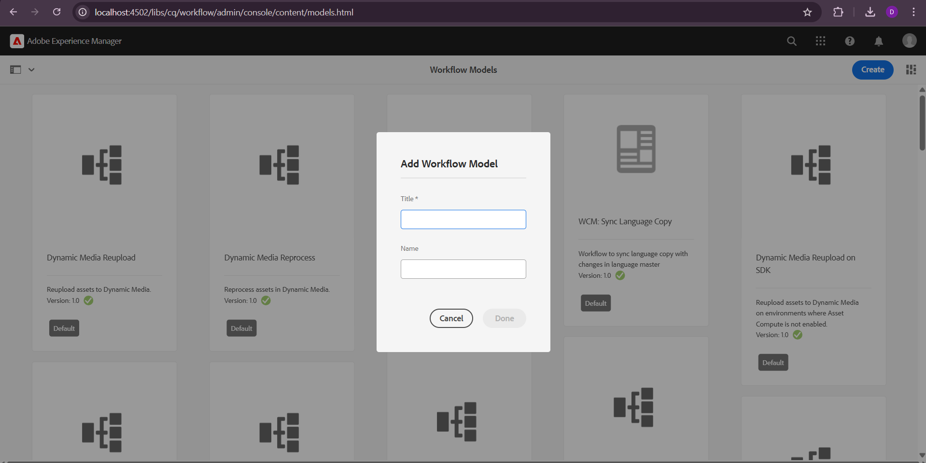

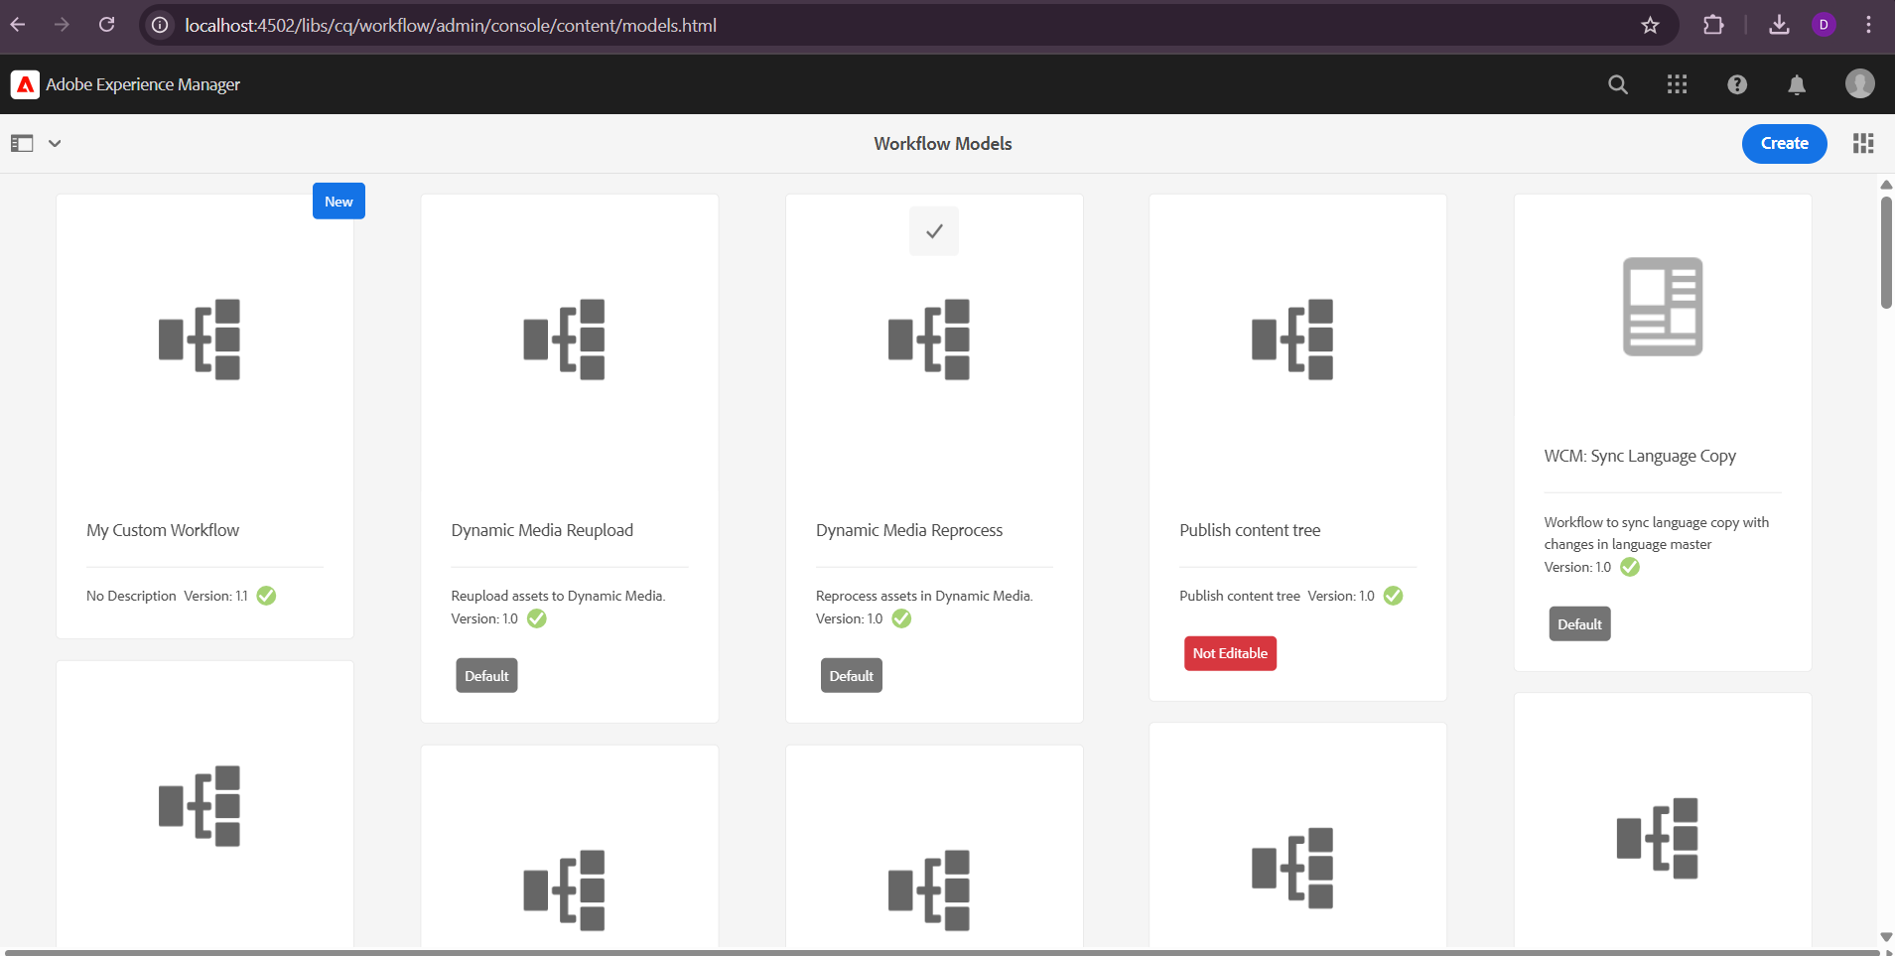

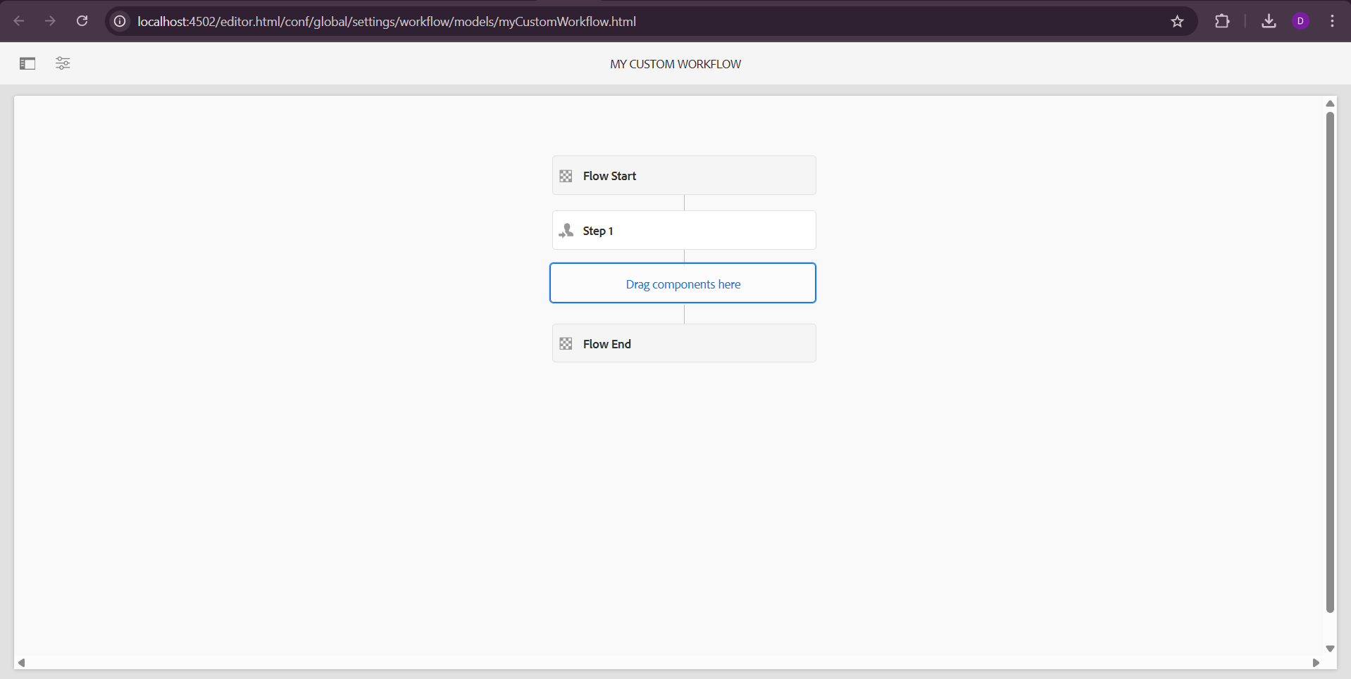

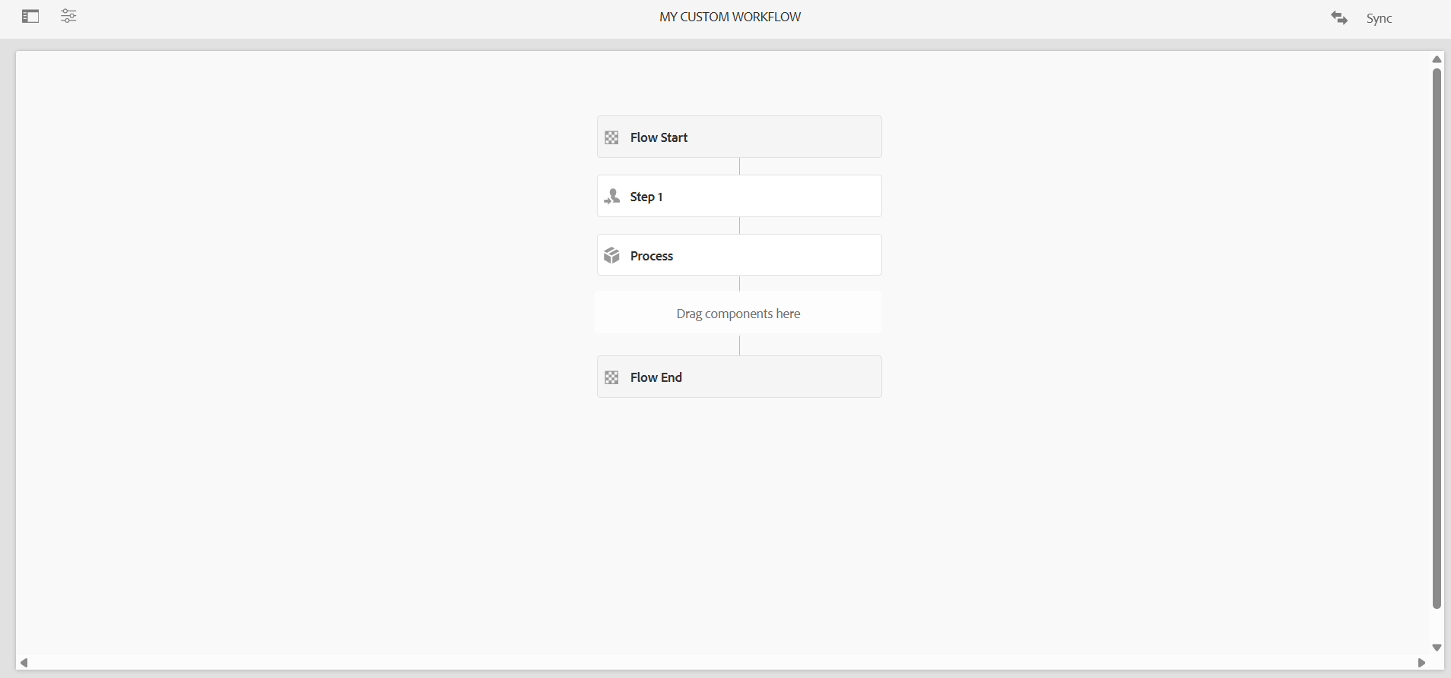

**2.Create custom workflow process and print the page title in logs and run this workflow in page so that it can give some metadata in logs**

Configure the Process Step : In Process Tab : Provide a custom class name like com.example.core.workflows.PrintPageTitleProcess Title: "Print Page Title Step

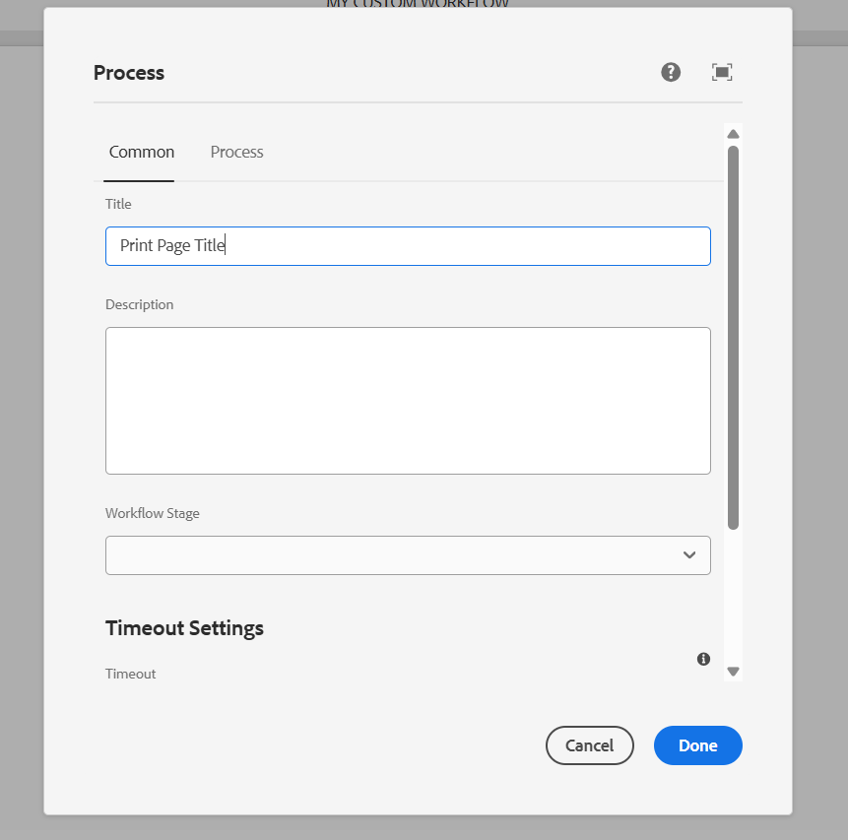

**Create a Workflow Process Java Class Go to AEM project:** /core/src/main/java/com/myTraining/core/workflows/PrintPageTitleProcess.java

@Component(service = WorkflowProcess.class, property = {"process.label=Print Page Title"})

public class PrintPageTitleProcess implements WorkflowProcess {

private static final Logger LOG = LoggerFactory.getLogger(PrintPageTitleProcess.class); @Override

public void execute(WorkItem workItem, WorkflowSession workflowSession, MetaDataMap metaDataMap) {

try {

String path = workItem.getWorkflowData().getPayload().toString();

ResourceResolver resolver = workflowSession.adaptTo(ResourceResolver.class);

if (resolver != null) {

Resource resource = resolver.getResource(path + "/jcr:content");

if (resource != null) {

String title = resource.getValueMap().get("jcr:title", String.class);

LOG.info("Page Title: {}", title);

}

else {

LOG.warn("Resource not found at: {}", path);

} } }

catch (Exception e)

{

LOG.error("Error executing workflow process: ", e);

} } }

Run the workflow:

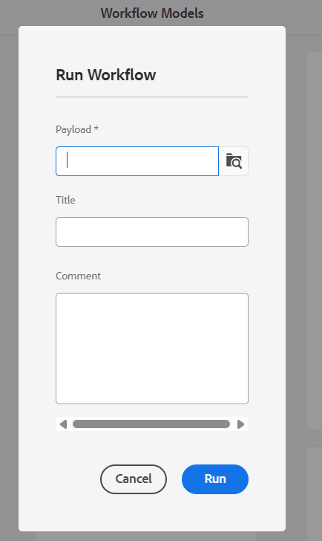

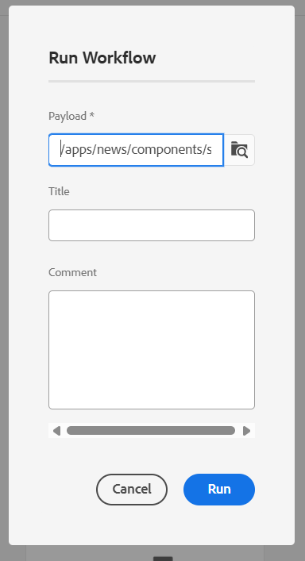

**3.Create Event handler in aem and print the resource path in logs.**

Create a java file named CustomeventHandler.java C:\Users\LENOVO\training\aem\codebase\myTraining\core\src\main\java\com\myTraining\core\li steners\CustomeventHandler.java

@Component(

service = EventHandler.class,

immediate = true,

property = {

EventConstants.EVENT_TOPIC + "=" + SlingConstants.TOPIC_RESOURCE_ADDED } ) public class ResourceEventHandler implements EventHandler {

private static final Logger LOG = LoggerFactory.getLogger(ResourceEventHandler.class); @Override

public void handleEvent(Event event) {

String resourcePath = (String) event.getProperty(SlingConstants.PROPERTY_PATH); LOG.info("Resource added at path: {}", resourcePath);

} }

**4.create sling job to print hello world message in logs:**

Create HelloWorldSlingJob.java file inside the following path core/src/main/java/myTraining /jobs/HelloWorldSlingJob.java

Package com.muTraining.jobs

import org.apache.sling.event.jobs.Job;

import org.apache.sling.event.jobs.consumer.JobConsumer;

import org.osgi.service.component.annotations.Component;

import org.slf4j.Logger;

import org.slf4j.LoggerFactory;

@Component(service = JobConsumer.class, property = {"job.topics=custom/job/helloworld"})

public class CustomSlingJob implements JobConsumer {

private static final Logger LOG = LoggerFactory.getLogger(CustomSlingJob.class); @Override

public JobResult process (Job job) {

LOG.info("Hello World from Sling Job!");

return JobResult.OK;

} }

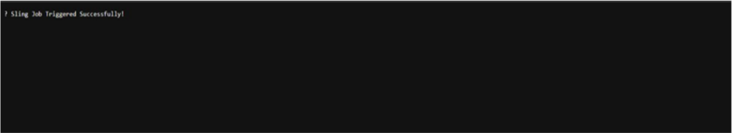

# 5.Create one schedular to print the yellow world in logs in every 5 mins through custom configuration using cron expression.

package com.myTraining .core.jobs;

import org.apache.sling.commons.scheduler.Scheduler; import org.osgi.service.component.annotations.Activate; import org.osgi.service.component.annotations.Component; import org.osgi.service.component.annotations.Reference; import org.osgi.service.metatype.annotations.Designate; import org.slf4j.Logger;

import org.slf4j.LoggerFactory;

@Component(service = Runnable.class, immediate = true, property = { "scheduler.expression=0 */5 * * * ?","scheduler.concurrent=false"}) @Designate(ocd = YellowWorldScheduler.Config.class)

public class YellowWorldScheduler implements Runnable {

private static final Logger LOG = LoggerFactory.getLogger(YellowWorldScheduler.class);

@Reference

private Scheduler scheduler; @Activate

protected void activate() {

LOG.info("Yellow World Scheduler Activated");

}

@Override

public void run() {

LOG.info("Yellow World from Scheduler!");

}}

# 6.Create 3 users and add them in a group(Dev author create this new group) and give permission to read only for /content and /dam folder only and they should have

**replication access as well.**

Go to AEM as an Administrator ([http://localhost:4502](http://localhost:4502/)). Navigate to Tools → Security → Groups

Click Create → Create Group.

Enter Group Name: eg:dev-authors

Click Save

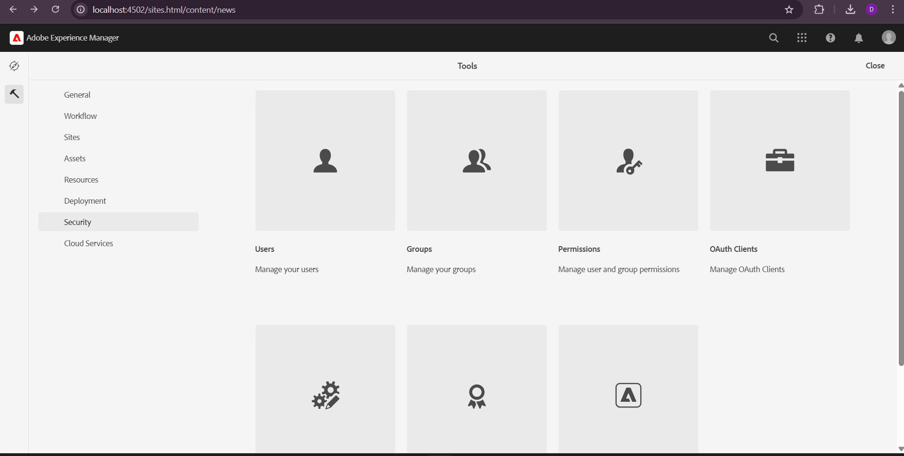

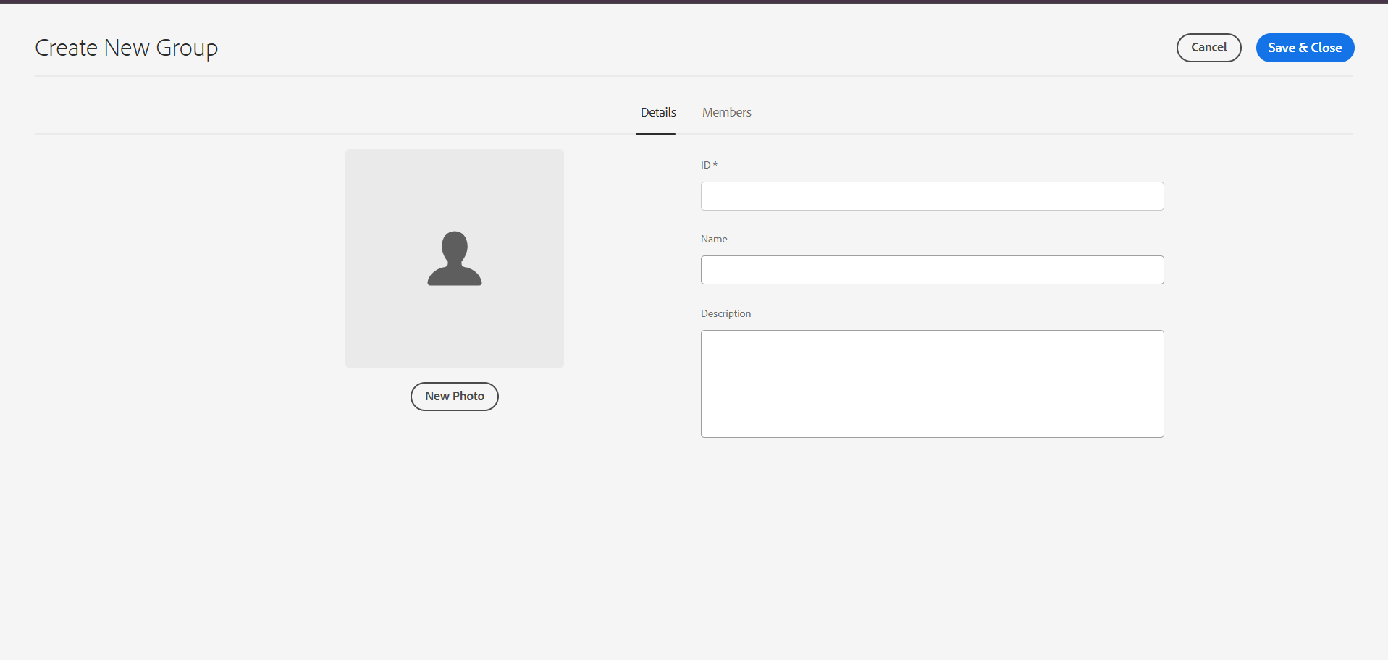

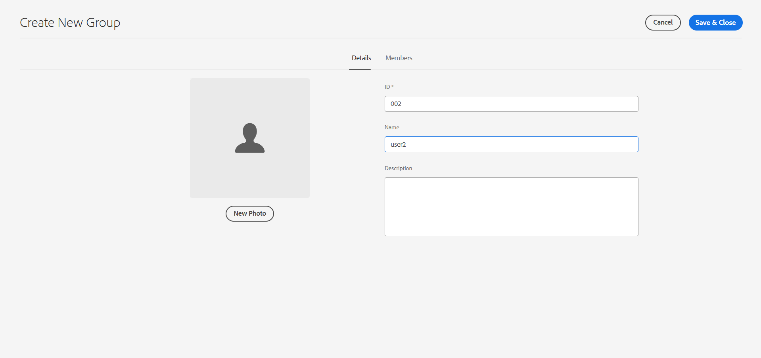

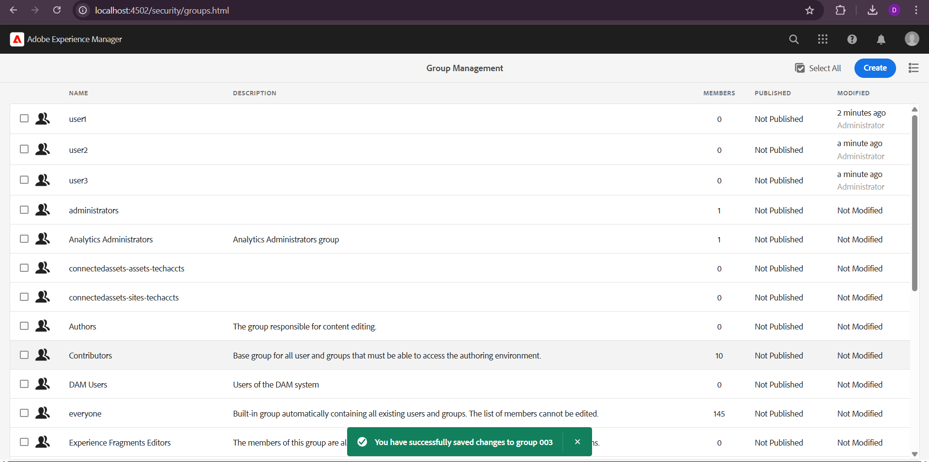

**Assign Permissions to the Group:**

Navigate to Tools → Security → Permissions.

Click on the group and set Read-Only Access.

