**Newsroom portfolio website:**

**Project Structure:**

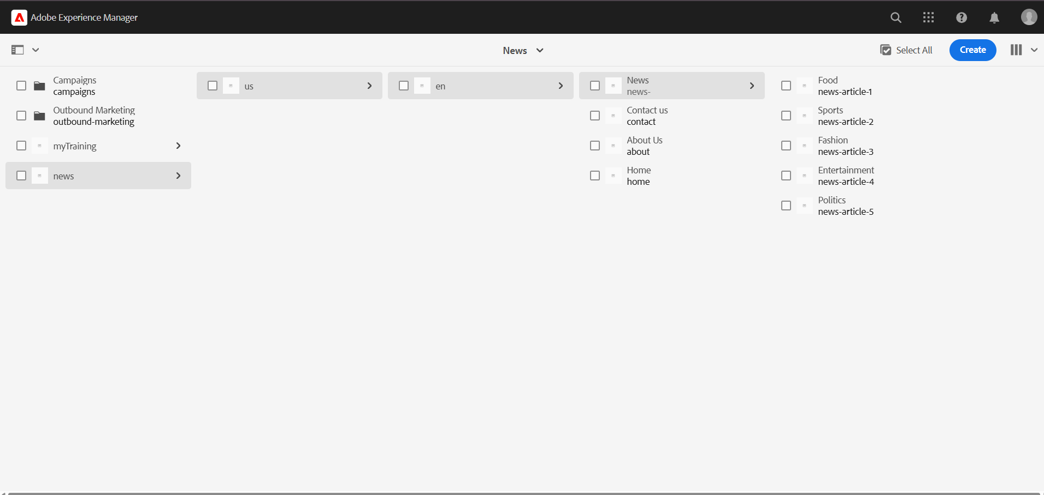

**1. Use the OOTB header component and create news(5), about me, contact me, and homepage. These pages should come in a header with proper styling and make sure books have a drop-down, so news should come.(The header should be used at the template level, so every page can use them).**

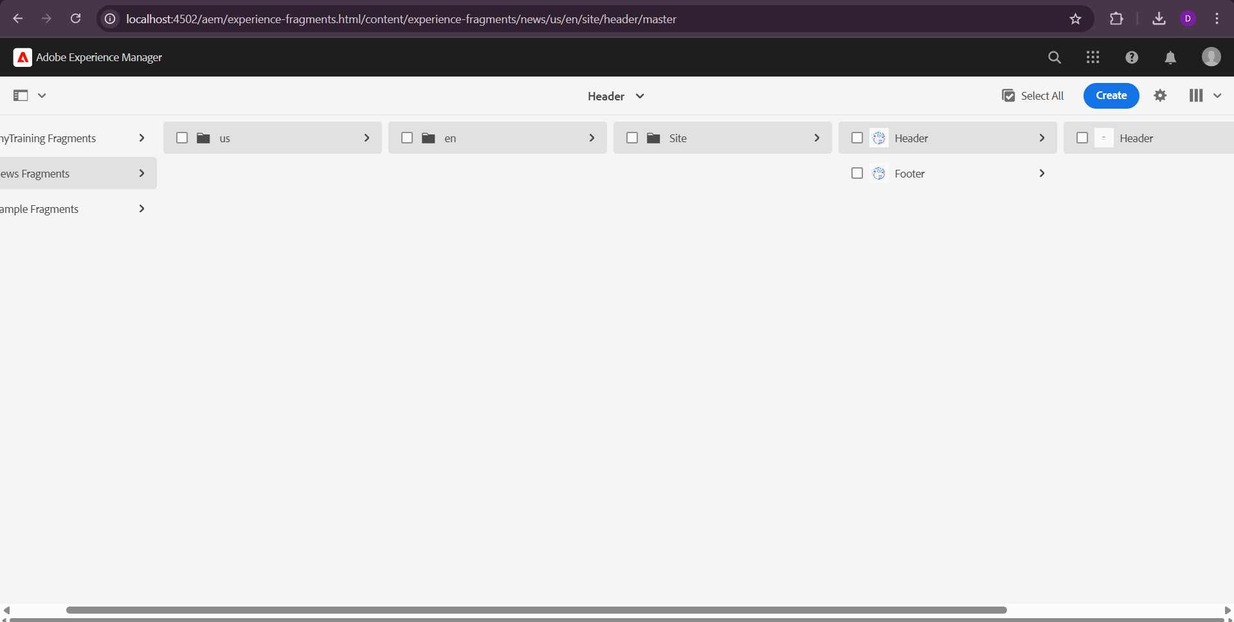



**On clicking the dropdowns we can navigate to the respective pages:**

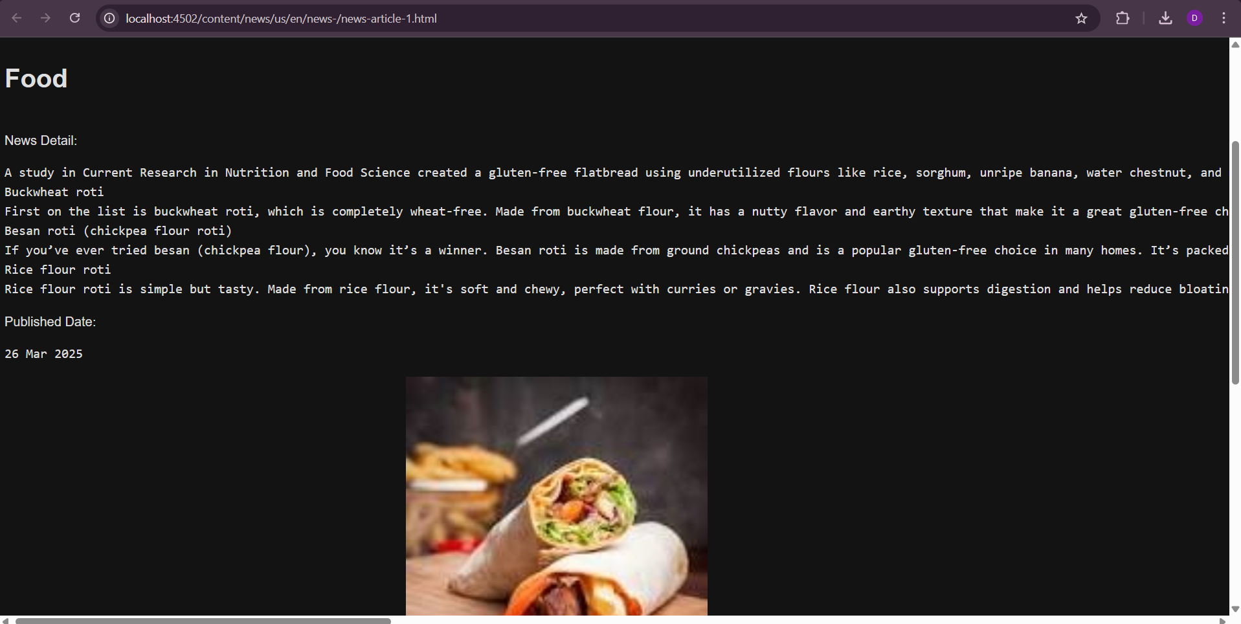

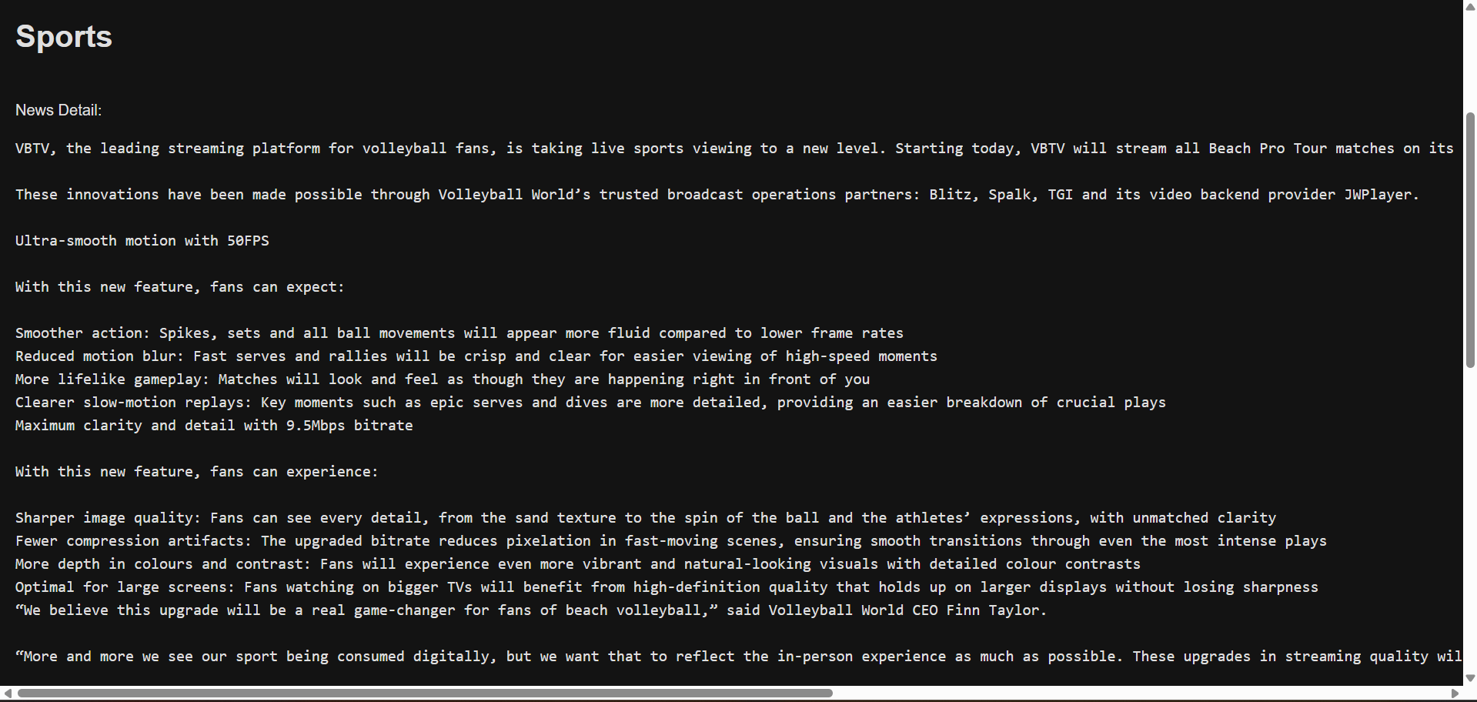

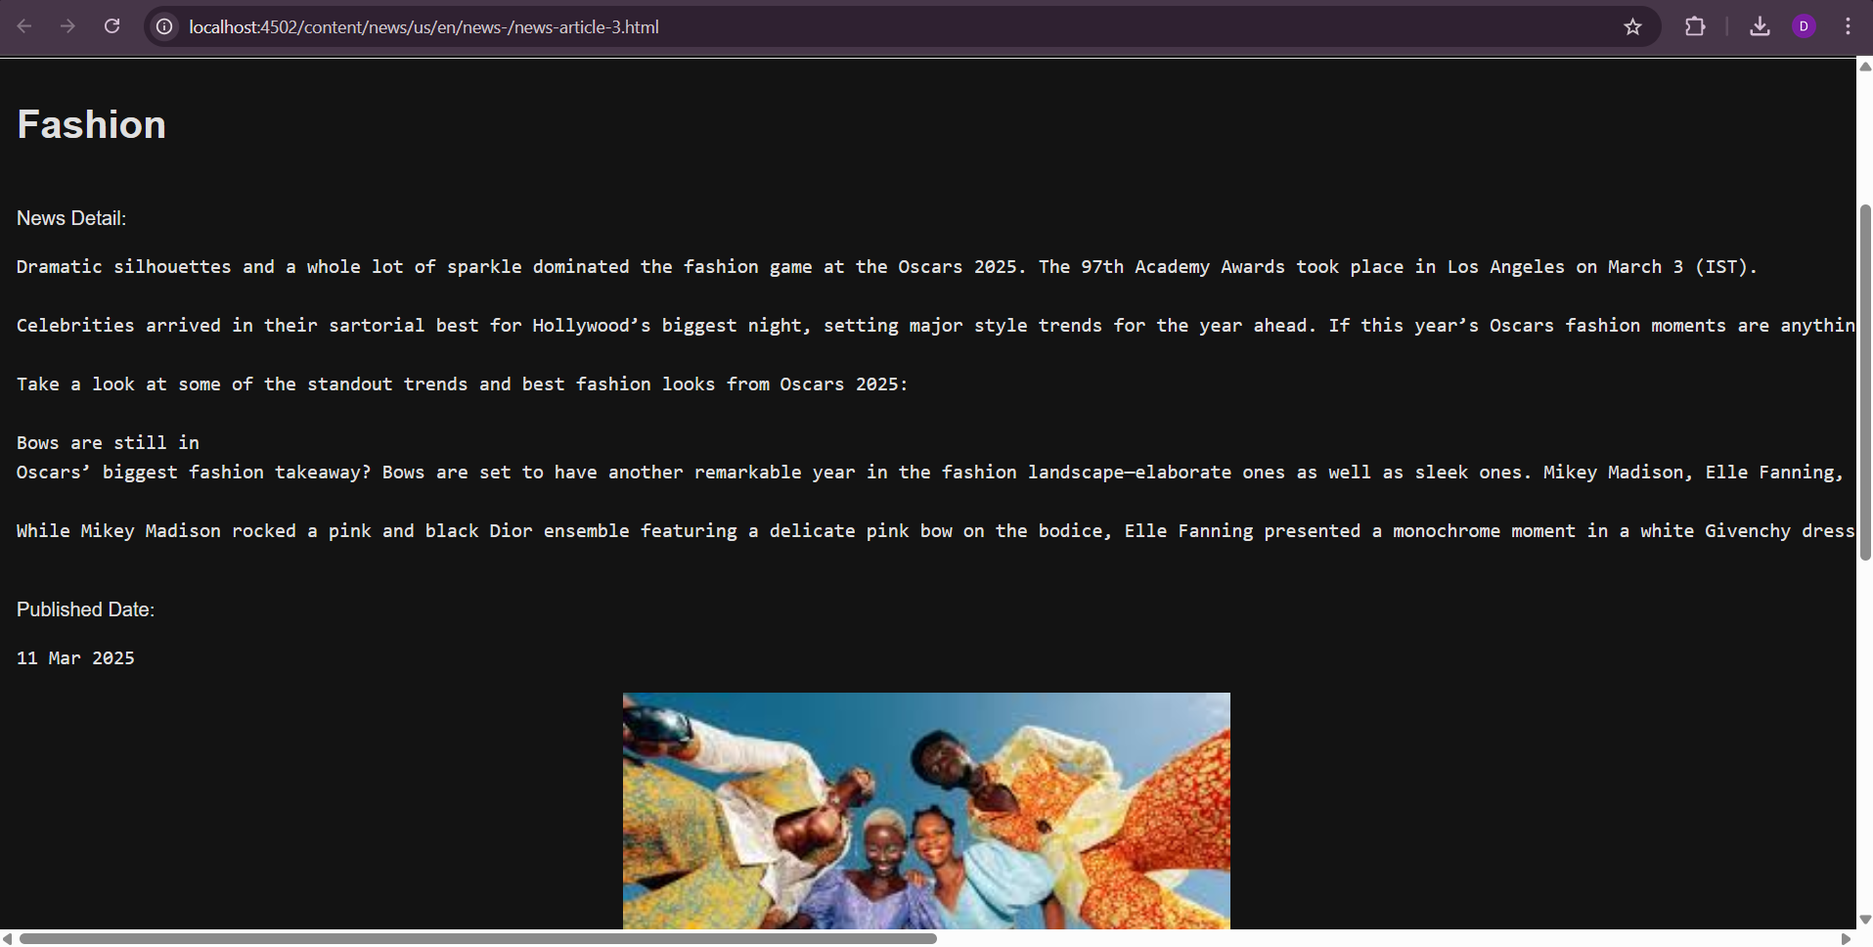

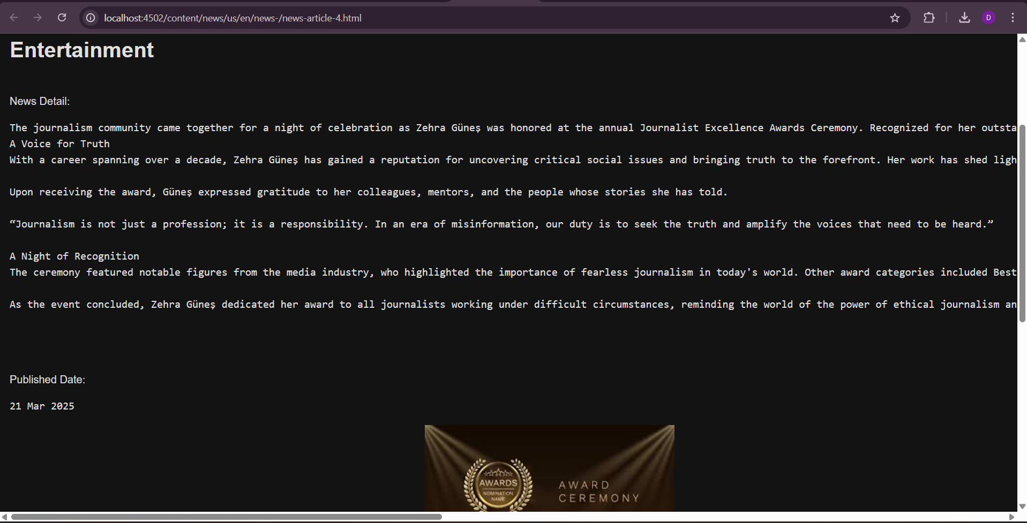

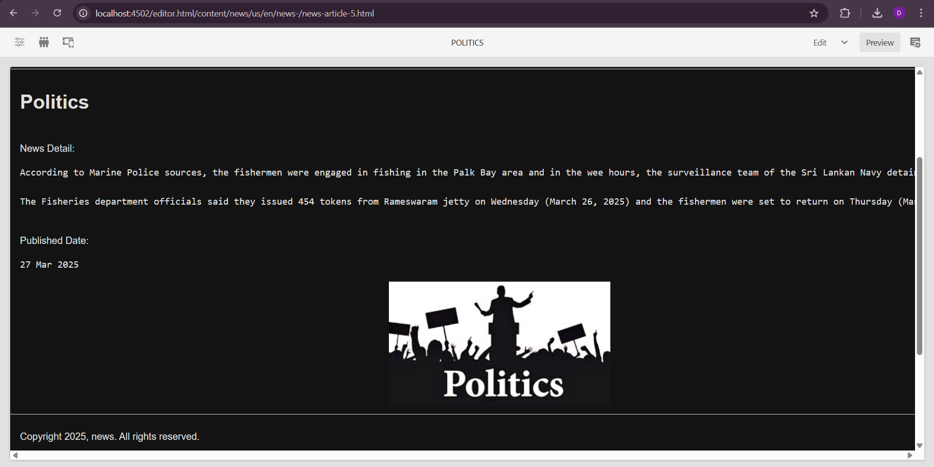

**2. Footer sections: About me, contact me, the latest 5 news-lists with hyperlinks should be opened in a new tab, and social media section.(The footer should be used at the template level, so every page can use them).**

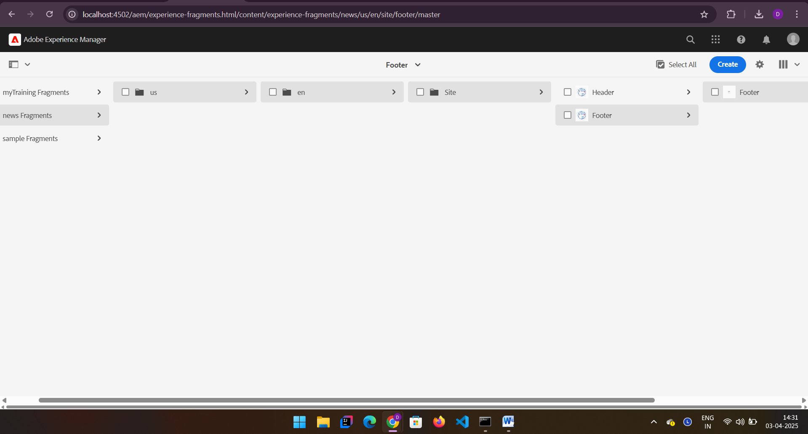

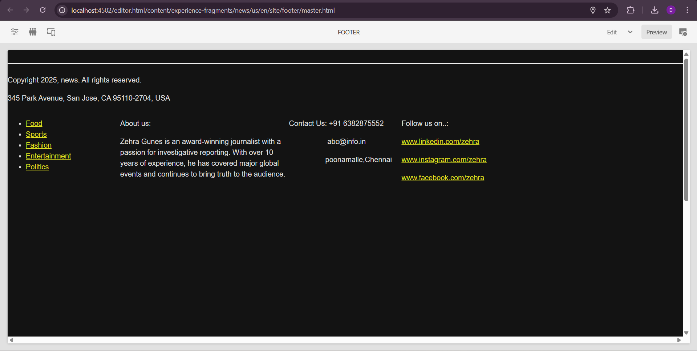

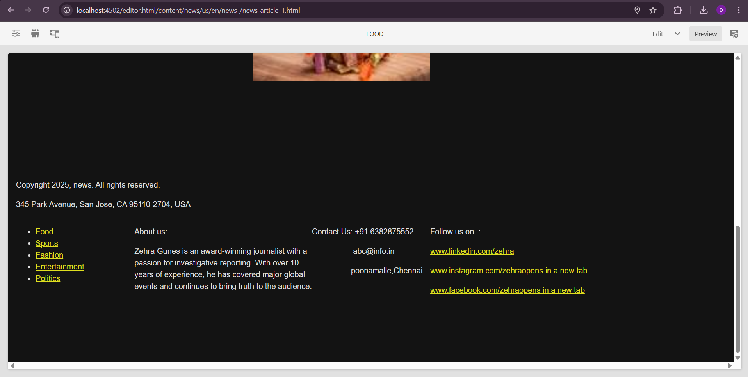

**3. Homepage: Use a teaser component to display some award ceremony for journalists so that it can have an image, title, some description, and a CTA (which will link to that page where the user can use the entire news for that award. The page will be created and authored in CTA).**

Go to AEM Start Page → Navigation > Sites > news

Create Page > Homepage

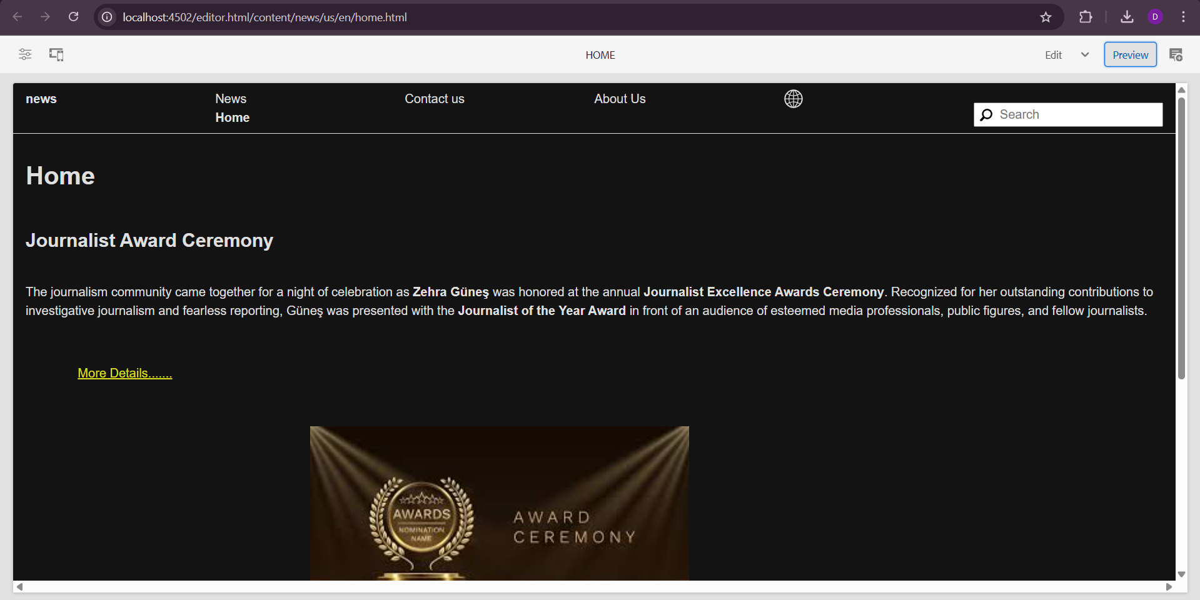

**If I clicked more details it goes to entertainment page:**

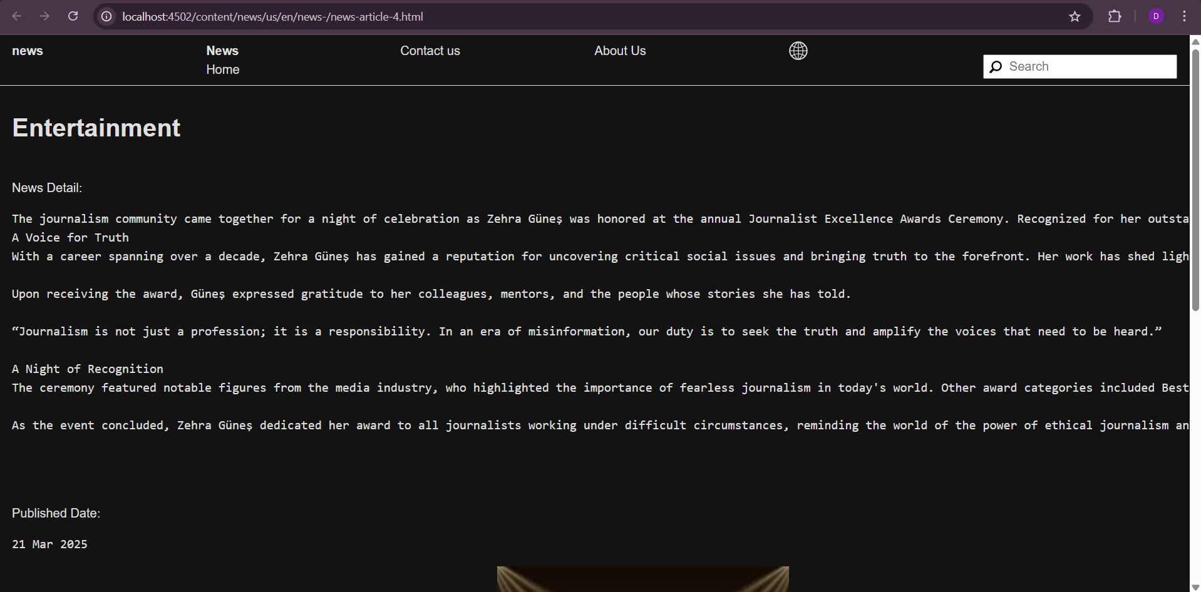

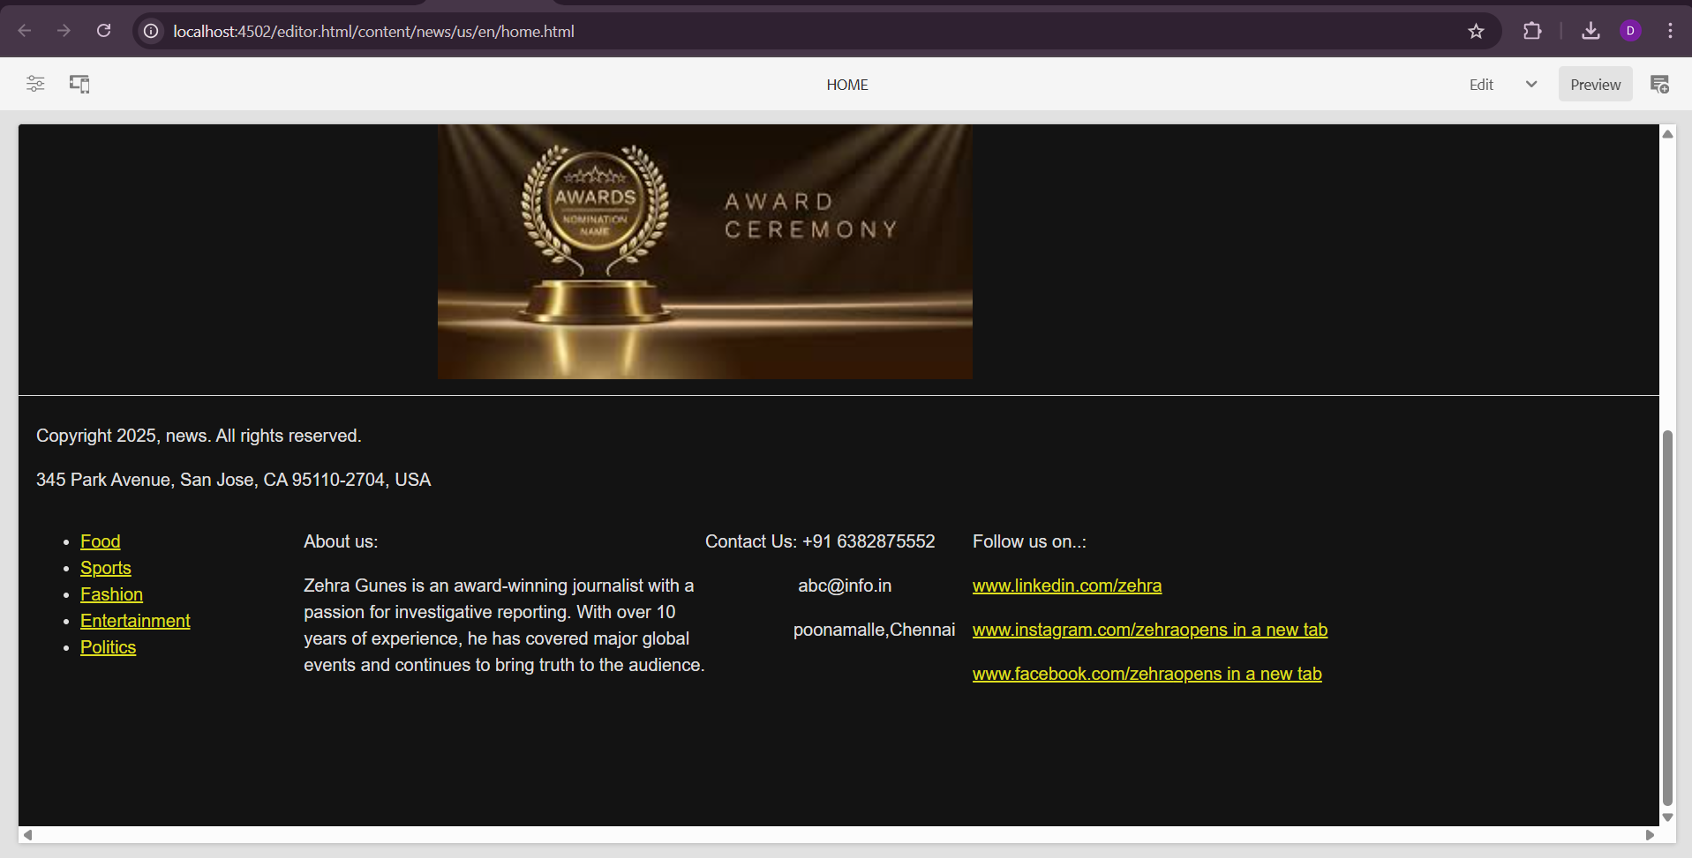

**4. News page: Create a NewsRoom component which will get the News page as parent path (news page should be authored). This component should fetch all the news created under the /contact/news folder and make sure all the books should be placed under the /content/news folder. Create news article pages under /content/news hierarchy and author the page with title, image, and text component, so that when the NewsRoom component is authored, it fetches these properties from each page to show on the news page as cards. Each card should have Title, news details, and image, and make sure each card has a unique title, description, and image.**

NewsRoomModel.java

package com.news.core.models;

import com.adobe.cq.sightly.WCMUsePojo;

import com.day.cq.wcm.api.Page;

import com.day.cq.wcm.api.PageManager;

import org.apache.sling.api.resource.Resource;

import org.apache.sling.models.annotations.DefaultInjectionStrategy;

import org.apache.sling.models.annotations.Model;

import org.apache.sling.models.annotations.injectorspecific.Self;

import javax.inject.Inject;

import java.util.ArrayList;

import java.util.Iterator;

import java.util.List;

@Model(adaptables =Resource.class, defaultInjectionStrategy = DefaultInjectionStrategy.OPTIONAL)

public class NewsRoomModel {

@Self private Resource resource;

public List getNewsArticles() {

List newsList = new ArrayList<>();

PageManager pageManager =

resource.getResourceResolver().adaptTo(PageManager.class);

Page newsPage = pageManager.getPage("/content/news");

if (newsPage != null) {

for (Iterator it = newsPage.listChildren(); it.hasNext();

)

{

Page articlePage = it.next();

String title = articlePage.getTitle();

String description = articlePage.getProperties().get("jcr:description", String.class);

String imagePath = articlePage.getContentResource().getChild("image").getValueMap().get("fileReference", String.class);

String link = articlePage.getPath() + ".html";

newsList.add(new NewsArticle(title, description, imagePath, link));

} }

return newsList;

}

public static class NewsArticle {

private final String link;

private final String title;

private final String image;

private final String description public NewsArticle(String title, String link, String image, String description) { this.link = link;

this.title = title;

this.image = image;

this.description = description;

}

public String getLink() {

return link;

}

public String getTitle() {

return title;

}

public String getImage() { return image; }

public String getDescription() { return description; }

} }

**Newsroom.html**

**newsroom.html:**

<div class="newsroom">

<div class="news-list">

<sly data-sly-use.newsroomModel="com.yourproject.core.models.NewsroomModel">

<sly data-sly-list.news="${newsroomModel.newsArticles}">

<div class="news-card">

<h2 class="news-title">${news.title}</h2>

<a href="${news.link}" target="_blank" class="read-more">Read More</a>

<img src="${news.image}" alt="${news.title}" class="news-image">

<p class="news-detail">${news.description}</p>

</div>

</sly>

</sly>

</div>

</div>

**.content.xml:**

<?xml version="1.0" encoding="UTF-8"?>

<jcr:root xmlns:sling=["http://sling.apache.org/jcr/sling/1.0"](http://sling.apache.org/jcr/sling/1.0) xmlns:cq=["http://www.day.com/jcr/cq/1.0"](http://www.day.com/jcr/cq/1.0) jcr:primaryType="cq:Component" jcr:title="NewsRoom"

sling:resourceSuperType="core/wcm/components/container/v1/container" componentGroup="news - General"/>

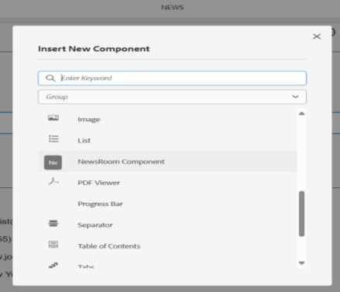

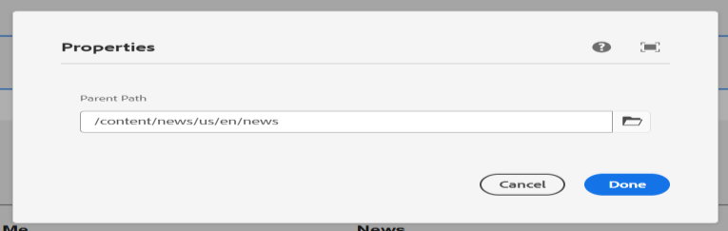

**5. About me page: Use the journalist component to provide some information about journalists. Only this component should be used on this page.**

Path: apps/NewsroomPortfolio/components/journalist

**.content.xml**

<?xml version="1.0" encoding="UTF-8"?>

<jcr:root xmlns:sling=["http://sling.apache.org/jcr/sling/1.0"](http://sling.apache.org/jcr/sling/1.0) xmlns:cq=["http://www.day.com/jcr/cq/1.0"](http://www.day.com/jcr/cq/1.0) jcr:primaryType="cq:Component" jcr:title="Journalist Component" componentGroup="news - General"/>

**JournalistModel.java:**

package com.yourproject.core.models;

import org.apache.sling.api.resource.Resource;

import org.apache.sling.models.annotations.DefaultInjectionStrategy; import org.apache.sling.models.annotations.Model;

import javax.inject.Inject;

@Model(adaptables = Resource.class, defaultInjectionStrategy = DefaultInjectionStrategy.OPTIONAL)

public class JournalistModel { @Inject

private String name; @Inject

private String bio; @Inject

private String image;

public String getName() { return name; } public String getBio() { return bio; } public String getImage() { return image; }

}

**journalist.html:**

<div class="journalist-profile">

<sly data-sly-use.model="com.yourproject.core.models.JournalistModel"/>

<div class="journalist-container">

<img src="${model.image}" alt="Journalist Image"/>

<h2>${model.name}</h2>

<p>${model.bio}</p>

</div>

</div>

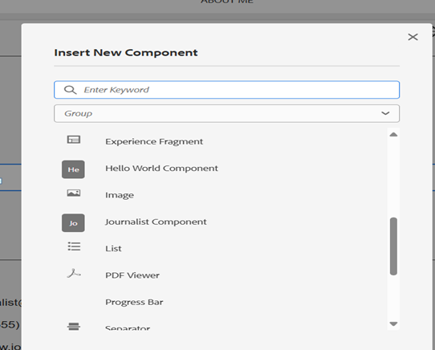

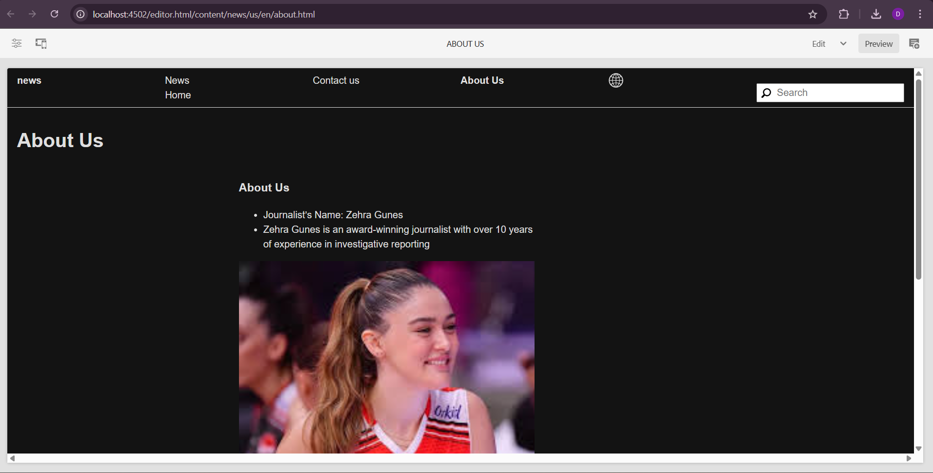

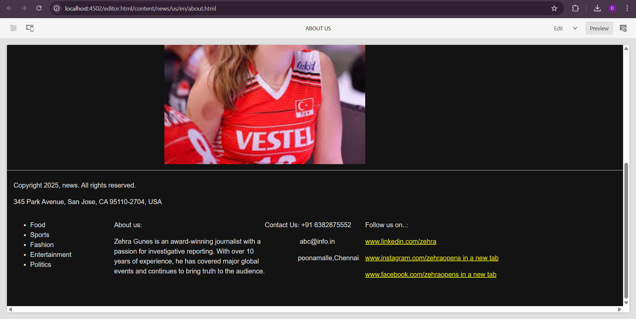

**6. Contact me page: Use text or teaser components to provide contact details to connect with the author or some social media profile links, so anybody can follow him on social media platforms.**

