Bus Ticket Booking Application

Introduction:

The “Bus Ticket Booking Application” is a JavaFX-based software solution designed to book a bus ticket. In this application provides users with a user-friendly interface to input their personal details. Online bus ticket booking platforms leverage cutting-edge technology to provide a hassle-free experience, enabling users to browse routes, select preferred seats, and make secure payments-all from the comfort of their homes.

Purpose:

The purpose of online bus ticket booking encompasses a range of advantages for both passengers and bus operators. This digital innovation serves multiple key purposes, contributing to the efficiency, convenience, and overall enhancement of the bus travel experience.

Key Features:

* User-Friendly Interface:

An intuitive and easy-to-navigate interface that allows users to quickly search for routes, view schedules, and book tickets seamlessly.

* Booking Confirmation and E-Tickets:

Instant confirmation of bookings and the issuance of electronic tickets (e-tickets) that users can conveniently access on their devices.

* Real-Time Availability and Schedules:

Live updates on seat availability, current schedules, and any changes or delays, allowing users to make informed decisions.

* Travel Alerts and Notifications:

Automated alerts and notifications via email or SMS to keep passengers informed about their booking status, departure times, and any changes to the schedule.

Target Audience:

The target audience for online bus ticket booking platforms is diverse, encompassing a broad range of individuals with varied travel needs and preferences. The platform caters to both domestic and international travelers seeking convenient and efficient ways to plan and secure their bus journeys. The primary target audience includes.

Future Enhancements:

1. Enhanced User Experience:

* Hyper-personalized booking: AI-powered recommendations based on travel history, preferences, and real-time data (traffic, weather) to suggest optimal routes, schedules, and even travel packages.
* Immersive virtual tours: 3D bus interiors and virtual reality tours of stops and destinations to help passengers make informed choices.
* Seamless multi-modal integration: Booking connecting flights, trains, or rental cars within the bus ticket booking platform, creating a smooth journey from door to door.

2. Smarter Booking and Travel Management:

* Dynamic pricing: AI-driven adjustments to ticket prices based on real-time demand and availability, potentially offering last-minute deals or surge pricing during peak travel times.
* Live bus tracking: Real-time GPS tracking of buses on a map, allowing passengers to monitor their journey and plan accordingly.

3. Additional Value-Added Services:

* Onboard entertainment: Streaming movies, music, or ebooks directly on passengers' devices through the booking platform.
* Food and beverage pre-ordering: Ordering meals or snacks from local vendors for delivery directly to their seats.

Hardware Requirements:

* To cater to a diverse audience, the Online Voting System maintains modest hardware requirements:
* Personal Computer or Laptop - Minimum 2GB RAM
* Processor: Dual-core or higher
* Display: 1024x768 resolution or higher
* Internet Connection

Software Requirements:

* The seamless operation of the Online Voting System relies on a set of essential software components:
* Java Development Kit (JDK) 8 or later
* Integrated Development Environment (IDE) – e.g., Eclipse, IntelliJ IDEA
* JavaFX library
* Operating System: Windows, Linux, or macOS
* Internet Browser for testing and deployment

Project Scope:

1. Global Reach:

* Online bus ticket booking platforms have the potential to reach a global audience, enabling users to plan and book bus journeys not only within their countries but also across borders.

1. Integration with Multi-Modal Transportation:

* The scope extends to integrating bus ticket booking with other modes of transportation, creating a seamless experience for users who may combine buses with trains, flights, or rideshare services.

1. Market Expansion and New Routes:

* The continuous growth of online booking platforms opens up opportunities for bus operators to explore and introduce new routes, catering to emerging travel demands and connecting previously underserved regions.

1. Innovative Payment Solutions:

* The scope includes the exploration of innovative payment solutions, such as cryptocurrency, mobile wallets, and other emerging financial technologies, to offer users more diverse and secure payment options.

1. Smart Transportation Hubs:

* Integration with smart transportation hubs and terminals, creating a network where users can seamlessly transition between different modes of transportation while utilizing a single online platform for bookings.

1. Enhanced Customer Experience:

* The scope involves continuous efforts to enhance the overall customer experience through user-friendly interfaces, personalized recommendations, and responsive customer support services.

1. Accessibility and Inclusivity:

* Efforts to make online bus ticket booking more accessible and inclusive by catering to users with diverse needs, including those with disabilities, and providing multilingual support.

1. Environmental Sustainability:

* The scope extends to promoting and integrating eco-friendly practices, such as carbon footprint awareness, to align with the growing demand for sustainable and responsible travel choices.

In summary, The scope of online bus ticket booking is vast and dynamic, driven by technological advancements and evolving consumer expectations. It encompasses a global reach, allowing users to plan and book bus journeys across borders. Integration with multi-modal transportation provides a comprehensive travel solution. Platforms contribute to market expansion by facilitating new routes and connecting underserved regions.

Innovative payment solutions, including cryptocurrency and mobile wallets, are explored for secure and diverse payment options. Smart transportation hubs enable seamless transitions between different modes of transportation through a single online platform. Ongoing efforts focus on enhancing the customer experience with user-friendly interfaces, personalized recommendations, and responsive customer support.

Algorithm:

1. Initialize the GUI:

* Create the main stage for the JavaFX application.
* Set up the layout, labels, text fields, date picker, combo box, and buttons.

1. User Input:

* Allow the user to input the following information:
* Origin (fromTextField)
* Destination (toTextField)
* Date of travel (datePicker)
* Seat selection (seatComboBox)

1. Validate Input:

* Ensure that the necessary fields are not empty.
* Validate the date format and ensure it is not in the past.

1. Book Ticket Button Action:

* When the "Book Ticket" button is pressed:
* Retrieve the values entered by the user (fromTextField, toTextField, datePicker, seatComboBox).
* Validate the input to ensure it is valid.
* If the input is valid, proceed to the next steps. Otherwise, show an error message.

1. Store Booking Information:

* Simulate the process of storing the booking information. In a real-world application, this would involve:
* Connecting to a database.
* Inserting a new record with the booking details (origin, destination, date, seat) into a 'Bookings' table.

1. Display Confirmation:

* Display a confirmation message to the user indicating that the ticket has been booked successfully.

1. Optional: Integration with Database:

* If you are working with a database, establish a connection to it.
* Write SQL queries to insert the booking information into the database.

This algorithm provides a concise gudide to the essential steps involved in the javaFX code for the bus ticket booking system.fell free to adapt and extend it based on your specific project requirements

Source code:

import javafx.application.Application;

import javafx.scene.Scene;

import javafx.scene.control.\*;

import javafx.scene.layout.GridPane;

import javafx.stage.Stage;

public class BusTicketBookingApp extends Application {

public static void main(String[] args) {

launch(args);

}

@Override

public void start(Stage primaryStage) {

primaryStage.setTitle("Bus Ticket Booking");

GridPane grid = new GridPane();

grid.setHgap(10);

grid.setVgap(10);

Label fromLabel = new Label("From:");

TextField fromTextField = new TextField();

Label toLabel = new Label("To:");

TextField toTextField = new TextField();

Label dateLabel = new Label("Date:");

DatePicker datePicker = new DatePicker();

Label seatLabel = new Label("Select Seat:");

ComboBox<String> seatComboBox = new ComboBox<>();

seatComboBox.getItems().addAll("A1", "A2", "B1", "B2", "C1", "C2");

Button bookButton = new Button("Book Ticket");

bookButton.setOnAction(e -> {

String from = fromTextField.getText();

String to = toTextField.getText();

String date = datePicker.getValue().toString();

String selectedSeat = seatComboBox.getValue();

// Implement logic to book the ticket (e.g., store in a database)

// This is a simplified example; in a real application, you'd connect to a database

System.out.println("Ticket booked from " + from + " to " + to + " on " + date + " for seat " + selectedSeat);

});

grid.add(fromLabel, 0, 0);

grid.add(fromTextField, 1, 0);

grid.add(toLabel, 0, 1);

grid.add(toTextField, 1, 1);

grid.add(dateLabel, 0, 2);

grid.add(datePicker, 1, 2);

grid.add(seatLabel, 0, 3);

grid.add(seatComboBox, 1, 3);

grid.add(bookButton, 1, 4);

Scene scene = new Scene(grid, 300, 200);

primaryStage.setScene(scene);

primaryStage.show();

}

}

Sample output:

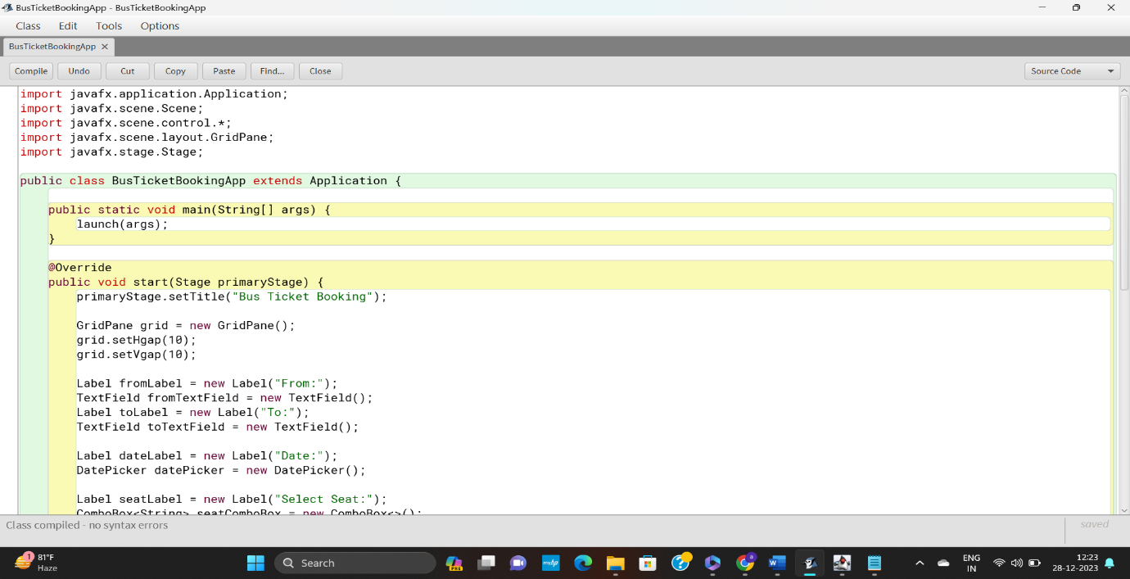

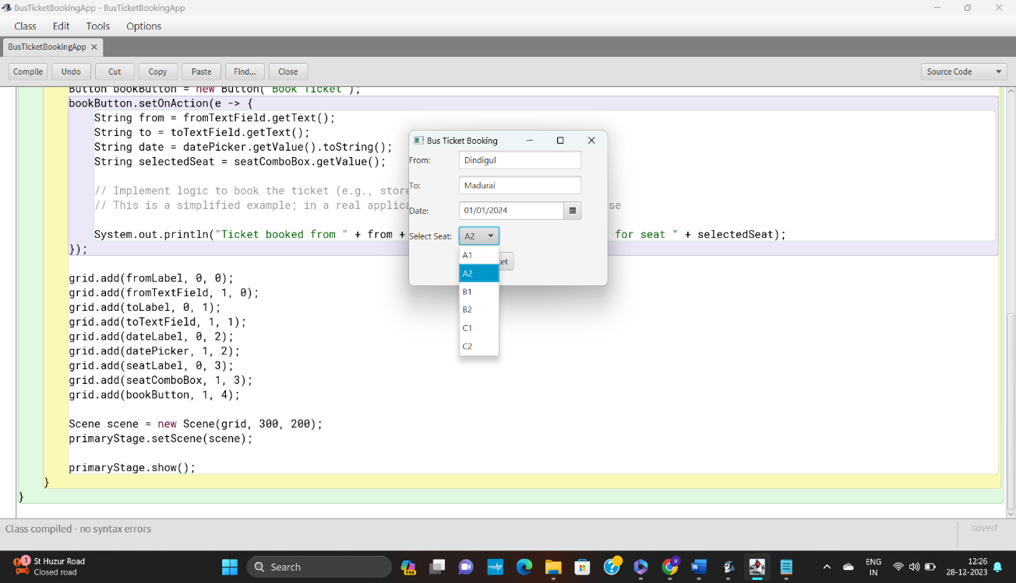

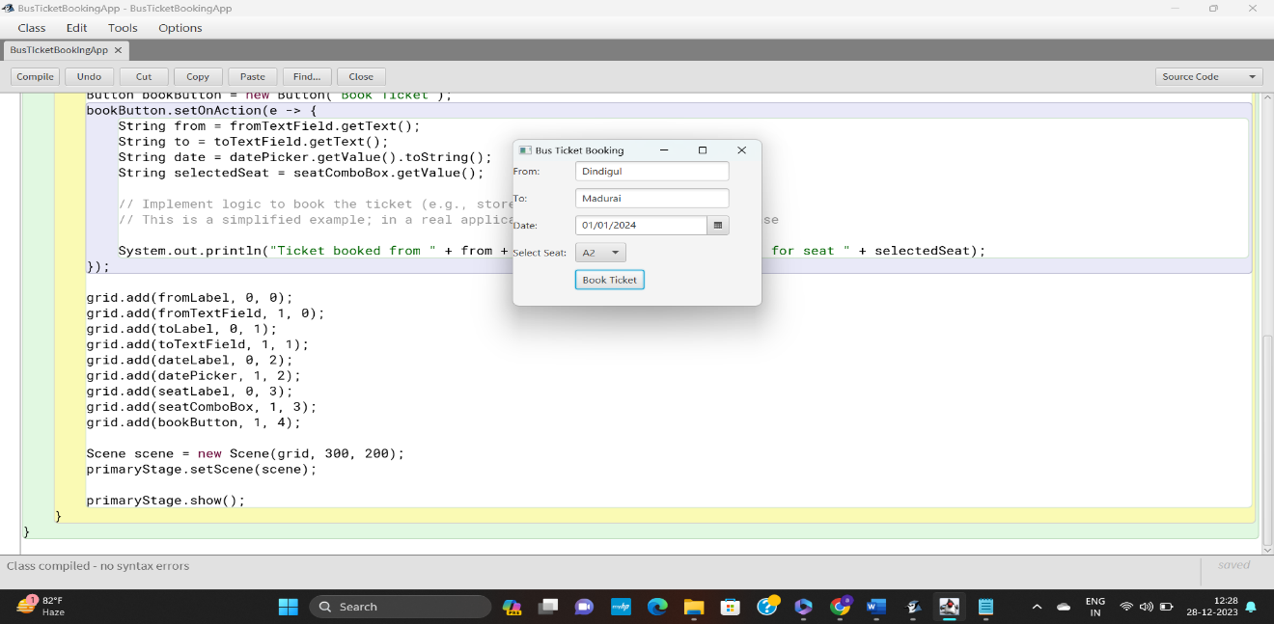

Overview:

The online bus ticket booking program implemented in JavaFX is designed to provide users with a simple interface for booking bus tickets. This program operates on a desktop application using JavaFX, allowing users to input details such as the origin, destination, date of travel, and seat selection. Below is an overview of the main components and functionalities of the program:

Key components:

1. Main Stage:

* The primary window that serves as the main interface for users to interact with the application.

1. Labels:

* Interface elements that provide descriptive text for input fields, such as "From," "To," "Date," and "Select Seat."

1. Text Fields:

* Input fields where users can enter information, such as the origin (fromTextField) and destination (toTextField).

1. Date Picker:

* A date selection widget (datePicker) that allows users to choose the travel date.

1. Combo Box:

* A dropdown list (seatComboBox) from which users can select their preferred seats.

1. Buttons:

* The "Book Ticket" button triggers the booking process, and additional buttons for potential actions.

Conclusion:

The bus ticket bookingApp demonstrates a functional implementation of bus ticket system. The application can further enhance its robustness and user experience

This report provides an overview of the application,highlights its strengths,identifies areas for improvement and offer recommendations for enhancement.