SOLAR ENERGY

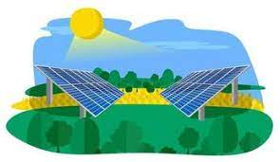

DONE BY

DHARUNPANDI S

92132213039

SOLAR ENERGY

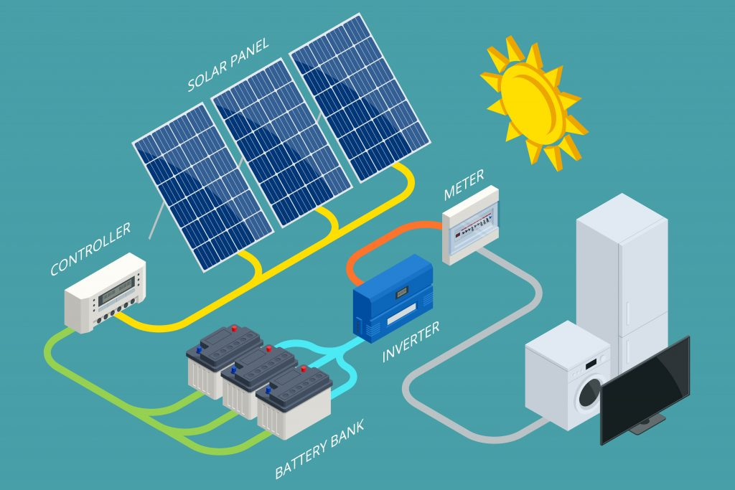

Introduction

* Solar energy is sunlight converted into electricity using solar panels.
* It's renewable, abundant, and environmentally friendly.
* This project explores how solar energy works and its benefits.

How Solar Energy Works

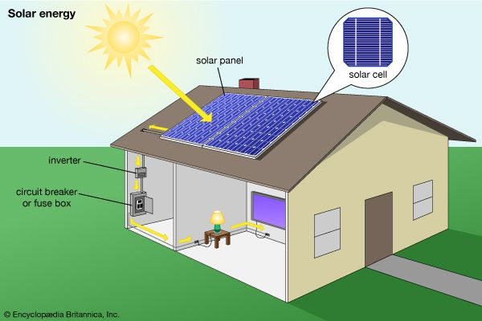

* Solar panels contain photovoltaic cells that convert sunlight into electricity.
* When sunlight hits these cells, it creates an electric current.
* This electricity can power homes, businesses, and even entire cities.

Advantages of Solar Energy

* Clean and renewable: It doesn't produce greenhouse gases or pollute the air.
* Cost-effective: Once installed, solar panels can provide free electricity for years.
* Low maintenance: Solar panels require minimal upkeep, reducing long-term costs.

Applications of Solar Energy

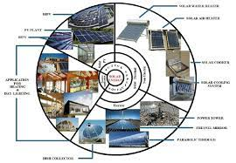

* Residential: Rooftop solar panels for homes to reduce electricity bills.
* Commercial: Solar farms generate large-scale electricity for businesses and communities.
* Off-grid: Remote areas can access electricity through solar-powered systems.

Challenges

* Intermittency: Solar energy production fluctuates based on weather and time of day.
* Energy storage: Storage solutions like batteries are needed to store excess energy for use during cloudy days or at night.
* Initial costs: While solar energy saves money in the long run, the upfront installation costs can be a barrier for some.

Future of Solar Energy

- Advancements in technology: Improvements in solar panel efficiency and storage solutions are making solar energy more reliable and accessible.

- Growing adoption: Governments and businesses worldwide are investing in solar energy to combat climate change and achieve energy independence.

- Potential for innovation: Research continues to explore new ways to harness solar energy more efficiently and sustainably.

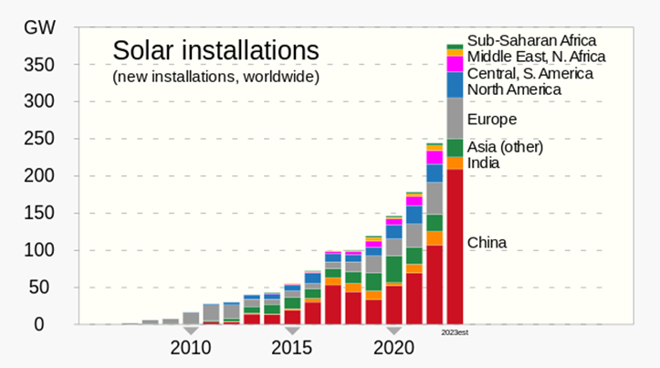

Useful Gadgets using Solar energy:

Solar-Powered Chargers:

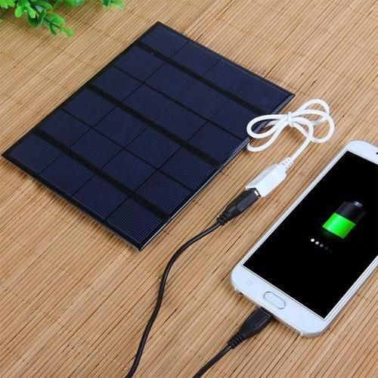

Solar chargers harness sunlight to charge devices like smartphones, tablets, cameras, and power banks. They are portable, making them ideal for outdoor activities such as hiking, camping, or traveling where access to electricity may be limited.

Solar-Powered Lights:

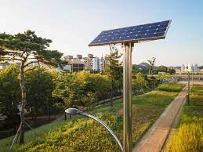

Solar-powered lights come in various forms, including garden lights, pathway lights, and outdoor security lights. They use solar panels to charge during the day and illuminate outdoor spaces at night, providing a sustainable and energy-efficient lighting solution.

Solar powered water purifiers

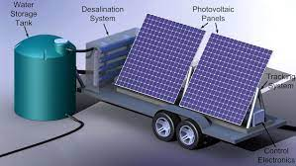

Solar water purifiers utilize sunlight to power the purification process, making them suitable for off-grid locations or areas with limited access to clean water. They can remove contaminants and pathogens from water, providing a reliable source of safe drinking water without relying on traditional electricity sources.

Stats about Solar Energy:

* Global Capacity (2020): Over 770 gigawatts (GW) of solar photovoltaic (PV) capacity installed worldwide.
* Cost Reduction (since 2010): Levelized cost of electricity (LCOE) from utility-scale solar PV projects decreased by over 80%.
* Employment (2019): Global solar PV industry employed over 3.8 million people.
* Emissions Reduction (2020): Solar PV systems avoided approximately 700 million tonnes of CO2 emissions.
* Investment (2020): Global investment in solar energy reached over $148 billion.
* Residential Adoption: Increasing numbers of homeowners are installing rooftop solar panels.
* Utility-Scale Projects: Large-scale solar projects contribute significantly to solar capacity growth worldwide.
* Decentralized Energy: Solar energy empowers communities, businesses, and individuals to generate their own electricity.
* Environmental Benefits: Solar energy produces minimal air and water pollution, reducing environmental impact.
* Energy Access: Solar energy provides electricity in remote and underserved areas.
* Economic Growth: Solar energy industry drives economic growth through job creation and investment opportunities.

