DAA Lab-2
Name- Dhathri Meda
Roll number – SE20UCSE040

Max and Min problem

When I tried with 6 elements-

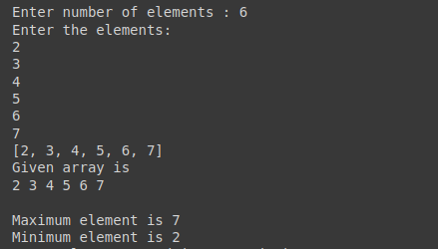

When I tried with larger number of elements to find time complexity-
