DAA Lab-3
Name- Dhathri Meda
Roll number – SE20UCSE040

Merge Sort

When I tried with 5 elements-
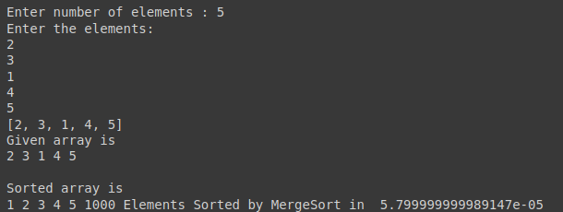

When I tried with larger number of elements to find time complexity-
