**Aim:** To understand the benefits of Cloud Infrastructure and Setup AWS Cloud9 IDE, Launch AWS Cloud9 IDE and Perform Collaboration Demonstration.

**Implementation and Output:**

Open the Amazon Web Services (AWS) home page. And Choose Create an AWS Account. Fill in appropriate information to complete sign up.

**Environment setup for AWS Cloud9**

**Step 1:** Open AWS click on Services and go to cloud9. Click on create environment and give the name to the environment, next step and create environment.

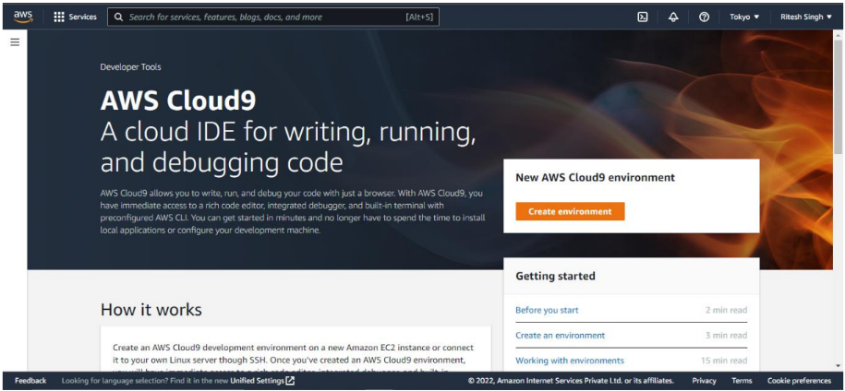

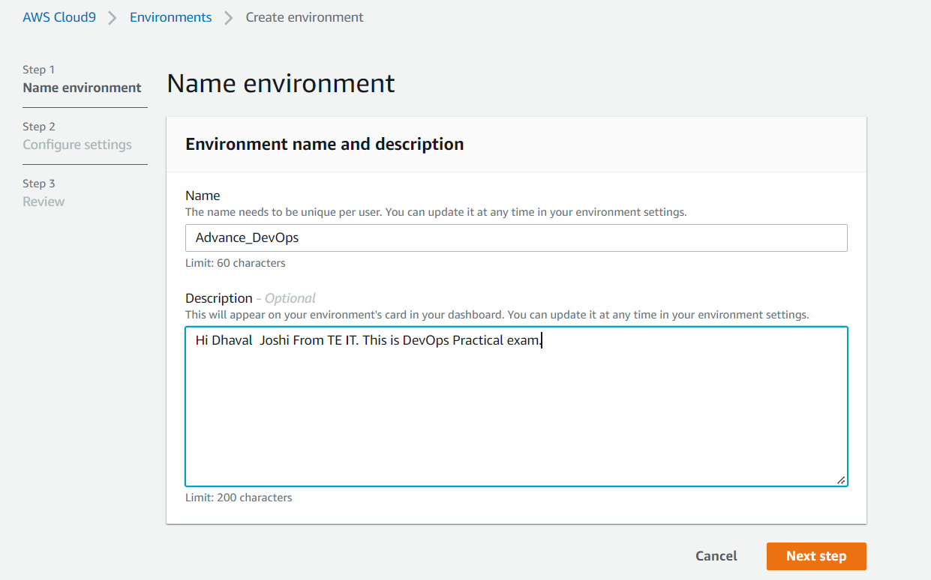

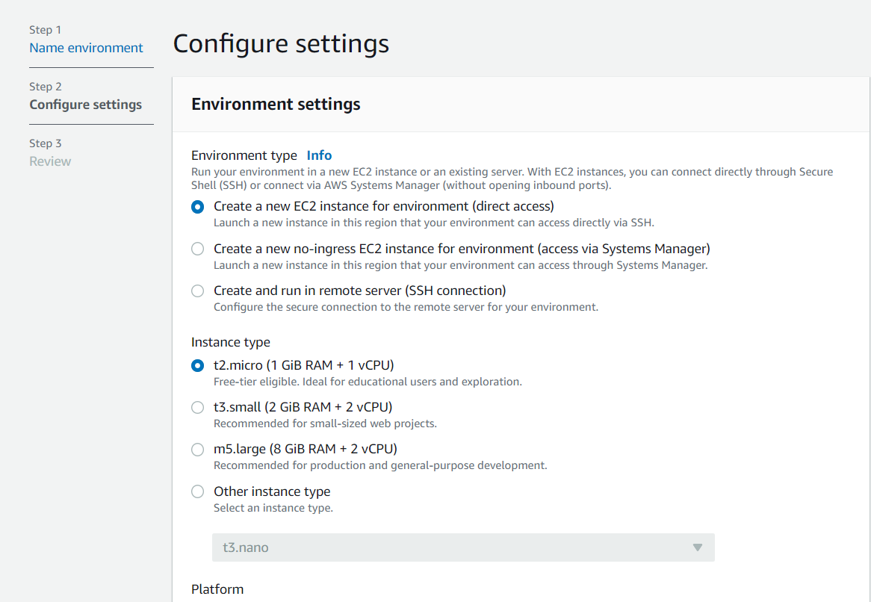

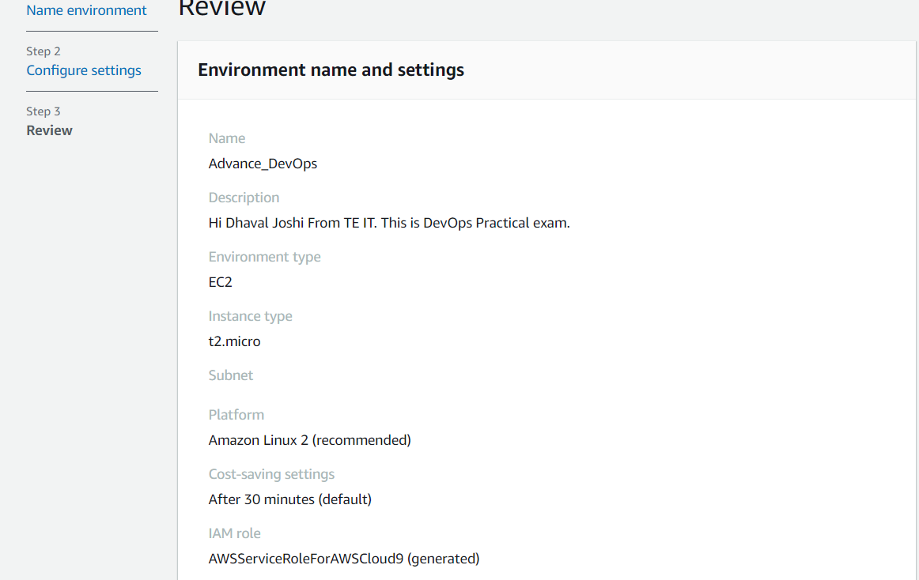

**Step 2:** Your AWS cloud9 environment will be displayed. (All integration will take place  here.)

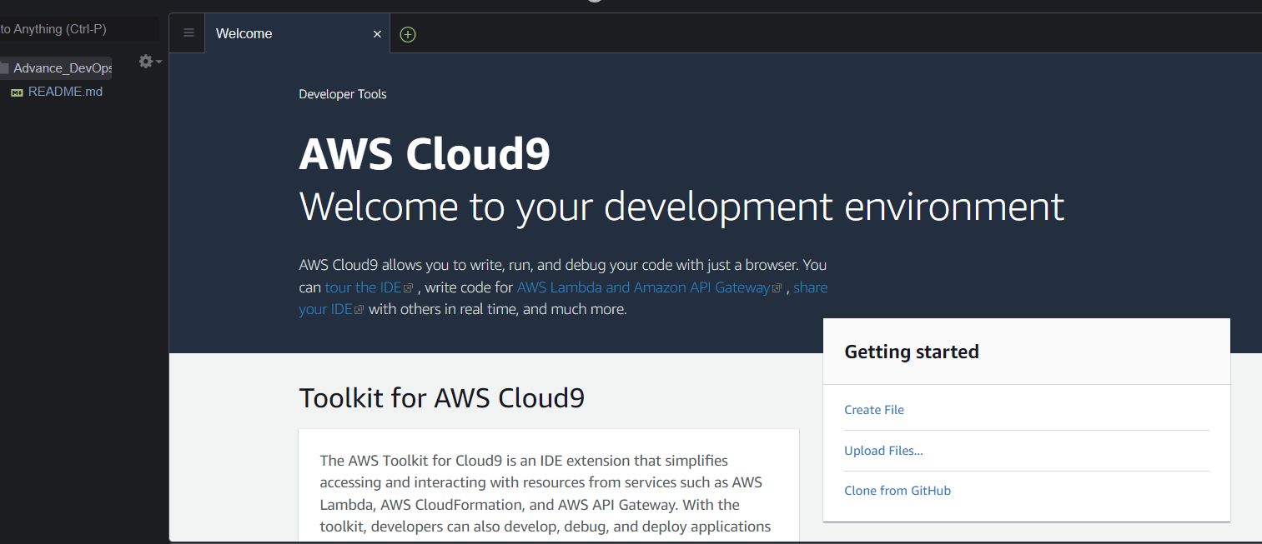

**Step 3:** Now We can write code

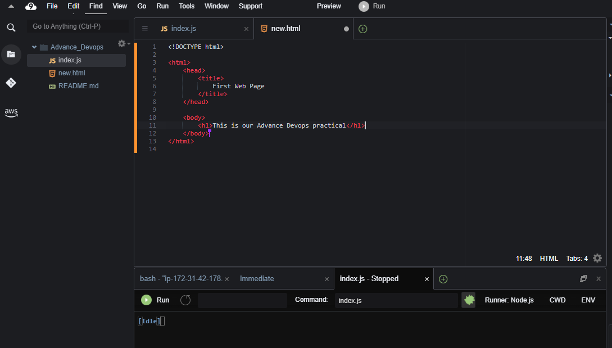

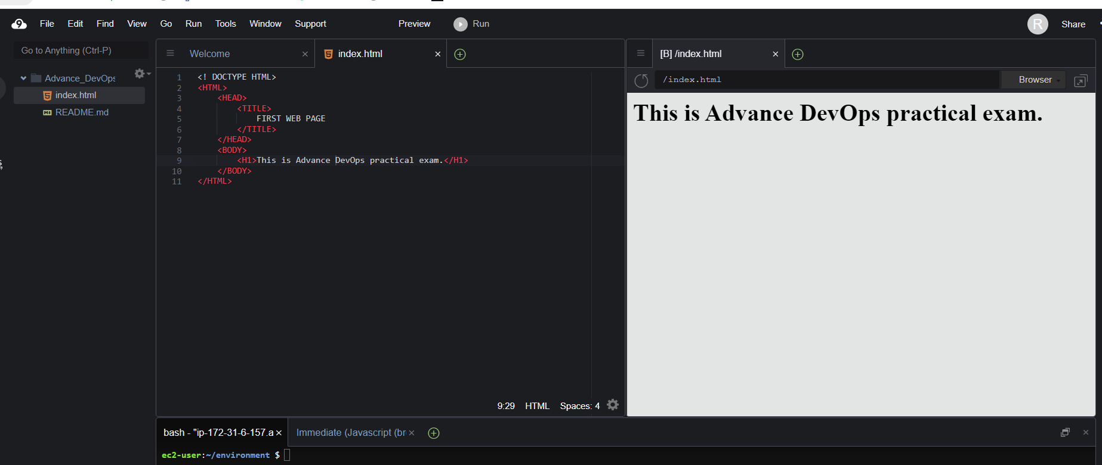

**To perform collaboration demonstration further steps are followed:-**

**Step 4 :-**  To create a new user you can create by clicking on share button and choosing to create a new user.

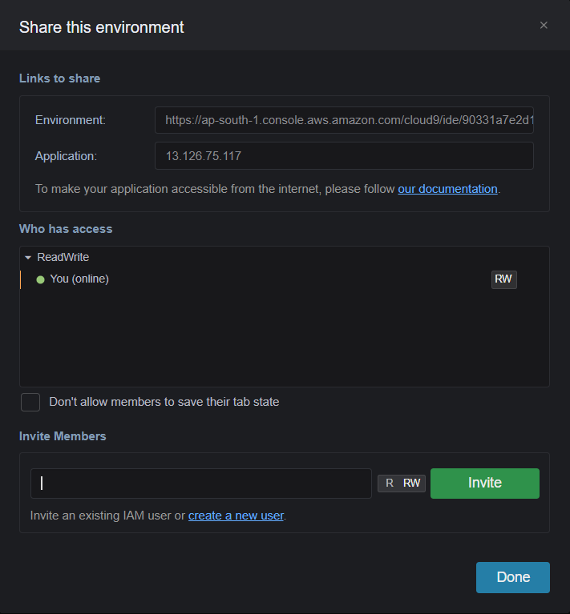

**Step 5:-** Give the username and select the appropriate checkboxes and then click next

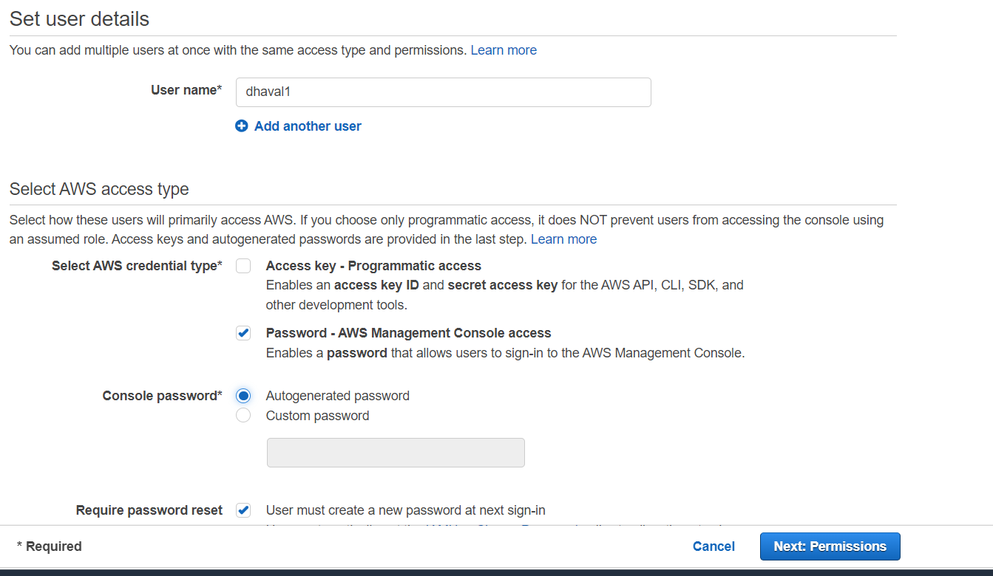

**Step 6 :-** Select the existing group or create a new group. And then click on create user. And select/ attach the policy (AWS CLOUD9 ENVIRONMENT MEMBER)

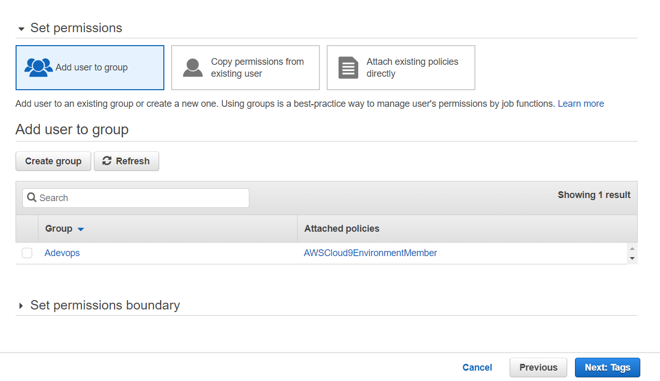

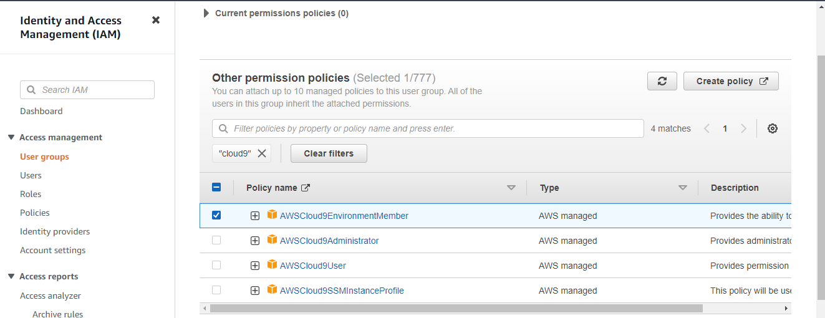

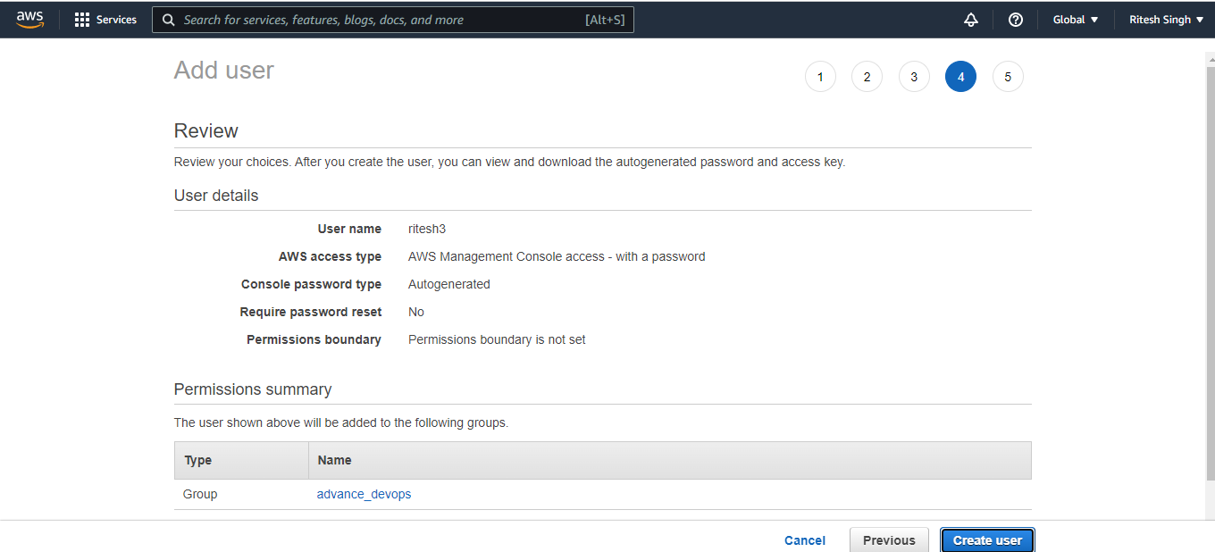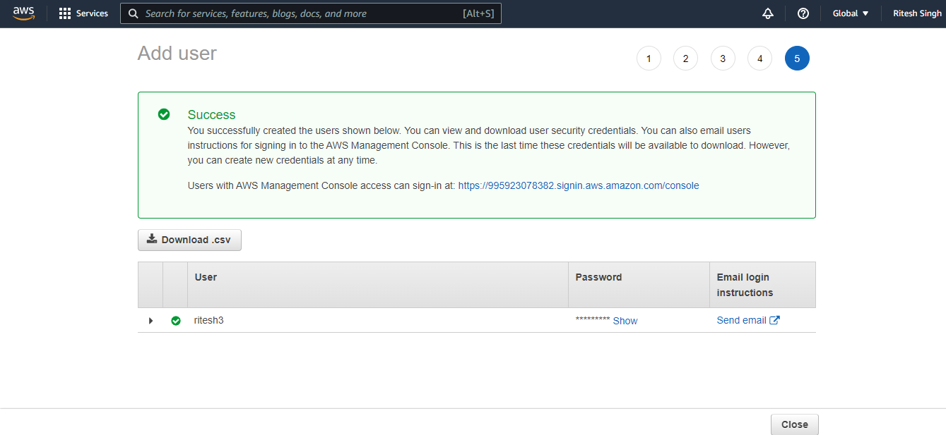

**Step 7 :-** The new user is added. Now carefully copy the password and paste it on your notepad and save it for future use.

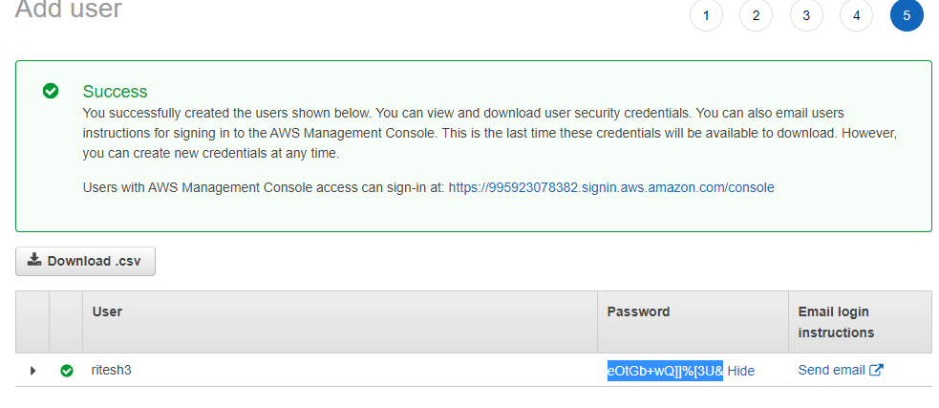

**Step 8 :-** Now copy the summary link from security credentials of the created user to login to console as a new user.

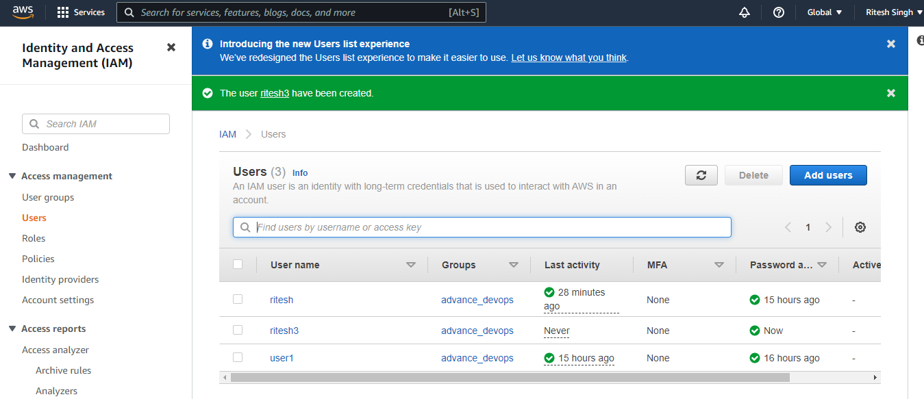

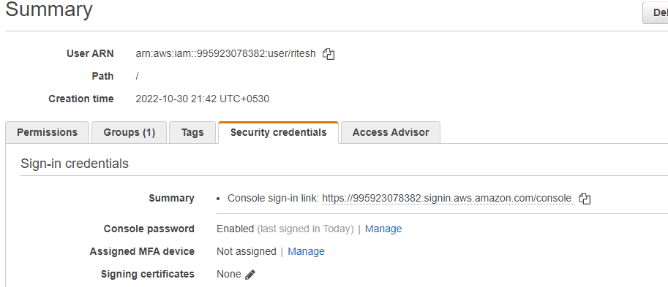

User pe click karne ka aur ye details aayega

**Step 9** :- Now open a new incognito tab and paste the link .

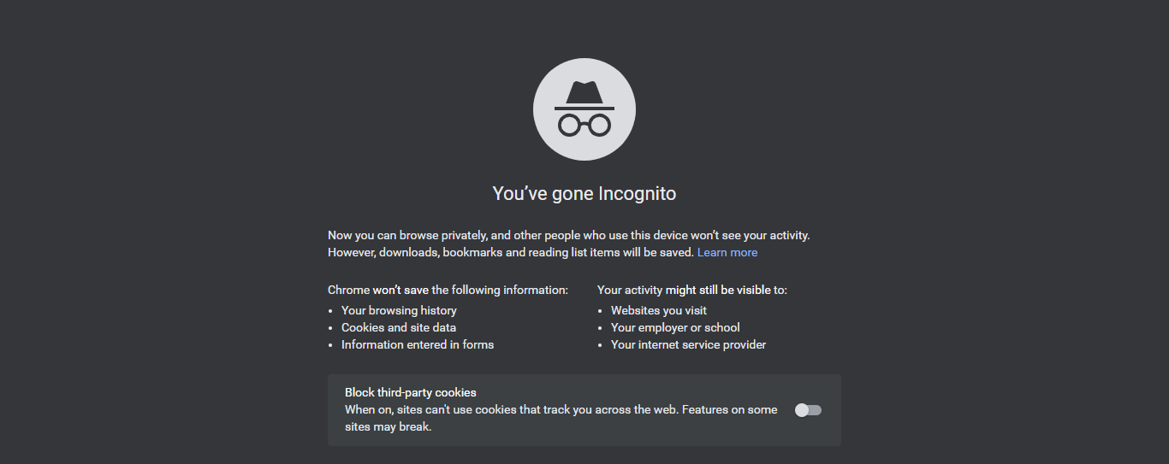

**Step 10 :-** Login to the AWS as IAM user credentials

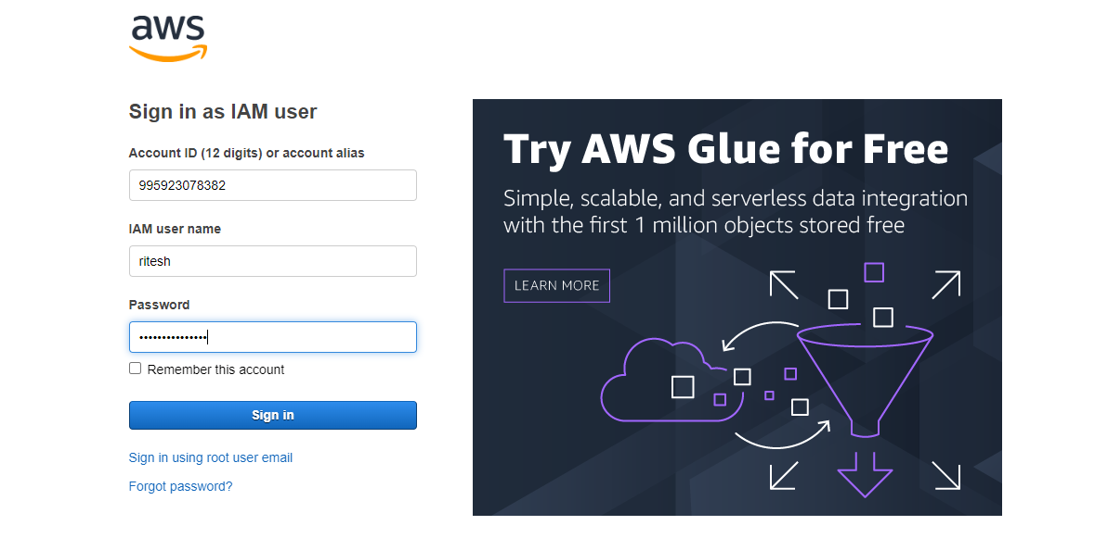

**Step 11 :-** Now Select on Cloud9 services and select Shared with you.

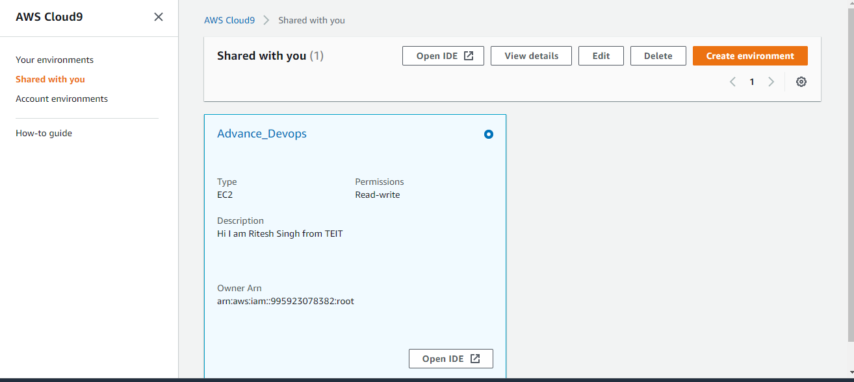

**Step 11:-** Now we have access to Cloud9 IDE as a user and from here we can make changes according to rights provided by the Root User as Read/Write.

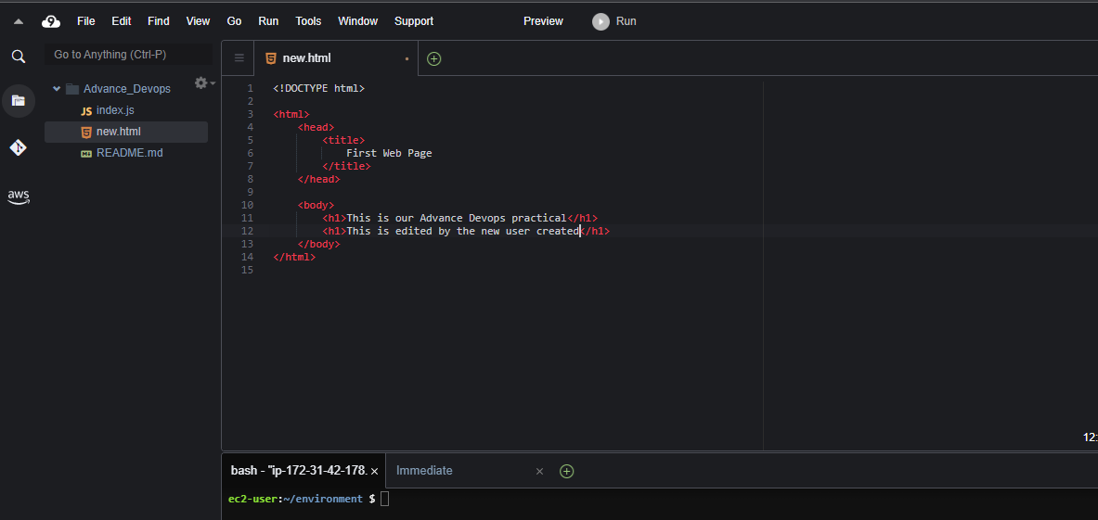

**Step 12:-** The changes which we make here will reflect to the root user at realtime.

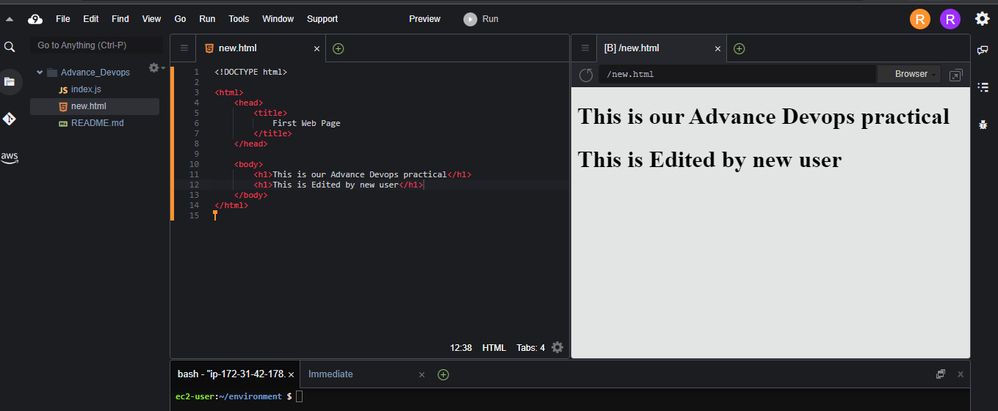

**Step 13:-** The changes is seen to the root user.

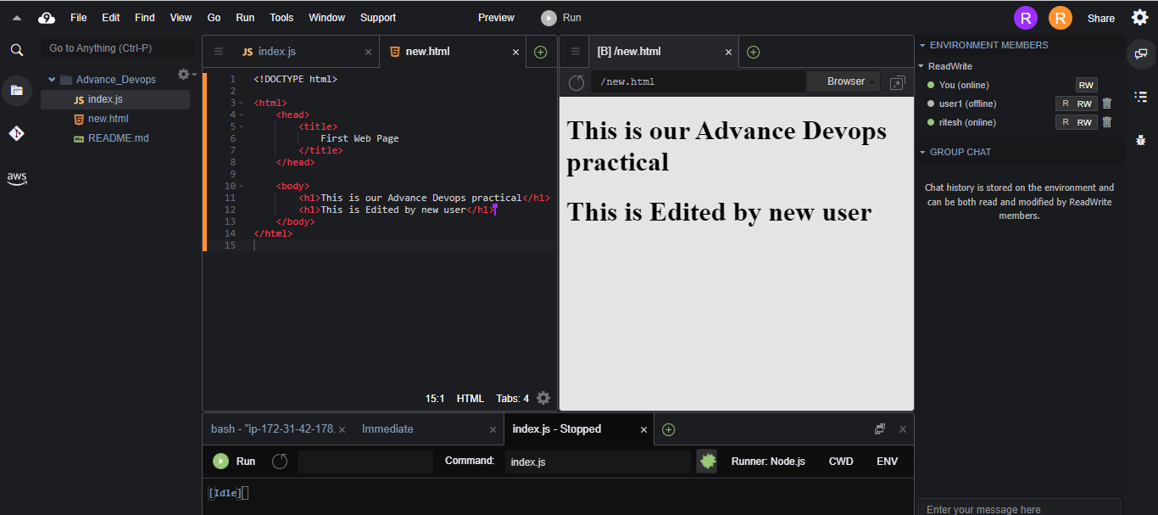

**Conclusion:**

Hence, we have understood the benefits of cloud infrastructure and setup AWS cloud9 IDE, launch  AWS cloud9 IDE and perform collaboration Demonstration.