**ISE 140 Term Project**

Operations Planning and Control



Submitted by: **Group 18**

Members: Dhaval Ajay Bhatt (13)

Juan Carlos Marquez (91)

Matthew John Triplett (148)

Sakshi Aggarwal (4)

Contents

1. Executive Summary 3

2. Introduction 3

3. Methods and Procedure 3

3.1 Forecast 3

3.2 Aggregate Plan 4

3.3 Material Required Planning 4

3.4 Capacity Plan and MPS 5

3.5 Scheduling 5

3.6 Promodel (simulation) 5

4. Results 5

5. Conclusions 6

6. References 6

7. Appendix 6

# Executive Summary

This report outlines the problems faced by Viking Division, a subsidiary of AK Enterprise and provides a solution to overcome them. The company is losing profits due to their patent expiration, a rise in competition in the market, and poor planning and forecasting techniques used in the production plan. The report predicts the sales figure for week 21-25 for Product 1, 2, 3 and 4. This forecast is used to make an aggregate plan to increase the profits and decrease the cost of operation. Aggregate planning helps in understanding how much manpower would be needed, how much would the inventory cost and also, decide the best approach on how to chase the demand. It also helped in capacity planning which help generate the bill of materials. A schedule is also created which describes the work percentage of each station and the cost of running them. A promodel simulation helps in understanding the plan and design for the new manufacturing plan. After the analysis, the entire cost of operation came out to be 617,929.88$

# Introduction

The Vikings Division, subsidiary of AK Enterprise, a company whose headquarter is in Pleaston, CA is a producer of nutritional product including adult medical nutrition supplements, paediatric infant formulas and ancillary equipment. Their main focuses of interest are the products 1, 2, 3 and 4. Over the years, due to their products being patented, there was no competition in the market. But as the patent expired and demand began to rise in the market, the competition began to grow.

Over the years, the firm has lost their profit. They had a poor history of meeting their demand on time. They consistently had demand backordered. Furthermore, there was very little cost containment in the production facility. They maintained high work-in-process (WIP) inventory leading to long production cycle times. They manufactured the wrong product quantities. Little forecasting was done to predict the upcoming demand. Poor utilization of the machines, running inappropriate lot sizes and using no formal scheduling methodology, all contributed to low levels of profit.

Since, the business was on the verge of failing, the company decided to take a look deep in its working. Manager, John Smith was asked to repair the relationship with customers, use some of his training in scientific management and reduce the cost and cycle times of the production facility.

Our job as the industrial engineer intern is to help Mr. Smith achieve the above mentioned goals with the data collected for the last 20 weeks.

# 3. Methods and Procedure

## 3.1 Forecast

After going through the data provided in Figure 1, each product is assigned to one person of the team. The first step was to forecast demand for week’s 21-25.This was done using various methodologies taught in class. The goal was to find the method with Mean Absolute Deviation (MAD) value less than 8. The list of methods finalized for each product is summarised in Figure 2.

Also, we found two new methods to forecast the sales for each product. The first method was Auto regression (AR) method and the second is the X11 method. We also created a forecast model for each product using the AR method.

Auto regression model is a time series model where the values are regressed on previous values from the same time series. The autoregressive model specifies that the output variable which depends [linearly](https://en.wikipedia.org/wiki/Linear_prediction) on its own previous values and on a stochastic term (an imperfectly predictable term); thus the model is in the form of a stochastic [difference equation](https://en.wikipedia.org/wiki/Difference_equation). We have utilized the AR (2) model where current values are based on previous two values. We want to predict sales for period 21-25 (yt) using sales values from period 1-20 (yt−1, yt−2), then the autoregressive model for doing so would be:

yt=β0+β1yt−1+β2yt−2+ϵt.

The second method X11 provides detailed information on seasonality, trends, the accuracy of the seasonality and the trend cycle fit. It is a very good method to predict the forecast for short term or medium term forecast. The procedure makes additive or multiplicative adjustments and creates an output data set containing the adjusted time series and intermediate calculations. The procedure makes additive or multiplicative adjustments and creates an output data set containing the adjusted time series and intermediate calculations. The procedure consists of the following steps:  
1) Estimate the trend by a moving average  
2) Remove the trend leaving the seasonal and irregular components  
3) Estimate the seasonal component using moving averages to smooth out the irregulars.

## 3.2 Aggregate Plan

The second step is to do an aggregate planning on the forecasted values for period 21-25. The planning was done using the Level policy and Chase policy. The Total cost is calculated by adding the following:

Regular cost: This cost is the total cost incurred in producing the required units.

Inventory cost: This cost arises from having to hold to products at an inventory location.

Hiring cost: When new workers are hired, they have to be paid a hiring cost.

Firing cost: when a worker is fired, a firing cost has to be paid.

Under time cost: When a worker is not fully utilized, and under time cost is incurred.

Each model is summarized in Figure 3. By creating a model based on both level and chase policy, we were able to select a bet fit model for each product which would give us the minimum cost and also decide the best approach on chasing the demand.

## 3.3 Material Required Planning

Material requirements planning (MRP) is a system for calculating the materials and components needed to manufacture a product. It consists of three primary steps: taking inventory of the materials and components on hand, identifying whichadditional ones are needed and then scheduling their purchase. The forecasted values gave us the answer of how much to order. We calculated the sub products needed for each product. The numbers of sub products needed are our gross requirement. The scheduled recipient is zero for each sub product as there is no incoming shipment. Next we calculated the planned order receipts and planned order release. This further answered the question of when to order. This is referred in Figure 16.

## 3.4 Capacity Plan and MPS

Capacity planning is the process of determining the production capacity needed by an organization to meet changing demands for its products. In the context of capacity planning, design capacity is the maximum amount of work that an organization is capable of completing in a given period. As there are no actual orders for periods 21-25, we considered the planned order release as the MPS values. Based on processing time, set up time, lead time we calculated the capacity of each workstation. A summary for each product is listed in Figure 24.

## 3.5 Scheduling

After the Capacity planning, the next was to calculate the cost of production at floor level. To calculate this various factors are taken into account. The downtime of the machine, workstation available time, total time required on workstation were all taken into account. Also, to complete the production on time, new machine might be needed. The cost of each new machine is also calculated. For dome, machines, there are extra available which were not needed. Those machines were sold off. The final workstation running is summarized in Figure25- Figure 28.

## 3.6 Promodel (simulation)

With the given machine downtimes and setup times, the problem we were attempting to solve with pro model involved shortening the cycle time. In order to shorten the cycle time, it was necessary to try and process the sub products in lots. The lot sizes would vary based on the results of the MPS, but in general it would allow us to shorten the cycle time by decreasing the amount of times a machine would need to be setup. If we were to process the parts individually, the cycle time would be very long because of the multiple setups required.

# 4. Results

The main goal to choose a forecast method is to minimize the MAD value and keep the value under 8. For product 1, using Linear regression the MAD value of 3.17. For product 2, using Exponential smoothing with seasonality has the MAD value of 4.5. For product 3, using Exponential smoothing with trend the MAD value of 4.32. For product 4, using Exponential smoothing with seasonality and trend the MAD value of 4.35. This summary is available in Figure 2.

By using the level policy, for product 1 the cost came out to be 58423$. By using the chase policy, for product 1 the cost came out to be 60022$.By using the level policy, for product 2 the cost came out to be 25452$.By using the chase policy, for product 2 the cost came out to be 25200$.By using the level policy, for product 3 the cost came out to be 83902$.By using the chase policy, for product 3 the cost came out to be 83764$.By using the level policy, for product 4 the cost came out to be 89612$.By using the chase policy, for product 3 the cost came out to be 189247$.

Based on the chosen policy for each product, a gross requirement of each sub product is calculated. Then the planned order release for each sub product is each week. Sub products 2 and 4 have a lead time which is taken into account. A summary for each sub product MRP is referred in Figure 16- figure 19.

After scheduling, the production cost for workstation 1 is 63,364.53$. The production cost for workstation 2 is 112,178.39$. For workstation 3, the production cost is 128,045.16$. And, lastly for workstation 4, the cost is 80,536.78$.

# 5. Conclusions

While forecasting for weeks 21-25 using various techniques, we were able to find the best suited method for each product and also minimize the MAD value (below 8). This would help the company to plan in-advance for the upcoming demand and manage some factors like inventory, workforce before hand. For product 1, the best method to forecast is Linear regression. For product 2, the best method to forecast is Exponential smoothing with seasonality. For product 3, the best method to forecast is Exponential smoothing with trend. For product 4, the best method to forecast is Exponential smoothing with seasonality and trend.

Aggregate planning helps the company to decide when to produce and how much to produce while maintaining minimum cost. We compared both the policies, i.e., Level and Chase, and suggested the best suited policy for each product. Based on the cost, for Product1, Level policy is finalized. For Product2, Chase policy is suited. For Product, Chase policy is suited. For Product3, Level policy is suited. This is summarized in Figure 8 – Figure 15.

After scheduling for each workstation, we maintained a minimum cost while meeting the demand in each week. We also, calculated the workstation percentages.

# 6. References

Wallis, Kenneth (1983) Models of X11 and X11 forecast procedures for preliminary and revised seasonal adjustments, 1-6, https://www.census.gov/ts/papers/Conference1983/Wallis1983.pdf

Stock, J.H., & Watson, M.W (1998), A comparison of linear and non-linear univariate models for forecasting Macroeconomic Time Series, National Bureau of Economic Research

# 7. Appendix

|  |  |  |  |  |
| --- | --- | --- | --- | --- |
| History Horizon | Product1 | Product2 | Product 3 | Product 4 |
| 1 | 26 | 51 | 1 10 | 227 |
| 2 | 42 | 42 | 123 | 47 |
| 3 | 79 | 42 | 128 | 157 |
| 4 | 58 | 45 | 136 | 57 |
| 5 | 66 | 45 | 139 | 261 |
| 6 | 66 | 47 | 134 | 51 |
| 7 | 61 | 42 | 142 | 181 |
| 8 | 77 | 46 | 149 | 61 |
| 9 | 107 | 49 | 158 | 305 |
| 10 | 112 | 47 | 147 | 59 |
| 11 | 115 | 50 | 139 | 195 |
| 12 | 116 | 49 | 140 | 79 |
| 13 | 125 | 53 | 143 | 320 |
| 14 | 138 | 52 | 156 | 72 |
| 15 | 147 | 48 | 161 | 230 |
| 16 | 150 | 47 | 170 | 83 |
| 17 | 161 | 45 | 169 | 360 |
| 18 | 162 | 49 | 176 | 77 |
| 19 | 179 | 42 | 181 | 260 |
| 20 | 188 | 50 | 188 | 94 |
| MAD Tolerance | 8 | 8 | 8 | 8 |

|  |  |  |
| --- | --- | --- |
| Product | Method | MAD |
| Product 1 | Linear Regression | 3.17 |
| Product 2 | Exponential smoothing with seasonality | 4.5 |
| Product 3 | Exponential smoothing with trend | 4.32 |
| Product 4 | Exponential smoothing with seasonality & trend | 4.35 |

Figure 1: 20 week given historical data

Figure 2: Best forecast method for each product with MAD value

|  |  |  |
| --- | --- | --- |
| Product | Level Policy Cost | Chase Policy Cost |
| Product 1 | 58423 | 60022 |
| Product 2 | 25452 | 25200 |
| Product 3 | 83902 | 73769 |
| Product 4 | 89612 | 189247 |

Figure 3: Best policy for each product with cost

Figure 4: Graph for product1 for period 1-20

Figure 5: Graph for product2 for period 1-20

Figure 6: Graph for product3 for period 1-20

Figure 7: Graph for product4 for period 1-20

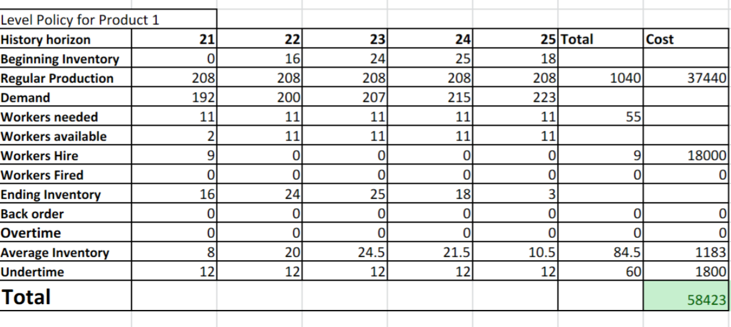Figure 8: Level policy for product 1

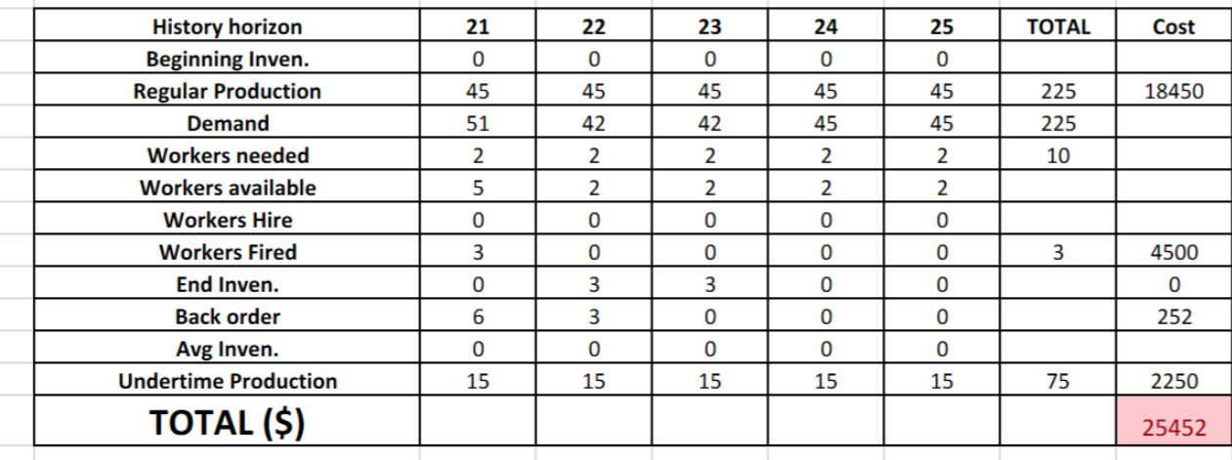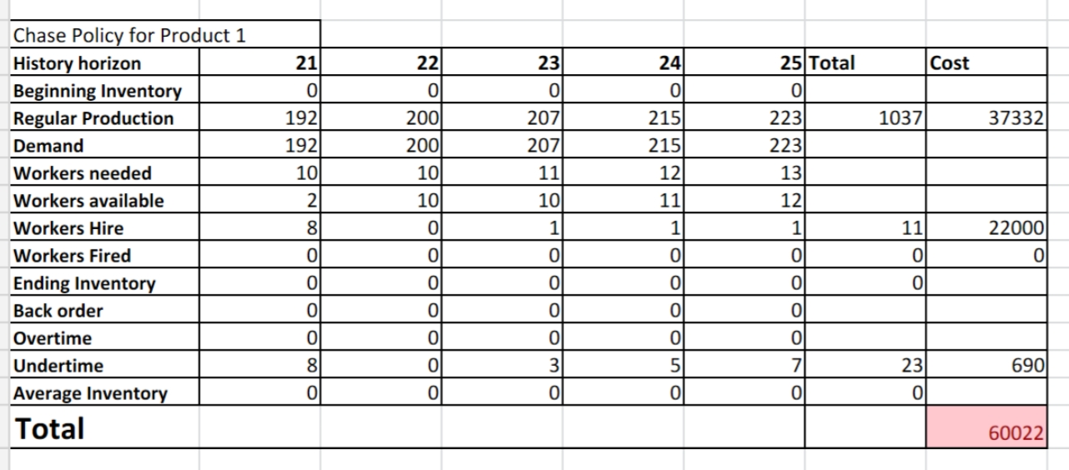Figure 9: Chase policy for product1

Figure 10: Level policy for product2

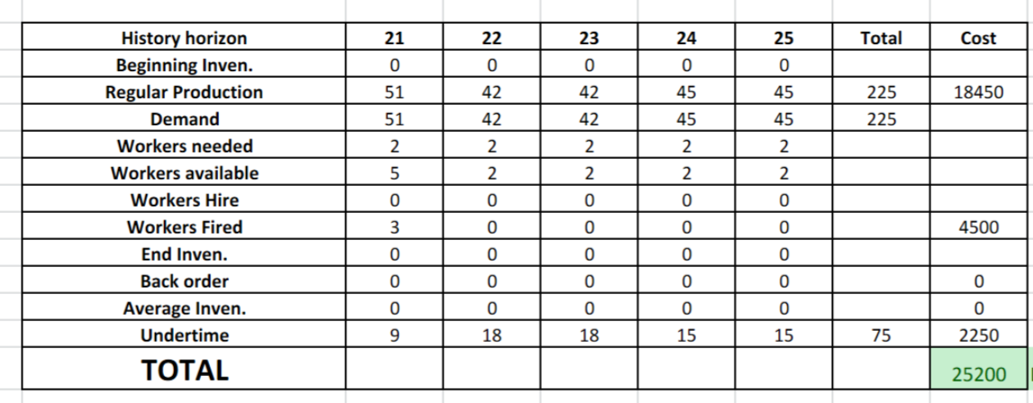Figure 11: Chase policy for product2

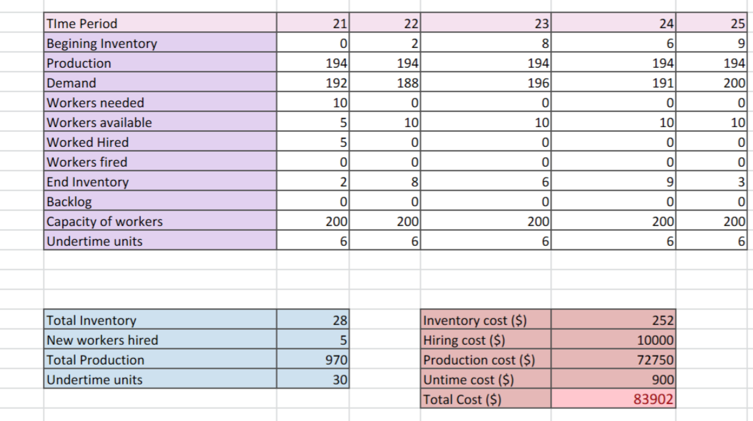Figure 12: Level policy for product 3

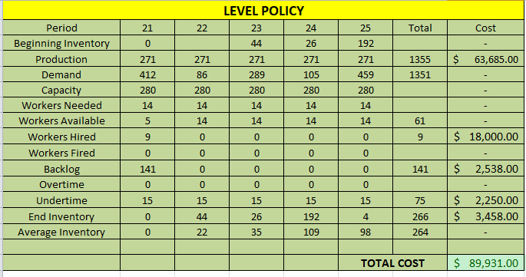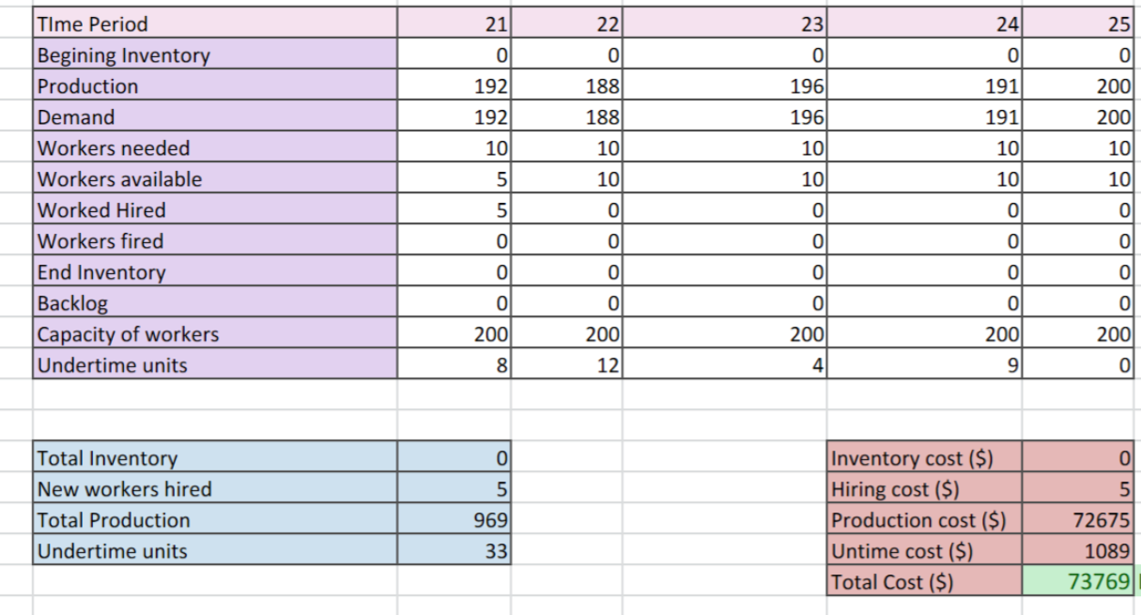 Figure 13: Chase policy for product3Figure 14: Level policy for product 4

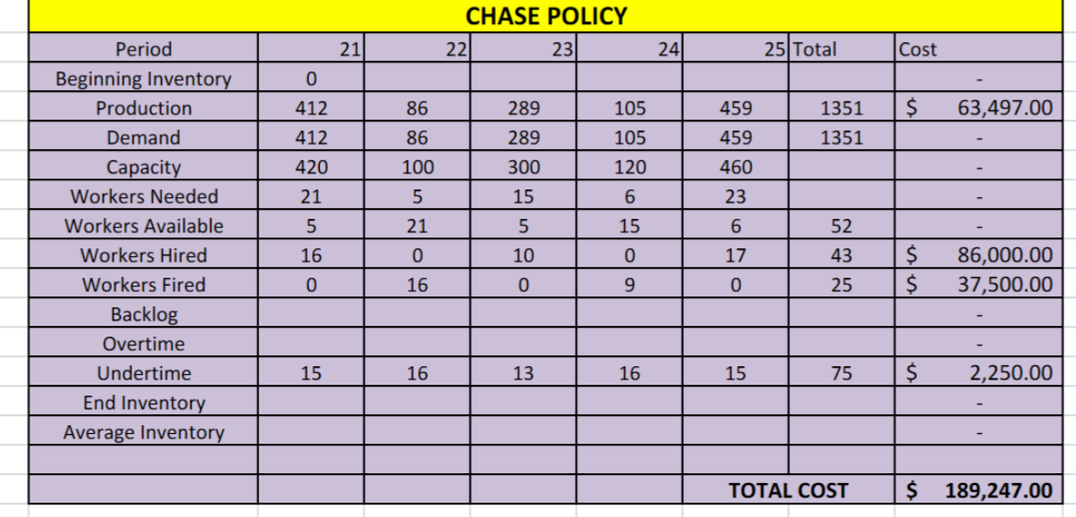

Figure 15: Chase policy for product 4

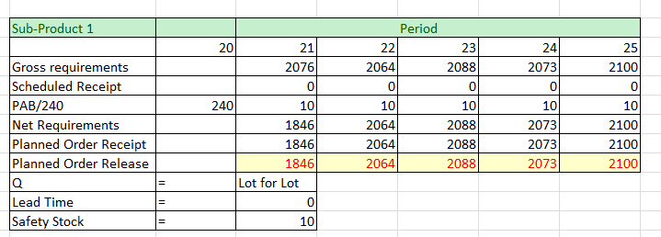

Figure 16: MRP for sub product1

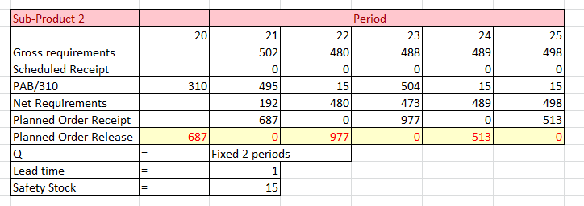Figure 17: MRP for sub product 2

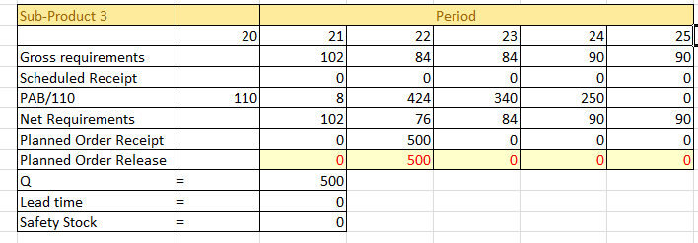

Figure 18: MRP for sub product 3

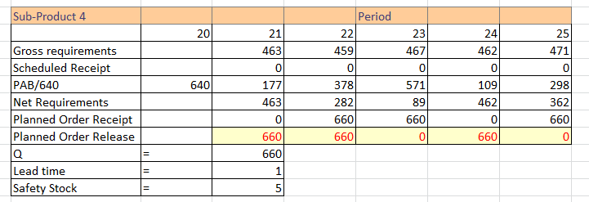 Figure 19: MRP for sub product 4

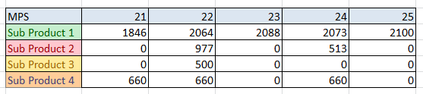 Figure 20: MPS for all the sub products

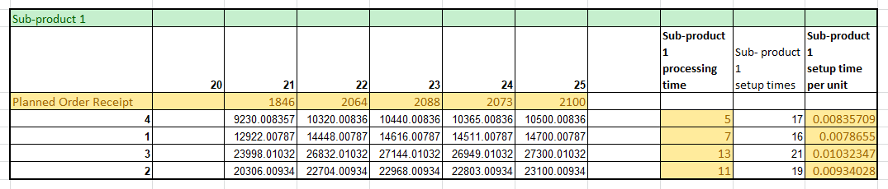

Figure 21: Capacity planning for sub product1

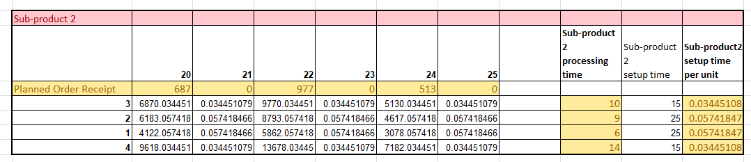Figure 22 : Capacity planning for sub product 2

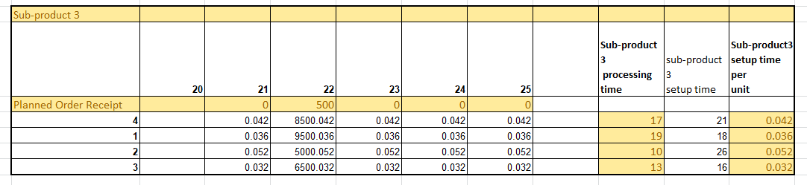

Figure 23 : capacity planning for sub product 3

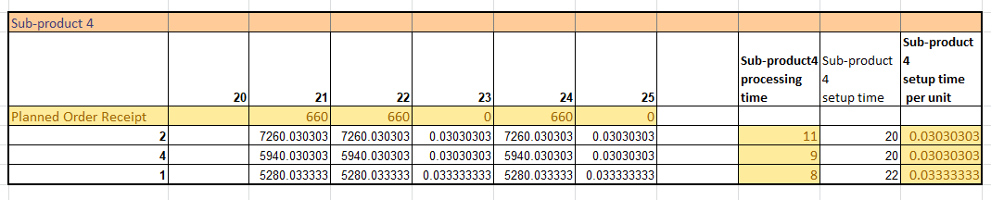Figure 23 : Capacity planning for sub product 4

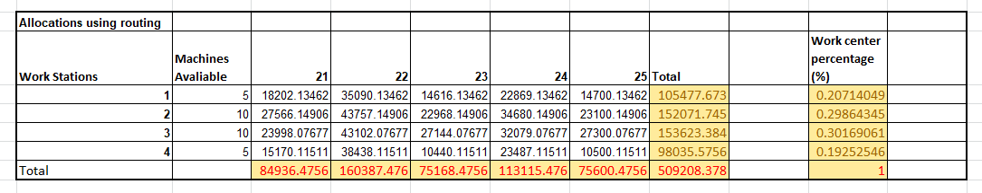Figure 24: Work center allocation

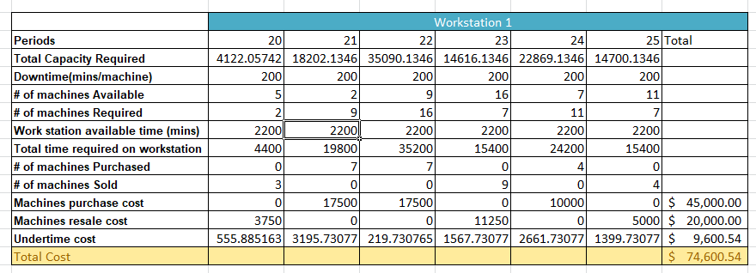Figure 25: Production plan for workstation 1

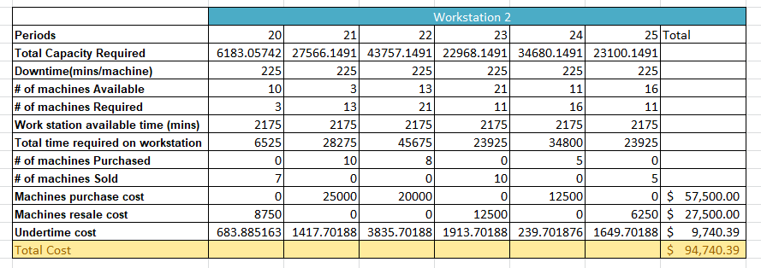Figure 26: Production cost for workstation 2

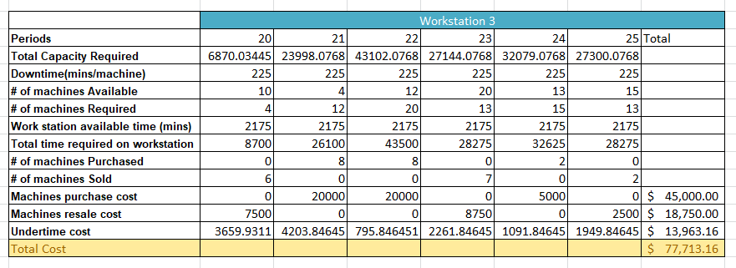Figure 27: Production cost for workstation 3

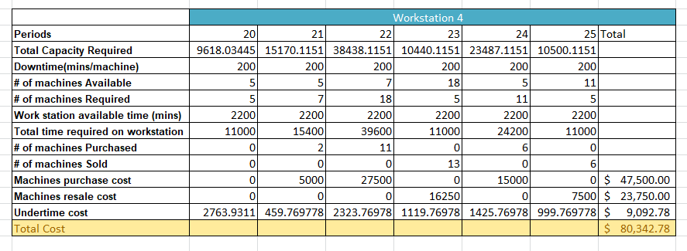Figure 28: Production cost for workstation4