**Topics: Descriptive Statistics and Probability**

1. **Look at the data given below. Plot the data, find the outliers and find out $μ, σ, σ^{2}$**

|  |  |
| --- | --- |
| **Name of company** | **Measure X** |
| Allied Signal | 24.23% |
| Bankers Trust | 25.53% |
| General Mills | 25.41% |
| ITT Industries | 24.14% |
| J.P.Morgan & Co. | 29.62% |
| Lehman Brothers | 28.25% |
| Marriott | 25.81% |
| MCI | 24.39% |
| Merrill Lynch | 40.26% |
| Microsoft | 32.95% |
| Morgan Stanley | 91.36% |
| Sun Microsystems | 25.99% |
| Travelers | 39.42% |
| US Airways | 26.71% |
| Warner-Lambert | 35.00% |
|  |  |

**Ans :**

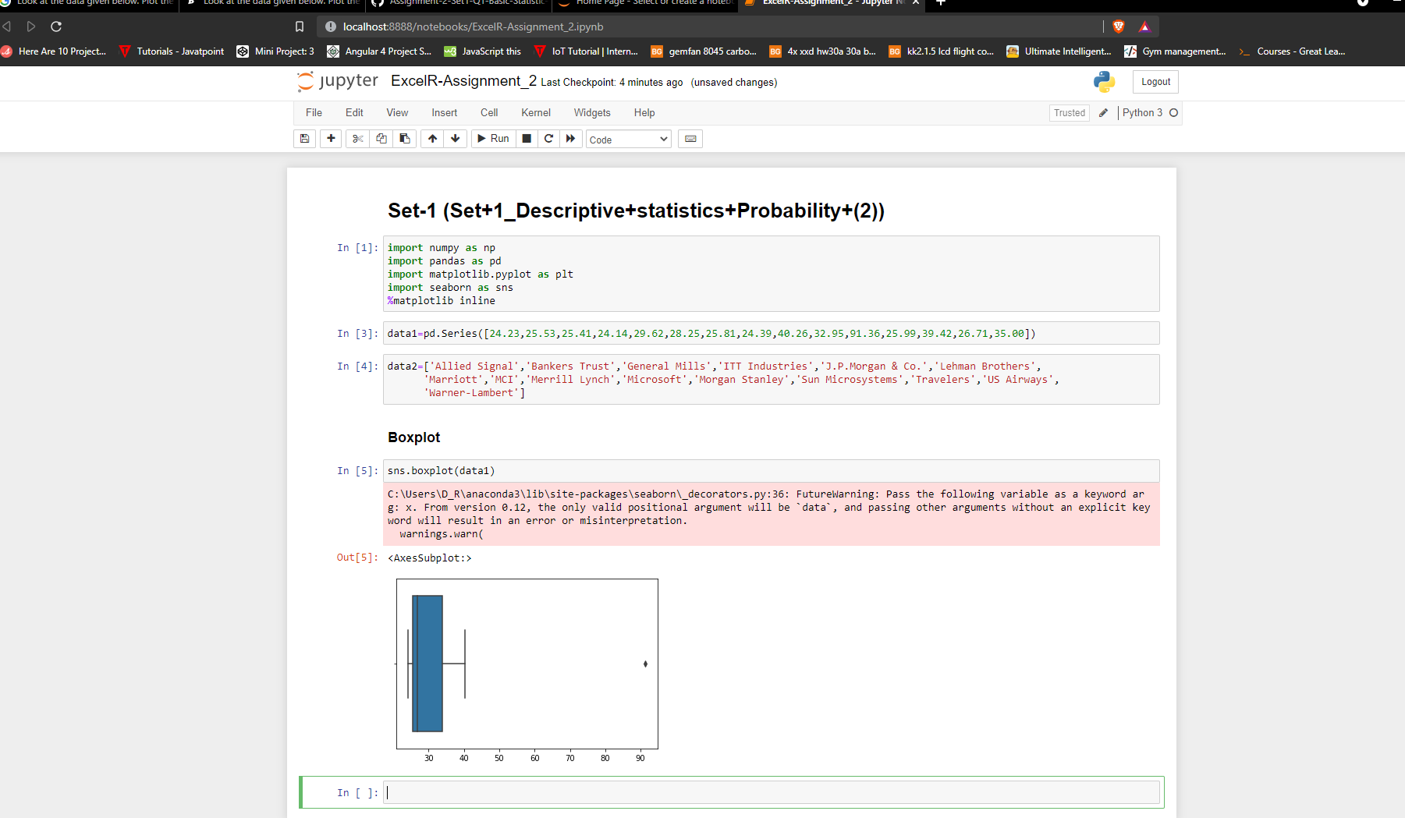

From above information we can see that there’s only one outlier i.e :Morgan Stanley – 91.36%



**Answer the following three questions based on the box-plot above.**

1. **What is inter-quartile range of this dataset? (please approximate the numbers) In one line, explain what this value implies.**
2. **What can we say about the skewness of this dataset?**
3. **If it was found that the data point with the value 25 is actually 2.5, how would the new box-plot be affected?**

**Ans :**

i) Inter-quartile range of this dataset is 12 - 5 = 7.

ii) We can say that this dataset is positively skewed.

iii) Then there would be no outliers.



**Answer the following three questions based on the histogram above.**

1. **Where would the mode of this dataset lie?**
2. **Comment on the skewness of the dataset.**
3. **Suppose that the above histogram and the box-plot in question 2 are plotted for the same dataset. Explain how these graphs complement each other in providing information about any dataset.**

**Ans :**

i) Mode of this dataset will lie : 4 to 8

ii) It is positively skewed.

iii) For finding out outliers, IQR, etc. we use boxplot and for finding mode we use histogram.

1. **AT&T was running commercials in 1990 aimed at luring back customers who had switched to one of the other long-distance phone service providers. One such commercial shows a businessman trying to reach Phoenix and mistakenly getting Fiji, where a half-naked native on a beach responds incomprehensibly in Polynesian. When asked about this advertisement, AT&T admitted that the portrayed incident did not actually take place but added that this was an enactment of something that “could happen.” Suppose that one in 200 long-distance telephone calls is misdirected. What is the probability that at least one in five attempted telephone calls reaches the wrong number? (Assume independence of attempts.)**

**Ans :**

Probability of getting wrong number = 1\200 = 0.005

Probability of not getting wrong number = 1-0.005 = 0.995

Probability of atleast getting one out of five is a wrong number

1 – probability of atleast getting one out of five calls are not wrong numbers

1 – (1 – 0.005)^5

1 – 0.975

0.024

2.5%

1. **Returns on a certain business venture, to the nearest $1,000, are known to follow the following probability distribution**

|  |  |
| --- | --- |
| **x** | **P(x)** |
| **-2,000** | **0.1** |
| **-1,000** | **0.1** |
| **0** | **0.2** |
| **1000** | **0.2** |
| **2000** | **0.3** |
| **3000** | **0.1** |

1. **What is the most likely monetary outcome of the business venture?**
2. **Is the venture likely to be successful? Explain**
3. **What is the long-term average earning of business ventures of this kind? Explain**
4. **What is the good measure of the risk involved in a venture of this kind? Compute this measure**

**Ans :**

i) Outcome of business venture is 0.3.

ii) Yes, p(x = 1000) + p(x = 2000) + p(x = 3000) = 0.2 + 0.3 + 0.1 = 0.6

iii) (0.1)(-2000)+(0.1)(-1000)+(0.2)(0)+(0.2)(1000)+(0.3)(2000)+(0.1)(3000)= 800

iv) We can say standard deviation.