**Arrays**

**---------------------------------------------------------------------------------------------------------------**

1) Write a C program to input 10 numbers through the keyboard into an array and

display the results of addition of even numbers and product of odd numbers.

#include<stdio.h>

main()

{

int a[10],i,j,k,ele,m=1,s=0;

printf("Enter the elements\n");

ele=sizeof(a)/sizeof(a[0]);

for(i=0;i<ele;i++)

scanf("%d",&a[i]);

printf("\n-----------------------\n");

for(i=0;i<ele;i++)

{

if(a[i]%2==0)

{

s=s+a[i];

}

else

m=m*a[i];

}

printf("s=%d m=%d",s,m);

}

2) Write a C program to input 10 numbers through the keyboard into an array and find the

biggest and smallest number in an Unsorted array without using any Sorting Technique.

#include<stdio.h>

main()

{

int a[10],i,j,k,l,ele,big,small;

printf("Enter the elements\n");

ele=sizeof(a)/sizeof(a[0]);

for(i=0;i<ele;i++)

scanf("%d",&a[i]);

big=a[0];

small=a[0];

printf("\n------------------\n");

for(i=0;i<ele;i++)

{

if(big<a[i+1])

big=a[i+1];

if(a[i]<small)

small=a[i];

}

printf("big =%d,small=%d\n",big,small);

}

3) Write a C program to input 10 numbers through the keyboard and find the number

of prime numbers count, store them into a seperate array and display it.

// WAP to input 10 numbers through the keyboard and find the number of prime numbers count, store them into a seperate array and display it.

#include<stdio.h>

main()

{

int a[10],b[10],i,j,c,k=0;

printf("Enter array :\n");

for(i=0;i<10;i++)

scanf("%d",&a[i]);

printf("Entered array is : ");

for(i=0;i<10;i++)

printf("%d ",a[i]);

for(i=0;i<10;i++)

{

for(j=2,c=0;j<a[i];j++)

{

if(a[i]%j == 0)

c++;

}

if(c == 0)

{

b[k] = a[i];

k++;

}

}

printf("\nArray A is : ");

for(i=0;i<10;i++)

printf("%d ",a[i]);

printf("\nArray b is : ");

for(i=0;i<k;i++)

printf("%d ",b[i]);

printf("\n");

}

4) Write a C program to findout second largest and second smallest elements of an

unsorted array without using any Sorting Technique.

5) Write a C program to reverse the elements of a given array.

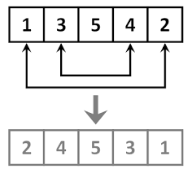

#include<stdio.h>

main()

{

int a[5],ele,i,j,k;

printf("Enter the elements\n");

ele=sizeof(a)/sizeof(a[0]);

for(i=0;i<ele;i++)

scanf("%d",&a[i]);

for(i=0;i<ele;i++)

printf("%d",a[i]);

printf("\n");

for(i=0,j=ele-1;i<j;i++,j--)

{

k=a[i];

a[i]=a[j];

a[j]=k;

}

for(i=0;i<ele;i++)

printf("%d",a[i]);

printf("\n");

}

6) Write a C program to delete an element at desired position from an array.

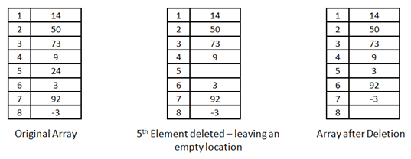

#include<stdio.h>

main()

{

int a[8],i,j,k,l;

printf("Entert the elements\n");

for(i=0;i<8;i++)

scanf("%d",&a[i]);

printf("Before\n");

for(i=0;i<8;i++)

printf("%d ",a[i]);

printf("\n");

printf("Enter the element you want to delet\n");

scanf("%d",&k);

for(i=k-1;i<7;i++)

a[i]=a[i+1];

printf("After\n");

for(i=0;i<7;i++)

printf("%d ",a[i]);

printf("\n");

}

7) Write a C program to insert an element at desired position in an array.

For Example if 'A' is to be stored at '0' position then,

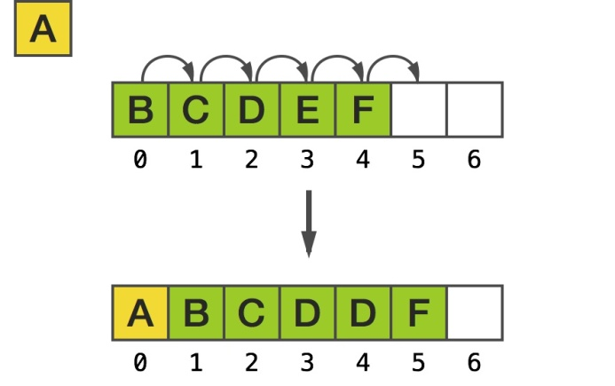

// WAP to insert an element at desired position in an array.

#include<stdio.h>

main()

{

int a[5],i,j,n,k;

n = sizeof(a)/sizeof(a[0]);

printf("Enter elements : \n"); //

for(i=0;i<n;i++) // fill array elements

scanf("%d",&a[i]); //

printf("\nEntered array is : "); //

for(i=0;i<n;i++) // print array

printf("%d ",a[i]); //

printf("\nEnter desired position : "); // take desire position

scanf("%d",&j); //

n = n-1;

//////////////////////////////////////////////// logic for shift

for(i=n;i>j;i--)

a[i] = a[i-1];

////////////////////////////////////////////////

printf("\nEnter new element : "); // enter new element

scanf("%d",&k); //

a[j] = k; // store that element at desire position

printf("\nNew array is :"); //

for(i=0;i<=n;i++) // print new array

printf("%d ",a[i]); //

printf("\n");

}

8) Write a C program which deletes the duplicate elements of an array.

A description...

// WAP which deletes the duplicate elements of an array.

#include<stdio.h>

main()

{

int a[10],i,j,k,n;

n = sizeof(a)/sizeof(a[0]);

printf("Enter array elements :\n");

for(i=0;i<n;i++)

scanf("%d",&a[i]);

printf("Entered array is : ");

for(i=0;i<n;i++)

printf("%d ",a[i]);

/////////////////////////////////////////////////////////

for(i=0;i<n;i++)

{

for(j=i+1;j<n;j++)

if(a[i]==a[j])

{

for(k=j;k<n;k++)

a[k] = a[k+1];

n--;

}

}

/////////////////////////////////////////////////////////

printf("\nNew array is : ");

for(i=0;i<n;i++)

printf("%d ",a[i]);

printf("\n");

}

9) Write a C program to find the duplicate elements of a given array and find the count of

duplicated elements.

Ex: if int a[] = {0,3,1,0,5,1,2,0,4,5}

output : -

The duplicate elements are existed in an array

0 -- 3 times

1 -- 2 times

5 -- 2 times

10) Write a program to print the non repeted numbers of a given array.

Ex : if int a[] = {0,3,1,0,5,1,2,0,4,5}

Output : 3, 2, 4

11) Write a program to copy the elements of one array into another array without duplicate

items as a first slot, and store duplicate elements as a second slot.

Ex: source array {10,2,4,5,2,1,3,4,6,5,8,9,2}

destination arrays {10,2,4,5,1,3,6,8,9} , { 2,2,4,5}

first slot second slot

Take two different arrays for first and second slots.

12) Write a C program to evaluate the following series. The series contains sum of

square of numbers from 1 to 'n'. Strore result of each term in an array. Calculate

value of ' S ' using array.

S = 1^2 + 2^2 + 3^2 + 4^2 + ------ n^2

= [ 1, 4, 9, 16, -------- n^2 ]

Suppose n = 4,

then S = 1^2+2^2+3^2+4^2;

S = 1+4+9+16;

S = 30.

1. Write a C program to implement the stack using arrays.

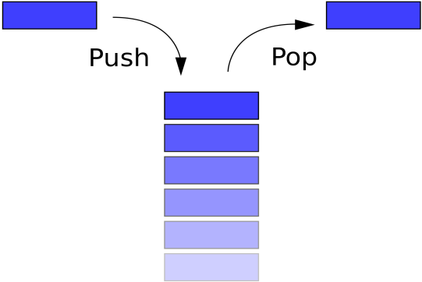

**STACK**

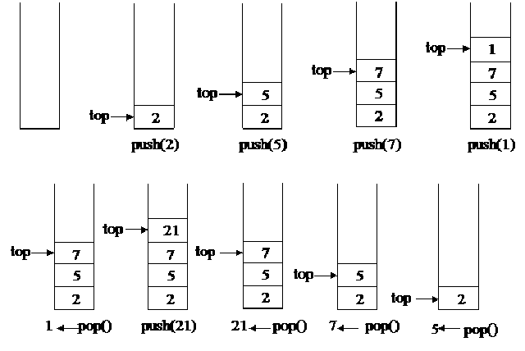

-------------------------------------------------------- END --------------------------------------------------------

Dear Students, if any mistakes found, Kindly inform to me.

A.Tandava Ramakrishna

Email: ramakrishna@vectorindia.org