Hello everyone!

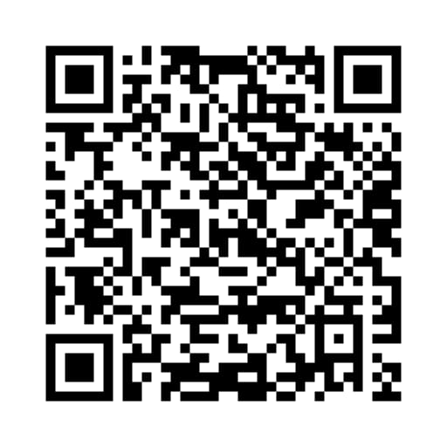We are students from Punjab Engineering College .We have come up with an interesting idea of sign to text and speech convertor . Please support our idea by voting for us.

Steps to vote for us:

1)Scan the QR code and go to the url.

2)Login using your google id or facebook id.

3)Wait for the webpage to load.

4)Vote for us by clicking on the red vote button.

WE REQUIRE YOUR VOTES EVERYDAY .YOU CAN VOTE FOR OUR PROJECT ONCE IN 24 HOURS TILL 3RD NOVEMBER,2019.

LINK FOR THE QR CODE(SCAN USING GOOGLE LENS)

<https://www.redbull.com/in-en/projects/red-bull-basement-university/project/1106>