**PART A**

(Part A: TO BE REFFERED BY STUDENTS)

**A.1 AIM:**

Develop a Mini Project in Java

**A.2 Pre requisite:**

Basic Knowledge of Java, Java FX.

**A.3 Outcome:**

After successful completion of this experiment students will be able to:

1. Develop a standalone application using Java

**A.4 Theory:**

A mini project is desirable to be completed by a group of two or three students that cover

following tools.

Java

Java FX

**A.5 Procedure/Task:**

1. Develop an application using Java and Java FX.
2. Prepare the document. Save and close the file and name it as RollNo._MiniProject.

**PART B**

(PART B: TO BE COMPLETED BY STUDENTS)

(Students must submit the soft copy as per following segments within two hours of the practical. The soft copy must be uploaded on the Blackboard or emailed to the concerned lab in charge faculties at the end of the practical in case the there is no Black board access available)

|  |  |
| --- | --- |
| Roll No. : C023 | Name: Dhaval Mehta |
| Class : B | Batch : B1 |
| Date of Experiment : | Date/Time of Submission : |
| Grade : |  |

**B.1 Project Details**

*(Detailed description of project. It should include answers to following questions)*

* **Motivation to take the proposed project:** To make the book my show manual easier to use and user friendly as many people are not knowing how to use the app correctly.
* **Working:** This program offers show times, movie tickets, snacks, combo offers, beverages, genre and many more things across different cities in India. First you need to choose the city then the movie that you want to watch and if you want any beverage or snacks you can pre book then as well so you don’t have to stand in the long queues to order your food.
* **Advantages and Disadvantages: -**

|  |  |
| --- | --- |
| Advantages | Disadvantages |
| Vast network of event organizers and major cinema chains | Mostly limited to urban areas as people in India are still apprehensive for online payments |
| Simple and convenient to use | Network Issues |
| Constantly updated with forthcoming events and movies | Unreliable Reviews |
| Many discounts and offers | User Errors |
| User friendly interface | Limited Payment Options |
| Secure payment |  |
| Easy and fast bookings |  |

* **Technologies used:** JAVA, JAVA Swing

**B.2 Output**

Without using JAVA Swing: -

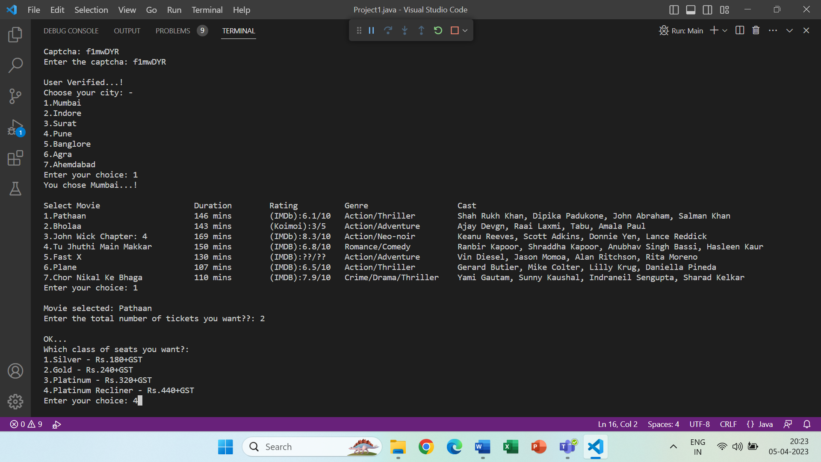

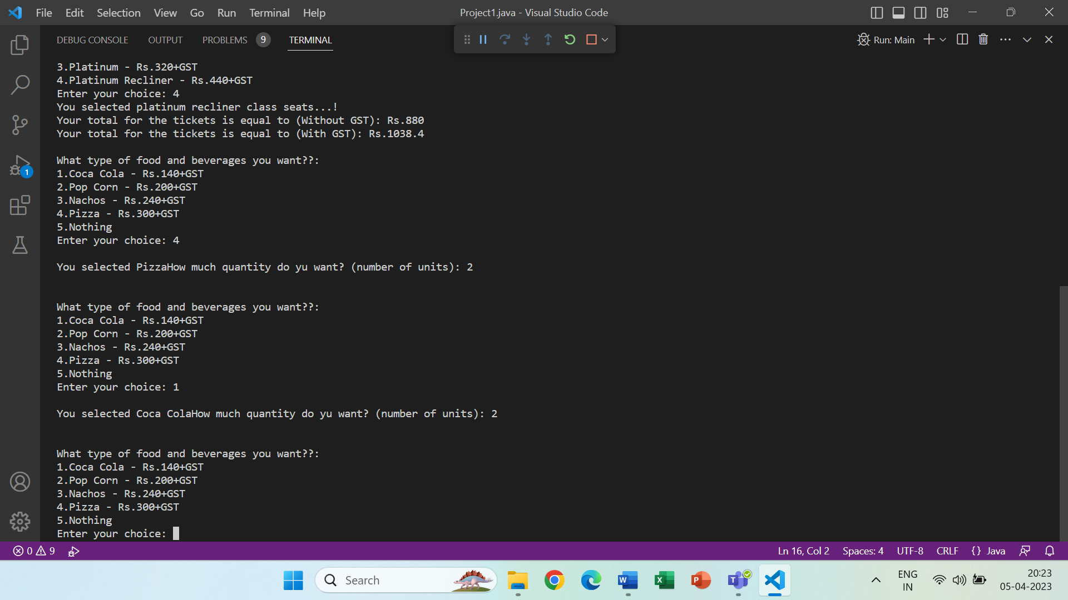

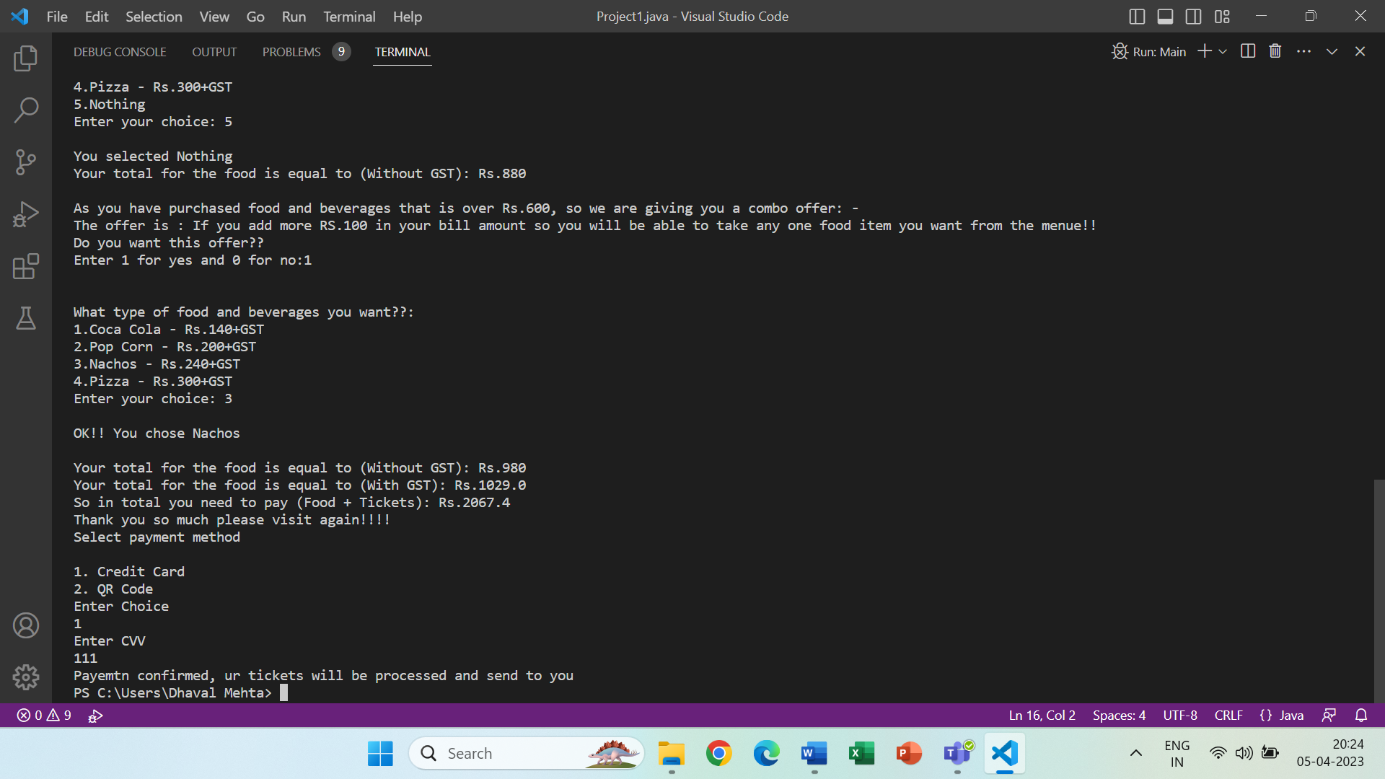

QR Code Generator: -

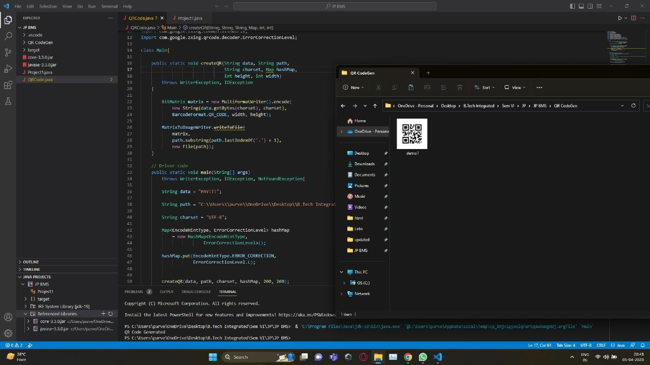

With JAVA Swing: -

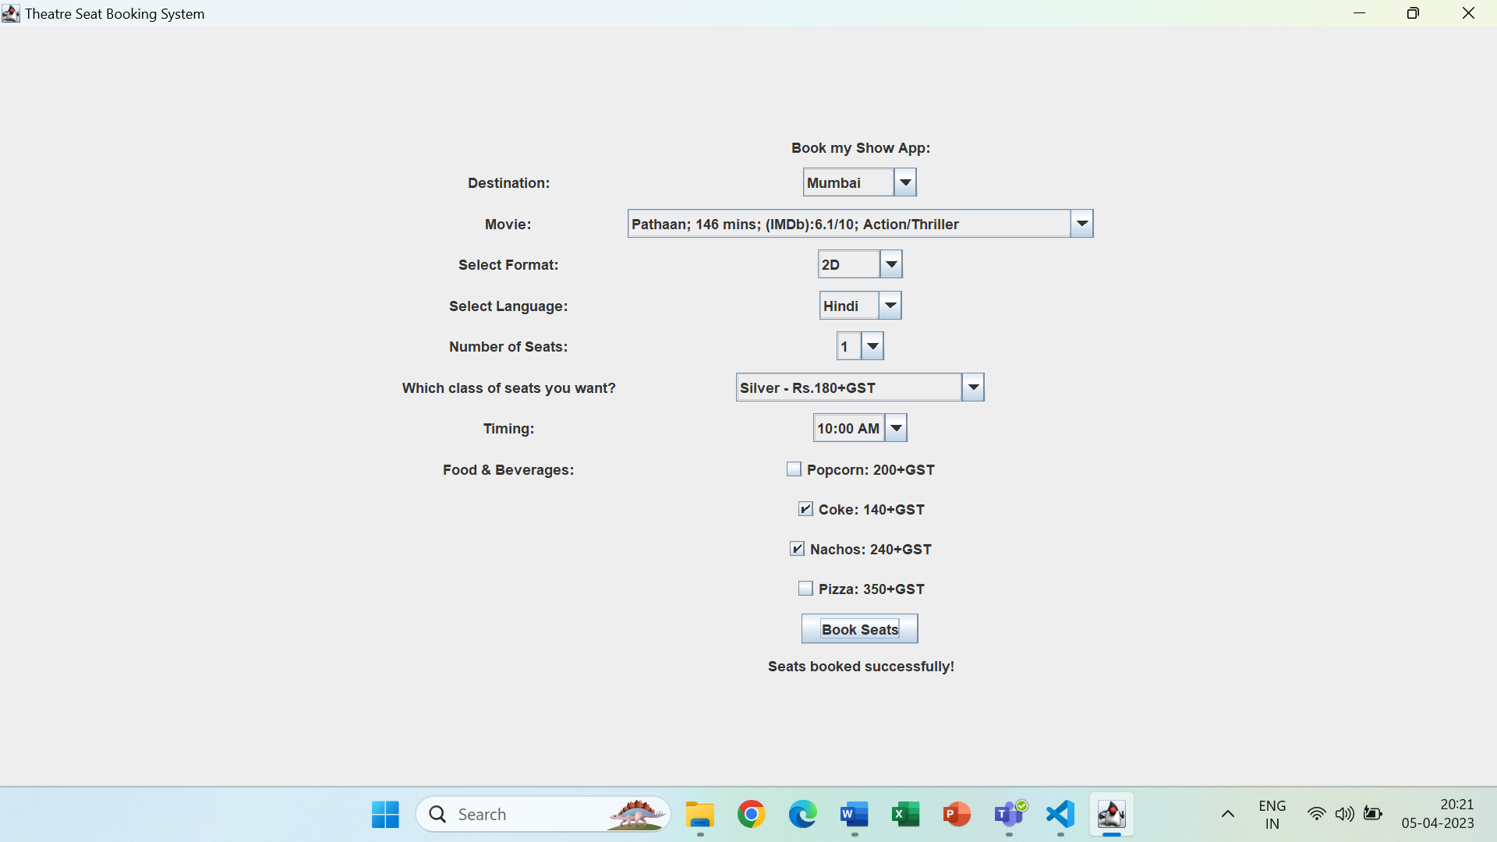

**B.3 Project Code :**

**Without using JAVA Swing: -**

import java.util.*;

// import javaone.*;

// import javaone.Main;

//import javax.lang.model.util.ElementScanner14;

//import com.google.zxing.NotFoundException;

//import com.google.zxing.WriterException;

//import javax.lang.model.util.ElementScanner14;

//import java.Console_Application.*;

import java.io.*;

class Main

{

    public static Double w_gst_tick_total_d;

    public static Double w_gst_food_total_d;

    static boolean checkCaptcha(String captcha, String user_captcha)

    {

        return captcha.equals(user_captcha);

    }

    // Generates a CAPTCHA of given length

    static String generateCaptcha(int n)

    {

        //to generate random integers in the range [0-61]

        Random rand = new Random(62);

        // Characters to be included

        String chrs = "abcdefghijklmnopqrstuvwxyzABCDEFGHIJKLMNOPQRSTUVWXYZ0123456789";

        // Generate n characters from above set and

        // add these characters to captcha.

        String captcha = "";

        while (n-->0){

            int index = (int)(Math.random()*62);

            captcha+=chrs.charAt(index);

        }

        return captcha;

    }

    //Function to show the selected movie...

    public static void movie_seat(int ch1)

    {

        if(ch1==1)

        {

            System.out.print("\nMovie selected: ");

            System.out.print("Pathaan");

        }

        else if(ch1==2)

        {

            System.out.print("\nMovie selected: ");

            System.out.print("Bholaa");

        }

        else if(ch1==3)

        {

            System.out.print("\nMovie selected: ");

            System.out.print("John Wick Chapter: 4");

        }

        else if(ch1==4)

        {

            System.out.print("\nMovie selected: ");

            System.out.print("Tu Juthi main Makkar");

        }

        else if(ch1==5)

        {

            System.out.print("\nMovie selected: ");

            System.out.print("Fast X");

        }

        else if(ch1==6)

        {

            System.out.print("\nMovie selected: ");

            System.out.print("Plane");

        }

        else if(ch1==7)

        {

            System.out.print("\nMovie selected: ");

            System.out.print("Chor Nikal Ke Bhaga");

        }

        else

        {

            System.out.print("Wrong number entered...! Please redo the process...!");

        }

    }

    public static void tick()

    {

        Scanner src =new Scanner (System.in);

        float w_gst_tick_total=0;

        int tick_total=0;

        int nums,ch;

        System.out.print("\nEnter the total number of tickets you want??: ");

        nums=src.nextInt();

        if(nums>10)

        {

            System.out.print("\nYou cannot take more than 10 tickets...!");

        }

        else

        {

            System.out.print("\nOK...");

            System.out.print("\nWhich class of seats you want?:");

            System.out.print("\n1.Silver - Rs.180+GST");

            System.out.print("\n2.Gold - Rs.240+GST");

            System.out.print("\n3.Platinum - Rs.320+GST");

            System.out.print("\n4.Platinum Recliner - Rs.440+GST");

            System.out.print("\nEnter your choice: ");

            ch=src.nextInt();

            if(ch==1)

            {

                System.out.print("You selected silver class seats...!");

                tick_total=nums*180;

            }

            else if(ch==2)

            {

                System.out.print("You selected gold class seats...!");

                tick_total=nums*240;

            }

            else if(ch==3)

            {

                System.out.print("You selected platinum class seats...!");

                tick_total=nums*320;

            }

            else if(ch==4)

            {

                System.out.print("You selected platinum recliner class seats...!");

                tick_total=nums*440;

            }

            else

            {

                System.out.print("\nWrong number selected...!");

            }

            System.out.print("\nYour total for the tickets is equal to (Without GST): Rs."+tick_total);

            w_gst_tick_total=tick_total;

            w_gst_tick_total_d=w_gst_tick_total+(w_gst_tick_total*0.18);

            System.out.print("\nYour total for the tickets is equal to (With GST): Rs."+w_gst_tick_total_d);

        }

    }

    public static void food_drink()

    {

        Scanner src =new Scanner (System.in);

        int ch2,ch3,food_total=0,quantity,offer,pay, payment=0;

        float w_gst_food_total=0;

        String cvv;

        do{

            System.out.print("\n\nWhat type of food and beverages you want??:");

            System.out.print("\n1.Coca Cola - Rs.140+GST");

            System.out.print("\n2.Pop Corn - Rs.200+GST");

            System.out.print("\n3.Nachos - Rs.240+GST");

            System.out.print("\n4.Pizza - Rs.300+GST");

            System.out.print("\n5.Nothing");

            System.out.print("\nEnter your choice: ");

            ch2=src.nextInt();

            if(ch2==1)

            {

                System.out.print("\nYou selected Coca Cola");

                System.out.print("How much quantity do yu want? (number of units): ");

                quantity=src.nextInt();

                food_total=food_total+(quantity*140);

            }

            else if(ch2==2)

            {

                System.out.print("\nYou selected Pop Corn");

                System.out.print("How much quantity do yu want? (number of units): ");

                quantity=src.nextInt();

                food_total=food_total+(quantity*200);

            }

            else if(ch2==3)

            {

                System.out.print("\nYou selected Nachos");

                System.out.print("How much quantity do yu want? (number of units): ");

                quantity=src.nextInt();

                food_total=food_total+(quantity*240);

            }

            else if(ch2==4)

            {

                System.out.print("\nYou selected Pizza");

                System.out.print("How much quantity do yu want? (number of units): ");

                quantity=src.nextInt();

                food_total=food_total+(quantity*300);

            }

            else if(ch2==5)

            {

                System.out.print("\nYou selected Nothing");

            }

            else

            {

                System.out.print("\nWrong number entered!!");

            }

        }while(ch2!=5);

        System.out.print("\nYour total for the food is equal to (Without GST): Rs."+food_total);

        if(food_total>=600)

        {

            System.out.print("\n\nAs you have purchased food and beverages that is over Rs.600, so we are giving you a combo offer: -");

            System.out.print("\nThe offer is : If you add more RS.100 in your bill amount so you will be able to take any one food item you want from the menue!!");

            System.out.print("\nDo you want this offer??\nEnter 1 for yes and 0 for no:");

            offer=src.nextInt();

            if(offer==1)

            {

                food_total=food_total+100;

                System.out.print("\n\nWhat type of food and beverages you want??:");

                System.out.print("\n1.Coca Cola - Rs.140+GST");

                System.out.print("\n2.Pop Corn - Rs.200+GST");

                System.out.print("\n3.Nachos - Rs.240+GST");

                System.out.print("\n4.Pizza - Rs.300+GST");

                System.out.print("\nEnter your choice: ");

                ch3=src.nextInt();

                switch(ch3)

                {

                    case 1:

                    {

                        System.out.print("\nOK!! You chose Coca Cola");

                        System.out.print("\n\nYour total for the food is equal to (Without GST): Rs."+food_total);

                        w_gst_food_total=food_total;

                        w_gst_food_total_d=w_gst_food_total+(w_gst_food_total*0.05);

                        System.out.print("\nYour total for the food is equal to (With GST): Rs."+w_gst_food_total_d);

                        System.out.print("\nSo in total you need to pay (Food + Tickets): Rs."+(w_gst_food_total_d+w_gst_tick_total_d));

                        System.out.print("\nThank you so much please visit again!!!!\n");

                        //Add Payments;

                        System.out.println("Select payment method");

                        System.out.println();

                        System.out.println("1. Credit Card");

                        System.out.println("2. QR Code");

                        System.out.println("Enter Choice");

                        payment=src.nextInt();

                        switch(payment){

                            case 1:

                            System.err.println("Enter CVV");

                            cvv=src.nextLine();

                            cvv=src.nextLine();

                            int a=cvv.length();

                            if(a>3){

                                System.out.println("invalid number entered");

                            }else{

                                System.err.println("Payemtn confirmed, ur tickets will be processed and send to you");

                            }

                            break;

                            case 2:

                            System.out.println("QR Code is being generated");

                            break;

                            default:

                            System.out.println("Inalid Input");

                            break;

                        }

                        break;

                    }

                    case 2:

                    {

                        System.out.print("\nOK!! You chose Pop Corn");

                        System.out.print("\n\nYour total for the food is equal to (Without GST): Rs."+food_total);

                        w_gst_food_total=food_total;

                        w_gst_food_total_d=w_gst_food_total+(w_gst_food_total*0.05);

                        System.out.print("\nYour total for the food is equal to (With GST): Rs."+w_gst_food_total_d);

                        System.out.print("\nSo in total you need to pay (Food + Tickets): Rs."+(w_gst_food_total_d+w_gst_tick_total_d));

                        System.out.print("\nThank you so much please visit again!!!!\n");

                        System.out.println("Select payment method");

                        System.out.println();

                        System.out.println("1. Credit Card");

                        System.out.println("2. QR Code");

                        System.out.println("Enter Choice");

                        payment=src.nextInt();

                        switch(payment){

                            case 1:

                            System.err.println("Enter CVV");

                            cvv=src.nextLine();

                            int a=cvv.length();

                            cvv=src.nextLine();

                            if(a>3){

                                System.out.println("invalid number entered");

                            }else{

                                System.err.println("Payemtn confirmed, ur tickets will be processed and send to you");

                            }

                            break;

                            case 2:

                            System.out.println("QR Code is being generated");

                            break;

                            default:

                            System.out.println("Inalid Input");

                            break;

                        }

                        break;

                    }

                    case 3:

                    {

                        System.out.print("\nOK!! You chose Nachos");

                        System.out.print("\n\nYour total for the food is equal to (Without GST): Rs."+food_total);

                        w_gst_food_total=food_total;

                        w_gst_food_total_d=w_gst_food_total+(w_gst_food_total*0.05);

                        System.out.print("\nYour total for the food is equal to (With GST): Rs."+w_gst_food_total_d);

                        System.out.print("\nSo in total you need to pay (Food + Tickets): Rs."+(w_gst_food_total_d+w_gst_tick_total_d));

                        System.out.print("\nThank you so much please visit again!!!!\n");

                        System.out.println("Select payment method");

                        System.out.println();

                        System.out.println("1. Credit Card");

                        System.out.println("2. QR Code");

                        System.out.println("Enter Choice");

                        payment=src.nextInt();

                        switch(payment){

                            case 1:

                            System.err.println("Enter CVV");

                            cvv=src.nextLine();

                            int a=cvv.length();

                            cvv=src.nextLine();

                            if(a>3){

                                System.out.println("invalid number entered");

                            }else{

                                System.err.println("Payemtn confirmed, ur tickets will be processed and send to you");

                            }

                            break;

                            case 2:

                            System.out.println("QR Code is being generated");

                            break;

                            default:

                            System.out.println("Inalid Input");

                            break;

                        }

                        break;

                    }

                    case 4:

                    {

                        System.out.print("\nOK!! You chose Pizza");

                        System.out.print("\n\nYour total for the food is equal to (Without GST): Rs."+food_total);

                        w_gst_food_total=food_total;

                        w_gst_food_total_d=w_gst_food_total+(w_gst_food_total*0.05);

                        System.out.print("\nYour total for the food is equal to (With GST): Rs."+w_gst_food_total_d);

                        System.out.print("\nSo in total you need to pay (Food + Tickets): Rs."+(w_gst_food_total_d+w_gst_tick_total_d));

                        System.out.print("\nThank you so much please visit again!!!!\n");

                        System.out.println("Select payment method");

                        System.out.println();

                        System.out.println("1. Credit Card");

                        System.out.println("2. QR Code");

                        System.out.println("Enter Choice");

                        payment=src.nextInt();

                        switch(payment){

                            case 1:

                            System.err.println("Enter CVV");

                            cvv=src.nextLine();

                            cvv=src.nextLine();

                            int a=cvv.length();

                            if(a>3){

                                System.out.println("invalid number entered");

                            }else{

                                System.err.println("Payemtn confirmed, ur tickets will be processed and send to you");

                            }

                            break;

                            case 2:

                            System.out.println("QR Code is being generated");

                            break;

                            default:

                            System.out.println("Inalid Input");

                            break;

                        }

                        break;

                    }

                    default:

                    {

                        System.out.print("You wntered a wrong number...!");

                        break;

                    }

                }

            }

            else

            {

                System.out.print("\nNo problem!! Here is your final bill:-");

                System.out.print("\n\nYour total for the food is equal to (Without GST): Rs."+food_total);

                w_gst_food_total=food_total;

                w_gst_food_total_d=w_gst_food_total+(w_gst_food_total*0.05);

                System.out.print("\nYour total for the food is equal to (With GST): Rs."+w_gst_food_total_d);

                System.out.print("\nSo in total you need to pay (Food + Tickets): Rs."+(w_gst_food_total_d+w_gst_tick_total_d));

                System.out.print("\nThank you so much please visit again!!!!\n");

                System.out.println("Select payment method");

                        System.out.println();

                        System.out.println("1. Credit Card");

                        System.out.println("2. QR Code");

                        System.out.println("Enter Choice");

                        payment=src.nextInt();

                        switch(payment){

                            case 1:

                            System.err.println("Enter CVV");

                            cvv=src.nextLine();

                            cvv=src.nextLine();

                            int a=cvv.length();

                            if(a>3){

                                System.out.println("invalid number entered");

                            }else{

                                System.err.println("Payemtn confirmed, ur tickets will be processed and send to you");

                            }

                            break;

                            case 2:

                            System.out.println("QR Code is being generated");

                            break;

                            default:

                            System.out.println("Inalid Input");

                            break;

                        }

            }

        }

        else

        {

            System.out.print("Here is your final bill:-");

            System.out.print("\n\nYour total for the food is equal to (Without GST): Rs."+food_total);

            w_gst_food_total=food_total;

            w_gst_food_total_d=w_gst_food_total+(w_gst_food_total*0.05);

            System.out.print("\nYour total for the food is equal to (With GST): Rs."+w_gst_food_total_d);

            System.out.print("\nSo in total you need to pay (Food + Tickets): Rs."+(w_gst_food_total_d+w_gst_tick_total_d));

            System.out.print("\n\nPayments: Enter 1 for Card and 2 for Digital Wallet");

            pay=src.nextInt();

            System.out.println("Select payment method");

                        System.out.println();

                        System.out.println("1. Credit Card");

                        System.out.println("2. QR Code");

                        System.out.println("Enter Choice");

                        payment=src.nextInt();

                        switch(payment){

                            case 1:

                            System.err.println("Enter CVV");

                            cvv=src.nextLine();

                            cvv=src.nextLine();

                            int a=cvv.length();

                            if(a>3){

                                System.out.println("invalid number entered");

                            }else{

                                System.err.println("Payemtn confirmed, ur tickets will be processed and send to you");

                            }

                            break;

                            case 2:

                            System.out.println("QR Code is being generated");

                            break;

                            default:

                            System.out.println("Inalid Input");

                            break;

                        }

            //Add payments;

            System.out.print("\nThank you so much please visit again!!!!\n");

        }

    }

    public static void main(String args[])

    {

        Scanner src =new Scanner (System.in);

        int i,j,ch,ch1,k;

        String captcha = generateCaptcha(7);

        System.out.println("Captcha: "+captcha);

        System.out.print("Enter the captcha: ");

        String user_captcha=src.nextLine();

        if(checkCaptcha(captcha, user_captcha))

        {

            System.out.print("\nUser Verified...!");

            System.out.print("\nChoose your city: -");

            System.out.print("\n1.Mumbai");

            System.out.print("\n2.Indore");

            System.out.print("\n3.Surat");

            System.out.print("\n4.Pune");

            System.out.print("\n5.Banglore");

            System.out.print("\n6.Agra");

            System.out.print("\n7.Ahemdabad");

            System.out.print("\nEnter your choice: ");

            ch=src.nextInt();

            switch(ch)

            {

                case 1:

                {

                System.out.print("You chose Mumbai...!");

                System.out.print("\n\nSelect Movie\t\t\tDuration\tRating\t\tGenre\t\t\tCast");

                System.out.print("\n1.Pathaan\t\t\t146 mins\t(IMDb):6.1/10\tAction/Thriller\t\tShah Rukh Khan, Dipika Padukone, John Abraham, Salman Khan");

                System.out.print("\n2.Bholaa\t\t\t143 mins\t(Koimoi):3/5\tAction/Adventure\tAjay Devgn, Raai Laxmi, Tabu, Amala Paul");

                System.out.print("\n3.John Wick Chapter: 4\t\t169 mins\t(IMDb):8.3/10\tAction/Neo-noir\t\tKeanu Reeves, Scott Adkins, Donnie Yen, Lance Reddick");

                System.out.print("\n4.Tu Jhuthi Main Makkar\t\t150 mins\t(IMDB):6.8/10\tRomance/Comedy\t\tRanbir Kapoor, Shraddha Kapoor, Anubhav Singh Bassi, Hasleen Kaur");

                System.out.print("\n5.Fast X\t\t\t130 mins\t(IMDB):??/??\tAction/Adventure\tVin Diesel, Jason Momoa, Alan Ritchson, Rita Moreno");

                System.out.print("\n6.Plane\t\t\t\t107 mins\t(IMDB):6.5/10\tAction/Thriller\t\tGerard Butler, Mike Colter, Lilly Krug, Daniella Pineda");

                System.out.print("\n7.Chor Nikal Ke Bhaga\t\t110 mins\t(IMDB):7.9/10\tCrime/Drama/Thriller\tYami Gautam, Sunny Kaushal, Indraneil Sengupta, Sharad Kelkar");

                System.out.print("\nEnter your choice: ");

                ch1=src.nextInt();

                movie_seat(ch1);

                tick();

                food_drink();

                break;

                }

                case 2:

                {

                System.out.print("You chose Indore...!");

                System.out.print("\n\nSelect Movie\t\t\tDuration\tRating\t\tGenre\t\t\tCast");

                System.out.print("\n1.Pathaan\t\t\t146 mins\t(IMDb):6.1/10\tAction/Thriller\t\tShah Rukh Khan, Dipika Padukone, John Abraham, Salman Khan");

                System.out.print("\n2.Bholaa\t\t\t143 mins\t(Koimoi):3/5\tAction/Adventure\tAjay Devgn, Raai Laxmi, Tabu, Amala Paul");

                System.out.print("\n3.John Wick Chapter: 4\t\t169 mins\t(IMDb):8.3/10\tAction/Neo-noir\t\tKeanu Reeves, Scott Adkins, Donnie Yen, Lance Reddick");

                System.out.print("\n4.Tu Jhuthi Main Makkar\t\t150 mins\t(IMDB):6.8/10\tRomance/Comedy\t\tRanbir Kapoor, Shraddha Kapoor, Anubhav Singh Bassi, Hasleen Kaur");

                System.out.print("\n5.Fast X\t\t\t130 mins\t(IMDB):??/??\tAction/Adventure\tVin Diesel, Jason Momoa, Alan Ritchson, Rita Moreno");

                System.out.print("\n6.Plane\t\t\t\t107 mins\t(IMDB):6.5/10\tAction/Thriller\t\tGerard Butler, Mike Colter, Lilly Krug, Daniella Pineda");

                System.out.print("\n7.Chor Nikal Ke Bhaga\t\t110 mins\t(IMDB):7.9/10\tCrime/Drama/Thriller\tYami Gautam, Sunny Kaushal, Indraneil Sengupta, Sharad Kelkar");

                System.out.print("\nEnter your choice: ");

                ch1=src.nextInt();

                movie_seat(ch1);

                tick();

                food_drink();

                break;

                }

                case 3:

                {

                System.out.print("You chose Surat...!");

                System.out.print("\n\nSelect Movie\t\t\tDuration\tRating\t\tGenre\t\t\tCast");

                System.out.print("\n1.Pathaan\t\t\t146 mins\t(IMDb):6.1/10\tAction/Thriller\t\tShah Rukh Khan, Dipika Padukone, John Abraham, Salman Khan");

                System.out.print("\n2.Bholaa\t\t\t143 mins\t(Koimoi):3/5\tAction/Adventure\tAjay Devgn, Raai Laxmi, Tabu, Amala Paul");

                System.out.print("\n3.John Wick Chapter: 4\t\t169 mins\t(IMDb):8.3/10\tAction/Neo-noir\t\tKeanu Reeves, Scott Adkins, Donnie Yen, Lance Reddick");

                System.out.print("\n4.Tu Jhuthi Main Makkar\t\t150 mins\t(IMDB):6.8/10\tRomance/Comedy\t\tRanbir Kapoor, Shraddha Kapoor, Anubhav Singh Bassi, Hasleen Kaur");

                System.out.print("\n5.Fast X\t\t\t130 mins\t(IMDB):??/??\tAction/Adventure\tVin Diesel, Jason Momoa, Alan Ritchson, Rita Moreno");

                System.out.print("\n6.Plane\t\t\t\t107 mins\t(IMDB):6.5/10\tAction/Thriller\t\tGerard Butler, Mike Colter, Lilly Krug, Daniella Pineda");

                System.out.print("\n7.Chor Nikal Ke Bhaga\t\t110 mins\t(IMDB):7.9/10\tCrime/Drama/Thriller\tYami Gautam, Sunny Kaushal, Indraneil Sengupta, Sharad Kelkar");

                System.out.print("\nEnter your choice: ");

                ch1=src.nextInt();

                movie_seat(ch1);

                tick();

                food_drink();

                break;

                }

                case 4:

                {

                System.out.print("You chose Pune...!");

                System.out.print("\n\nSelect Movie\t\t\tDuration\tRating\t\tGenre\t\t\tCast");

                System.out.print("\n1.Pathaan\t\t\t146 mins\t(IMDb):6.1/10\tAction/Thriller\t\tShah Rukh Khan, Dipika Padukone, John Abraham, Salman Khan");

                System.out.print("\n2.Bholaa\t\t\t143 mins\t(Koimoi):3/5\tAction/Adventure\tAjay Devgn, Raai Laxmi, Tabu, Amala Paul");

                System.out.print("\n3.John Wick Chapter: 4\t\t169 mins\t(IMDb):8.3/10\tAction/Neo-noir\t\tKeanu Reeves, Scott Adkins, Donnie Yen, Lance Reddick");

                System.out.print("\n4.Tu Jhuthi Main Makkar\t\t150 mins\t(IMDB):6.8/10\tRomance/Comedy\t\tRanbir Kapoor, Shraddha Kapoor, Anubhav Singh Bassi, Hasleen Kaur");

                System.out.print("\n5.Fast X\t\t\t130 mins\t(IMDB):??/??\tAction/Adventure\tVin Diesel, Jason Momoa, Alan Ritchson, Rita Moreno");

                System.out.print("\n6.Plane\t\t\t\t107 mins\t(IMDB):6.5/10\tAction/Thriller\t\tGerard Butler, Mike Colter, Lilly Krug, Daniella Pineda");

                System.out.print("\n7.Chor Nikal Ke Bhaga\t\t110 mins\t(IMDB):7.9/10\tCrime/Drama/Thriller\tYami Gautam, Sunny Kaushal, Indraneil Sengupta, Sharad Kelkar");

                System.out.print("\nEnter your choice: ");

                ch1=src.nextInt();

                movie_seat(ch1);

                tick();

                food_drink();

                break;

                }

                case 5:

                {

                System.out.print("You chose Banglore...!");

                System.out.print("\n\nSelect Movie\t\t\tDuration\tRating\t\tGenre\t\t\tCast");

                System.out.print("\n1.Pathaan\t\t\t146 mins\t(IMDb):6.1/10\tAction/Thriller\t\tShah Rukh Khan, Dipika Padukone, John Abraham, Salman Khan");

                System.out.print("\n2.Bholaa\t\t\t143 mins\t(Koimoi):3/5\tAction/Adventure\tAjay Devgn, Raai Laxmi, Tabu, Amala Paul");

                System.out.print("\n3.John Wick Chapter: 4\t\t169 mins\t(IMDb):8.3/10\tAction/Neo-noir\t\tKeanu Reeves, Scott Adkins, Donnie Yen, Lance Reddick");

                System.out.print("\n4.Tu Jhuthi Main Makkar\t\t150 mins\t(IMDB):6.8/10\tRomance/Comedy\t\tRanbir Kapoor, Shraddha Kapoor, Anubhav Singh Bassi, Hasleen Kaur");

                System.out.print("\n5.Fast X\t\t\t130 mins\t(IMDB):??/??\tAction/Adventure\tVin Diesel, Jason Momoa, Alan Ritchson, Rita Moreno");

                System.out.print("\n6.Plane\t\t\t\t107 mins\t(IMDB):6.5/10\tAction/Thriller\t\tGerard Butler, Mike Colter, Lilly Krug, Daniella Pineda");

                System.out.print("\n7.Chor Nikal Ke Bhaga\t\t110 mins\t(IMDB):7.9/10\tCrime/Drama/Thriller\tYami Gautam, Sunny Kaushal, Indraneil Sengupta, Sharad Kelkar");

                System.out.print("\nEnter your choice: ");

                ch1=src.nextInt();

                movie_seat(ch1);

                tick();

                food_drink();

                break;

                }

                case 6:

                {

                System.out.print("You chose Agra...!");

                System.out.print("\n\nSelect Movie\t\t\tDuration\tRating\t\tGenre\t\t\tCast");

                System.out.print("\n1.Pathaan\t\t\t146 mins\t(IMDb):6.1/10\tAction/Thriller\t\tShah Rukh Khan, Dipika Padukone, John Abraham, Salman Khan");

                System.out.print("\n2.Bholaa\t\t\t143 mins\t(Koimoi):3/5\tAction/Adventure\tAjay Devgn, Raai Laxmi, Tabu, Amala Paul");

                System.out.print("\n3.John Wick Chapter: 4\t\t169 mins\t(IMDb):8.3/10\tAction/Neo-noir\t\tKeanu Reeves, Scott Adkins, Donnie Yen, Lance Reddick");

                System.out.print("\n4.Tu Jhuthi Main Makkar\t\t150 mins\t(IMDB):6.8/10\tRomance/Comedy\t\tRanbir Kapoor, Shraddha Kapoor, Anubhav Singh Bassi, Hasleen Kaur");

                System.out.print("\n5.Fast X\t\t\t130 mins\t(IMDB):??/??\tAction/Adventure\tVin Diesel, Jason Momoa, Alan Ritchson, Rita Moreno");

                System.out.print("\n6.Plane\t\t\t\t107 mins\t(IMDB):6.5/10\tAction/Thriller\t\tGerard Butler, Mike Colter, Lilly Krug, Daniella Pineda");

                System.out.print("\n7.Chor Nikal Ke Bhaga\t\t110 mins\t(IMDB):7.9/10\tCrime/Drama/Thriller\tYami Gautam, Sunny Kaushal, Indraneil Sengupta, Sharad Kelkar");

                System.out.print("\nEnter your choice: ");

                ch1=src.nextInt();

                movie_seat(ch1);

                tick();

                food_drink();

                break;

                }

                case 7:

                {

                System.out.print("You chose Ahemdabad...!");

                System.out.print("\n\nSelect Movie\t\t\tDuration\tRating\t\tGenre\t\t\tCast");

                System.out.print("\n1.Pathaan\t\t\t146 mins\t(IMDb):6.1/10\tAction/Thriller\t\tShah Rukh Khan, Dipika Padukone, John Abraham, Salman Khan");

                System.out.print("\n2.Bholaa\t\t\t143 mins\t(Koimoi):3/5\tAction/Adventure\tAjay Devgn, Raai Laxmi, Tabu, Amala Paul");

                System.out.print("\n3.John Wick Chapter: 4\t\t169 mins\t(IMDb):8.3/10\tAction/Neo-noir\t\tKeanu Reeves, Scott Adkins, Donnie Yen, Lance Reddick");

                System.out.print("\n4.Tu Jhuthi Main Makkar\t\t150 mins\t(IMDB):6.8/10\tRomance/Comedy\t\tRanbir Kapoor, Shraddha Kapoor, Anubhav Singh Bassi, Hasleen Kaur");

                System.out.print("\n5.Fast X\t\t\t130 mins\t(IMDB):??/??\tAction/Adventure\tVin Diesel, Jason Momoa, Alan Ritchson, Rita Moreno");

                System.out.print("\n6.Plane\t\t\t\t107 mins\t(IMDB):6.5/10\tAction/Thriller\t\tGerard Butler, Mike Colter, Lilly Krug, Daniella Pineda");

                System.out.print("\n7.Chor Nikal Ke Bhaga\t\t110 mins\t(IMDB):7.9/10\tCrime/Drama/Thriller\tYami Gautam, Sunny Kaushal, Indraneil Sengupta, Sharad Kelkar");

                System.out.print("\nEnter your choice: ");

                ch1=src.nextInt();

                movie_seat(ch1);

                tick();

                food_drink();

                break;

                }

                default:

                {

                System.out.print("Wrong number entered...! Redo the process...!");

                break;

                }

            }

        }

        else

        {

            System.out.print("\nInvalid captcha please try again...!");

        }

    }

}

**With JAVA Swing: -**

import javax.swing.*;

import java.awt.*;

import java.awt.event.*;

public class TheatreSeatBookingSystem extends JFrame implements ActionListener {

    private JComboBox cityComboBox;

    private JComboBox movieComboBox;

    private JComboBox timingComboBox;

    private JCheckBox popcornCheckBox;

    private JCheckBox cokeCheckBox;

    private JButton bookButton;

    private JLabel statusLabel;

    public TheatreSeatBookingSystem() {

        setTitle("Theatre Seat Booking System");

        setDefaultCloseOperation(JFrame.EXIT_ON_CLOSE);

        setSize(1000, 1000);

        JPanel panel = new JPanel(new GridBagLayout());

        GridBagConstraints constraints = new GridBagConstraints();

        constraints.insets = new Insets(5, 5, 5, 5);

        JLabel headingJLabel = new JLabel("Book my Show App:");

        constraints.gridx = 1;

        constraints.gridy = 0;

        panel.add(headingJLabel, constraints);

        JLabel cityLabel = new JLabel("Destination:");

        constraints.gridx = 0;

        constraints.gridy = 1;

        panel.add(cityLabel, constraints);

        String[] cities = {"Delhi", "Mumbai", "Indore", "Pune", "Goa", "Ahemdabad","Banaglore"};

        cityComboBox = new JComboBox(cities);

        constraints.gridx = 1;

        constraints.gridy = 1;

        panel.add(cityComboBox, constraints);

        JLabel movieLabel = new JLabel("Movie:");

        constraints.gridx = 0;

        constraints.gridy = 2;

        panel.add(movieLabel, constraints);

        String[] movies = {"Pathaan\t\t\t; 146 mins\t; (IMDb):6.1/10\t; Action/Thriller\t\t", "Bholaa\t\t\t; 143 mins; \t(Koimoi):3/5; \tAction/Adventure; ", "John Wick Chapter: 4; \t\t169 mins; \t(IMDb):8.3/10; \tAction/Neo-noir;","Fast X; \t\t\t130 mins; \t(IMDB):7/10; \tAction/Adventure;","Plane\t\t\t\t; 107 mins\t; (IMDB):6.5/10; \tAction/Thriller;"};

        movieComboBox = new JComboBox(movies);

        constraints.gridx = 1;

        constraints.gridy = 2;

        panel.add(movieComboBox, constraints);

        JLabel formatLabel = new JLabel("Select Format:");

        constraints.gridx = 0;

        constraints.gridy = 3;

        panel.add(formatLabel, constraints);

        String[] formats = {"2D","3D","4D","4D MAX"};

        JComboBox formatsComboBox = new JComboBox(formats);

        constraints.gridx = 1;

        constraints.gridy = 3;

        panel.add(formatsComboBox, constraints);

        JLabel languagJLabel = new JLabel("Select Language:");

        constraints.gridx = 0;

        constraints.gridy = 4;

        panel.add(languagJLabel, constraints);

        String[] languages = {"English","Hindi","Tamil","Telegu"};

        JComboBox languagesComboBox = new JComboBox(languages);

        constraints.gridx = 1;

        constraints.gridy = 4;

        panel.add(languagesComboBox, constraints);

        JLabel seatsLabel = new JLabel("Number of Seats:");

        constraints.gridx = 0;

        constraints.gridy = 5;

        panel.add(seatsLabel, constraints);

        String[] seats = {"1","2","3","4","5","6","7","8","9","10"};

        JComboBox seatsComboBox = new JComboBox(seats);

        constraints.gridx = 1;

        constraints.gridy = 5;

        panel.add(seatsComboBox, constraints);

        JLabel seatclassLabel = new JLabel("Which class of seats you want?");

        constraints.gridx = 0;

        constraints.gridy = 6;

        panel.add(seatclassLabel, constraints);

        String[] seatclasses = {"Silver - Rs.180+GST","Gold - Rs.240+GST","Platinum - Rs.320+GST","Platinum Recliner - Rs.440+GST"};

        JComboBox seatsclassesComboBox = new JComboBox(seatclasses);

        constraints.gridx = 1;

        constraints.gridy = 6;

        panel.add(seatsclassesComboBox, constraints);

        JLabel timingLabel = new JLabel("Timing:");

        constraints.gridx = 0;

        constraints.gridy = 7;

        panel.add(timingLabel, constraints);

        String[] timings = {"10:00 AM", "1:00 PM", "4:00 PM", "7:00 PM", "10:00 PM"};

        timingComboBox = new JComboBox(timings);

        constraints.gridx = 1;

        constraints.gridy = 7;

        panel.add(timingComboBox, constraints);

        JLabel foodLabel = new JLabel("Food & Beverages:");

        constraints.gridx = 0;

        constraints.gridy = 8;

        panel.add(foodLabel, constraints);

        popcornCheckBox = new JCheckBox("Popcorn: 200+GST");

        constraints.gridx = 1;

        constraints.gridy = 8;

        panel.add(popcornCheckBox, constraints);

        cokeCheckBox = new JCheckBox("Coke: 140+GST");

        constraints.gridx = 1;

        constraints.gridy = 9;

        panel.add(cokeCheckBox, constraints);

        JCheckBox nachosCheckBox = new JCheckBox("Nachos: 240+GST");

        constraints.gridx = 1;

        constraints.gridy = 10;

        panel.add(nachosCheckBox, constraints);

        JCheckBox pizzaCheckBox = new JCheckBox("Pizza: 350+GST");

        constraints.gridx = 1;

        constraints.gridy = 11;

        panel.add(pizzaCheckBox, constraints);

        bookButton = new JButton("Book Seats");

        bookButton.addActionListener(this);

        constraints.gridx = 1;

        constraints.gridy = 12;

        panel.add(bookButton, constraints);

        statusLabel = new JLabel();

        constraints.gridx = 1;

        constraints.gridy = 13;

        panel.add(statusLabel, constraints);

        add(panel);

        setVisible(true);

    }

    public void actionPerformed(ActionEvent e) {

        String city = (String) cityComboBox.getSelectedItem();

        String movie = (String) movieComboBox.getSelectedItem();

        String timing = (String) timingComboBox.getSelectedItem();

        boolean popcorn = popcornCheckBox.isSelected();

        boolean coke = cokeCheckBox.isSelected();

        // Book seats and update status label

        // ...

        statusLabel.setText("Seats booked successfully!");

    }

    public static void main(String[] args) {

        new TheatreSeatBookingSystem();

    }

}

QR Code Generator: -

import java.io.File;

import java.io.IOException;

import java.util.HashMap;

import java.util.Map;

import com.google.zxing.BarcodeFormat;

import com.google.zxing.EncodeHintType;

import com.google.zxing.MultiFormatWriter;

import com.google.zxing.NotFoundException;

import com.google.zxing.WriterException;

import com.google.zxing.client.j2se.MatrixToImageWriter;

import com.google.zxing.common.BitMatrix;

import com.google.zxing.qrcode.decoder.ErrorCorrectionLevel;

class Main{

    public static void createQR(String data, String path,

                                String charset, Map hashMap,

                                int height, int width)

        throws WriterException, IOException

    {

        BitMatrix matrix = new MultiFormatWriter().encode(

            new String(data.getBytes(charset), charset),

            BarcodeFormat.QR_CODE, width, height);

        MatrixToImageWriter.writeToFile(

            matrix,

            path.substring(path.lastIndexOf('.') + 1),

            new File(path));

    }

    // Driver code

    public static void main(String[] args)

        throws WriterException, IOException,

            NotFoundException

    {

        String data = "PAY!!!";

        String path = "D:\\D Drive (Dhaval)\\NMIMS Computer 3rd Year\\NMIMS Computer Semester 6\\Java Programming\\Project\\Final Project JAVA (C001, C023, C029)dem.png";

        String charset = "UTF-8";

        Map<EncodeHintType, ErrorCorrectionLevel> hashMap

            = new HashMap<EncodeHintType,

                        ErrorCorrectionLevel>();

        hashMap.put(EncodeHintType.ERROR_CORRECTION,

                    ErrorCorrectionLevel.L);

        createQR(data, path, charset, hashMap, 200, 200);

        System.out.println("QR Code Generated");

    }

}

**B.4 Conclusion:**

**Successfully competed the mini project. Also finished the mini project in both console application as well as GUI.**

**B.5 Observations and Learning:**

**Learned how to use GUI in java and many new features of java by the help of this project like Swing, QR code generator, classes, functions, inheritance, packages and many more.**