USA – EAST & WEST COAST TOUR

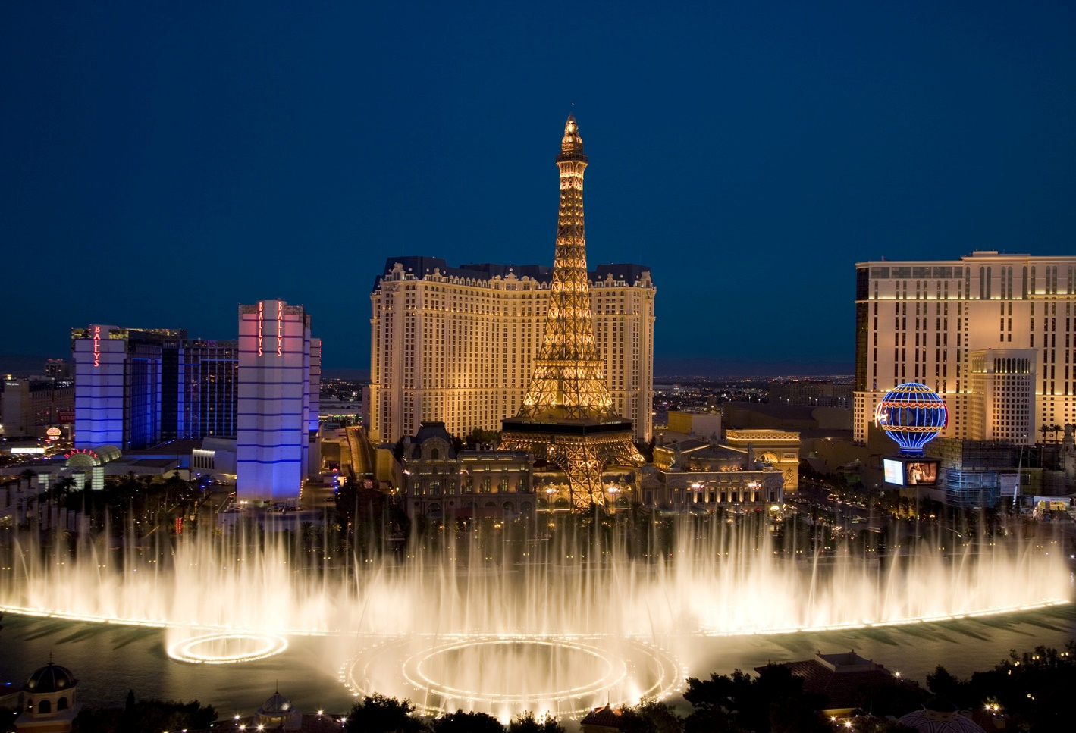12 NIGHTS / 13 DAYS

**ITINERARY**

**DAY 1**

**MUMBAI - NEW YORK**

Welcome to NY!!!! Your pick up will be done on SIC basis. Private pick up is also available at an additional cost if pre booked.

Experience a World Class New York hotel located in fashionable area of Midtown Manhattan when you check into the luxurious midtown property LE PARKER MERIDIEN with breathtaking views of Central Park and the Manhattan skyline. (Check in time 3 PM).

Meet your tour manager at 7 PM in the hotel lobby to start the tour. Enjoy a wonderful buffet Indian dinner at restaurant (walking distance). After dinner, enjoy free time at Times Square on own to see the city in action at night. Overnight at Hotel.

***Meals****: - -, -, Dinner*

***Note****: -*

1. *One carry on and one suitcase per person only.*
2. *Please note that the hotel may take your Credit card at the time of check in towards Incidentals. The hold on the card will be released once the guests check out if no charges are incurred. Porterage is not included in the cost.*
3. *There is no coach on this day.*

**DAY 2**

**NY SOL/ ONE WORLD/ DOUBLE DECKER**

Depart from the hotel at 8 AM in the morning for your breakfast at an American restaurant. After breakfast, proceed to go on to the Statue of Liberty Ferry from Battery Park. View the world famous iconic Statue symbolizing the country’s freedom. Lunch on own. Make a pit stop to see the “NY BULL” on Wall St. This bronze statue weighs 3200 kgs & is a symbol of financial optimism & prosperity. Enjoy a scenic view from the top of Freedom tower observation deck. This is now the tallest building on the Western Hemisphere and stands in place of Twin towers. We will make a photo stop at Ground Zero (*entrance to 9/11 memorial is not included*). Get down to get a closer look at Rockefeller center comprising of 19 high rise commercial buildings. Declared a national historic monument, you will be able to get quick photos of this landmark. Explore Souvenir shopping to take some excellent mementos back home. Experience New York at its best from a double-decker bus. In “The City that Never Sleeps,” the best sightseeing happens after the sun goes down. Discover the brilliant lights, stunning views and vibrant nightlife with double-decker Night Tour! Overnight at hotel.

***Meals****: - Breakfast, -, Dinner*

**DAY 3**

**NEW YORK – PHILADELPHIA – BALTIMORE - WASHINGTON DC**

Get an early start to your day & drive to Philadelphia (approximately 2 hours’ drive without traffic). Enjoy an entertaining tour of the largest city in Pennsylvania State (guided city tour). Our entertaining tour guide is a history buff, and he will relate the love of the city and a real sense of Philadelphia’s place in history to the group. Lunch on own. Drive to the beautiful city of Baltimore (2 hours’ drive approximately) Enjoy free time on own at Baltimore’s inner harbor offering a wide variety of restaurants, shopping, street performances and much more aboard Water Taxi. Drive to outskirts of DC to check into your hotel (approximately one hour’ drive). Dinner en-route. Check into Marriott Tysons or similar. Overnight at hotel.

***Meals****: - Breakfast, -, Dinner*

**DAY 4**

**HARRISBURG CITY TOUR OF DC/ AIR & SPACE/MUSEUM OF NATURAL HISTORY/HERSHEY’S**

Today after breakfast, enjoy city tour of DC with a specialized guide covering all the major landmarks. See all the key attractions in DC and learn about the history and trivia that surrounds Washington on this interactive tour of the capital city. You will visit the major monuments on this quick and efficient.

At the end of the city tour, you will be given time at Air & space museum (1 hour and 30 minutes) to view all the different exhibits related to space & Aeronautics. Lunch on own. You will also be given time to visit museum of Natural history (1 hour and 30 minutes).

Proceed to Hershey’s Chocolate world & enjoy a ride depicting the various stages of chocolate making. Dinner at Indian restaurant & check into Hotel (Hilton Harrisburg or Similar). Overnight at hotel.

***Meals****: - Breakfast, -, Dinner*

**DAY 5**

**NIAGARA FALLS- PENN STATE CAPITOL/ CORNING/NIAGARA BY NIGHT**

After breakfast, proceed to do the Pennsylvania Capitol tour (if open for tours) & drive to Corning Glass museum (approximately 3 hours) to view over 40,000 objects representing more than 3500 years’ of glass making. Lunch on own. Proceed to Niagara Falls (approximately 2 hours of drive). Dinner at Indian restaurant enroute. View the illumination of falls at night. This illumination includes a range of colors that alternate throughout the evening and shine over all of Niagara Falls & stay overnight at hotel (Sheraton at the falls or similar).

***Meals****: - Breakfast, -, Dinner*

**DAY 6**

**NIAGARA FALLS MAID OF THE MIST/ CAVE OF THE WINDS/IMAX**

Today after breakfast, enjoy a 30 minute IMAX movie at the Niagara adventure theatre. To view you next attraction, Cave of the Winds, you will take an elevator ride- 175 feet below to get to a feel the power of Niagara Falls first hand. Geared-up in a souvenir rain poncho and specially designed sandals, guests follow wooden walkways along Niagara River to the Hurricane Deck. Do not forget to take extra pair of clothes as you will definitely get wet. You will also take a closer look at the Bridal Veil Falls in a boat ride abroad Maid of the Mist. Lunch on own. Evening Free on own. Dinner at Indian restaurant & overnight at hotel.

***Meals****: - Breakfast, -, Dinner*

***Note****: - The hotel is walking distance to the park. There will be no coach on this day of the tour.*

**DAY 7**

**BUFFALO – LAS VEGAS (NO FULL DAY COACH)**

After breakfast, our representative will pick you up from the hotel for airport transfer based on your individual flights (*please note that check out time is 11 AM*).

Welcome to LAS VEGAS!!!! Your pick up will be done by our airport representative at Baggage claim for Domestic passengers on private basis. In order for us to coordinate the pick-up, we need a valid contact number for the passengers. Check into Hotel PARIS (*Check in time 3 PM*).

Meet your tour manager at 6 PM in the hotel lobby to start the tour. Enjoy a wonderful buffet dinner at Indian restaurant. Take a ride 46 stories up in an Exhilarating, adrenaline charged glass elevator of Eiffel tower in PARIS hotel to get an amazing 360 degree views of the city. This attraction is half scale replica of world famous Paris, France Landmark and the views of bright, colorful lights are unmatched from the top.

Overnight at hotel.

***Meals****: - Breakfast, -, Dinner*

***Note****: -*

1. *Packed breakfast option is not available for guests departing by early morning flight from Buffalo.*
2. *Please note that the hotel in Vegas may take your Credit Card at the time of check in towards Incidentals. The hold on the card will be released once the guests check out if no charges are incurred. If you would like to do an early check in, please check in with the front desk. Early check in fee is approximately $22 per room based on availability.*

**DAY 8**

**LAS VEGAS - BIG BUS TOUR (NO FULL DAY COACH)**

Today is a free day on own. If you have booked your Grand Canyon through us, our Tour manager will drop you off at the pickup location for your tour and Breakfast will be packed for those passengers taking the Grand Canyon coach tours. For passengers, choosing to not take the Grand Canyon, you will be provided with continental buffet breakfast at St. Louis Café restaurant inside Paris.

After Dinner at Indian restaurant, you will be taken around the city in a Double-decker bus where your guide will explain all about Sin city. As dusk falls, the city turns on. See the dazzling neon lights as you travel down the strip and roll past casinos, wedding chapels and historic landmarks into the heart of downtown. Overnight at hotel.

***Meals****: - Breakfast, -, Dinner*

**DAY 9**

**LOS ANGELES CITY TOUR/OUE SKYSPACE**

After buffet breakfast at the hotel, have an early start & depart for Los Angeles. Stop for lunch en-route. Visit OUE Skyspace and experience a panoramic 360-degree view from the second tallest building West of Mississippi. The building structure is designed to withstand earthquakes to the magnitude of 8.3 on Richter scale. You will be taken to the 70th floor to get a wonderful view of the city. You can also slide from one level of the building to another to get a glimpse of the city in its glory.

Proceed for City Tour of Los Angeles. Enjoy a guided tour of Los Angeles by our experienced tour guide. Drive through the busy streets of Avenue of Stars, Kodak Theater and Rodeo Drive. Get your picture of the famous Hollywood sign from one of the vantage points. Dinner at Indian restaurant.

Check into Hotel for Overnight stay.

***Meals****: - Breakfast, -, Dinner*

**DAY 10**

**LOS ANGELES UNIVERSAL STUDIOS/SANTA MONICA BEACH**

After breakfast at the hotel, You will then be taken to Universal Studios to enjoy the full day at the park. This Sprawling Amusement park with thrilling theme rides, restaurants, shows, shops and one of the oldest real working movie studio in use is definitely a unique & fun filled experience for the whole family. From there, drive to Santa Monica Beach & enjoy a relaxed time at the Pier. With a carousel, an arcade, an amusement park, restaurants, the Santa Monica Pier offers a wide range of activities for the whole family. Drive to Indian restaurant for dinner Evening Dinner at Indian restaurant. Overnight at Hotel.

***Meals****: - Breakfast, -, Dinner*

***Note****: - The itinerary in Los Angeles is subject to change based on traffic conditions.*

**DAY 11**

**SAN FRANCISCO - SOLVANG/HORSE TROLLEY**

Today after breakfast, you will drive to Solvang (approximately 3 hours). Also known as Danish city of California, Solvang is known for its’ untamed beauty and perfect weather all throughout the year. Enjoy Lunch on own. You will take a historic 25-minute ride though the city’s downtown in a Horse trolley (IF OPEN). Board your bus & drive to San Francisco (approximately 4 hours). Dinner at Indian restaurant & overnight at Hotel.

***Meals****: - Breakfast, -, Dinner*

**DAY 12**

**SAN FRANCISCO BAY CRUISE/CITY TOUR/CABLE CAR**

You will have a full day to enjoy in San Francisco today. After breakfast at the hotel, enjoy the amazing skyline of San Francisco on BAY CRUISE with spectacular views of Alcatraz, Golden Gate Bridge & Bay Bridge. An Audio tour in 16 languages is available to get detailed history of this great city. Lunch on own. Your guide today will cover all the major highlights of the city in an in-depth city tour including TWIN PEAKS, San Francisco's Twin Peaks are two prominent hills near the center of the city. Each one stands at about 922 feet tall, and they offer amazing views of the Bay Area all the way down to the water. Enjoy a wonderful ride aboard Cable car, the world’s last manually operated Cable car system (if operational). Dinner at Indian restaurant & Overnight at hotel.

***Meals****: - Breakfast, -, Dinner*

**DAY 13**

**SAN FRANCISCO - MUMBAI**

Today after breakfast, check out from the hotel (check out time is 11 am). The hotel offers complimentary shuttle to the airport. Please check with the bell desk regarding shuttle timings. If you have any early flight & no shuttle is operational, please take a cab on own. (Shuttle timings is from 5 AM to 9 PM).

***Meals****: - Breakfast, -, -*

***Note****: - Shuttle timings is from 5 AM to 9 PM*

**DEPARTURE DATES**

|  |  |  |  |
| --- | --- | --- | --- |
| APRIL 2017 | 19, 26 | AUGUST 2017 | 2, 9, 16, 23, 30 |
| MAY 2017 | 3, 10, 17, 24, 31 | SEPTEMBER 2017 | 6, 13, 20, 27 |
| JUNE 2017 | 7, 14, 21, 28 | OCTOBER 2017 | 4, 11, 18, 25 |
| JULY 2017 | 5, 12, 19, 26 | NOVEMBER 2017 | 1 |

**HOTELS**

|  |  |  |
| --- | --- | --- |
| **CITY** | **HOTEL** | **No of Nights** |
| **New York** | Le Parker Meridian or similar | 02 |
| **Washington** | Marriott Tysons Corner / Courtyard by Marriott Silver Springs North or similar | 01 |
| **Harrisburg, PA** | Hilton Harrisburg or similar | 01 |
| **Niagara Falls NY** | Sheraton at the Falls or similar | 02 |
| **Las Vegas** | Hotel Paris or similar | 02 |
| **Los Angeles** | Double Tree by Hilton Torrance or similar | 02 |
| **San Francisco** | San Mateo Marriott or similar | 02 |

**TOUR COST**

**Tour cost given below is per person in US$**

|  |  |  |  |  |
| --- | --- | --- | --- | --- |
| **BASIC TOUR COST** | | | | |
| **Tour Name** | **DBL** | **TRIPLE** | **QUAD** | **CHILD** |
| USA West Coast Tour | 3247 | 3028 | 2915 | 1775 |

**TOUR INCLUSIONS**

* All hotels as mentioned below
* Airport transfer on SIC basis from JFK to New York Hotel.
* Airport transfer on private basis from Niagara hotel to Buffalo Airport & Las Vegas Airport to Vegas hotel.
* Airport transfer through hotel shuttle in San Francisco.
* 12 Dinners at Indian restaurant (choice of Veg, Non Veg & Jain)
* 11 American Buffet breakfasts & 01 Continental Breakfast
* Hindi speaking tour director
  + East Coast Tour Director will meet at 7 PM on Day 1 in the hotel lobby and be with the group till end of Day 6.
  + West Coast Tour Director will meet at 6PM on Day 7 in Vegas Hotel lobby and be with the group till the end of Day 12
* Tour will be conducted in a 55 seater/22 seater/15 seater/van based on the number of people signed for the tour.
* Wi-Fi at all hotels as well as 55 seater coach. N/A for smaller coaches/vans.
* Sightseeing:
  + Statue Of Liberty
  + Wall St Bull
  + Freedom Tower
  + Pit Stop at Rockefeller Center
  + Pit Stop at Ground Zero
  + Double Decker City Tour In NY
  + Philadelphia City Tour (Guided)
  + Baltimore Water Taxi
  + City Tour Of DC (Guided)
  + Air & Space Museum
  + Hershey’s Chocolate World
  + Pennsylvania State Capitol (if open) Guided
  + Corning Glass Museum
  + Illumination Of Falls
  + Imax Movie In Niagara
  + Cave Of The Winds
  + Maid Of The Mist
  + Trolley Ride in Niagara
  + Double-decker City Tour In Vegas
  + Eiffel Tower in Paris
  + Oue Skyspace With Slide
  + Santa Monica Beach
  + City Tour Of Los Angeles (Guided)
  + Universal Studios
  + Horse Trolley in Solvang (not operational during few dates in August & September) as well as when the temp is above 95 degrees.
  + Bay Cruise
  + City Tour Of San Francisco (Guided)
  + Flyer SF
  + Cable Car (If Operational)

**EXCLUSIONS:**

* **Govt Service Tax of 5% over and above the Tour Cost mentioned payable to the Govt of India**
* Lunches
* Mandatory tips (East Cost $12 + West Coast $10 per person for the duration of the tour) to be given to the tour director. This cannot be pre-paid.
* International & Domestic Air Ticket cost.
* Any increase in Airfare, Visa fees, Airport taxes, Govt Taxes, Fuel Surcharges and any applicability of new taxes from Govt.
* Any up gradation in Airline class or hotel room category
* Cost of Air ticket deviation charges
* Any increase in the rate of exchange leading to an increase in all land arrangements which may come in to effect prior to departure
* Cost of pre or post tour hotel accommodation
* Any extra expense such as route change, Airline change, Date change, Accommodation facilities, etc. incurred due to the unforeseen, unavoidable forced majeure circumstances during the tour
* Cost of insurance
* Porterage, laundry, telephone charges, shopping, wines and alcoholic beverages, mineral water, items of personal nature and food or drink which is not part of a set group menu
* Any extra cost incurred on behalf of an individual due to illness, accident, hospitalization, or any personal emergency
* Any services or activity charges other than those included in the group tour itinerary
* To and fro Air fare, Airport transfers, visa fees to join/leave the group and Airport snack hamper for joining and leaving guests
* Anything specifically not mentioned in the ‘tour price includes’ column

**NOTE:**

* Rates are Subject to change without prior notice. Rooms are Subject to availability.
* The above rate are valid for the requested period only.
* No reservation is made. No refund on any unutilized services.
* Local City tax if applicable needs to be paid directly at the Hotel.
* Bedding configuration is not guaranteed, subject to an availability.
* Hotel category is based on respective vendor discretion & It may vary as per International/ Local standard.
* Clients arriving at odd hours may be charged additionally.
* The transfers are valid if the hotel is within city limits. Services are subject to availability.
* Itinerary is subject to change depending on Flight Schedule, Availability of Rooms and Road Conditions.
* The final tour cost will be calculated in INR based on the rate of exchange applicable as per the date on which final payment is made.
* Payment will be collected as per the rates of exchange applicable on the day of the payments.
* Above is a tentative proposed itinerary. Final itinerary will be given after confirmation of the tour programmed.
* The above quotation has been based on specific hotels. In case the hotel rooms are not available as specified above the alternate hotels will be suggested. The difference in cost is payable extra.
* Orbitrek Tours & Travels reserves the right to make minor modifications to the daily itinerary flow based on weather, traffic, or other conditions for the convenience of the traveling customers. We reserve the right to use Van/Minibus/Coach depending on the number of passengers.
* In case of coach break down due to mechanical failures, the company will make every effort to fix the problem but please note that there will be no monetary compensation for the inconvenience caused.
* International check in timing is 1400 hrs and check out timing is 1100 hrs.
* Early check-in and late checkout are on request basis only and subject to room availability.