USA – EAST COAST TOUR

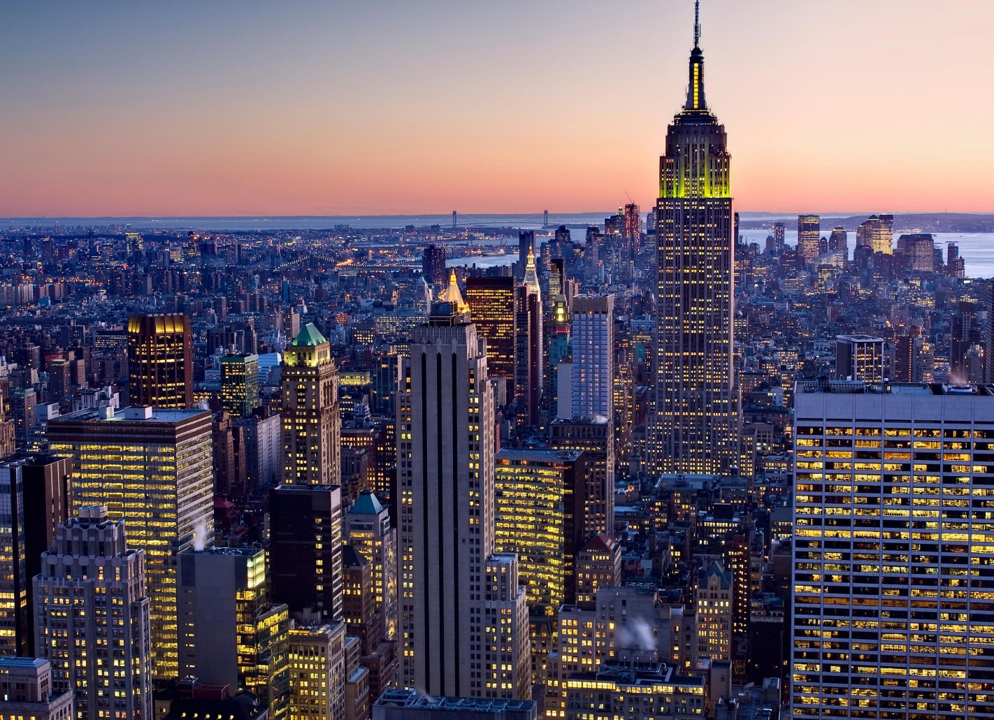6 NIGHTS / 7 DAYS

**ITINERARY**

**DAY 1**

**ARRIVAL IN NEW YORK**

**Welcome to New York!!!**

Welcome to NY!!!! Your pick up will be done on SIC basis. Private pick up is also available at an additional cost if pre booked.

Check into Hotel Le Parker Meridian (Check in time 3 PM).

Meet your tour manager at 7 pm in the hotel lobby to start the tour. Enjoy a wonderful buffet dinner at Indian restaurant (walking distance). After dinner, enjoy free time at Times Square on own to see the city in action at night. Overnight at Hotel.

***Meals****: - -, -, Dinner*

***Note****: -*

1. *One carry on and one suitcase per person only*
2. *Please note that the hotel may take your Credit card at the time of check in towards Incidentals. The hold on the card will be released once the guests check out if no charges are incurred. Porterage is not included in the cost.*

**DAY 2**

**NEW YORK CITY TOUR**

Depart from the hotel at 8 AM in the morning for your breakfast at an American restaurant. After breakfast, proceed to go on to the Statue of Liberty Ferry from Battery Park. View the world famous iconic Statue symbolizing the country’s freedom. Lunch on own. Make a pit stop to see the “NY BULL” on Wall St. This bronze statue weighs 3200 kgs and is a symbol of financial optimism & prosperity. Enjoy a scenic view from the top of Freedom tower observation deck. This is now the tallest building on the Western Hemisphere and stands in place of Twin towers. We will make a photo stop at Ground Zero (*entrance to 9/11 memorial is not included*). Get down to get a closer look at Rockefeller center comprising of 19 high rise commercial buildings. Declared a national historic monument, you will be able to get quick photos of this landmark. Explore Souvenir shopping to take some excellent mementos back home. Experience New York at its best from a double-decker bus. In “The City that Never Sleeps,” the best sightseeing happens after the sun goes down. Discover the brilliant lights, stunning views and vibrant nightlife with double-decker Night Tour! Overnight at hotel.

***Meals****: - Breakfast, -, Dinner*

**DAY 3**

**NEW YORK – PHILADELPHIA – BALTIMORE - WASHINGTON DC**

Get an early start to your day & drive to Philadelphia (approximately 2 hours’ drive without traffic. Enjoy an entertaining tour of the largest city in Pennsylvania State (guided city tour). Our entertaining tour guide is a history buff, and he will relate the love of the city and a real sense of Philadelphia’s place in history to the group. Lunch on own. Drive to the beautiful city of Baltimore (2 hours’ drive approximately) Enjoy free time on own at Baltimore’s inner harbor offering a wide variety of restaurants, shopping, street performances and much more abroad Water Taxi. Drive to outskirts of DC to check into your hotel (approximately one hour drive). Dinner en-route. Check into Marriott Tysons or Similar. Overnight at hotel.

***Meals****: - Breakfast, -, Dinner*

**DAY 4**

**WASHINGTON DC**

Today after breakfast, enjoy city tour of DC with a specialized guide covering all the major landmarks. See all the key attractions in DC and learn about the history and trivia that surrounds Washington on this interactive tour of the capital city. You will visit the major monuments on this quick and efficient city tour.

At the end of the city tour, you will be given time at Air & Space Museum (1 hour and 30 minutes) to view all the different exhibits related to Space & Aeronautics. Lunch on own. You will also be given time to visit Museum of Natural History (1 hour and 30 minutes).

Later proceed to Hershey’s Chocolate world & enjoy a ride depicting the various stages of chocolate making. Dinner at Indian restaurant & check into Hotel (Hilton Harrisburg or similar). Overnight at hotel.

***Meals****: - Breakfast, -, Dinner*

**DAY 5**

**PENNSYLVANIA CAPITOL TOUR - NIAGARA FALLS**

After breakfast, proceed to do the Pennsylvania Capitol tour (if open for tours) & drive to Corning Glass museum (approximately 3 hours) to view over 40,000 objects representing more than 3500 years’ of glass making. Lunch on own. Proceed to Niagara Falls (approximately 2 hours of drive). Dinner at Indian restaurant en-route. View the illumination of the falls at night. This illumination includes a range of colors that alternate throughout the evening and shine over all of Niagara Falls & stay overnight at hotel (Sheraton at the Falls or similar)

***Meals****: - Breakfast, -, Dinner*

**DAY 6**

**NIAGARA FALLS (NO COACH)**

The hotel is walking distance to the park. There will be no coach on this day of the tour.

Today after breakfast, enjoy a 30 minute IMAX movie at the Niagara adventure theatre. To view you next attraction, Cave of the Winds, you will take an elevator ride- 175 feet below to get to a feel the power of the Niagara Falls first hand. Geared-up in a souvenir rain poncho and specially designed sandals, guests follow wooden walkways along Niagara River to the Hurricane Deck. Do not forget to take extra pair of clothes as you will definitely get wet. You will also take a closer look at the Bridal Veil Falls in a boat ride abroad Maid of the mist. Lunch on own. Evening is free for you to explore on your own. Dinner at Indian restaurant & overnight at hotel.

***Meals****: - Breakfast, -, Dinner*

**DAY 7**

**NIAGARA – MUMBAI**

After breakfast, our representative will pick you up from the hotel for airport transfer based on your individual flights (please note that check out time is 11 am).

***Meals****: - Breakfast, -, -*

***Note****: - Packed breakfast option is not available for guests departing by early morning flight.*

**DEPARTURE DATES:**

|  |  |  |  |
| --- | --- | --- | --- |
| APRIL 2018 | 19, 26 | AUGUST 2018 | 2, 9, 16, 23, 30 |
| MAY 2018 | 3, 10, 17, 24, 31 | SEPTEMBER 2018 | 6, 13, 20, 27 |
| JUNE 2018 | 7, 14, 21, 28 | OCTOBER 2018 | 4, 11, 18, 25 |
| JULY 2018 | 5, 12, 19, 26 | NOVEMBER 2018 | 1, 15 |

**HOTELS**

|  |  |  |
| --- | --- | --- |
| **CITY** | **HOTEL** | **No of Nights** |
| **New York** | Le Parker Meridian or similar | 02 |
| **Washington** | Marriott Tysons Corner / Courtyard by Marriott Silver Springs North or similar | 01 |
| **Harrisburg, PA** | Hilton Harrisburg or similar | 01 |
| **Niagara Falls NY** | Sheraton at the Falls or similar | 02 |

**TOUR COST**

**Tour cost given below is per person in US$**

|  |  |  |  |  |
| --- | --- | --- | --- | --- |
| **BASIC TOUR PACKAGE** | | | | |
| **Tour Name** | **DBL** | **TRIPLE** | **QUAD** | **CHILD** |
| USA East Coast Tour | 1763 | 1712 | 1604 | 1010 |

Supplement charge for airport transfer from Newark Intl. Airport / LaGuardia Airport applies.

|  |  |
| --- | --- |
| **AIRPORT** | **FLAT RATE (approx)** |
| Newark Intl. Airport (EWR) | US$ 250 |
| LaGuardia Airport (LGA) | US$ 85 |

**TOUR INCLUSIONS**

* SIC Airport Transfers from JFK to hotel on Day 01
* Private Transfer from hotel to Buffalo Airport on Day 07
* 6 Nights’ Accommodation in above mentioned hotels
* 6 American Buffet Breakfasts
* 6 Dinners at Indian Restaurant (Veg/Non Veg / Jain)
* Hindi speaking tour director (will meet at 7 PM on day 1 & be with the group till end of day 6)
* Tour will be conducted in a 55 seater/22 seater/15 seater/van based on the number of people signed for the tour
* Wi-Fi at all hotels as well as 55 seater coach. N/A for smaller vans/coaches.
* Sightseeing:
  + Statue Of Liberty
  + Wall St Bull
  + Freedom Tower
  + Pit Stop at Rockefeller Center
  + Pit Stop at Ground Zero
  + Double Decker City Tour In NY
  + Philadelphia City Tour (Guided)
  + Baltimore Water Taxi
  + City Tour Of DC (Guided)
  + Air & Space Museum
  + Hershey’s Chocolate World
  + Pennsylvania State Capitol (if open) Guided
  + Corning Glass Museum
  + Illumination Of Falls
  + Imax Movie In Niagara
  + Cave Of The Winds
  + Maid Of The Mist

**EXCLUSIONS:**

* **Govt Service Tax of 5% over and above the Tour Cost mentioned payable to the Govt of India**
* Lunches
* Mandatory tips ($12 per person for the entire tour) to be given to the tour director. This cannot be pre-paid.
* International & Domestic Air Ticket cost.
* Any increase in Airfare, Visa fees, Airport taxes, Govt Taxes, Fuel Surcharges and any applicability of new taxes from Govt.
* Any up gradation in Airline class or hotel room category
* Cost of Air ticket deviation charges
* Any increase in the rate of exchange leading to an increase in all land arrangements which may come in to effect prior to departure
* Cost of pre or post tour hotel accommodation
* Any extra expense such as route change, Airline change, Date change, Accommodation facilities, etc. incurred due to the unforeseen, unavoidable forced majeure circumstances during the tour
* Cost of insurance
* Porterage, laundry, telephone charges, shopping, wines and alcoholic beverages, mineral water, items of personal nature and food or drink which is not part of a set group menu
* Any extra cost incurred on behalf of an individual due to illness, accident, hospitalization, or any personal emergency
* Any services or activity charges other than those included in the group tour itinerary
* To and fro Air fare, Airport transfers, visa fees to join/leave the group and Airport snack hamper for joining and leaving guests
* Anything specifically not mentioned in the ‘tour price includes’ column

**NOTE:**

* Rates are Subject to change without prior notice. Rooms are Subject to availability.
* The above rate are valid for the requested period only.
* No reservation is made. No refund on any unutilized services.
* Local City tax if applicable needs to be paid directly at the Hotel.
* Bedding configuration is not guaranteed, subject to an availability.
* Hotel category is based on respective vendor discretion & It may vary as per International/ Local standard.
* Clients arriving at odd hours may be charged additionally.
* The transfers are valid if the hotel is within city limits. Services are subject to availability.
* Itinerary is subject to change depending on Flight Schedule, Availability of Rooms and Road Conditions.
* The final tour cost will be calculated in INR based on the rate of exchange applicable as per the date on which final payment is made.
* Payment will be collected as per the rates of exchange applicable on the day of the payments.
* Above is a tentative proposed itinerary. Final itinerary will be given after confirmation of the tour programmed.
* The above quotation has been based on specific hotels. In case the hotel rooms are not available as specified above the alternate hotels will be suggested. The difference in cost is payable extra.
* Orbitrek Tours & Travels reserves the right to make minor modifications to the daily itinerary flow based on weather, traffic, or other conditions for the convenience of the traveling customers. We reserve the right to use Van/Minibus/Coach depending on the number of passengers.
* In case of coach break down due to mechanical failures, the company will make every effort to fix the problem but please note that there will be no monetary compensation for the inconvenience caused.
* International check in timing is 1400 hrs and check out timing is 1100 hrs.
* Early check-in and late checkout are on request basis only and subject to room availability.