USA – WEST COAST TOUR

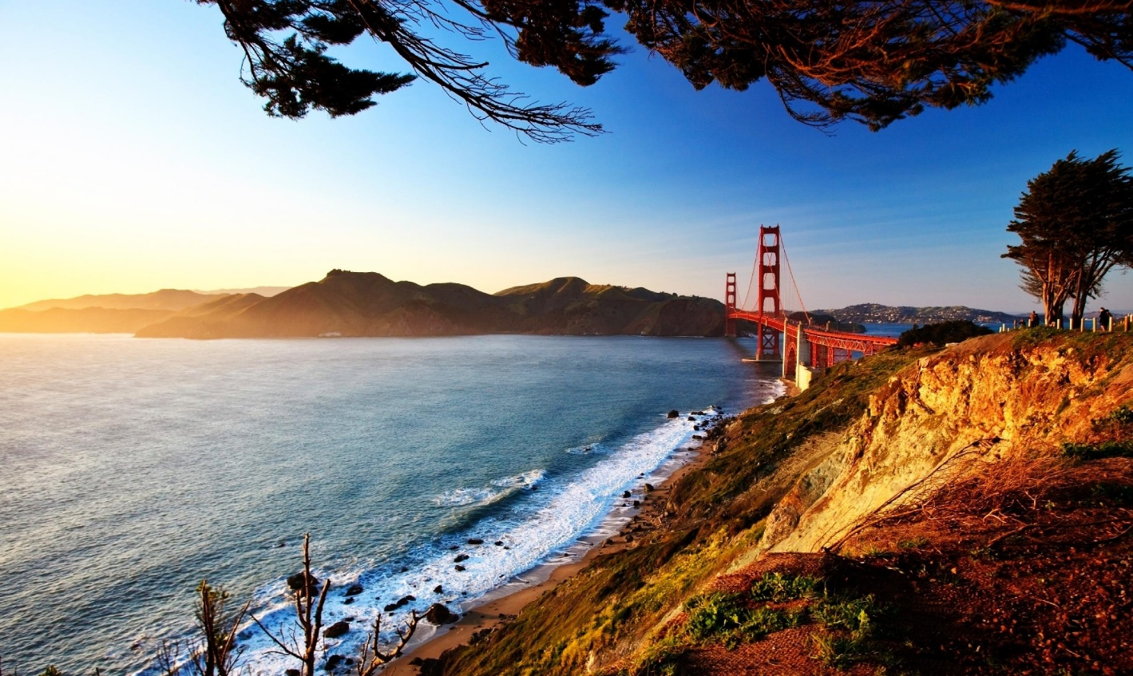6 NIGHTS / 7 DAYS

**ITINERARY**

**DAY 1**

**LAS VEGAS – VEGAS EIFFEL TOWER (NO FULL DAY COACH)**

**Welcome to LAS VEGAS!!!!**

Your pick up will be done by our airport representative at baggage claim for Domestic passengers on private basis. (Inorder for us to coordinate the pick-up, we need a valid contact number for the passengers). Check into Hotel PARIS (Check in time 3 PM).

Meet your tour manager at 6 PM in the hotel lobby to start the tour. Enjoy a wonderful buffet dinner at Indian restaurant. Take a ride 46 stories up in an Exhilarating, adrenaline charged glass elevator of Eiffel tower in PARIS hotel to get an amazing 360 degree views of the city. This attraction is half scale replica of world famous Paris, France Landmark and the views of bright, colorful lights are unmatched from the top.

Overnight at hotel.

***Meals****: - -, -, Dinner*

***Note****: - Please note that the hotel may take your Credit card at the time of check in towards Incidentals. The hold on the card will be released once the guests check out if no charges are incurred. If you would like to do an early check in, please check in with the front desk. Early check in fee is approximately $22 per room based on availability.*

**DAY 2**

**LAS VEGAS – FREE DAY / OPTIONAL GRAND CANYON – BIG BUS TOUR (NO FULL DAY COACH)**

Today is a free day on own. If you have booked your Grand Canyon through us, our Tour Manager will drop you off at the pickup location for your tour and Breakfast will be packed for those passengers taking the Grand Canyon coach tours. For passengers, choosing to not take the Grand Canyon, you will be provided with continental buffet breakfast at St. Louis Café restaurant inside Paris.

After Dinner at Indian restaurant, you will be taken around the city in a Double-decker bus where your guide will explain all about Sin city. As dusk falls, the city turns on. See the dazzling neon lights as you travel down the strip and roll past casinos, wedding chapels and historic landmarks into the heart of downtown. Overnight at hotel.

***Meals****: - Breakfast, -, Dinner*

**DAY 3**

**LAS VEGAS - LOS ANGELES - CITY TOUR, OUE SKYSPACE**

After buffet breakfast at the hotel, have an early start & depart for Los Angeles. Stop for lunch en-route. Visit OUE Skyspace and experience a panoramic 360-degree view from the second tallest building West of Mississippi. The building structure is designed to withstand earthquakes to the magnitude of 8.3 on Richter scale. You will be taken to the 70th floor to get a wonderful view of the city. You can also slide from one level of the building to another to get a glimpse of the city in its glory.

Proceed for City Tour of Los Angeles. Enjoy a guided tour of Los Angeles by our experienced tour guide. Drive through the busy streets of Avenue of Stars, Kodak Theater and Rodeo Drive. Get your picture of the famous Hollywood sign from one of the vantage points. Dinner at Indian restaurant.

Check into Hotel for Overnight stay.

***Meals****: - Breakfast, -, Dinner*

**DAY 4**

**LOS ANGELES UNIVERSAL STUDIOS, SANTA MONICA BEACH**

After breakfast at the hotel, you will then be taken to Universal Studios to enjoy the full day at the park. This Sprawling Amusement park with thrilling theme rides, restaurants, shows, shops and one of the oldest real working movie studio in use is definitely a unique & fun filled experience for the whole family. From there, drive to Santa Monica Beach & enjoy a relaxed time at the Pier. With a carousel, an arcade, an amusement park, restaurants, the Santa Monica Pier offers a wide range of activities for the whole family. Drive to Indian restaurant for dinner Evening Dinner at Indian restaurant. Overnight at Hotel.

***Meals****: - Breakfast, -, Dinner*

***Note****: - The itinerary in Los Angeles is subject to change based on traffic conditions.*

**DAY 5**

**LOS ANGELES - SAN FRANCISCO SOLVANG / HORSE TROLLEY**

Today after breakfast, you will drive to Solvang (approximately 3 hours). Also known as Danish city of California, Solvang is known for its’ untamed beauty and perfect weather all throughout the year. Enjoy Lunch on own. You will take a historic 25-minute ride though the city’s downtown in a Horse trolley (IF OPEN). Board your bus & drive to San Francisco (approximately 4 hours). Dinner at Indian restaurant & overnight at Hotel.

***Meals****: - Breakfast, -, Dinner*

**DAY 6**

**SAN FRANCISCO BAY CRUISE/CITY TOUR/CABLE CAR**

You will have a full day to enjoy in San Francisco today. After breakfast at the hotel, enjoy the amazing skyline of San Francisco on BAY CRUISE with spectacular views of Alcatraz, Golden Gate Bridge & Bay Bridge. An audio tour in 16 languages is available to get detailed history of this great city. Lunch on own. Your guide today will cover all the major highlights of the city in an in-depth city tour including TWIN PEAKS, San Francisco's Twin Peaks are two prominent hills near the center of the city. Each one stands at about 922 feet tall, and they offer amazing views of the Bay Area all the way down to the water. Enjoy a wonderful ride aboard Cable car (the world’s last manually operated Cable car system- if operational).

Enjoy and Discover San Francisco’s biggest landmarks and attractions in an awe inspiring 3D movie that has you flying with your feet dangling over the city by the bay. The Flyer SF is the perfect way to end your tour.

Dinner at Indian restaurant & Overnight at hotel.

***Meals****: - Breakfast, -, Dinner*

**DAY 7**

**SAN FRANCISCO - MUMBAI**

Today after breakfast, check out from the hotel (check out time is 11 am). The hotel offers complimentary shuttle to the airport. Please check with the bell desk regarding shuttle timings. If you have any early flight & no shuttle is operational, please take a cab on own.

***Meals****: - Breakfast, -, -*

***Note****: - Shuttle timings is from 5 AM to 9 PM*

**DEPARTURE DATES**

|  |  |  |  |
| --- | --- | --- | --- |
| APRIL 2017 | 25 | AUGUST 2017 | 1, 8, 15, 22, 29 |
| MAY 2017 | 2, 9, 16, 23, 30 | SEPTEMBER 2017 | 5, 12, 19, 26 |
| JUNE 2017 | 6, 13, 20, 27 | OCTOBER 2017 | 3, 10, 17, 24, 31 |
| JULY 2017 | 4, 11, 18, 25 | NOVEMBER 2017 | 7 |

**HOTELS**

|  |  |  |
| --- | --- | --- |
| **CITY** | **HOTEL** | **No of Nights** |
| **Las Vegas** | Hotel Paris or similar | 02 |
| **Los Angeles** | Double Tree by Hilton Torrance or similar | 02 |
| **San Francisco** | San Mateo Marriott or similar | 02 |

**TOUR COST**

**Tour cost given below is per person in US$**

|  |  |  |  |  |
| --- | --- | --- | --- | --- |
| **BASIC TOUR COST** | | | | |
| **Tour Name** | **DBL** | **TRIPLE** | **QUAD** | **CHILD** |
| USA West Coast Tour | 1797 | 1706 | 1645 | 1080 |

**TOUR INCLUSIONS**

* All hotels as mentioned below
* Airport transfers on private basis (from Las Vegas Airport). Departure will be via hotel shuttle in San Francisco.
* 6 Dinners at Indian restaurant (choice of veg, non veg & Jain)
* 5 American buffet breakfasts & 01 Continental Breakfast (packed)
* Hindi speaking tour director (will meet at 6 pm on day 1 in the hotel lobby & be with the group till end of day 6)
* Tour will be conducted in a 55 seater/22 seater/15 seater/van based on the number of people signed for the tour.
* Wi-Fi at all hotels as well as 55 seater coach. N/A for smaller coaches/vans.
* Sightseeing:
  + Double-decker City Tour In Vegas
  + Eiffel Tower in Paris
  + Oue Skyspace With Slide
  + Santa Monica Beach
  + City Tour Of Los Angeles (Guided)
  + Universal Studios
  + Horse Trolley in Solvang (not operational during few dates in August & September) as well as when the temp is above 95 degrees.
  + Bay Cruise
  + City Tour Of San Francisco (Guided)
  + Flyer SF
  + Cable Car (If Operational)

**EXCLUSIONS:**

* **Govt Service Tax of 9% over and above the Tour Cost mentioned payable to the Govt of India**
* Lunches
* Mandatory tips ($10 per person for the duration of the tour) to be given to the tour director. This cannot be pre-paid.
* International & Domestic Air Ticket cost.
* Any increase in Airfare, Visa fees, Airport taxes, Govt Taxes, Fuel Surcharges and any applicability of new taxes from Govt.
* Any up gradation in Airline class or hotel room category
* Cost of Air ticket deviation charges
* Any increase in the rate of exchange leading to an increase in all land arrangements which may come in to effect prior to departure
* Cost of pre or post tour hotel accommodation
* Any extra expense such as route change, Airline change, Date change, Accommodation facilities, etc. incurred due to the unforeseen, unavoidable forced majeure circumstances during the tour
* Cost of insurance
* Porterage, laundry, telephone charges, shopping, wines and alcoholic beverages, mineral water, items of personal nature and food or drink which is not part of a set group menu
* Any extra cost incurred on behalf of an individual due to illness, accident, hospitalization, or any personal emergency
* Any services or activity charges other than those included in the group tour itinerary
* To and fro Air fare, Airport transfers, visa fees to join/leave the group and Airport snack hamper for joining and leaving guests
* Anything specifically not mentioned in the ‘tour price includes’ column

**NOTE:**

* Rates are Subject to change without prior notice. Rooms are Subject to availability.
* The above rate are valid for the requested period only.
* No reservation is made. No refund on any unutilized services.
* Local City tax if applicable needs to be paid directly at the Hotel.
* Bedding configuration is not guaranteed, subject to an availability.
* Hotel category is based on respective vendor discretion & It may vary as per International/ Local standard.
* Clients arriving at odd hours may be charged additionally.
* The transfers are valid if the hotel is within city limits. Services are subject to availability.
* Itinerary is subject to change depending on Flight Schedule, Availability of Rooms and Road Conditions.
* The final tour cost will be calculated in INR based on the rate of exchange applicable as per the date on which final payment is made.
* Payment will be collected as per the rates of exchange applicable on the day of the payments.
* Above is a tentative proposed itinerary. Final itinerary will be given after confirmation of the tour programmed.
* The above quotation has been based on specific hotels. In case the hotel rooms are not available as specified above the alternate hotels will be suggested. The difference in cost is payable extra.
* Orbitrek Tours & Travels reserves the right to make minor modifications to the daily itinerary flow based on weather, traffic, or other conditions for the convenience of the traveling customers. We reserve the right to use Van/Minibus/Coach depending on the number of passengers.
* In case of coach break down due to mechanical failures, the company will make every effort to fix the problem but please note that there will be no monetary compensation for the inconvenience caused.
* International check in timing is 1400 hrs and check out timing is 1100 hrs.
* Early check-in and late checkout are on request basis only and subject to room availability.