# Deploying Shared Contracts

# At Transaction Value 1

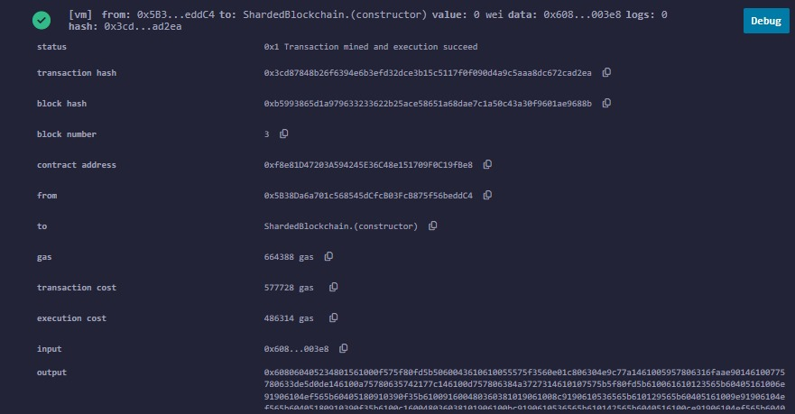

# At transaction value 100

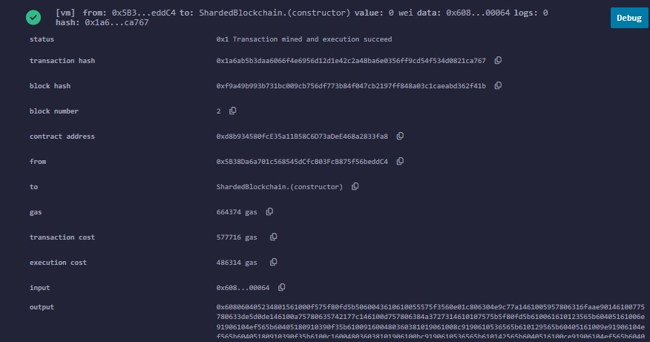

# At transaction value 1000

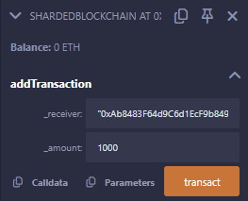

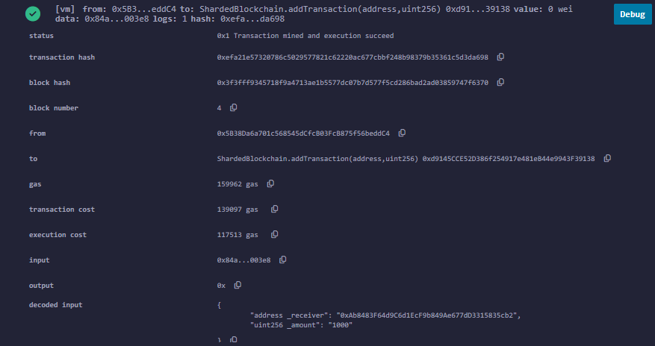

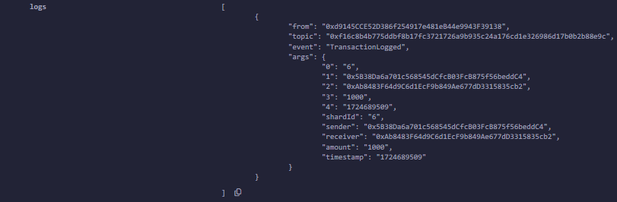

# Storage being taken

{

"0x1067e207f3a3e45d01a1c2fa0f4f47d38ea7ac9223d8e697f73f5b732cc447dd": {

"key": "0x5e794a9b4993e105344618b5713d9a76b3053780dcd5e516cc87ed8991c4dcb3",

"value": "0xab8483f64d9c6d1ecf9b849ae677dd3315835cb2"

},

"0x5e794a9b4993e105344618b5713d9a76b3053780dcd5e516cc87ed8991c4dcae": {

"key": "0x62103cf3131c85df57aad364d21cba02556d3092d6cb54c298c2e7726a7870be",

"value": "0x02"

},

"0x6ae2bd59403227d4b6d5b264ae6fe6908c794ced3c03407926051b634afcd964": {

"key": "0x5e794a9b4993e105344618b5713d9a76b3053780dcd5e516cc87ed8991c4dcb1",

"value": "0x66ccac65"

},

"0x74c0ee1288c7dfd98d6c158e29b5effbee92d8e5a5aed97b9ac884c07e24144a": {

"key": "0x5e794a9b4993e105344618b5713d9a76b3053780dcd5e516cc87ed8991c4dcb4",

"value": "0x03e8"

},

"0x8f25b36785e0c3050db51d2d71110967f9e718018b8a779e99b56722dece6b36": {

"key": "0x5e794a9b4993e105344618b5713d9a76b3053780dcd5e516cc87ed8991c4dcb0",

"value": "0x03e8"

},

"0x9933b55bcf16d74f82330386a7dd8121a83bd82a4bdd24557a06f267db6fe53e": {

"key": "0x5e794a9b4993e105344618b5713d9a76b3053780dcd5e516cc87ed8991c4dcb5",

"value": "0x66ccae4f"

},

"0xa29d5cb89db49c186db90995be4aab1846936a4a0a48f33df306ce271824da04": {

"key": "0x5e794a9b4993e105344618b5713d9a76b3053780dcd5e516cc87ed8991c4dcb2",

"value": "0x5b38da6a701c568545dcfcb03fcb875f56beddc4"

},

"0xb10e2d527612073b26eecdfd717e6a320cf44b4afac2b0732d9fcbe2b7fa0cf6": {

"key": "0x0000000000000000000000000000000000000000000000000000000000000001",

"value": "0x0a"

},

"0xd2dd2b3e6441851ac3c3dd969d771d30da9a010b070a71dbb440df5c1f58a545": {

"key": "0x5e794a9b4993e105344618b5713d9a76b3053780dcd5e516cc87ed8991c4dcaf",

"value": "0xab8483f64d9c6d1ecf9b849ae677dd3315835cb2"

},

"0xfcab1efd68432fa6bd2ac26aa3627dd6d2d45d73de8e4f49d94933fb5e0ddff2": {

"key": "0x5e794a9b4993e105344618b5713d9a76b3053780dcd5e516cc87ed8991c4dcae",

"value": "0x5b38da6a701c568545dcfcb03fcb875f56beddc4"

}

}

# Showing State for blockchain mining

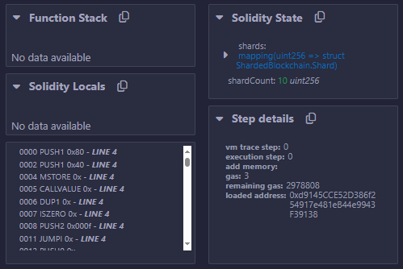

# Describing all the functions being debugged

[

{

"inputs": [

{

"internalType": "uint256",

"name": "_shardCount",

"type": "uint256"

}

],

"stateMutability": "nonpayable",

"type": "constructor"

},

{

"anonymous": false,

"inputs": [

{

"indexed": false,

"internalType": "uint256",

"name": "shardId",

"type": "uint256"

},

{

"indexed": false,

"internalType": "address",

"name": "sender",

"type": "address"

},

{

"indexed": false,

"internalType": "address",

"name": "receiver",

"type": "address"

},

{

"indexed": false,

"internalType": "uint256",

"name": "amount",

"type": "uint256"

},

{

"indexed": false,

"internalType": "uint256",

"name": "timestamp",

"type": "uint256"

}

],

"name": "TransactionLogged",

"type": "event"

},

{

"inputs": [

{

"internalType": "address",

"name": "_receiver",

"type": "address"

},

{

"internalType": "uint256",

"name": "_amount",

"type": "uint256"

}

],

"name": "addTransaction",

"outputs": [],

"stateMutability": "nonpayable",

"type": "function"

},

{

"inputs": [

{

"internalType": "uint256",

"name": "shardId",

"type": "uint256"

}

],

"name": "getTransactionCount",

"outputs": [

{

"internalType": "uint256",

"name": "",

"type": "uint256"

}

],

"stateMutability": "view",

"type": "function"

},

{

"inputs": [

{

"internalType": "uint256",

"name": "shardId",

"type": "uint256"

}

],

"name": "getTransactions",

"outputs": [

{

"components": [

{

"internalType": "address",

"name": "sender",

"type": "address"

},

{

"internalType": "address",

"name": "receiver",

"type": "address"

},

{

"internalType": "uint256",

"name": "amount",

"type": "uint256"

},

{

"internalType": "uint256",

"name": "timestamp",

"type": "uint256"

}

],

"internalType": "struct ShardedBlockchain.Transaction[]",

"name": "",

"type": "tuple[]"

}

],

"stateMutability": "view",

"type": "function"

},

{

"inputs": [],

"name": "shardCount",

"outputs": [

{

"internalType": "uint256",

"name": "",

"type": "uint256"

}

],

"stateMutability": "view",

"type": "function"

},

{

"inputs": [

{

"internalType": "uint256",

"name": "",

"type": "uint256"

}

],

"name": "shards",

"outputs": [

{

"internalType": "uint256",

"name": "shardId",

"type": "uint256"

}

],

"stateMutability": "view",

"type": "function"

}

]

# Gas Estimate Details

{

"Creation": {

"codeDepositCost": "463400",

"executionCost": "infinite",

"totalCost": "infinite"

},

"External": {

"addTransaction(address,uint256)": "infinite",

"getTransactionCount(uint256)": "infinite",

"getTransactions(uint256)": "infinite",

"shardCount()": "2403",

"shards(uint256)": "infinite"

},

"Internal": {

"determineShard(address,address)": "infinite"

}

}