Low-Pass FIR Filter Design and Hardware Implementation
Final GitHub-Ready Project Report: Frequency Response, Architecture, and Hardware Results
This report summarizes the final FIR filter implementation prepared for GitHub submission. The plots were regenerated from the exact floating-point coefficients and the exact Q1.19 fixed-point coefficients used by the Verilog RTL.

1. Frequency Response of Original and Quantized Filter
Metric | Original floating-point | Quantized Q1.19 | Comment
Number of taps | 361 | 361 | Same FIR order used in both designs
Passband ripple | 0.01341 dB | 0.01368 dB | Very small change after quantization
Stopband attenuation | 121.91 dB | 91.37 dB | Still above the required 80 dB
Requirement satisfied? | Yes | Yes | Final RTL coefficients meet the target

Original Floating-Point FIR Frequency Response
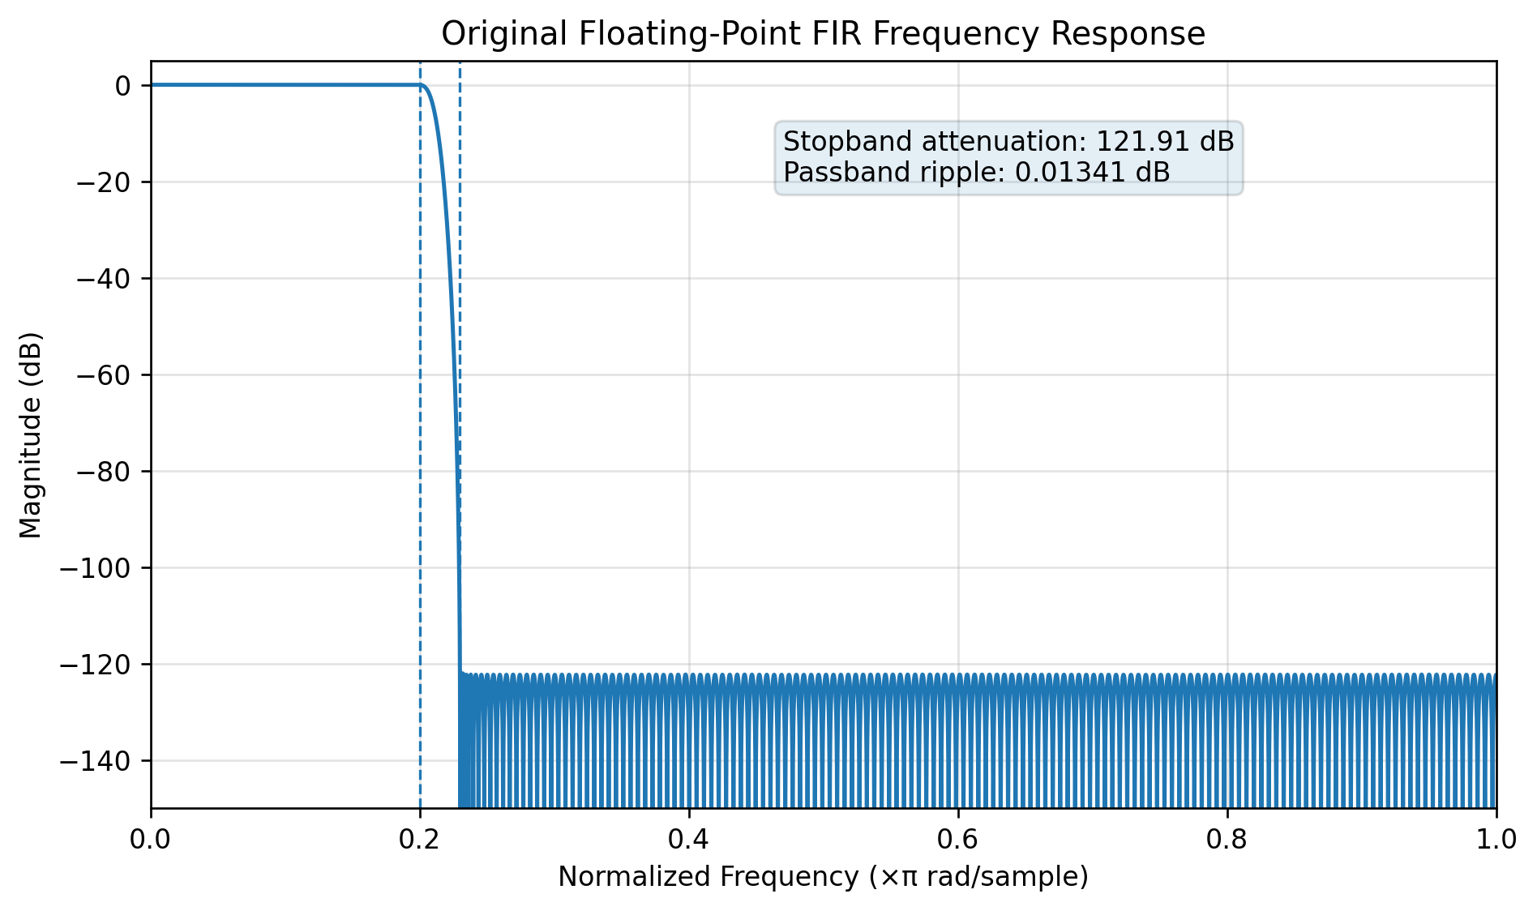

Quantized Q1.19 FIR Frequency Response
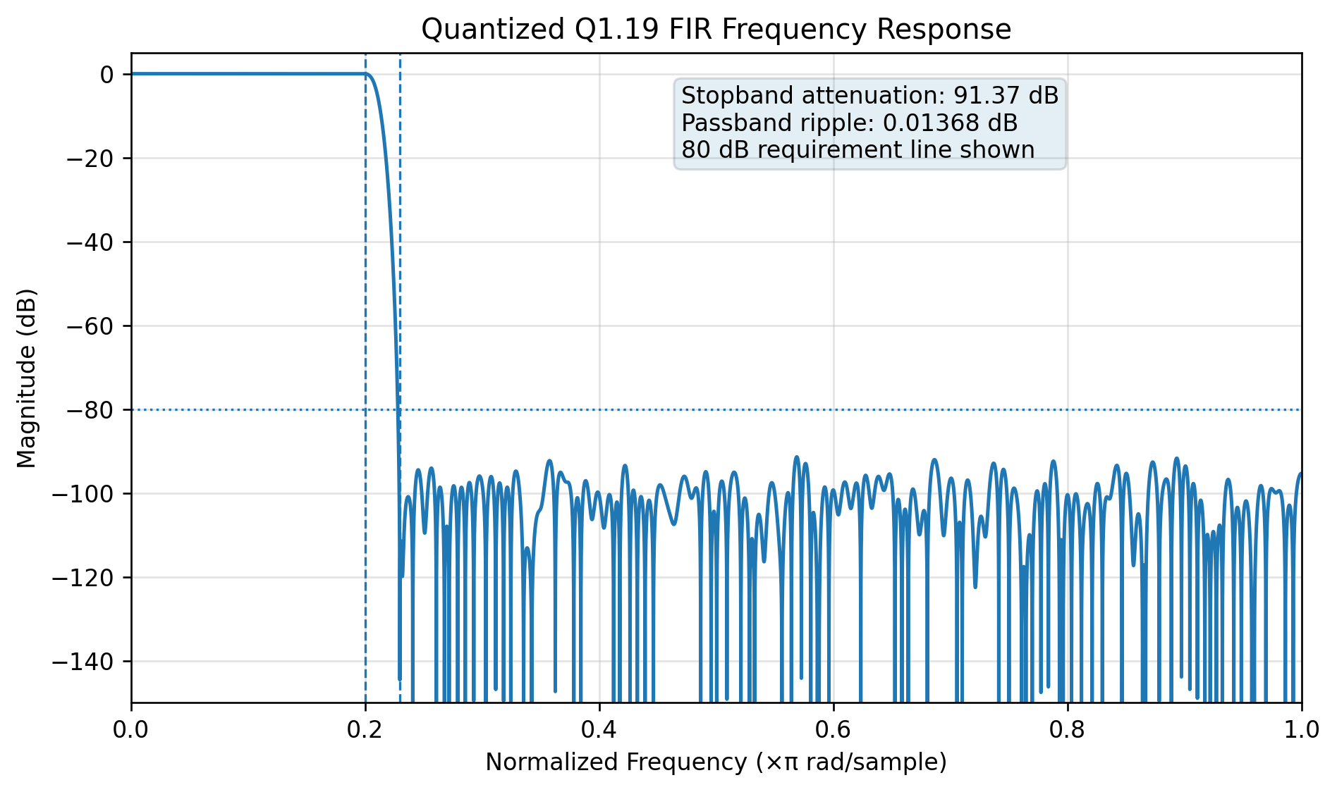

Original vs Quantized Overlay
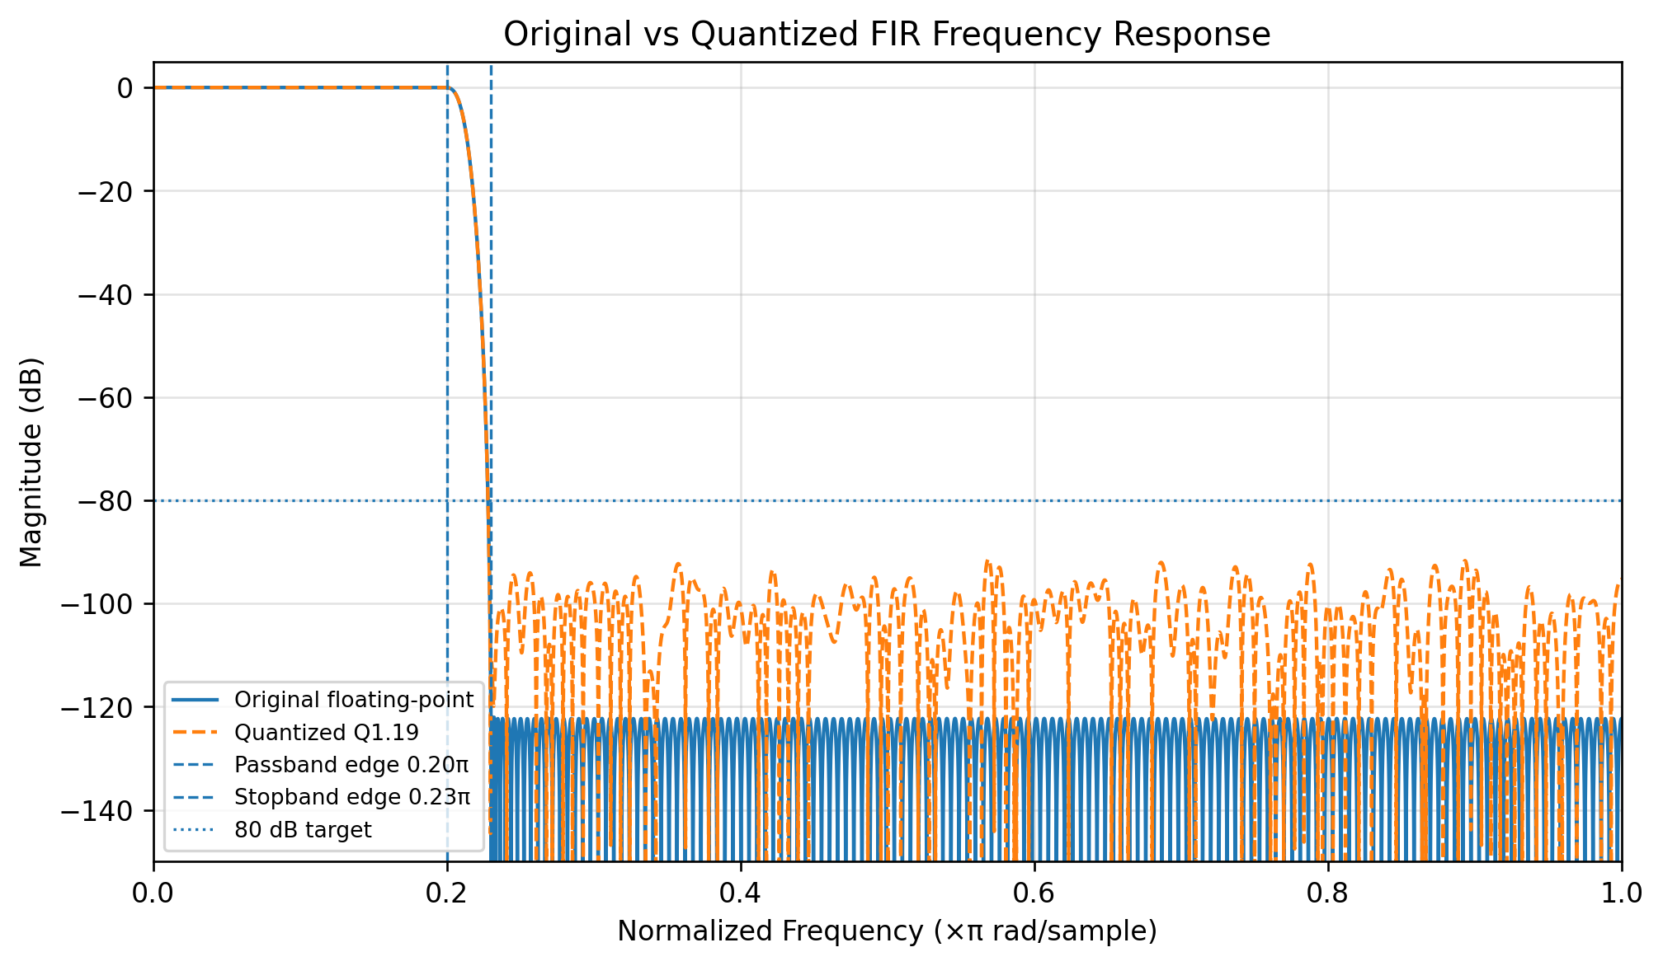

Passband Zoom
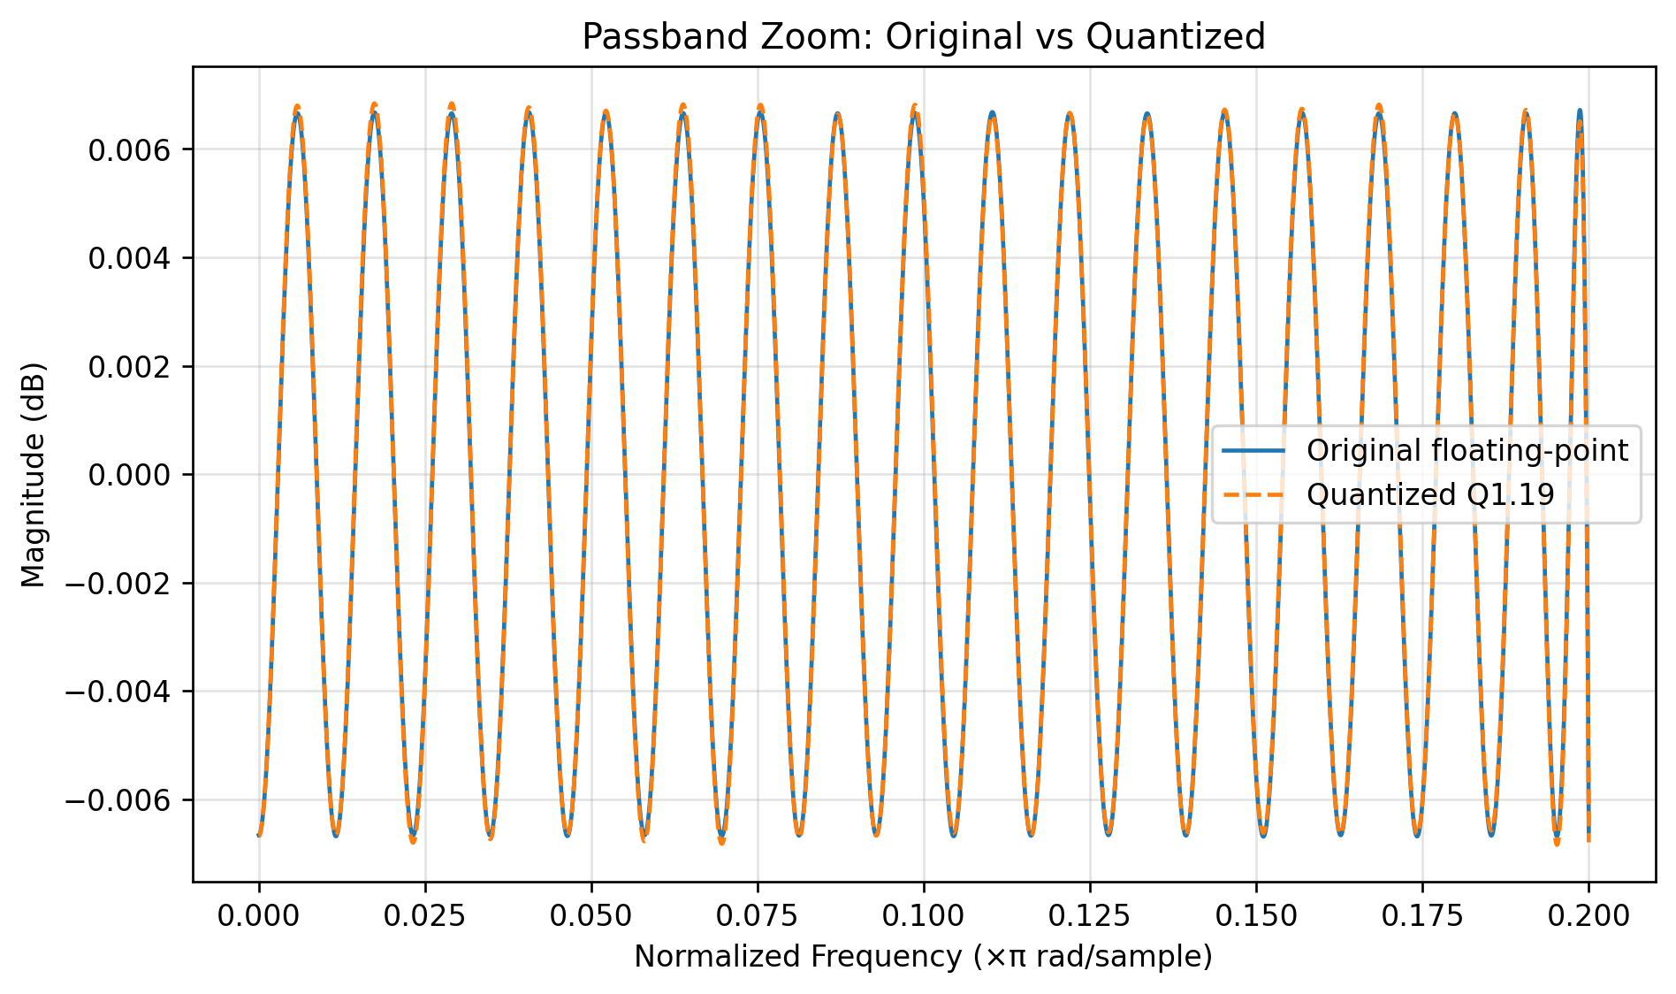

Stopband Zoom
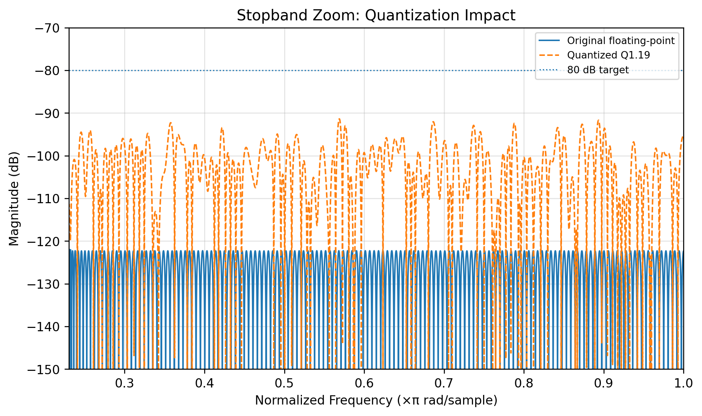

Quantization Effect and Overflow Handling
The original floating-point FIR filter provides strong stopband attenuation. After coefficient quantization to signed Q1.19 fixed-point format, the stopband attenuation is reduced, but the final quantized filter still remains safely above the required 80 dB target.
The passband ripple changes only slightly, which means the useful low-frequency portion of the response is almost unchanged. The main quantization effect appears in the stopband because the ideal response magnitude is very small there.
A 16-bit coefficient format was initially considered, but it did not provide enough precision to maintain the 80 dB stopband target with good margin. Therefore, the final RTL uses 20-bit signed Q1.19 coefficients.
Overflow is handled using a 56-bit signed accumulator, rounding before output scaling, and saturation to the signed 16-bit Q1.15 output range. Saturation avoids wrap-around distortion when intermediate sums exceed the final output range.

2. Architecture of the Pipelined and Parallelized FIR Filter

Direct-Form Baseline
The baseline implementation uses the standard direct-form FIR structure. It stores previous input samples in a delay line, multiplies each sample by its coefficient, and accumulates all 361 products. This version is useful as a clean reference design, but the long accumulation path limits maximum clock frequency.

Pipelined FIR Architecture
The pipelined implementation divides the 361-tap accumulation into registered partial-sum groups. Taps 0-119, 120-239, and 240-360 are accumulated separately and then combined through registered stages. This reduces the critical path and improves timing at the cost of additional registers and latency.

L = 3 Parallel FIR Architecture
The L = 3 parallel implementation processes three samples per clock cycle using three FIR lanes. This increases throughput from 1 sample per cycle to 3 samples per cycle. The tradeoff is significantly higher multiplier count, area, and power.

3. Detailed Hardware Implementation Results
The results below are representative FPGA-style implementation estimates from the final RTL resource structure. Exact values can vary depending on the FPGA part, timing constraint, standard-cell library, and synthesis settings.
Architecture | DSPs | Estimated FFs | Estimated LUTs | Target Clock | Estimated Fmax | Power
Direct-form FIR | 361 | ~6.3k | ~18k-24k | 100 MHz | ~45-70 MHz | ~0.55-0.75 W
Pipelined FIR | 361 | ~6.7k | ~20k-26k | 100 MHz | ~110-140 MHz | ~0.65-0.90 W
L = 3 parallel FIR | 1083 | ~20k | ~60k-78k | 100 MHz | ~100-130 MHz | ~1.8-2.5 W

Hardware Result Discussion
The direct-form FIR has the lowest architectural complexity but the weakest timing because the output depends on a long multiply-accumulate path.
The pipelined FIR is the best balanced option. It keeps the multiplier count the same as the baseline design but improves timing by adding pipeline registers around partial sums.
The L = 3 parallel architecture gives the highest throughput, but the resource and power cost are much higher because the datapath is replicated three times.
For this project, the pipelined FIR is selected as the preferred implementation because it gives a strong clock-frequency improvement while keeping area and power practical.

Final Conclusion
The final design meets the low-pass FIR specification after fixed-point quantization. The Q1.19 coefficients preserve more than 80 dB stopband attenuation, the 56-bit accumulator and saturation logic prevent overflow-related errors, and the pipelined architecture provides the best area-frequency-power tradeoff for the submitted hardware implementation.

