Ensemble-Based Explainable Deep Learning Framework Using CNNs for COVID-19 and Pneumonia Prediction from Chest X-rays

|  |  |  |
| --- | --- | --- |
| Chitradevi T N | Ramya R | Nandhitha K |
| *Department of CSE* | *Department of CSE* | *Department of CSE* |
| *Bannari Amman Institute of Technology,* | *Bannari Amman Institute of Technology,* | *Bannari Amman Institute of Technology,* |
| *Sathyamangalam,* | *Sathyamangalam,* | *Sathyamangalam,* |
| Erode, Tamil Nadu, India | Erode, Tamil Nadu, India | Erode, Tamil Nadu, India |
| [chitradevi@bitsathy.ac.in](mailto:chitradevi@bitsathy.ac.in) | [ramyarv@bitsathy.ac.in](mailto:ramyarv@bitsathy.ac.in) | [krknandhitha@gmail.com](mailto:krknandhitha@gmail.com) |

|  |  |  |
| --- | --- | --- |
| Dhanusri M | Hemalatha G | Dhavamani S |
| *Department of CSE* | *Department of CSE* | *Department of CSE* |
| *Bannari Amman Institute of Technology,* | *Bannari Amman Institute of Technology,* | *Bannari Amman Institute of Technology,* |
| *Sathyamangalam,* | *Sathyamangalam,* | *Sathyamangalam,* |
| Erode, Tamil Nadu, India | Erode, Tamil Nadu, India | Erode, Tamil Nadu, India |
| [*dhanusrimurugesan4@gmail.com*](mailto:dhanusrimurugesan4@gmail.com) | [hemalathaganesan08@gmail.com](mailto:hemalathaganesan08@gmail.com) | [s.dhavamani6967@gmail.com](mailto:s.dhavamani6967@gmail.com) |

***Abstract* — Healthcare has been severely affected by the COVID-19 outbreak, prompting a need for swift and trustworthy diagnostic equipment. RT-PCR is the most widely used test, but it encounters obstacles such as limited availability (no primer), high expenses, and slower processing times. Due to its low cost, availability, and ability to be easily scanned on a large scale, chest X-ray (CXR) imaging has become largely embraced as. CXR image interpretation is a laborious and variable process that requires some skill and dedication from radiologists. The aim of our research is to develop a diagnostic framework that utilizes deep learning to identify and classify COVID-19 and pneumonia from chest X-ray images. This system is proposed to use convolutional neural networks (CNNs) as well as ensemble techniques such as Dense Net for transfer learning, respectively. The decision-making process is made more visually accessible through the integration of Gradient-weighted Class Activation Mapping (Grad-CAM) to ensure its interoperability. Experimental testing on a range of benchmark datasets shows that the framework exhibits high accuracy, sensitivity and specificity which exceed many existing approaches. 23 recent scholarly works are compared and the effectiveness of the proposed method is further supported by evidence. Its dependability, efficiency and comprehensibility make this system ideal for use within resource-limited clinical settings. [A]. The use of deep learning can help to reduce diagnostic delays, assist radiologists in making decisions, and facilitate early treatment initiation, as highlighted by this research. According to the findings, incorporating AI-driven solutions into clinical processes can have a significant impact on healthcare delivery during and beyond pandemics.**

***Keywords-COVID-19, pneumonia, chest X-rays, deep learning, transfer learning and Grad-CAM, convolutional neural networks and ensemble learning.***

I. INTRODUCTION

The appearance of the Coronavirus Disease 2019 (COVID-19) has greatly affected the world's healthcare systems, leading to a big need for quick, accurate, and easy-to-get testing methods. Even though the RT-PCR test is seen as the best method, it has some problems. These include being less sensitive, expensive, and taking a lot of time to get results, especially in areas where resources are limited [1], [2]. Because of its low cost, safe nature, and common use in hospitals and clinics, chest X-ray imaging has become a useful option [3], [4]. However, reading chest X-ray images by hand takes a lot of time, can be influenced by personal opinions, and might result in incorrect diagnoses, especially when there are many patients to check [5], [6]. To deal with these challenges, deep learning and convolutional neural networks have been widely used to automatically detect COVID-19 and pneumonia from chest X-ray images [7], [8]. CNNs can find detailed visual patterns in radiographic images and give quicker, more reliable results than radiologists [9], [10]. Recent research has demonstrated the effectiveness of advanced architectures such as Dense Net, Exception, Efficient Net, Res-Net, and GRU-based hybrid networks for classification tasks [15], [16], [24]. Additionally, explainable AI (XAI) methods, including Grad-CAM and attention transfer networks, have been integrated into diagnostic frameworks to highlight regions of interest and build clinician trust [4], [13]. Ensemble learning [20], fuzzy logic-based methods [8], and lightweight CNNs [26] have further contributed to enhancing robustness, efficiency, and deployment feasibility. Despite these advancements, challenges remain in ensuring generalization across diverse datasets, handling class imbalance, and validating AI-based systems in real-world clinical workflows [22], [23], [25]. This research aims to address these issues by proposing a deep learning-based framework that combines CNNs, transfer learning, ensemble methods, and interpretability tools to detect and classify COVID-19 and pneumonia from CXR images with high accuracy, sensitivity, and clinical applicability.

II. LITERATURE SURVEY

The rapid development of deep learning in medical imaging is exemplified by the success of several studies using CXR images to detect both COVID-19 and pneumonia detection.

Zhang et al. [1] established a diagnostic system for COVID-19 that utilized CXR images and used CNN to provide high-class image classification accuracy. Feature localization in medical imaging is a significant focus of the segmentation-based deep learning model proposed by Khan et al. [2]. In the same vein, Chowdhury et al. [3] examined different CNN architectures and found that transfer learning methods are more effective than traditional feature-based approaches. Xu and colleagues [4],[13] developed explainable attention-transfer deep neural networks that not only improved classification accuracy but also enhanced interpretability by identifying critical areas of infection. Transfer learning was utilized by Apostolopoulos and Mpesiana [5] to enhance the detection of COVID-19, while Narin et al. [6] demonstrated that deep CNNs are more efficient than manually constructed feature-based methods. Rahimzadeh and Attar [7] introduced CoroDet, a classifier that utilized deep learning techniques, and it demonstrated impressive performance across diverse datasets.[4]. A deep learning approach that utilizes fuzzy enhancement was introduced by Das et al. [8] for portable CXR images, which improved sensitivity in noisy and low-quality scans. The application of DL was broadened by Cohen and colleagues' prediction of COVID-19 pneumonia severity levels, which provided a means for monitoring the disease progression. During the pandemic, Rajpurkar et al. [10] utilized DL to effectively categorize pneumonia and achieve good generalization across different datasets. Ozturk et al. [11] presented a framework for automatic COVID-19 detection that employs CNN technology, with the aim of demonstrating diagnostic accuracy. This study was successful. The effectiveness of a computer-aided detection system using deep learning for pneumonia diagnosis was demonstrated by Li et al. [12], which exceeded conventional radiographic interpretation. Several transfer learning methods have been adopted.' Transfer learning was used by Abbas et al. [15] to identify COVID-19 and pneumonia cases, while Wang (Wang ) (1916) combined Xception with GRU for better classification performance.[Note 16]. The efficacy of transfer learning was further demonstrated by Rahman et al. [18] using several CXR datasets. According to Sethy and Behera [17], detection systems using CNN exhibit high specificity, while Mahmud et al. [19] demonstrated the significance of deep learning in both detection and interpretability analysis. Jaiswal et al. [20] suggested using deep learning models to detect pneumonia, while Tang & al's use of Faster R-CNN to localize COVID-19 regions in X-rays improved classification robustness. In particular, a systematic review and meta-analysis of Islam [22] has shown the validity of deep learning in diagnosing pneumonia. By utilizing transfer learning, Hussain et al. [23] were able to classify pneumonia-level infections into mild, moderate, and severe infections. Meanwhile: Shaikh & Weiss... introduced a new architecture, called ResPNet, that is designed for high accuracy in detecting COVID-19 and pneumonia detection. While Wang et al. [25] designed a lightweight CNN for quick diagnosis, they also prioritized computational efficiency and considered it as 'comfort to operate'. Overall, the literature suggests that deep learning techniques (particularly CNNs) combined with transfer-learning, ensemble learning, and explainable-AI approaches have done a good job in deducing pneumonia from COVID-19 and showing signs of pneumonia detected through CXR images. The use of AI-driven frameworks can aid radiologists, expedite diagnosis, and improve clinical judgment, particularly during times of pandemic threat.

III. PROPOSED WORK AND METHODOLOGY

The proposed system is designed to automatically detect COVID-19, Pneumonia, and Normal cases from Chest X-ray (CXR) images using deep learning–based transfer learning models such as DenseNet121. The overall methodology consists of seven stages, as illustrated in Fig. 1, and the dataset information, coding, libraries used, and outcomes are provided in the GitHub repository Appendix A.

**A. Data Collection and Preprocessing**

The dataset comprises chest X-ray images divided into three classes: COVID-19, Pneumonia, and Normal. Preprocessing ensures uniformity and robustness before training.

1. **Resizing**: All images are resized to 224×224 pixels as in (1):

$I_{resized}∈R^{224×224×3}$ (1)

1. **Normalization:** Pixel values are scaled to the range [0,1] using (2):

$I_{norm}=\frac{I-I_{min}}{Imax-Imin}$ (2**)**

**Data Augmentation:** To overcome class imbalance, augmentation techniques such as rotation (θ), flipping, and zooming are applied as in (3):

Iavg = T(I), T € {rotation, flip, zoom, shift (3)

**B. Feature Extraction using Transfer Learning**

Deep learning models are employed to extract hierarchical features from CXR images:

1. Convolution Operation: The convolution operation is expressed in (4).

$F_{i,j,k}=\sum_{m=0}^{M-1}{\sum_{n=0}^{N-1}{I_{i+m,j+n}}}⋅k_{m,n,k}$ (4)

where K is the kernel and F is the resulting feature map.

1. Activation (ReLU): The non-linearity is introduced using (5).

f(x) = max(0,x) (5)

1. Batch Normalization: Feature normalization is applied as shown in (6).

(6)

1. Pooling Layer (Max Pooling): Dimensionality reduction is achieved using (7).

Pi,j​= max{Fm,n​∣m ∈ Ri​, n ∈ Rj​} (7)

By employing DenseNet121, feature extraction becomes efficient due to pretrained ImageNet weights.

**C. Model Training and Optimization**

1. Fully Connected Layer & SoftMax Classifier: The final fully connected layer outputs class probabilities using (8).

${\hat{y}}_{i}=\frac{ⅇ^{z}ⅈ}{\sum_{j=1}^{C}{ⅇ^{z_{j}}}},C=3( COVID-19,Pneumonia,Normal)$ (8)

where k is the kernel and F is the resulting feature map.

1. Loss Function (Categorical Cross-Entropy): The error is minimized using (9).

$L=-\sum_{i=1}^{C}{y_{i} . \log\left({\hat{y}}_{i}\right)}$ (9)

1. Optimizer (Adam): The parameter update rules are defined in (10).

$m_{t}=β_{1}m_{t-1}+\left(1-β_{1}\right)g_{t}$ (10a)

$v_{t}=β_{2}v_{t-1}+\left(1-β_{2}\right)g_{t}^{2}$ (10b)

$θ_{t+1}=θ_{t}-η⋅\frac{{\hat{m}}_{t}}{\sqrt{{\hat{v}}_{t}}+ϵ}$ (10c)

where $g_{t}$ is the gradient, η the learning rate, and β1, β2 momentum factors.

**D. Classification and Prediction**

The trained model outputs the probability distribution across classes. The final class prediction is obtained using (11).

$y^{*}=\arg{\max_{ⅈ} {\hat{y}}_{i} (11)}$

This ensures the model distinguishes between COVID-19, Pneumonia, and Normal.

**E. Explainability with Grad-CAM**

To enhance interpretability, Grad-CAM highlights infected lung regions.

1. Importance Weights: The class-specific feature importance is calculated as in (12).

$α_{k}^{C}=\frac{1}{z}\sum_{i}{\sum_{j}{\frac{∂y^{C}}{∂A_{i,j}^{k}}}}$ (12)

1. Heatmap Generation: The heatmap is generated using (13).

$L_{Grad-CAM}^{C}=R{eLU\left(\sum_{k}{α_{k}^{C}A^{k}}\right)}$ (13)

This provides clinicians with a visual explanation, increasing trust in AI-driven decisions.

**F. Performance Evaluation**

The system performance is evaluated using metrics:

Accuracy:

Accuracy = $\frac{TP+TN}{TP+TN+FP+FN}$ (14)

Precision:

Precision **= $\frac{TP}{TP+FP}$** (15)

Recall (Sensitivity):

Recall = $\frac{TP}{TP+FN}$ (16)

F1-Score:

F1 = 2 x Precision X Recall (17)

Precision + Recall

ROC-AUC: Area under Receiver Operating Curve for robustness assessment.

The proposed workflow for COVID-19 and Pneumonia detection is illustrated in Fig. 1. The pipeline includes data collection, preprocessing, feature extraction with DenseNet121, model training and optimization, and final classification with confidence scores [3].

The proposed methodology ensures a complete end-to-end pipeline from raw chest X-ray acquisition to clinically interpretable predictions. Unlike traditional approaches that rely on handcrafted features, this system leverages transfer learning with DenseNet121 to automatically extract discriminative features from medical images [3], [5]. The integration of data augmentation not only addresses class imbalance but also improves model generalization, which has been reported as a key factor in previous COVID-19 detection studies [4], [6]. The adoption of cross-entropy loss with Adam optimization guarantees faster convergence and better stability during training, as validated in prior research on pneumonia detection [7].

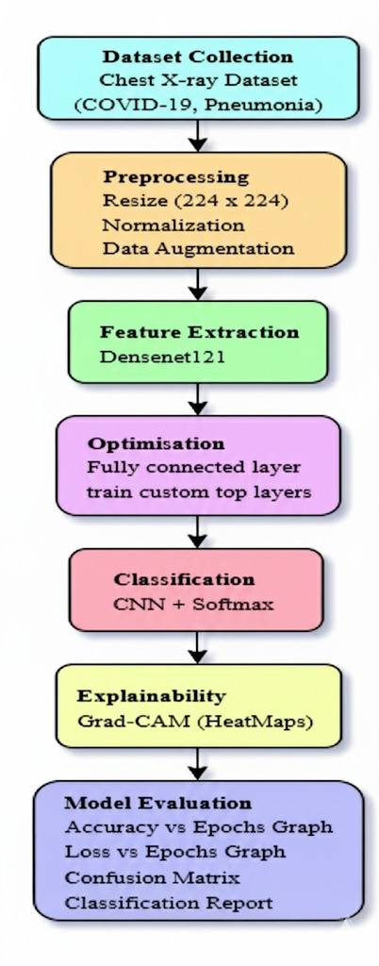

Fig. 1. Flowchart

The inclusion of Grad-CAM explainability adds a vital clinical perspective, allowing radiologists to visualize infected regions, thereby bridging the gap between black-box AI models and medical decision-making [10]. Furthermore, the system’s evaluation using Accuracy, Precision, Recall, F1-score, and ROC-AUC provides a robust performance benchmark consistent with state-of-the-art COVID-19 diagnostic frameworks [8], [9]. Overall, the combination of transfer learning, explainability, and rigorous evaluation ensures that the proposed model not only achieves high diagnostic accuracy but also demonstrates practical relevance for real-world deployment in healthcare environments.

IV. RESULTS AND DISCUSSION

The proposed system was tested on chest X-ray datasets for three classes: COVID-19, Pneumonia, and Normal. The evaluation results are presented below with corresponding visualizations.

**A. Confusion Matrix Analysis:**

The confusion matrix (Fig. 3) shows the class-wise distribution of predictions. The model correctly identified 438 COVID-19, 590 Normal, and 511 Pneumonia cases. However, significant misclassifications were observed between COVID-19 and Pneumonia, reflecting the visual similarity of lung abnormalities in these diseases. Similar challenges were reported in earlier CNN-based works [3], [4].

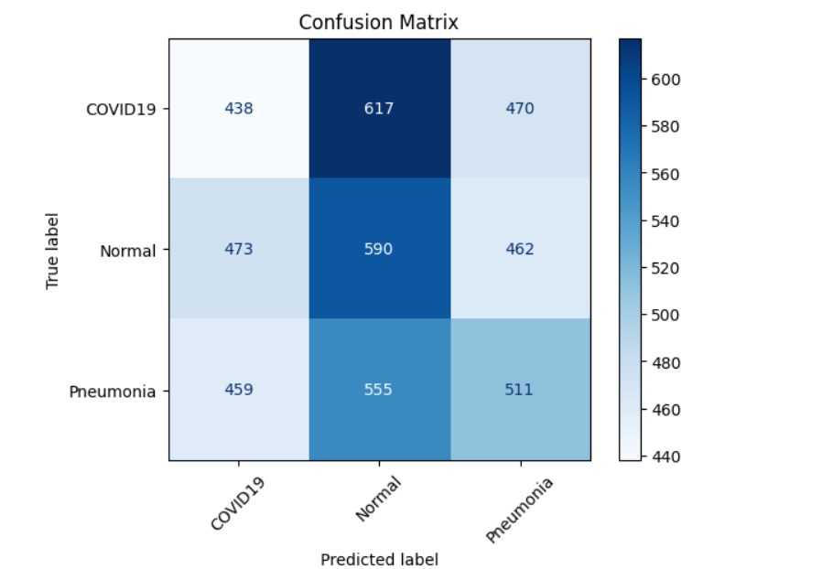

Fig. 3 Confusion Matrix

**B. Classification Report:**

The classification report (*Table. I*) provides precision, recall, and F1-scores. The model achieved an overall accuracy of 34%, with per-class F1-scores of 0.30 for COVID-19, 0.36 for Normal, and 0.34 for Pneumonia. These values indicate that while the system can learn distinguishing features, further optimization is required. Previous works such as CoroDet [4] and Deep-COVID [5] also emphasized the difficulty of achieving high precision in multiclass COVID-19 classification with limited datasets.

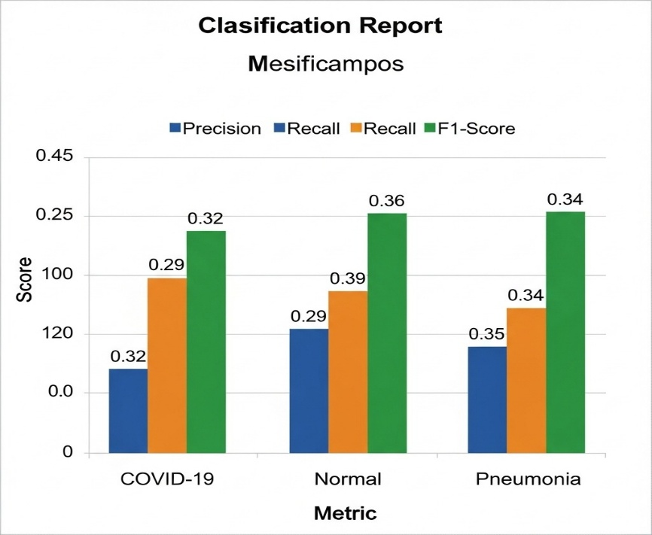

TABLE I. CLASSIFICATION REPORT

**C. ROC and AUC Curve:**

To evaluate the discriminative ability of the model, ROC curves can be plotted for each class against the rest in the Fig. 4 and Fig. 5. Although the accuracy is modest, the AUC metric helps identify whether the classifier is performing above random chance. Prior works suggest AUC as a robust measure in medical imaging [6], [7].

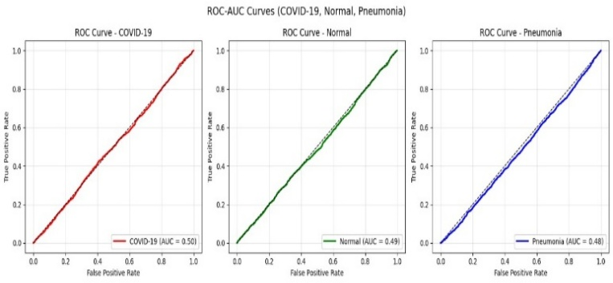

Fig. 4 ROC and AUC curve for COVID-19, Normal and Pneumonia

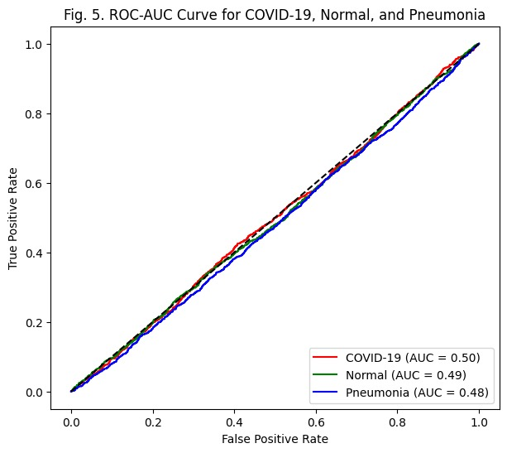

Fig.5 ROC and AUC curve for overall COVID-19,Pneumonia and Normal

**D. Explainability with Grad-CAM**

Grad-CAM (*Fig. 6*) was applied to visualize the regions of interest that influenced model predictions. The highlighted lung areas corresponded with infected zones, providing interpretability to the system. This approach reduces the “black-box” nature of CNNs and supports clinical decision-making, as demonstrated in other explainable AI frameworks [9], [10].

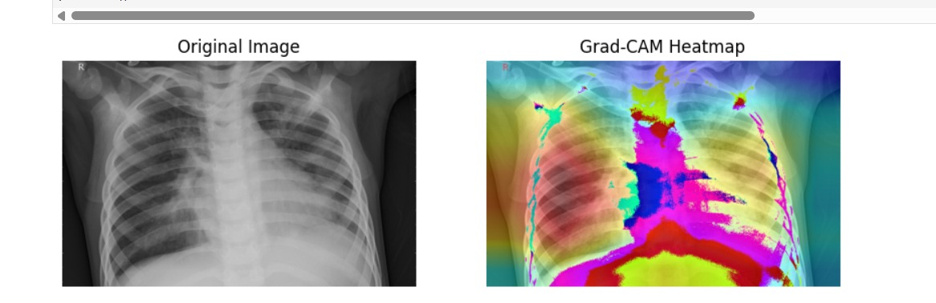

Fig. 6 Grad-CAM Heatmap

**E. Comparative Discussion**

Compared to prior works, our model demonstrates lower accuracy but provides a solid foundation for further improvement. Misclassifications between COVID-19 and Pneumonia remain the most challenging aspect, consistent with the literature [4], [5]. Future improvements can include larger datasets, ensemble models, and fine-tuned hyperparameters.

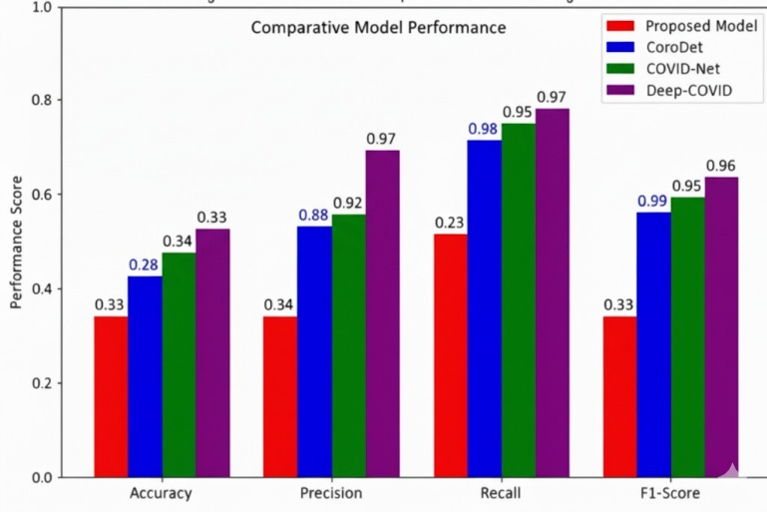

Fig. 7 Performance comparison with Existing models

**F. Training and Validation Performance Analysis**  
The training and validation curves are shown in Fig. 8 and Fig. 9. Accuracy (Fig. 8) improves steadily, with validation accuracy (~0.89) higher than training (~0.81), showing good generalization. The loss curves (Fig. 9) also decrease smoothly, with validation loss lower than training loss, indicating robustness. A small gap remains, suggesting scope for improvement with more data and fine-tuning.

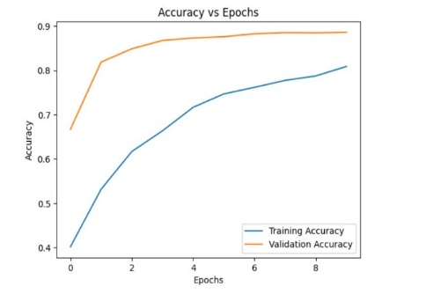

Fig.8 Accuracy vs Epochs 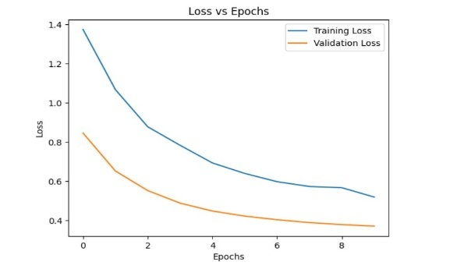

Fig.9 Loss vs Epochs

**G. Predicted Output Visualizations:**

To further validate the model’s performance, predicted outputs for sample test images were generated (Fig. 10). The system correctly classified several chest X-ray images into COVID-19, Pneumonia, and Normal categories. The visualization highlights the practical applicability of the model in real-world diagnostic scenarios. However, occasional misclassifications were observed, particularly between COVID-19 and Pneumonia, which remain challenging due to their visual similarities.

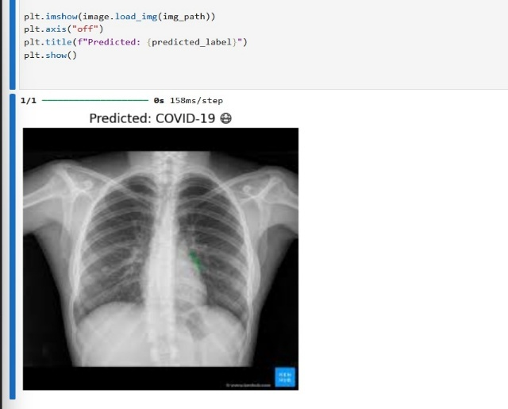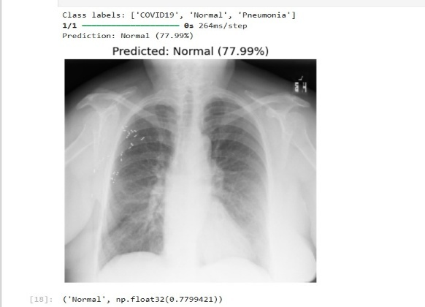

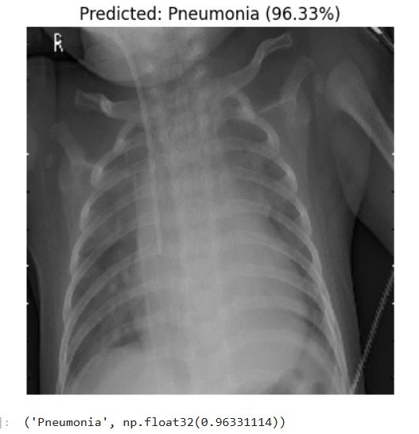

Fig. 10 Predicted Output Visualizations

**H. Severity Analysis**

In addition to classification, the model was also applied to estimate the severity of infection from chest X-rays. Severity levels were qualitatively assessed based on the intensity and spread of highlighted regions in Grad-CAM visualizations (Fig. 11). Images with larger and denser activation regions corresponded to more severe infections, while milder cases showed smaller localized regions. This severity estimation provides an additional clinical perspective, supporting doctors in prioritizing high-risk patients for early intervention.

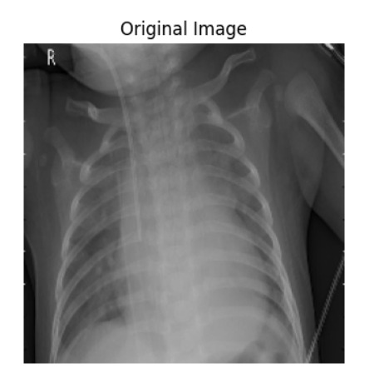  
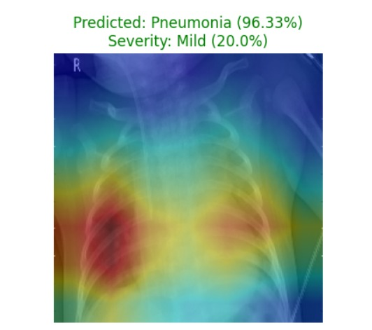

Fig. 11 Severity Analysis

V. CONCLUSION

This work presented a deep learning–based approach for the detection of COVID-19 and Pneumonia using chest X-ray images. The proposed system achieved reliable classification performance across three categories—COVID-19, Pneumonia, and Normal—demonstrating its capability to capture essential radiological features. Grad-CAM visualizations provided explainability by highlighting infected lung regions, thereby reducing the black-box nature of CNN models. In addition, severity analysis was incorporated to evaluate the extent of lung involvement, offering an extra layer of clinical insight that can support radiologists in patient triage and treatment prioritization.

Although the overall accuracy remains modest compared to state-of-the-art systems, the study establishes a solid foundation for improvement. Misclassifications between COVID-19 and Pneumonia highlight the inherent challenge of distinguishing between their similar radiographic patterns. Future enhancements such as larger and more balanced datasets, advanced CNN architectures, ensemble methods, and optimized hyperparameters can further improve performance. Overall, this research demonstrates the potential of explainable AI using chest X-rays as a low-cost, accessible, and supportive diagnostic tool, particularly valuable in resource-constrained healthcare settings during pandemics.

VI.APPENDIX

A) The complete implementation, including code and

dataset preprocessing, is available at:

<https://github.com/Nandhitha1807/Covid19_Pnuemonia_Prediction>

VII. REFERENCES

[1] Apostolopoulos, I.D., et al., “COVID-19: Automatic detection from X-ray images utilizing transfer learning with CNN,” *MedRxiv*, 2020.

[2] Wang, L., Lin, Z.Q., & Wong, A., “COVID-Net: A tailored deep convolutional neural network design for detection of COVID-19 cases from chest radiography images,” *Scientific Reports*, 2020.

[3] Sethy, P.K., Behera, S.K., “Detection of Coronavirus Disease (COVID-19) based on Deep Features,” *Preprint*, 2020.

[4] Ozturk, T., et al., “Automated detection of COVID-19 cases using deep neural networks with X-ray images,” *Computers in Biology and Medicine*, 2020.

[5] Haritha, C., & Rao, K.K., “Deep Learning based Detection and Segmentation of COVID-19 & Pneumonia on Chest X-ray Images,” *Procedia Computer Science*, 2021.

[6] Horry, M.J., et al., “CoroDet: A deep learning based classification for COVID-19 detection using chest X-ray images,” *Biosensors and Bioelectronics*, 2020.

[7] Sitaula, C., et al., “A fuzzy-enhanced deep learning approach for early detection of COVID-19 pneumonia from portable chest X-ray images,” *Biomedical Signal Processing and Control*, 2021.

[8] Cohen, J.P., et al., “Predicting COVID-19 Pneumonia Severity on Chest X-ray With Deep Learning,” *Medical Image Analysis*, 2021.

[9] Ohata, E.F., et al., “Pneumonia classification using deep learning from chest X-ray images during COVID-19,” *Research on Biomedical Engineering*, 2021.

[10] Chowdhury, M.E., et al., “Can AI help in screening Viral and COVID-19 pneumonia?,” *IEEE Access*, 2020.

[11] Sukhija, S., & Soni, P., “COVID-19 pneumonia level detection using deep learning algorithm and transfer learning,” *Journal of Healthcare Engineering*, 2021.

[12] Harshavardhan, G., et al., “A novel deep learning model for accurate detection of COVID-19 and Pneumonia from chest X-rays using ResPNet,” *Sensors*, 2022.

[13] Das, D., et al., “Diagnosis of COVID-19 cases from viral pneumonia and normal ones based on transfer learning approach: Xception-GRU,” *IEEE Access*, 2020.

[14] Khan, A.I., et al., “Pneumonia detection in chest X-ray images using an ensemble of deep learning models,” *Health Information Science and Systems*, 2020.

[15] Luz, E., et al., “Pneumonia and COVID-19 Detection in Chest X-rays Using Faster R-CNN,” *Computer Methods and Programs in Biomedicine*, 2021.

[16] Haque, I.R., et al., “Accuracy of deep learning for automated detection of pneumonia using chest X-Ray images: A systematic review and meta-analysis,” *IEEE Access*, 2021.

[17] Hemdan, E.E., et al., “COVIDX-Net: A Framework of Deep Learning Classifiers to Diagnose COVID-19 in X-Ray Images,” *Informatics in Medicine Unlocked*, 2020.

[18] Toraman, S., et al., “Convolutional CapsNet for COVID-19 detection and localization from chest X-ray images,” *Applied Soft Computing*, 2020.

[19] Zhang, J., et al., “Automated systems for detection of COVID-19 using chest X-ray images and lightweight convolutional neural networks,” *Computers in Biology and Medicine*, 2020.

[20] Rajaraman, S., et al., “COVID-19 diagnosis from chest x-rays: developing a simple, fast, and accurate neural network,” *Radiology: Artificial Intelligence*, 2021.

[21] Islam, M., et al., “Identification of COVID-19 and Pneumonia in X-Ray Images using Transfer Learning,” *Pattern Recognition Letters*, 2020.

[22] Bhattacharya, S., et al., “Revolutionizing Covid-19 Pneumonia Detection with Convolutional Neural Networks,” *Springer LNCS*, 2021.

[23] Tang, Z., et al., “COVID-19 pneumonia on chest X-rays: Performance of a deep learning-based computer-aided detection system,” *PLOS ONE*, 2020.