**Project description**

**In this project I have scrapped a data from times of india article using Requests,Bs4,Beautifulsoup modules**

**Program:**

import requests

from bs4 import BeautifulSoup

def timesofindia():

url = "https://timesofindia.indiatimes.com/home/headlines"

page_request = requests.get(url)

data = page_request.content

soup = BeautifulSoup(data,"html.parser")

counter = 0

for divtag in soup.find_all('div', {'class': 'headlines-list'}):

for ultag in divtag.find_all('ul', {'class': 'clearfix'}):

if (counter <= 10):

for litag in ultag.find_all('li'):

counter = counter + 1

print(str(counter) + " - https://timesofindia.indiatimes.com" + litag.find('a')['href'])

print(str(counter) + "." + litag.text + " - https://timesofindia.indiatimes.com" + litag.find('a')['href'])

if __name__ == "__main__":

timesofindia()

**Executed in pycharm**

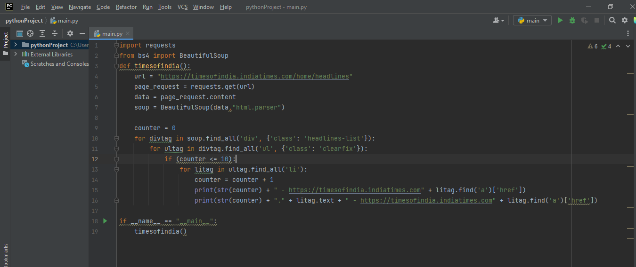

The scrapped data :

I have scrapped headlines links from the Times of india article and the links are there,if we clicked the link it will show the respective heading page

C:\Users\LENOVO\PycharmProjects\pythonProject\venv\Scripts\python.exe C:\Users\LENOVO\PycharmProjects\pythonProject\main.py

1 - https://timesofindia.indiatimes.com/india/demon-why-sc-should-not-take-note-of-such-cases/articleshow/96817753.cms

1.Why SC shouldn't waste time on DeMon-like cases7 Jan 2023, 1935 hrs IST - https://timesofindia.indiatimes.com/india/demon-why-sc-should-not-take-note-of-such-cases/articleshow/96817753.cms

2 - https://timesofindia.indiatimes.com/india/pm-modi-dials-uttarakhand-cm-dhami-promises-all-financial-and-technical-support/articleshow/96838532.cms

2.PM dials Dhami, promises ‘all financial & technical support’ - https://timesofindia.indiatimes.com/india/pm-modi-dials-uttarakhand-cm-dhami-promises-all-financial-and-technical-support/articleshow/96838532.cms

3 - https://timesofindia.indiatimes.com/india/national-highway-stretches-to-be-opened-only-after-safety-audits/articleshow/96839242.cms

3.NH stretches to be opened only after safety audits - https://timesofindia.indiatimes.com/india/national-highway-stretches-to-be-opened-only-after-safety-audits/articleshow/96839242.cms

4 - https://timesofindia.indiatimes.com/india/over-6900-domestic-violence-plaints-filed-by-women-in-2022/articleshow/96839600.cms

4.Over 6,900 domestic violence plaints filed by women in 2022 - https://timesofindia.indiatimes.com/india/over-6900-domestic-violence-plaints-filed-by-women-in-2022/articleshow/96839600.cms

5 - https://timesofindia.indiatimes.com/india/1-9c-at-main-city-station-as-delhi-faces-extended-cold-wave/articleshow/96838163.cms

5.1.9°C at main city station as Delhi faces extended cold wave - https://timesofindia.indiatimes.com/india/1-9c-at-main-city-station-as-delhi-faces-extended-cold-wave/articleshow/96838163.cms

6 - https://timesofindia.indiatimes.com/india/oldest-civil-criminal-cases-started-before-current-sc-judges-were-even-born/articleshow/96838299.cms

6.Oldest cases started before current SC judges were born - https://timesofindia.indiatimes.com/india/oldest-civil-criminal-cases-started-before-current-sc-judges-were-even-born/articleshow/96838299.cms

7 - https://timesofindia.indiatimes.com/business/india-business/govt-to-disband-telecom-body-dcc-finance-ministrys-doe-to-step-in/articleshow/96838272.cms

7.Govt to disband telecom body DCC - https://timesofindia.indiatimes.com/business/india-business/govt-to-disband-telecom-body-dcc-finance-ministrys-doe-to-step-in/articleshow/96838272.cms

8 - https://timesofindia.indiatimes.com/world/pakistan/austerity-drive-imf-deadlock-how-pakistans-economic-crisis-is-getting-worse/articleshow/96835384.cms

8.How Pakistan's economic crisis is getting worse - https://timesofindia.indiatimes.com/world/pakistan/austerity-drive-imf-deadlock-how-pakistans-economic-crisis-is-getting-worse/articleshow/96835384.cms

9 - https://timesofindia.indiatimes.com/world/china/china-covid-wrap-demand-for-indian-generic-drugs-skyrockets-in-china-country-says-final-farewell-to-zero-covid/articleshow/96836342.cms

9.Covid: Demand for Indian generic drugs shoots up in China - https://timesofindia.indiatimes.com/world/china/china-covid-wrap-demand-for-indian-generic-drugs-skyrockets-in-china-country-says-final-farewell-to-zero-covid/articleshow/96836342.cms

10 - https://timesofindia.indiatimes.com/india/pmo-holds-high-level-meet-on-joshimath-subsidence/articleshow/96828346.cms

10.'Safety of people priority': PMO holds meet on Joshimath crisis - https://timesofindia.indiatimes.com/india/pmo-holds-high-level-meet-on-joshimath-subsidence/articleshow/96828346.cms

11 - https://timesofindia.indiatimes.com/city/lucknow/new-jamtara-emerges-on-ups-border-with-haryana-rajasthan/articleshow/96824556.cms

11.New Jamtara emerges on UP’s border with Haryana, Rajasthan - https://timesofindia.indiatimes.com/city/lucknow/new-jamtara-emerges-on-ups-border-with-haryana-rajasthan/articleshow/96824556.cms

12 - https://timesofindia.indiatimes.com/education/foreign-universities-in-india-must-employ-regular-international-faculty-ugc-chairperson-m-jagadesh-kumar/articleshow/96822191.cms

12.‘Foreign univs in India must employ regular international faculty’ - https://timesofindia.indiatimes.com/education/foreign-universities-in-india-must-employ-regular-international-faculty-ugc-chairperson-m-jagadesh-kumar/articleshow/96822191.cms

Process finished with exit code 0

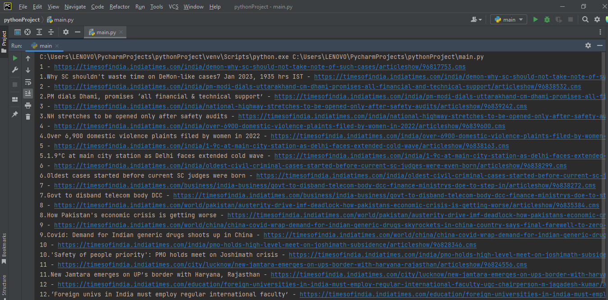

Scrapped data

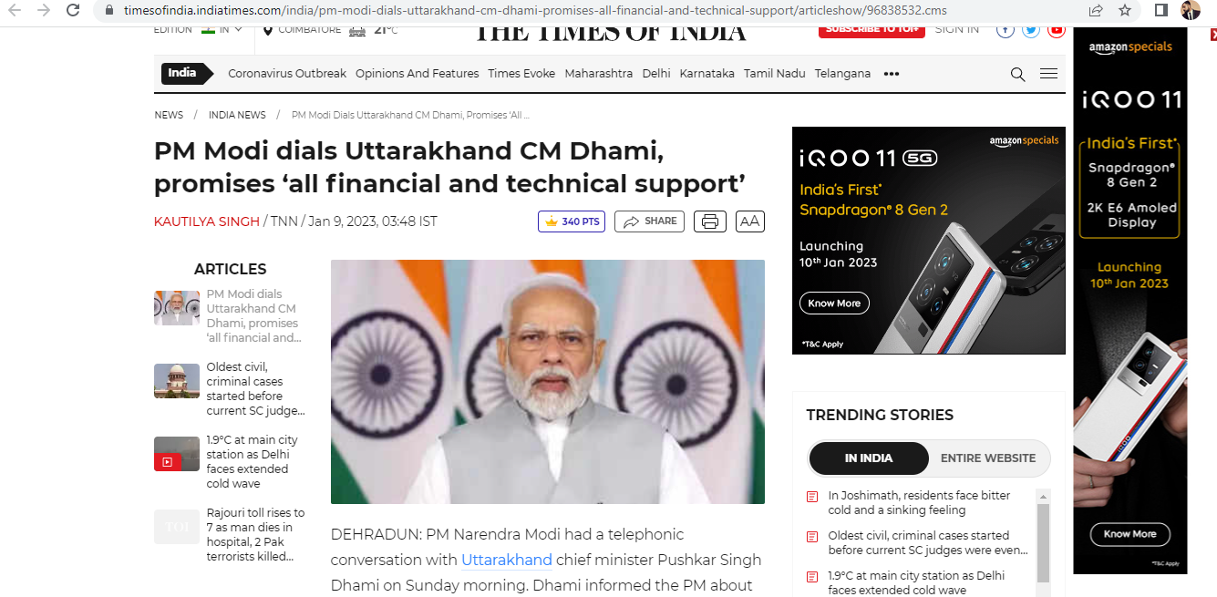

Result :

I have scrapped data from times of india using requests,bs4 module successfully