13-1)Write a shell script to check whether a particular user has logged in or not. If he has logged in, check whether he has eligibility to receive a message or not.

PROGRAM

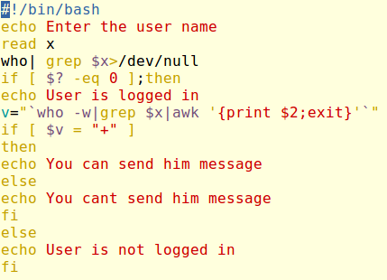

OUTPUT

