13-10) Write a shell script to accept empno, empname , basic. Find DA,HRA,TA,PF using following rules. Display empno, empname, basic, DA,HRA,PF,TA,GROSS SAL and NETSAL. Also store all details in a file called emp.dat Rules: HRA is 18% of basic if basic > 5000 otherwise 550 DA is 35% of basic PF is 13% of basic IT is 14% of basic TA is 10% of basic

PROGRAM

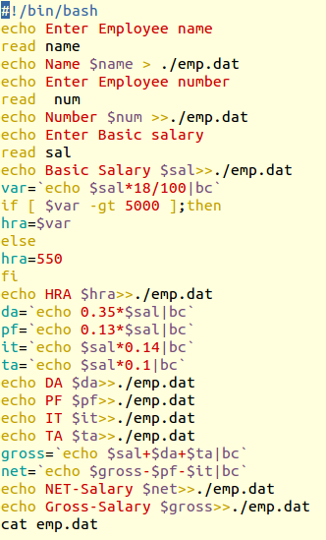

OUTPUT

