13-11) Write a shell script to demonstrate break and continue statements

PROGRAM

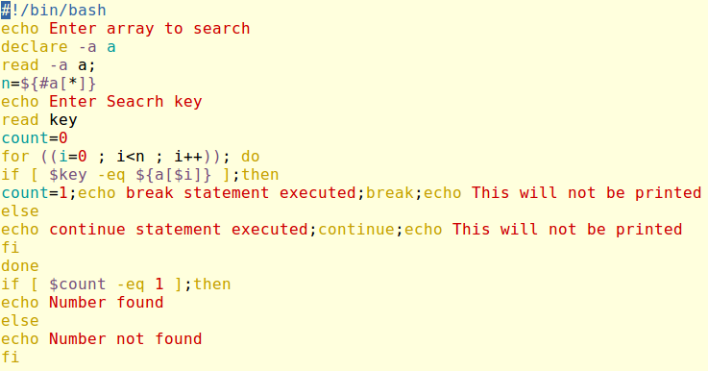

OUTPUT  
