13-12) Write a shell script to satisfy the following menu options 1. Display current directory path 2. Display today's date 3. Display users who are connected to the Unix system 4. Quit

PROGRAM

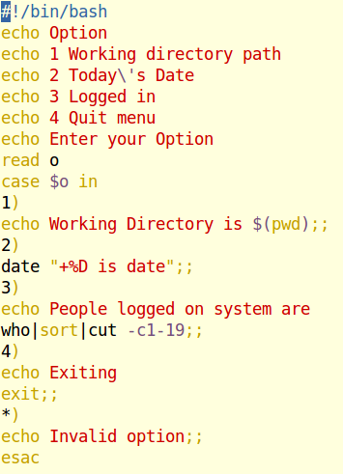

OUTPUT

