13-13) Write a shell script to delete all files whose size is zero bytes from current directory

PROGRAM

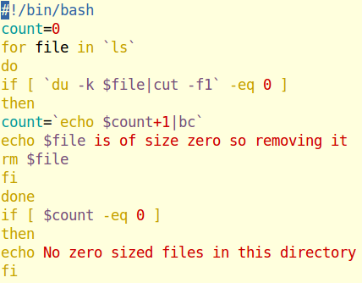

OUTPUT

