13-14) Write a shell script to display string palindrome from given arguments

PROGRAM

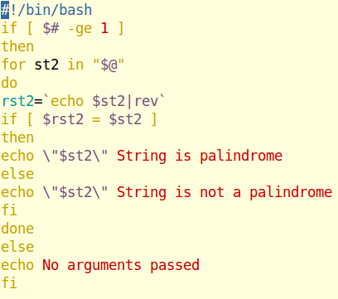

OUTPUT

