13-15) Write a shell script which will display Armstrong numbers from given arguments

PROGRAM

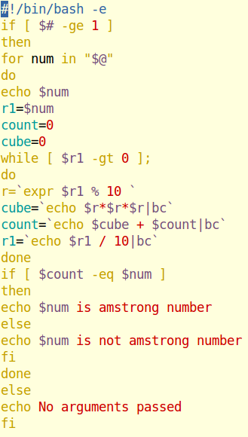

OUTPUT

