13-16) Write a shell script to display reverse numbers from given argument list

PROGRAM

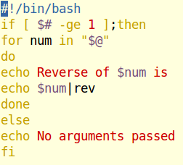

OUTPUT

