13-17) Write a shell script to display factorial value from given argument list

PROGRAM

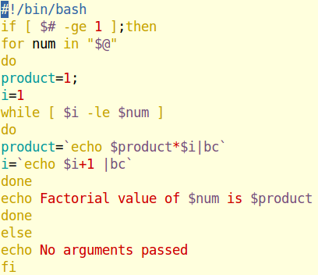

OUTPUT

