13-18) Write a shell script which will find maximum file size in the given argument list

PROGRAM

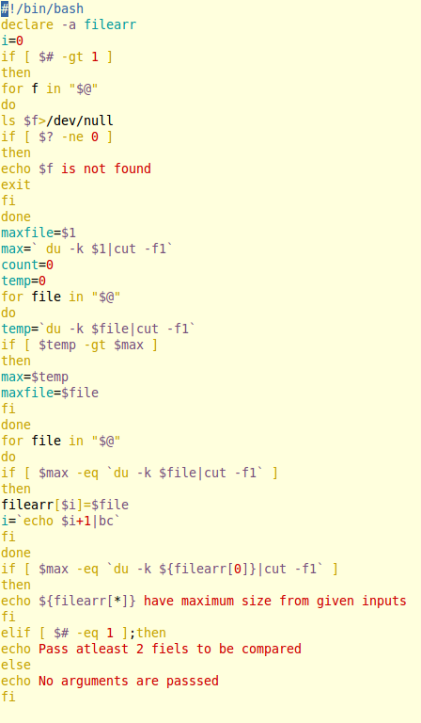

OUTPUT

