13-19) Write a shell script which will greet you “Good Morning”, ”Good Afternoon”, “Good Evening’ and “Good Night” according to current time

PROGRAM

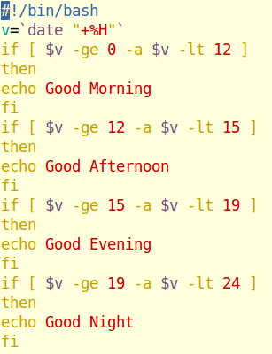

OUTPUT

