13-2) Write a shell script to accept the name of the file from standard input and perform the following on it a) File executable b) File readable c) File writable d) Both readable & writable

PROGRAM

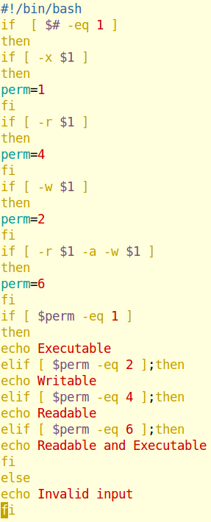

OUPUT

