13-20) Write a shell script to sort the elements in a array using bubble sort technique

PROGRAM

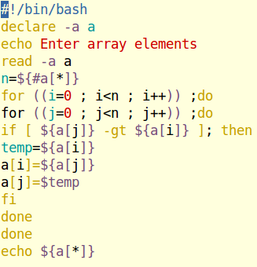

OUTPUT

