13-21) Write a shell script to find largest element in a array

PROGRAM

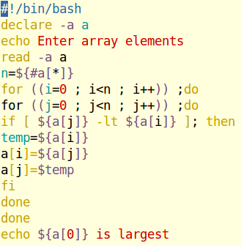

OUTPUT

