13-22)Write a awk program to print sum, average of student marks list

PROGRAM

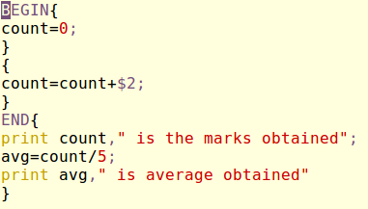

OUTPUT

