13-23)Write a awk program to display students pass/fail report

PROGRAM

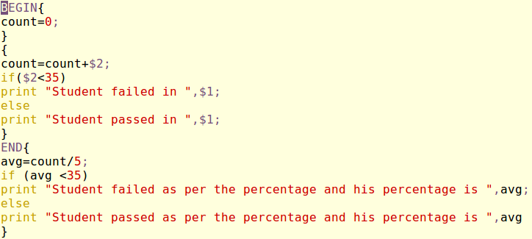

OUTPUT

